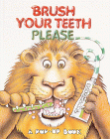

Even the FIERCEST OF THE Animals Likes to Keep a bright smile.

For more information about dental health contact
UCF Student Health Services



For an appointment, call toll-free at

1-800-613-8544

4000 Central Florida Blvd.

Post Office Box 163333

Orlando, FL 32616-3333

All copyrights reserved

Pamphlet design
By
S. R.P.M.

UCF Knight’s
Student Dental Hygeine Manual

Brushing
your teeth



the Floss between You and Cavities
cav·i·ty ('ka-v&-tE):
1 : an unfilled space within a mass; especially : a hollowed-out space
2 : an area of decay in a tooth.

Cavities can lead to some of your most painful moments if not taken care of.

Hearing the word Cavity can feel like the end of the world. Fear not, there is hope. With daily care, you too can have healthy teeth and, most importantly, avoid a cavity.
Dental Hygiene is a quick and painless procedure that can be done as simple as 1-2-3. Just stick to the following steps and you’ll be on your way to healthy teeth in no time.
Step 1 Supplies
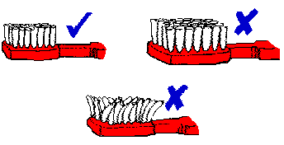
In the fight to avoid cavities you will need three basic that can be easily purchased in a drugstore.
A durable toothbrush made of soft or hard bristles. Either type will do depend on your preference and gum sensitivity.
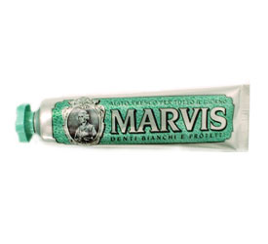

Use toothpaste that has a “tartar fighting” and whitening ingredient.

An 8oz cup filled 1/2- 3/5^{th’s} with Scope© mouthwash and a second cup filled with water.
Step 2 Set-up
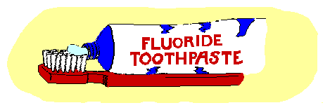
Before starting to brush your teeth, squeeze a generous amount of toothpaste, enough to cover the length of the bristles, on your toothbrush.
Mouthwash is the last line of defense against germs that cause plaque and bad breath, so use regularly after every brush.
Step 3 Brushing

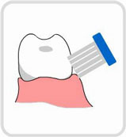
Brush your teeth in smooth circular counter-clock motions. Do the top row first, then the bottom row. Follow by re-brushing both sets as one, making sure you pay close attention to “trouble areas” such as the hard to reach back teeth. Remember, you want to get rid of as much tartar as possible.
If you feel the need to use more paste, go ahead and add more on to the brush.

Step 4 Rinsing
When you have finished brushing your teeth, spit any into the sink. Next, take a gulp of water from the second cup filled with water and rinse out the foamy coating left inside of your mouth.

It may take more than one gulp of water to completely rinse so repeat as desired.
Once you feel you have completely rinsed all the toothpaste foam coating from inside your mouth, repeat the step again only this time use the cup filled with mouthwash.

Congratulations!

You have completed all necessary steps to ensure a brighter, healthier, and cleaner smile safe from cavities and other painful offensives.

Advice


Brushing will not only aid in the daily battle against cavities, but is proven to fight plaque and the gum disease gingivitis. To maintain a healthier and cleaner smile, brush, gargle, and floss after every meal.
Tooth brushing alone can not always avoid an on coming cavity, so remember to visit your dentist regularly (at least twice a year) for a check-up.

