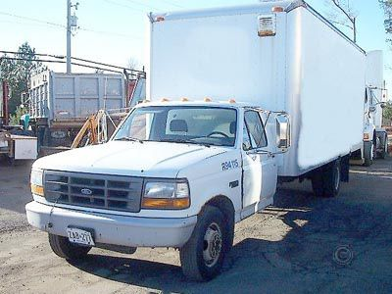

VEHICLE INFORMATION:
  Year | 1994
  Make | FORD
  Model | F-350
  Price | $5,500.00
  Mileage | 175,000
  Date | 3/14/2006
  Ad Code | CTBJXN
  Web Ad ID | 5051695
Note: Information and availability subject to change. Please contact the dealer for complete information.
Mileage recorded at time of listing.
DESCRIPTION:
20' box, 4' barn doors in back, 7.3 diesel, auto. 175,000 km. $5500.

1-888-248-5691

Asking : 5,500.00
Last price: _______________________

1996 FORD F-SERIES | $7,500.00
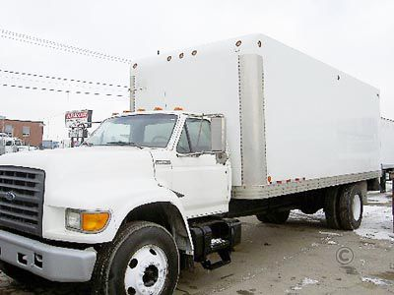

VEHICLE INFORMATION:
  Year | 1996
  Make | FORD
  Model | F-SERIES
  Price | $7,500.00
  Stock # | 1414
  Date | 3/14/2006
  Ad Code | CSZXVB
  Web Ad ID | 5060030
Note: Information and availability subject to change. Please contact the dealer for complete information.
Mileage recorded at time of listing.
DESCRIPTION:
Cummins, 210 hp, 6 spd., 10 + 21 axles, hydraulic brakes, 22 ft. van body.

UNIVERSAL TRUCKS
(905)564-4944

Asking: 7,500.00
Last price: ________________

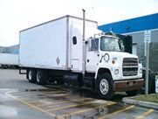

Year: 1994
Make: FORD
Model: EXPEDITOR
Model Detail:
Price: $7,900
Mileage: ------- km
Date: 3/14/2006
Ad Type: Private

Comment: Cat engine, 10 spd, sleeper, 26 ft. box, tandem axle, nice clean. $7900. or b.o.
(416)953-2308, 705-327-7673

Asking: 7,900.00
Last price: __________

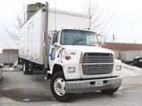

Year: 1994
Make: FORD
Model: L8000
Model Detail:
Price: $7,999
Mileage: ------- km
Date: 3/14/2006
Ad Type: Private
READY TO GO TO WORK!! - MUST SEE!!
Comment: With tailgate, diesel, 6 spd, 24 ft box, air brakes, cert. & e-tested, new clutch, rad., leaf springs and more, Reduced for a quick sale $7,999 obo. Serious enquiries only.

(416)272-9465

Asking: 7,999.00
Last price: __________

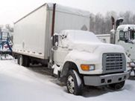

Year: 1995
Make: FORD
Model: F-800
Model Detail:
Price: $10,500
Mileage: ------- km
Date: 3/14/2006
Ad Type: Dealer
Comment: 8.3L turbo diesel cummins, Allision auto, air, brakes, air ride suspension, 24 ft van body with alum hydraulic tailgate, ex-government vehicle in excellent cond., like new. $10,500.
Dixie Truck Centre
11838 4th Line Acton
(905)877-4242 or 1-877-706-4242
Asking: 10,500.00
Last price: _______

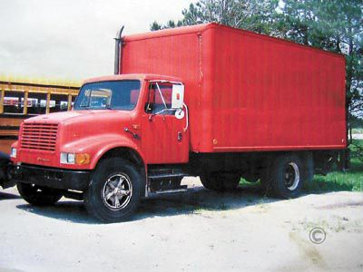

VEHICLE INFORMATION:
  Year | 1990
  Make | INTERNATIONAL
  Model | 4600
  Price | $7,995.00
  Mileage | 90,000
  Date | 3/14/2006
  Ad Code | CTCJZV
  Web Ad ID | 5071829
Note: Information and availability subject to change. Please contact the dealer for complete information.
Mileage recorded at time of listing.
DESCRIPTION:
Truck is in amazing condition, rebuilt motor, low km, no leaks, super clean, 2 dr., 7.3, diesel, red exterior, power tail gate, 90,000 km. $7995.

ALL AROUND TRUCK & CAR
(519)245-9309

Asking: 7,995.00
Last price: __________

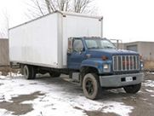

Year: 1993
Make: GMC
Model: TOPKICK
Model Detail:
Price: $7,000
Mileage: 205,000 km
Date: 3/14/2006
Ad Type: Private
Comment: 3116 CAT,195HP,6SP, HUDRALIC BRAKES, 26`FT BOX, ROOL UP DOOR, WALK RAMP, READY TO WORK, E-TEST & SAFETY, $7000 OBO 205,000 km. $7,000
416-895-3281
Asking: 7,000
Last price: _________

