Habituation

In

Snails

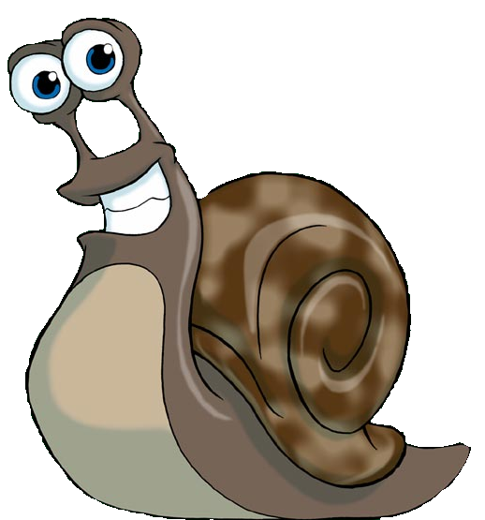

Contents

Abstract Page 3

Introduction Page 4

Hypothesis Page 6

Method Page 7

Results Page 9

Discussion Page 10

References Page 11

Abstract

Does habituation occur in snails? I am researching this by putting snails on a surface and hitting the surface to cause harsh vibrations. A group of 15 snails will be put on the surface and it will be recorded how many react each time. The experiment needs no human contribution other then mine.

Results show that the snails became used to the banging and saw it as not harmful and soon began to stop reacting to it.

Introduction

Habituation is learning process exhibited by several different species. Although it’s quite simple, it’s been suggested by Razran (1971) that habituation may be the basis of all other forms of learning. The mechanisms of habituation are usually closely regarded as akin to the mechanisms of learning.

An example of habituation is wearing a watch, if you were to put your watch on your other arm it would feel strange and out of place, as it would if you took it off the arm it’s on now. This is because your body has got used to it being on one arm and not the other. If you were to leave the watch on the other arm for a few days then you would forget about it.
This process is known as Habituation and can be summed up as when stimuli are neither harmful nor helpful to any creature it will eventually be ignored.
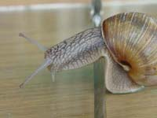
A quick way of testing this is to gently touch a snail’s tentacle, when touched it will withdraw sharply. If it is touched repeatedly eventually the snail will see that this is doing it no harm and not bother withdrawing its tentacle as much.
Habituation is a phenomenon that is widespread across the animal kingdom, it helps them survive by balancing responses to either harmful stimuli or stimuli with uncertain significance. For example a toad doesn’t want to catch inedible food, he will eventually learn what food is inedible and what food he can eat through habituation.
Another example is the escape response of a guppy, if a shadow is put over the fish then it will retreat, if this stimulus is presented every two minutes then eventually the fish will not respond to shadows.
An effect of habituation is usually that a response that a habituated response will soon reappear if stimuli is withheld for a long time, the guppy will start retreating again if no shadows are shown for about a day.
However, habituation to the shadow the next day will occur quicker because the animal has previously been habituated. This process is known as dishabitation.
No animal can afford to ignore potentially dangerous stimuli; the process of habituation is a compromise between saving energy and the animal saving itself. In relation, the snail will not be afraid after a while of no harmful stimuli but when the stimulus is first presented the snail should cower in an attempt to preserve it’s own life.

Humphrey (1933) studied the process of habituation, and he was one of the first. He placed a number of snails on a glass plate; he would then give the plate a sharp jerk that would cause the snails to react and to withdraw reflexively into their shells. After each jerk, the number of snails that had withdrawn was counted, it was found that after several trials the number showing withdrawal reflexes decreased and less and less would withdraw into their shells.

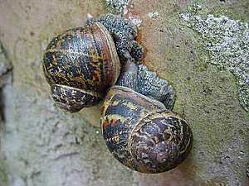
Since Humphrey’s study a variety of techniques have been used to study habituation. Such as Carew, Pinsker and Kandel (1972) found repeated stimulation of the aplysia’s siphon causes a reduction in the magnitude of gill withdrawal and Groves and Thompson (1970) found that repeated stimulation of a cats hind paw caused a reduction in the amount the cat flexed its leg, Boulis and Sahley (1988) found that repeated stimulation to the abdomen of a leech caused a reduction in the shortening reflex and Davis (1970) who tested rats by making them listen to loud tones.
Hypothesis

As with all living creatures, if a stimulus is found to be non-harmful then the creature will eventually stop worrying about it. In this case the snails will eventually learn not to fear as the surface they are resting on s banged, as they find out it isn’t harmful to them in the least. This will not happen immediately as naturally creatures are wary but should begin to take affect and stop snails reacting after about 5-10 hits.
Method

Research Design
Independent measures will be used for this experiment, as they are separate, different snails being used.
Repeated measures would be useless as the snails would eventually learn to habituate anyway and finding Matched Pairs within snails would be nearly impossible and therefore impractical.

Research Method
A field experiment will be used for the snails; this is so that the snails don’t act differently by being in a different type of environment. Obviously it cannot be kept exactly like their own environment and the snails will have been moved to get to the experiment. However, damp grass and leaves will be put on the sheet of glass so the snails feel less stressed.
A lab experiment wouldn’t be appropriate as the lighting and the environment are too artificial. An Observational study wouldn’t be too useful as it would take a long time and thus be rather impractical.

Sample
About thirty snails (so many snails makes sure of the results not just being a one off) of similar sizes and species (brown garden snail, Helix aspersa) will be used. They need to be of similar size and species as a younger or older snail may react different, for example an old snail may not be as bothered by the sounds and vibrations of harsh bangs against the surface and a young snail may be more alert. The same applies with different species; they may act differently depending on this.

Controlled Variables
The surface and the leaves will always be kept damp no matter what to make the snails feel less stressed, this will be controlled. Also the amount of stimulations will be controlled to be about the same volume and force, and each snail’s trauma in getting to the experiment will have to be minimal.

Measured Variables
The amount of snails that withdraw reflexively into their shell will be recorded each time. This will be the general basis of the experiment and will hopefully give confirmation that habituation does exist in snails.

Confounding Variables
There should be no confounding variables in this procedure as it is easier than working with humans; snails are less complex beings, with no known cognition.

Internal Variables
It can’t be told for certain how long a snail has lived for and what has happened to the snail, perhaps a snail which is still healing from a cracked shell would be less likely to retreat quickly, things like this are completely out of control.

Bias
The only bias possible in an experiment testing reflexes is experimenter bias, there could be some ambiguity as to whether or not a snail did actually reflexively withdraw or not.

Reliability
This experiment is relatively simple, and as a result there is no reason why it shouldn’t work. The results should show correlation with what’s expected to happen and it will be repeated a few times to make sure that it works properly.

Validity
This experiment has been done before by Humphrey (1933) so the procedure will just be following his that was already proved valid, yet it was quite an old experiment so it can’t be trusted completely. Also, the presence of a human at the time of the experiment may affect the snails and may make them react more. However, eventually the experiment should still have the same effect.

Ethics
There are no ethical problems when dealing with invertebrates. The snails should suffer no psychological harm and will be released straight back to the wild afterwards.
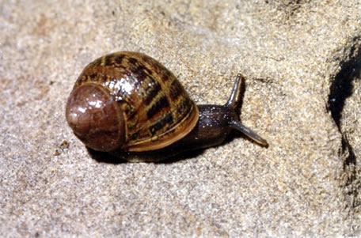
In this case the knowledge gained justifies the procedure, as the procedure should cause no harm whatsoever. The experiment will not harm or stress the snails, they aren’t social animals so they wont mind being caged for a short period as long as the experiment takes and common garden snails are not an endangered species, they are actually an incredibly common species.
Results

Surface Bangs No of snails reacting
- 15
- 15
- 15
- 15
- 13
- 14
- 12
- 13
- 13
- 12
- 12
- 11
- 14
- 11
- 10
- 12
- 9
- 8
- 8
- 7
- 6
- 7
- 8
- 7
- 6
- 6
- 5
- 5
- 5
30 5
Discussion

Findings show that eventually the snails will stop reacting to the banging of the surface on which they are standing. This is the same as was predicted, although the snails did not reacting as soon as was predicted in the hypothesis, only a couple more would stop reacting after every bang.
Additionally, a trend seemed to form that the younger and smaller snails were more alert and took more repetitions to calm down. Older and larger snails seemed to be more relaxed and would not worry as much.

Unfortunately the experiment has some certain disadvantages. Firstly it lacked ecological validity as snails would not usually have any banging on their surface and wouldn’t be used to such stimuli and thus would be more alert then they would with something they knew better.
Also, the snails may have reacted differently if they were not in a large group of fifteen. It could be that if the snails were alone then they would be more alert and thus reacted less.

In conclusion the experiment was a success and we know that habituation occurs in snails, to what point however is unknown. Possible follow-up experiments on habituation would probably best be suited in less intelligent creatures such as insects to see if they followed the same patterns.
References

