New Mexico Journal
Vol. 1, No. 1 – March 2005

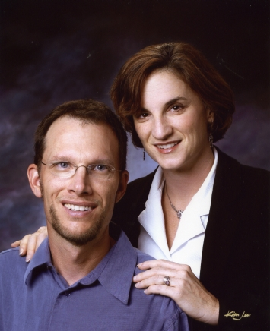
Happy Equinox /St. Patrick’s Day /Easter/Spring!!
That’s our shorthand way of saying we were too lame to send out a Christmas letter, so here’s our substitute.
A springtime greeting is appropriate because spring is definitely here in New Mexico and it’s just early March. It was almost 70 today, blazing blue skies, some snow on the mountains and daffodils blooming in Albuquerque. Lovely.
Yes I did say New Mexico – see, one reason Mike and I wanted to send a note to all of you was that we’ve had a tumultuous year and a half and wanted to catch you up. As we have moved around, we have felt the loss of friends keenly and we want to do everything we can to keep you all in our circle, even if we’re thousands of miles away.
Here’s the haiku version:
Kidney stone – gall bladder – car accident – more gall bladder – infertility – Jazz Fest - job change – leave New Orleans – arrive in Albuquerque – Balloon Fiesta – doctoral thesis – Telluride – snow - near death experience - kidney stone
So that about wraps it up for us. Unless you’d like details? But of course! And if it’s more than you wanted to know, well, hey – now you know us a little better. Feel the love.

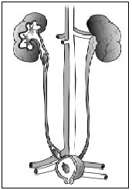
Kidney stone
In November 2003, Mike was felled by a kidney stone, which he will tell you is the worst pain he’s ever felt in his life. I can only tell you he was crawling on the emergency room floor and whimpering. This, too, did pass, and some nice narcotics helped get him through it. He was advised to drink a lot more water.

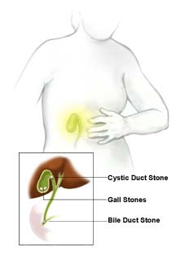
Gall bladder
Later that month, while visiting my folks in Florida at Thanksgiving, he had bouts of intense gastrointestinal pain that has plagued him since 1999. When he could no longer drink water without pain, we found ourselves in the ER again. Diagnosis? Gall stones – lots of them. They removed the big honker blocking his bile duct and sent us on our way after several days with orders to have the offending organ removed in New Orleans. He did get it out in late January, 2004, in a simple outpatient surgery. In the intervening time, however, he could eat absolutely no fat. I didn’t think Mike could lose more weight but he was pretty gaunt.
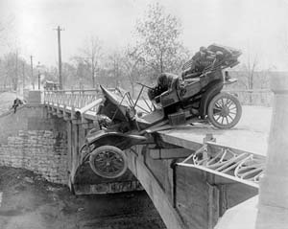
Car accident

Also in the intervening time, I was rear-ended by a car (an SUV driven, naturally, by a young man in his 20s going way too fast). My Saturn was an accordion, I had physical therapy for three months and I’m still getting chiropractic care. Could have been far worse, but let’s just say I’d prefer not to ever find out. And yes I’m suing and I hired Johnny Cochran’s New Orleans firm. I don’t know if that helps, but it sounds good, right?
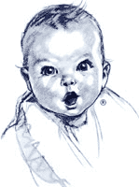

No babies
And because we couldn’t get enough of doctors, we decided to undergo fertility testing after having trouble conceiving. After several months of tests, we found out that I have the precise diagnosis of “unexplained infertility.” Basically my FSH, the hormone that regulates ovulation, is very high, which means my egg quality just ain’t too good. Why? There could be many reasons, so it’s hard to say. Age, environmental triggers, could be lifestyle choices – who knows? We were advised that our best chance was in vitro fertilization using donor eggs.
(My patience with the medical establishment ran out that day. The way my female doctor laid this news on me was short, sharp and not so sweet.)
So needless to say, our lives were consumed for about five months with many things medical and fighting with insurance companies. I only lay this litany on you because it was all so unusual for us. This was more medical care than we’ve had in 10 years.
Don’t lose heart, though! We certainly don’t mean to dump on you, just give you an update.

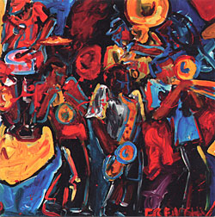
Jazz Fest
And of course Jazz Fest in April helped lighten the mood. The New Orleans Jazz and Heritage Festival was just minutes from our home and it was a banner year. We saw Etta James, Dave Brubeck, Bonnie Rait, Dr. John, Johnny Clegg and the Blind Boys of Alabama.

Job change
Yes, the music that permeates New Orleans can only be described as sublime. Alas, other things about the city are not and it was with mixed feelings that, once Mike finished his course work for his doctorate in political science, I began looking for other jobs. I won’t go into much detail, but I had been unhappy for some time at New Orleans CityBusiness and there had been much turmoil and turnover there. I tried unsuccessfully to find other jobs in the Big Easy, then I looked at jobs in Austin, Houston and in Albuquerque and the last one gave me the most serious nibble.
Mike and I had vacationed in New Mexico, and the New Mexico Business Weekly was part of the chain I had worked for in Texas. They offered me all my seniority, the editor was awesome and I made my decision.

Leave New Orleans
So once again we found ourselves packing up a moving van and, with Hannibal between us, rolling out of a city that had, despite its many problems, become home. Our numerous goodbyes revealed how many strong ties we had formed there. It was a lot tougher leaving than I thought it would be and I think we both got choked up as we steered the van onto I-10 listening to WWOZ – the best radio station on the planet.

Arrive ABQ – doctoral thesis - Telluride
So that was about 8 months ago and here we are. I am a reporter covering real estate, tribal business, the arts and banking. I am also editing some projects and I’ve been doing more freelancing, for Art Business News, Crafts Business and Stage Directions magazine and may have a shot at a piece in Fortune’s Small Business magazine thanks to my editor. (For a list of some of Megan’s art and business articles, click here. Also try the New Mexico Business Weekly site.)
Mike is working diligently on his dissertation. He defends his prospectus on April Fool’s Day (hmmmm…) which is really the toughest hurdle in the University of New Orleans’ Political Science Ph.d process. We’ve had some fabulous times here exploring the city, Santa Fe, the Sandia and Manzano mountains, the Trinity Site and the Very Large Array (think “Contact” with Jodie Foster) and are planning more adventures. One major highlight Mike and I experienced was a ride in a hot air balloon over Albuquerque during the annual Balloon Fiesta. We also took a Labor Day camping trip to Telluride, Colorado for the film festival there (coldest night of my life, but the films were good).


Snow
New Mexico weather is fantastic. We are a mile high, so we get all four seasons, but none are too extreme. If we need a snowy mountain experience, it’s just 30 minutes away, and then we can come back into temperate climes. It was fun showing Hannibal snow again after nine years.

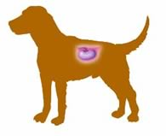
Near death experience
Our biggest scare came about a month and a half ago when Hannibal seemed on the verge of death. He’s 14 so of course his health is not what it was. He has arthritis and moves slowly these days. But he was in such obvious pain we really thought it was the end. An ultrasound revealed --- drum roll, please --- a kidney stone. Poor guy. He’s much better now, although he’s definitely showing his age. Just goes to show, like father like puppy!

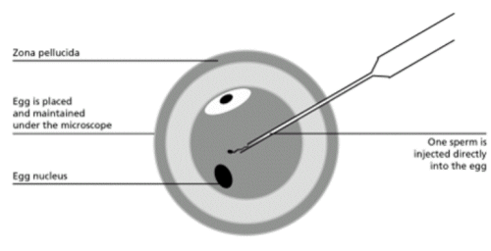

Babies?
As for human babies, I got a similar diagnosis from a doctor here, but I’ve decided I don’t want to pursue IVF. It’s very expensive, it’s not certain and I’d probably have to use donor eggs. I am currently seeking second opinions on whether I must have surgery for a very large fibroid. I hope to avoid it.
We joined Resolve, an infertility support group here, and are exploring the idea of adoption. We would welcome any input from any of you out there who have gone this route!!!
Well that’s about it, folks. I hope you will excuse the length, but now that we’re caught up our next communiqué won’t be nearly so long!! We’ve been out of touch with some of you for such a long time – we’d love to hear from you. And come visit us!
Our contact information:

Megan Kamerick & Michael Hess
1300 Hermosa Dr. SE
Albuquerque, NM 87108

Home phone: 505-265-4433
Megan’s cell: 504-400-0957
Mike’s cell: 504-715-6299

Joint email: megan_and_michael@hotmail.com
Mike: mlhess@uno.edu
Megan: megankamerick@yahoo.com

Look for our webpage, with photos, to be updated soon. Mike is trying to make it more current…it says we still live in San Antonio!
http://www.geocities.com/Athens/4209

