Officer Training -

President

Mark Kramer, DTM,
District 5 Coach/Mentor/Sponsor Chair
mkramer@flash.net

President’s Standards

The “standards” outline your duties as president. Following these standards will help ensure your success and the success of your club. You’ll also find these standards in the manual When You Are The President.

Your standards outside of the club meeting:
- Attend district-sponsored club officer training
- Ensure club officers meet officer and meeting standards
- Oversee the plan to achieve Distinguished Club Progam goals and ensure club is Distinguished
- Encourage communication & leadership development by promoting CC/AC/CL/AL awards
- Ensure club has an ongoing membership building program
- Attend (or authorize another member) and vote club’s proxy at district council meetings
- Attend regional conference and International Convention and vote club’s proxy or send proxy to District Governor
- Oversee administrative operation of club as per the club constitution and bylaws
- Maintain relationship with the District and with Toastmasters International
- Schedule and chair monthly executive committee meetings
- Arrange for a replacement if unable to attend a club or executive committee meeting
- Search for leaders, ensure all club offices are filled for the succeeding term, and ensure timely elections are conducted
- Prepare your successor for office
Your standards at the club meeting:
- Ensure meetings start and end on time
- Make sure guests are warmly and enthusiastically welcomed and introduced
- Allow time before and after the meeting to speak with guests
- Read and/or display the club mission at every meeting
- Discuss the Distinguished Club Program and the club’s progress and achievements in it
- Recognize member achievements in Toastmasters and in their personal lives
- Report on the “Moments of Truth” the club is achieving

Summing Up Your 20 Standards
- Create a vision of club success and plan to make your club vision a reality
- Lead excellent executive committee meetings
- Conduct effective, enjoyable meetings
- Ensure successful club administration
- Represent the club at area, district, and international levels

Achieving Your Standards

Create A Vision And Plan To Make Your Club Vision A Reality
- Communicate your vision to the executive committee and club members
  - Use the executive committee to set and achieve goals

- Set a goal to make your club a quality club
  - Conduct modules from The Successful Club Series (item 289)

- Set a goal to make every meeting outstanding
  - Everyone participates
  - Present effective evaluations
  - Master Your Meetings (item 1312)
  - Patterns In Programming (item 1314)
    - Hold nonstandard meetings (ex. a Backwards meeting or a Grab Bag meeting).
    - Hold unique Table Topics (ex. put on an impromptu play or host a talk show)

- Set educational goals
  - Work with members to set goals along the communication and leadership tracks
  - Members should be working the Competent Leadership Manual at every meeting – how has your club incorporated the CL Manual into meetings?
  - Provide new members with mentors
    - Mentoring (item 296)
  - Track each member’s progress

- Set membership goals (at least charter strength – 20 members)
  - See the membership section in “When You Are The President”
  - Toastmasters International website www.toastmasters.org (search Membership)
  - District 5 website www.d5toastmasters.org (click Membership Building)
  - Dynamic Speakers website www.geocities.com/dynamicspeaker (click Members)
  - A Simple Membership Building Contest (item 1621)
  - Membership Building 101 (item 1622)
  - Vote in new members and be sure they understand their responsibilities in “A Toastmasters Promise”

- Track club progress using the Distinguished Club Program
  - Routinely share progress with club members
  - Submit accomplishments immediately
  - Distinguished Club Program / Club Success Plan (item 1111) – presidents receive in June

- Provide a harassment-free environment
  - Remember “A Toastmasters Promise”

Lead Excellent Executive Committee Meetings
- Review progress and plans
  - Distinguished Club Program
  - Ask how each officer doing
  - 12 month calendar
  - Status on open action items
  - New items

- Turn the executive committee into a super team. What’s a super team?
- Commitment to performance and goals
- Inventive and creative methods of removing obstacles to success
- Visible and accessible to others
- Exude energy, excitement, and commitment
- Work together

- Verify all officers are fulfilling their responsibilities
  - Try the Executive Board Game in this handout

PRESIDENT CASE STUDY #1
Dealing With Deadbeat Officers

Background
You have been president for three months. The club’s treasurer has not attended two of the three executive committee meetings and has missed half of the club meetings. You haven’t received a treasurer’s report so you do not know the status of the club’s finances, and the treasurer has not returned your telephone calls.

Question For Discussion
What can you do?

Conduct Effective, Enjoyable Meetings
- Contact the VPE several days prior to each meeting to make sure everything is set; reconfirm just before meeting

- Read and follow Master Your Meetings (item 1312) also
  - Henderson’s Parliamentary Guide (item 170)
  - Parliamentary Procedure At A Glance (item B25)
  - Robert’s Rules Of Order (Item B30)
  - Parliamentary Procedure In Action (item 237)

- Arrive early and welcome members and guests
  - Congratulate members on Toastmasters achievements and life events
  - Provide guests with a welcome packet

- Start and end meetings on time
PRESIDENT CASE STUDY #2
When Club Meetings Don’t Start On Time

Background
Your meeting is scheduled to start at 7pm. At 6:55pm you begin to feel uneasy because the Table Topics Master has not yet arrived and your club starts its meetings with Table Topics. To make matters worse, only five club members have arrived.

Just as the clock strikes 7pm the Table Topics Master whisks in complaining about traffic. She asks for time to prepare for her role. Finally, she signals she is ready and you begin the meeting at 7:10pm.

Question For Discussion
As the club president, how can you avoid such situations and start the meeting on time?

PRESIDENT CASE STUDY #3
When Club Meetings Don’t End On Time

Background
Your meeting is scheduled to end at 1pm but meetings rarely end by then and often run 10 minutes late.

Question For Discussion
What can the club do to end meetings on time?

Ensure Successful Club Administration
- Encourage all club officers to attend officer training and verify their attendance

- Search for club leaders

- The Area Governor is the club’s advisor – maintain communication with your Area Governor

- Have all members sign up for the District 5 email distribution list (www.d5toastmaters.org)

- Confirm that all necessary paperwork is submitted
  - Officer lists to both the District and Toastmasters International in June and December
  - Dues and membership lists in March and September

PRESIDENT CASE STUDY #4
When Dues Are Due

Background
You just received the dues renewal invoice* for April-September from Toastmasters. You meet with the treasurer, vice president membership, and secretary to discuss it. What do you do about these four issues?

Two new members, Elizabeth Buchwald and Arturo Gonzalez, joined the club in March and their names are missing from the invoice. The vice president membership has already submitted their applications for membership along with their member fees and dues through September.

Two members listed on the invoice, James Davidson and Ted Franks, have told the vice president membership that they will no longer be participating in the club.

One member, Elena Petrovski, has not yet paid dues to the treasurer.

One member, James Bond, has a new address.

* The invoice lists each current club member along with their member number, address, amount of dues, and a checkbox for you to check if a member is renewing. The invoice may either be submitted via mail or updated on the Toastmasters International website.

Represent The Club At Area, District, And International Levels
- Act as a liaison in club and area/district matters

- Participate in and vote at area and district functions

- Vote at the regional and international business meetings

Reviewing Your Standards
- Create a vision of club success and plan to make your club vision a reality
- Lead excellent executive committee meetings
- Conduct effective, enjoyable meetings
- Ensure successful club administration
- Represent the club at area, district, and international levels

Open Discussion

Mark’s Further Discussion About Each Standard

Attend district-sponsored club officer training

Your presence here satisfies this standard.


Ensure club officers meet officer and meeting standards

At the front of each officer manual and in every Officer Training session, like this one, officers learn the standards that they must meet. Encourage every officer to attend Officer Training and read their manuals. Clubs receive officer manuals in June each year. At mid-year, outgoing officers should pass on their manuals to incoming officers. New manuals may be downloaded from the Toastmasters International website or purchased through the Toastmasters catalog at any time.

Consider using the Executive Board Game included at the end of this handout. The duties for every officer are assigned points that total up to about 250. Each time an officer fulfills a duty, points are awarded. Each month, publish a chart to the club showing each officer’s progress in the game and suggest to each officer what could be done during the next month to earn points. At the end of the term, award the officer with the most points or the first to reach 250 point an Outstanding Member pin or other award from the Toastmasters catalog. The reason this works is that it helps officers see their progress, reminds them of their duties, provides a level of motivation, makes them accountable to the club, and is fun.

Oversee the plan to achieve Distinguished Club Program goals and ensure club is Distinguished
Clubs that follow the Distinguished Club Program are successful; those that do not are unlikely to be successful. At the beginning of the year, work with the executive committee to develop a plan for achieving all 10 goals. Review progress and the plan at monthly executive committee meetings. Get members to sign up for goals of earning CC, AC, CL, and AL awards and keep them appraised of their progress throughout the year. Share the club’s progress on the Distinguished Club Program with all club members monthly.

Your club’s progress on the Distinguished Club Program is tracked on the Toastmasters International website. You should check it monthly to ensure that your records and Toastmasters International records are in sync. The most common discrepancy is caused by not submitting member achievements to Toastmasters International. Some clubs make this the responsibility of the VPE, others the secretary, others the members themselves, and others someone else. Make sure your club members know who is responsible for notifying Toastmasters International of member accomplishments and make sure that the information is submitted immediately upon achievement so that it does not get forgotten.

Encourage communication and leadership development through promoting of CC, AC, CL, and AL awards

Ensure members know about the communication and leadership programs and what it takes to earn awards. Consider giving a speech about this at one meeting. Emphasize that earning a CC or CL only provides the basic skills. Much more can be learned through the advanced programs.

Ensure that the VPE speaks with club members to get their goals for the year and regularly follows up with members about their progress. Routinely share member progress at meetings.

Ensure club has an ongoing membership building program

The number one question I heard as a district officer was: “How do we increase our membership?” There is no shortage of suggestions on how to build membership. VPM training goes into this in-depth. While the VPM should be leading an ongoing strong membership building program, all members are responsible for helping to build membership. As president, encourage members to constantly work to bring new members to the club.

The Toastmasters catalog is full of membership building programs and ideas that have a proven track record – these programs work and many are very simple to implement. Try just a couple and see if it doesn’t bring your club immediate results:
- See the membership section in “When You Are The President”
- A Simple Membership Building Contest (item 1621)
- Membership Building 101 (item 1622)
- Toastmasters International website www.toastmasters.org (search Membership)
- District 5 website www.d5toastmasters.org (click Membership Building)
- Dynamic Speakers website www.geocities.com/dynamicspeaker (click Members)

Attend and vote club’s proxy at district council meetings or authorize a club member to do so

Twice a year, at the fall and spring District Conferences, every club is granted two votes on district business. It is very important that your club be represented at the meeting to vote on important business. If not enough clubs are represented, we cannot conduct official business. About a month before each conference you will receive a proxy form. If you are unable to attend the conference, complete the proxy to appoint another club member to vote for you. Proxy directions are on the District 5 website (http://www.d5toastmasters.org/proxies.shtml).

Attend regional conference and International Convention and vote club’s proxy or send proxy to District Governor

Like the district, the region and international business meetings cannot conduct business unless enough clubs are represented. You will receive these proxy forms as well. Even if you plan to attend the Regional Conference and the International Convention you must still send the proxy to the District Governor immediately after receiving it in the mail. If you do attend these business meetings, the District Governor will return the proxy to you.

Oversee administrative operation of club in compliance with the club constitution and bylaws
Every club has the same club constitution and bylaws. Your club completed it and submitted its agreement to it when it chartered. If you need a copy of it you can purchase a copy through the Toastmasters catalog. Every club should keep a set with their supplies so that they can refer to them.

Some clubs may want to create additional rules. Clubs call these rules different things. One term for them are “functional rules.” For example, your club may want to institute a rule that members must pay a fine of a nickel or a quarter for each crutch word used as counted by the Ah Counter. There are no guidelines for functional rules. Your club will need to decide how many votes it takes to pass or remove a functional rule.


Maintain relationship with the District and with Toastmasters International

Throughout the year you will be asked for information from the district and Toastmasters International. It’s important that you reply quickly when asked.

Remember that your district and international officers and staff are here to support you. Take advantage of their knowledge, advice, and experience. Please deal directly with your Area Governor unless you are contacted by someone else. Your Area Governor will escalate issues if necessary.

Frequently check the District 5 and Toastmasters International websites. They contain a vast amount of information and are an excellent resources:
- District 5 website: www.d5toastmasters.org
- Toastmasters International website: www.toastmasters.org

Very important for all members: The District 5 email distribution list receives important information members and clubs need to know. Every single member of your club should be signed up. This is the best way to know what’s happening in Toastmasters. To sign up, go to the District 5 website at www.d5toasmasters.org and enter your email address in the lower left box that reads “enter email” then click Yahoo! Groups Join Now!

Schedule and chair monthly executive committee meetings

Regular executive committee meetings lead to the successful running of a club. All officers should attend and it should be open to other members to attend if they wish. While agendas are fairly flexible, you should, at a minimum, review the club’s status on every goal of the Distinguished Club Program and review the plan to become Distinguished.

I suggest that the executive committee discuss the following:
- Distinguished Club Program status and game plan to achieve Distinguished status
- Status of all officers – how is each doing?
- Set membership goals and report on the status -- discuss status of current membership building programs and plans for future membership building programs
- Amount in the Treasury
- Review a 12 month schedule (yes, your term ends after 6 months but you should not leave the next executive committee starting from scratch; some clubs even use an 18 month schedule)
  - When will the club begin collecting and send in dues? Hint: start mid-February and mid-August and submit them mid-March and mid-September to give yourself time
  - When will the club hold elections? Hint: no later than the end of May and end of November so that newly elected officers have the most time to prepare and choose from officer training sessions which start in June and December
  - When will the club hold officer installation? Hint: end of June and December
  - When will the club conduct the “Moments Of Truth” module? At least once a year
  - When will the club conduct other key modules such as “Evaluate To Motivate”?
  - Are there any dates that the club will not meet? For example, will the club meet if the meeting falls on the same day as the 4th of July?
  - Are there any dates for special events? Some clubs, for example, hold occasional non-standard meetings to get out of the same old routine (one club, for example, designates one meeting each month to a non-standard meeting format)
  - When will the club hold its club contests? Hint: February/March and August/September are best because Area contests are held in March/April and September/October
  - When is the Area Contest (March/April or September/October)? Division Contest (April or October)? District Conference (May or November)? Regional Conference (June)? International Convention(August)?
- Review club rules once each term – should any be changed?
- Status on old business or open action items
- New business

Arrange for a replacement if unable to attend a club or executive committee meeting

Life gets busy. Make certain that someone will cover for you if you are unable to attend a meeting. The VPE, VPM, and VPPR are next in line in succession. Make sure that the club has written instructions about the Presiding Officer role so that your replacement knows what to do in your absence.


Search for leaders, ensure all club offices are filled for the succeeding term, and ensure timely elections are conducted

Conduct elections by the end of May and end of November so that officers can train their successors for a month and to ensure that newly elected officers have the most choice of officer training sessions – they begin in June and December.

Remember: Presidents cannot be elected for more than two successive terms.

Prepare your successor for office

Immediately following elections, meet with the incoming president to discuss the status of the club and the standards of the president.

Ensure meetings start and end on time

Don’t let your club slip into a culture of starting late or ending late.

If your club tends to start late, change the culture by banging the gavel exactly when the meeting is supposed to begin. If the meeting is to start at 12:00 then bang the gavel at 12:00. Start the meeting whether everyone is ready or not. After a few weeks, everyone will get the message that the meeting starts on time.

If your meetings tend to end late, tweak the agenda. Clubs are required to include certain segments in the meeting but have flexibility in the order and how they are conducted. Don’t be afraid to try out new meeting formats to see if they improve meeting length. Adopt changes that work and drop those that don’t. Ask your Area Governor how other clubs order their meetings. Or, better yet, ask your Area Governor for the name of a club that efficiently runs their meetings and then go visit the club.

At Dynamic Speakers we experimented until we found an efficient meeting format. We incorporated the following changes to speed up our one hour meetings:
- We eliminated inspirational remarks at the beginning of the meeting
- We limit the Toastmaster’s opening remarks to 2-3 minutes
- We perform Table Topics after speeches and before evaluations and have the Timer flag the Table Topics Master at 40 minutes into the meeting to signal time is up (this also has the additional benefit of giving evaluators more time to craft a better evaluation)
- We wait to collect all comments and votes until the business portion of the meeting; we then hand out awards following the business portion of the meeting

Have speakers that go over their allotted time? Try a clapdown. Once the speaker has ventured 30 seconds beyond the allotted time, such as 7:30 for a 5-7 minute speech, the Timer begins to clap and the rest of the members join in. The Toastmaster then returns to the lectern to dismiss the speaker.

Make sure guests are warmly and enthusiastically welcomed and introduced. Allow time before and after the meeting to speak with guests

Every member is responsible for greeting guests but it’s impressive when the President greets a guest. At the beginning of the meeting introduce the guest to everyone and, at the end of the meeting, ask the guest if they wish to comment on the meeting. Most importantly, invite the guest to return and always ask the guest to join.

Read and/or display the club mission at every meeting

Include the club mission in the Secretary’s minutes, too.

Discuss the Distinguished Club Program and the club’s progress and achievements in it

Regularly share with all club members how the club is progressing in the Distinguished Club Program. Include a progress chart in the weekly meeting minutes.

Recognize member achievements in Toastmasters and in their personal lives
Keep an eye out on everyone’s progress. Know when a member is about to achieve something and recognize that achievement as soon as it is achieved. For example, some clubs purchase a new badge when a member reaches a level of achievement. Know to order the badge in advance to award it to the member at the moment of achievement.

Toastmasters is more than just Toastmasters. Life events happen to all of us. Share them with the club.

Report on the “Moments of Truth” the club is achieving

Conduct the “Moments Of Truth” module once every year. It is a comprehensive evaluation of the club by the members. During the process you’ll identify areas for improvement and develop actions. Review those actions at meetings. Note that the “Moments Of Truth” module will take up an entire meeting. It is well worth it to take the time to hold a meeting based on this module.

Case Studies Answers

Case Study #1 – Deadbeat Officers
- Meet privately with the treasurer and review his duties with him to ensure he understands them. Explain how important these duties are to the club and ask for his commitment to performing them.
- If he is willing to carry out his duties, follow up with him regularly to confirm that he is doing so.
- If he is unable to commit to performing his duties, offer to find an assistant to help him or give him the opportunity to resign from office.
- If he resigns from office, the club must fill the vacancy by a special election held at the next meeting following the announcement of the vacancy. Be sure to retrieve all files, checkbooks, etc. from the former treasurer.

Case Study #2 – When Meetings Don’t Start On Time
- Always start the meeting on time even if some members have not yet arrived. If your meetings typically start late, this could be a cultural change and may take a few meetings for members to adjust to starting on time. Once they get used to it they will make an effort to be punctual.
- If your club starts with Table Topics, have an alternate Table Topics ready to go. For example, purchase Stand Up and Speak! Table Topics Game (item 1316), Table Talk (item 1318), or Public Speaking For Dummies (item 1318PS).
- If necessary, re-arrange the meeting agenda so that, whatever is scheduled first, is moved to later on in the agenda.

Case Study #3 – When Meetings Don’t End On Time
- Review the agenda and look for areas that may be modified, consolidated, eliminated, or re-arranged to make the meeting more efficient
- Have an agreed upon time when Table Topics is to end and have the Timer flag the Table Topics Master when this time is reached
- Consider using a clapdown when members go 30 seconds beyond their allotted time. The Timer begins the clapping and the other members join in. If you allow the Toastmaster 2-3 minutes for introductory comments and the Toastmaster is still speaking at 3:30, then you would clapdown the Toastmaster. If a speaker is giving a 5-7 minute speech and you reach 7:30, then you would clapdown the speaker and the Toastmaster would immediately return to the lectern.

Case Study #4 – When Dues Are Due
- Simply write in Elizabeth Buchwald and Arturo Gonzalez’s names and addresses at the bottom of the list.
- Since James Davidson and Ted Franks will not be paying, do not check their boxes.
- Since Elena Petrovski has not paid her dues, do not check her box. Do not hold back the rest of the member’s dues while waiting for Elena to pay her dues.
- Cross out James Bond’s address and write in the correct address.
The Executive Board Game
Developed for Dynamic Speakers Club #457 by Mark Kramer, ATM/B, July 2001

How do we measure officer success? We know what each position entails. Rather than checking off each completed responsibility, how about turning it into a game? The duties for each office have been divided up so that each officer has the potential to earn up to about 250 points. Award points throughout the term. At the end of the term, the officer with the most points or the first to reach 250 wins an Outstanding Member pin or other award.

Why this works: It provides a measure of officer performance, reminds officers of their duties, keeps club members informed on how their officers are performing, adds a little competition, and is fun.

The president should keep score; however, if another member is designated, then the president can be part of the game as well. The president should, monthly, share with members how each officer is performing in the game. The president should also send officers reminders each month about what they can do to earn points.

Assumptions:
- 6 months to a term
- 26 meetings in a term
- 1 executive committee meeting per month
- 4 new members per term
- VPPR responsible for a quarterly newsletter
- Sergeant At Arms responsible for tallying ballots
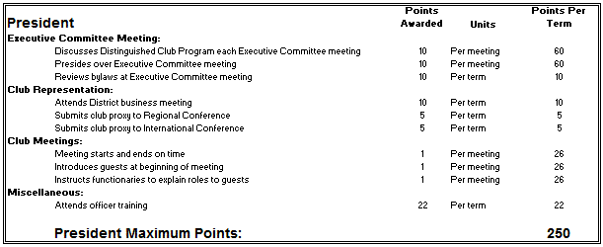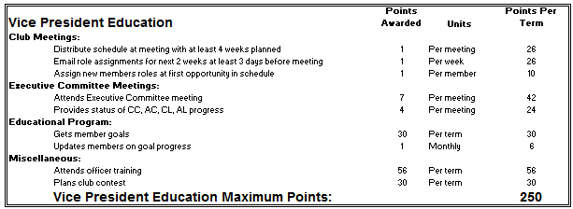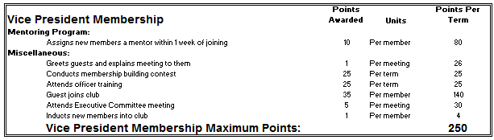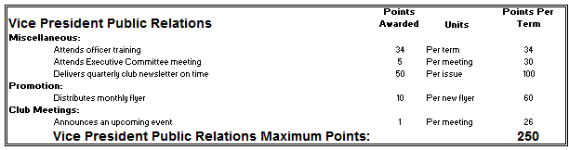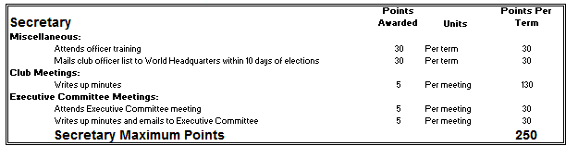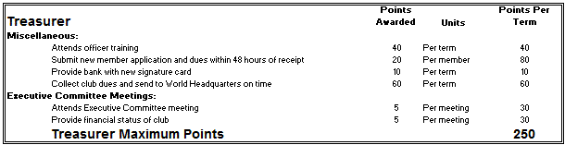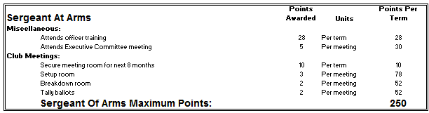
At

Resources

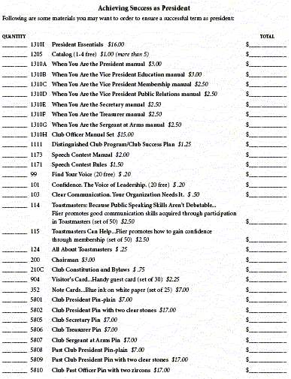

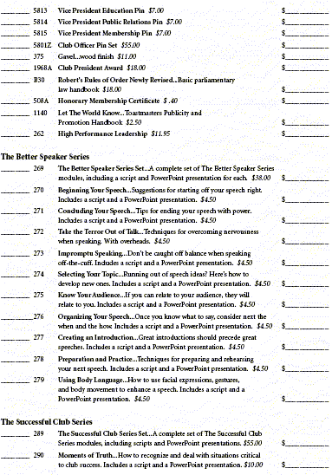
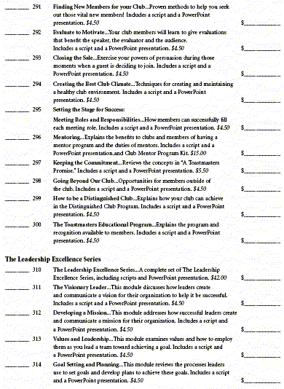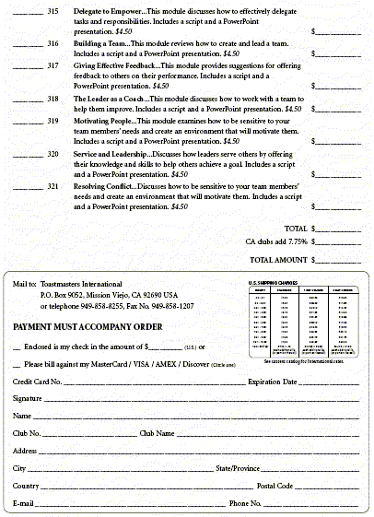

Useful Websites

District 5 – www.d5toastmasters.org

Toastmasters International – www.toastmasters.org

Old Area 16 Newsletter – http://flashpages.prodigy.net/mkramer/area16/area16_newsletters.htm

Dynamic Speakers Club #457 Members Page – www.geocities.com/dynamicspeaker

