Nihilism | 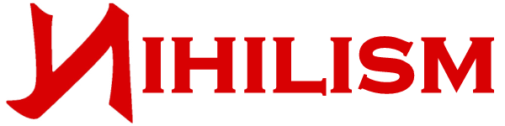
Nihilism
Nihilism
Nihilism

Nihilism

