ARIEL CASTRO

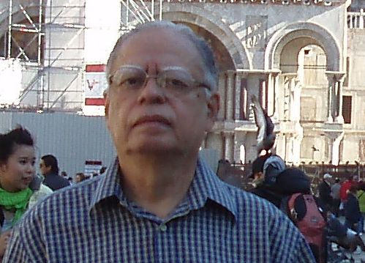
The author of this little book, José Ariel Castro, is a Brazilian professor and was born in Rio de Janeiro in 1937. He graduated in Modern Languages (1959) and completed his formal post-graduation studies at the level of specialization, master degree and PhD in Portuguese language at the Federal University of Rio de Janeiro – UFRJ (1968-1974). For his PhD he attended also at the same time several courses under the guidance of the Emeritus Professor Kurt Baldinger at the Neuphilologische Fakultät of the University of Heidelberg, where Baldinger had been the last Rektor. Later on he accomplished a post-doctorate in Linguistic Geography and Historical Linguistics granted by the German Foundation Alexander von Humboldt Stiftung at the same University (1976-1978). After obtaining in the UFRJ the degree of “Livre Docente” (1977), a traditional academic title which qualifies a teacher to work on a rank above the Associate Professor, he became Full Professor of Romanve Philology in its Faculty of Letters (1981) with special attention to the relation between History and language practice and development. He is now a pensionated professor at the UFRJ.
As a researcher, the author has tried to find the historical meaning of documents from medieval Portugal to the time of the discovery of Brazil and the following colonial period, revealing unedited life and work details of historical, cultural or literary personages like the troubadour Raimbaut de Vaqueiras, the Portuguese king Afonso Henriques and his children, the Portuguese navigator Pedro Alvares Cabral and his notary Pero Vaz de Caminha, the jesuit José de Anchieta, the navigator Amerigo Vespucci and others. As a historian, he is a researcher that does everything with documents he analyses and is a frequent consultant to the main European and Brazilian libraries besides the use of his own large private library. Typical of this kind of work are his essays on the Brazilian language, officially Portuguese, and culture: Fundamentos da história externa do português do Brasil, Língua, sociedade e cultura no Brasil, Formação e desenvolvimento da língua nacional brasileira, Ação dos jesuítas no processo de formação cultural do Brasil, O movimento academicista e o processo cultural do Brasil colônia, Literatura e sociedade no Brasil joanino. He was visiting professor for courses and/or conferences in the universities of Berlin, Mainz, Heidelberg, Venice, Cagliari, Padova and Pavia.
Ariel Castro has a Homepage, Ariel Castro’s Corner since June 22, 1996, where he displays many examples of what he has researched and written in the fields o Linguistics, Philology, Literature and History, regarding Brazil, Portugal, France and Western Europe in general.

Obras de Ariel Castro
Professor Titular
Universidade Federal do Rio de Janeiro

VII

AMÉRICO, AMÉRICA!

Preliminary notes to an English edition of the book

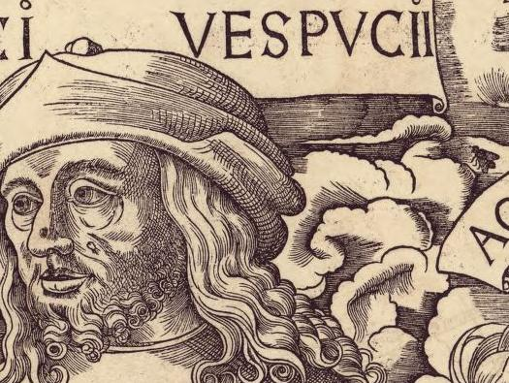

RIO DE JANEIRO

NAVONA EDITORA

2009

CHRONOLOGY: Vespucci and Waldseemüller

This chronology reflects the book Américo, América!, whose contents evidences how ridiculous is in the XXIst Century and in the historiographical work the historical character Amerigo Vespucci going on as a liar, a male prostitute or a duper. He was a man of the Renaissance in Florence with all his intelect, ideals and myths.

1451, May 2: René II is born in Joinville, near Nancy.
1454, March 9: Amerigo Vespucci is born in Florence, Italy.
c. 1473 Martin Waldseemüller (Martinus Hylacomylus) is born in Radolfzell at the Lake Constance.
1477 Duke René II of Lorraine defeats Charles the Bold, whose daughter Marie de Bourgogne in the same year marries Maximilian, future emperor of the Holy Roman Empire, having from the marriage Philippe le Beau, future king of Castille, and Marguerite d’Autriche.
1479 – 1481 Vespucci and his uncle Giorgio Antonio Vespucci in France.
1480 Botticelli’s acquaintance with the Vespuccis through Giorgio Antonio Vespucci.
1482 Marie de Bourgogne dies. Philippe le Beau becomes Duke of Burgundy.
1482 Mathias Ringmann (Philesius Vogesigena) is born probably in Eichhoffen (Alsace).
1483 King Louís XI of France dies.
1486 René II cecomes grand chambellain of Charles VIII, successor of Louís XI in France.
1496 Philippe le Beau marries Juana, daughter of the Catholic Kings, Ferdinand and Isabella.
1496 Possibility of Vespucci having embarked in one of the more than 100 ships for the marriage of Juana in the Low Countries.
1497 Vespucci’s first voyage: sails from Cadiz, May 10th, 1497.
1499 Vespucci’s second voyage: departure from Cadiz, May 18th, 1499.
1499 June, 27: Vespucci discovers Brazil before Pedro Alvares Cabral in the Amapá State eastern region of sea mangroves and after an attempt to land some days later, he navigates always down in coastal waters as far as the northern Brazil and due to the action of a westerly maritime current his ships are deviated northward to the proximity of the Island of Trinidad..
1499 November –December: Hojeda returns to Spain by the end of November or beginnings of December.

1499 Pesquisa contra Alonso de Hojeda sobre su primer viaje á las Indias.
1500 June: Vespucci returns to Spain.
1500 July 18: Vespucci’s private letter to his ex-boss Lorenzo di Pier Francesco dei Medici on his independent voayage of 1499-1500. After the letter, a new law forbade foreigners to participate of Spanish expeditions
1501 Due to the law, Vespucci moved away to Portugal to help discover the whereabouts of Pedro Alvares Cabral.
1501 Vespucci’s third voyage: sails from Lisbon May 13th according to his private letter from Cabo Verde, June 4th 1501. Or May 14th, according to Mundus Novus. Or still May 10th (Lettera and Quattuor Navigationes). Considering the very much minor time of recalling, May 13th must have been the real date. Arrived in Lisbon on September 7th, 1502.
1503 Vespucci’s fourth voyage: May 10th, 1503. Arrival in Lisbon on September 7th, 1502.
1504, July 22 to September 4, 1504 - Vespucci writes in Portugal the book on his four voyages hoping to have the success Mundus Novus.
1504 Before going to Spain with Philip I and already interested on the theme of the Portuguese in India, the Seigneur De Ville, future minister of West Indies of the future king of Castille, buys in Tournai a carpet on the theme as a gift for a mission in France.
1504 September 4 1504: Vespucci finishes the book of his navigations he will dedicate to king Ferdinand.
1504 September – October: Vespucci sends his book to Ferdinand possibly through the bishop Juan Rodriguez de Fonseca.
1504 October – Ferdinand probably reads during this month thebook of Vespucci’s navigations dedicated to him and written in Portugal.
1504, October to November – Fearful of future actions being taken by king Emmanuel against him, Vespucci decides to return to Spain .
1504, November 26: Death of queen Isabella.
1504, November 26: Juana and Philippe le Beau become queen and king consort of Castille and Leon.
1504 Having read Vespucci’s account and waiting for Columbus’s detailed news, Ferdinand decides to strengthen his plan to reach the spices islands by the West..
1504 December, 13 or 14 Meeting between king Ferdinand and Bartholomew Columbus on the 4th voyage of Christopher Columbus.
1505 January, first days – Meeting between Vespucci and king Ferdinand according to the conjugation of the following facts: the categorical indication of the donation of the primitive text of the Quattuor Navigationes by Vespucci to the king (1507); the frustrated interview of Ferdinand with Bartholomew Columbus (from the 13th to the 15th December, 1504); having already read the first version of the book, his probable immediate decision to summon Vespucci, in Seville, to a meeting, implemented in less than tree weeks; and the date of the declaration of the Florentine notary Lorenzo di Piero Choralmi da Dicomano of February 10, 1505 on the translated text as Lettera al Soderini; whose printing must be authorized by Ferdinand about 40 days before as the owner of the book.
1505 February 10, Florentine notary Choralmi da Dicomano registers Vespucci’s Lettera al Soderini.
1505 Edition of Mundus Novus, with the title De Ora Antarctica, by Mathias Ringman. His verses on Vespucci in this publication appear in the books of Gauthier Lud (Speculum Orbis, Mars1507) and Waldseemüller (Cosmographiae Introductio, April 1507).
1505 April 24: Letter of naturalization in favor of Vespucci, for Castella and León.
1506 After the Villafafila Agreement Jean de Luxembourg gets letter of naturalization and is charged with the responsibility for the West Indies matter substituting Gaspar de Gricio.
1506 June-July: The Spices Project begins to be known in details by Philip I and his auxiliaries including the responsibilities in it of Amerigo Vespucci and Vicente Yánez Pinzón.
1506 August 23: Letter of PhilipI to the directors of the Casa de La Contratación ordering a written opinion whose contents should be obtained from Vespucci and Pinzón and on the situation of the West Indies in general and the Spices Project in particular.
1506 September 15: the Casa de la Contratación instructs Vespucci for the travel to Burgos to meet the king.
1506 September 23 Arrival of Vespucci in Burgos to meet the king probably in the afternoon.
1506 September 24: Vespucci with Mr. De Ville, gran chambelano of Philip I because the king was sick. To the meeting were present Diego de Guevara, translator, and Philibert de Veyré, diplomat. Vespucci leaves his documents to be delivered to Philip I.
1506 September 24 in the afternoon: Philip I worsens and dies on the 25th September.
1506, November 4 : The unstable situation in Spain makes De Ville to retire to the Low Countries with the documents and delivers them to Duke René II of Lorraine.
1507 After March 7, Mathias Ringmann reaches Saint-Dié when the Introductio was almost ready for publication.
1507 April 25: With Vespucci’s material, Waldseemüller publishes the Cosmographie Introductio but as his author only in 1509.
1508 Amerigo Vespucci is named Pilot Major by Ferdinand as a consequence of his correct behavior on September 24, 1506 and the publishing of the Quattuor Navigationes in St. Dié.
1508 September 22: Jean de Luxembourg, seigneur de Ville, dies in Brussels.
1511 Mathias Ringmann dies at age 29.

1511 Vespucci is cited by Herrera for having protected in 1511 Portuguese pilots in the charge of Pilot Major.

1512 February 22nd: Vespucci dies.
1513 Edition of Ptolemy’s Geographia, with 1000 copies, in Strasbourg made by Waldseemüller and Ringmann.
1515 The news of Balboa’s discovery of the Pacific Ocean reach St. Dié and Germany. Martin Waldseemüller, becomes enthusiastic about the fact, retakes his map of 1507, modifies it with new data and the artistic portraits he received from Burgos in 1507 through Duke René II, but owing to personal difficulties does not succeed in going on and hands on all his renewed material, which ultimately comes to the hands of Johannes Schöner.
1518 Waldseemüller dies. After his death the name America began to be restored in maps.
1520 Diego de Guevara, Spanish by birth, translator and interpreter of Philip I, a man important in the field of arts in the Low Countries, dies.

