UDC 9 (479.22) 34

Democratic Republic of Georgia (1918-1921)

by Dr. Levan Z. Urushadze (Tbilisi, Georgia)

Edited by Dr. Paata Bukhrashvili (Tbilisi, Georgia)

ISBN 99940-0-539-1

The Democratic Republic of Georgia (DRG. “Sakartvelos Demokratiuli Respublika” in Georgian) was the first modern establishment of a Republic of Georgia in 1918 - 1921. The DRG was established after the collapse of the Russian Tsarist Empire that began with the Russian Revolution of 1917. Its established borders were with Russia in the north, and the Mountainous Republic of the Northern Caucasus, Turkey, Armenia, and Azerbaijan in the south. It had a total land area of roughly 107,600 km² (by comparison, the total area of today's Georgia is 69,700 km²), and a population of 2.5 million. As today, its capital was Tbilisi and its state language - Georgian.
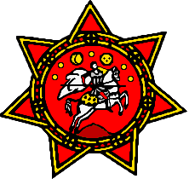
THE NATIONAL FLAG AND COAT OF ARMS OF THE DEMOCRATIC REPUBLIC OF GEORGIA

A Trans-Caucasian house of representatives convened on February 10, 1918, establishing the Trans-Caucasian Democratic Federative Republic, which existed from February, 1918 until May, 1918. The Trans-Caucasian Democratic Federative Republic was managed by the Trans-Caucasian Commissariat chaired by representatives of Georgia, Azerbaijan and Armenia. On May 26, 1918 this Federation was abolished and Georgia declared its independence.

Politics

In February 1917, in Tbilisi the first meeting was organised concerning the future of Georgia. The main organizer of this event was an outstanding Georgian scientist and public benefactor, Professor Mikheil (Mikhako) Tsereteli (one of the leaders of the Committee of Independence of Georgia from 1914-1918). The participants at this meeting were: the National-Democrat Colonel David (Data) Vachnadze (since 1919 a member of the Parliament of Georgia), Social-Federalists General Ioseb Gedevanishvili, Mikheil Tsereteli (from 1918-1920 Ambassador of Georgia in Norway) and Social-Democrats (Mensheviks) Noe Zhordania (since October, 1918 Chairman of the Government of DRG), Evgeni Gegechkori (from 1917-1918 Chairman of the Trans-Caucasian Commissariat, and, since May 26, 1918 - Minister of Foreign Affairs of DRG), and Meliton Kartsivadze (since 1919 Member of the Parliament of Georgia). They decided to proclaim the independence of Georgia.
In 1917, in accordance with this, the Autocephaly (independence) of the Georgian Orthodox and Apostolic Church was restored.
On May 22, 1918, in Batumi (administrative center of the Autonomous Republic of Ajara of Georgia), the second meeting was organized, by Professor Zurab Avalishvili (outstanding Georgian scientist, diplomat and public benefactor). The participants of this meeting were: Zurab Avalishvili (representing the National-Democratic Party of Georgia), Noe Zhordania (representing the Social-Democratic Party), Akaki Chkhenkeli (representing the Social-Democratic Party), Niko Nikoladze (Outstanding Georgian public benefactor and writer, Honorary Chairman and one of the founders of the Georgian National-Democratic Party) and Petre Surguladze (representing the National-Democratic Party). After this meeting, Zurab Avalishvili created the document which became the "Declaration of State Independence of Georgia".
The "Declaration of the State Independence of Georgia" was adopted by the National Council of Georgia on May 26, 1918 (see photo). Many prominent Georgian politicians and public figures, as well as many guests attended, among them General Schulenburg. Thus was created the government of the Democratic Republic of Georgia. The first Chairman of the Government was Noe Ramishvili, a Social-Democrat). Among members of the Government were representatives of the Social-Democratic Party, the Social-Federalists, the National-Democratic Party, and the Social-Revolutioners.
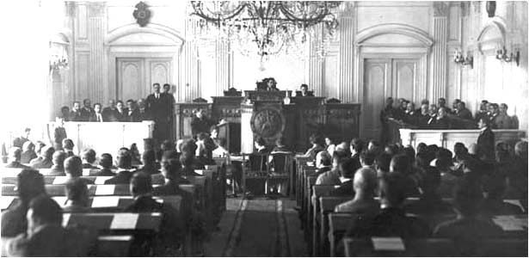
THE HISTORICAL MEETING OF THE NATIONAL COUNCIL OF GEORGIA, TBILISI, MAY 26, 1918

After October, 1918, the government was ruled by Noe Zhordania (leader of the Georgian Social-Democratic (Menshevik) Party).
The Chairman of the National Parliament was Nikolay (Karlo) Chkheidze (one of leaders of the Social-Democratic Party), the Deputy Chairman was an outstanding Georgian historian and public benefactor, Professor Ekvtime Takaishvili (one of the leaders of the Georgian National-Democratic Party), and the 2nd Deputy Chairman was Alexandre Lomtatidze (Social-Democrat). It was an established multiparty system: among the members of the Government and the Parliament were also representatives of the National-Democratic Party, the Party of Georgian Social-Federalists, Party of Social-Revolutioneers and other political organizations. The Parliament had 130 members. Famous Members of the Parliament were: Revaz (Rezo) Gabashvili (National-Democrat), Samson Pirtskhalava (Social-Federalist), Seit Devdariani (Social-Democrat), Vasil Tsereteli (National-Democrat), Dr. Giorgi Gvazava (National-Democrat), Meliton Kartsivadze (Social-Democrat), Iason Javakhishvili (National-Democrat), Irakli (Kaki) Tsereteli (Social-Democrat), Levan Natadze (Social-Democrat), Alexandre Tsereteli (Social-Federalist), Ioseb Dadiani (National-Democrat), Razhden Arsenidze (Social-Democrat), Shalva Amirejibi (National-Democrat), etc.
In 1919 free, democratic multiparty elections were held and a National Parliament (Dampudznebeli Kreba in Georgian) of the Democratic Republic of Georgia elected.
The independence of the Democratic Republic of Georgia was de jure recognized by Romania, Argentina, Germany, Turkey, Belgium, United Kingdom, France, Japan, Italy, Poland, Czech Republic, and Russia, among other countries.
On February 21, 1921 the Constitution of the Democratic Republic of Georgia was adopted by the Parliament. The Parliament proclaimed with this Constitution an absolute equality of race and sex, freedom of the press and the speech, freedom of religion and all other basic freedoms. Also adopted were other important legal acts among them: Law about the Regular Army (1918), Law about the Education (1918), Law about the State Language (1918), Act about the "People's Council of Abkhazia" (1918), Law about the Citizenship (1919), etc.
From late 1919 to early 1920, the government of Bolshevik Russia achieved decisive success in all points of the Russian Civil War. The policy of Great Britain had failed in "the Russian Problem". After that there was raised a question: how best to direct attention to the national states in the Trans-Caucasus (Georgia, Azerbaijan, and Armenia) formed from the former tsarist Russian Empire? Early on, France and Italy continued to be passive and gave up their activities in the Russian post-imperial space.
In January 27, 1921 Great Britain, together with the allied countries, recognized the Democratic Republic of Georgia de jure in an attempt to block Soviet Russia from reabsorbing Georgia. However, on February 25, 1921, the Bolshevik Russia's Red Army reoccupied the country and Georgia became a Soviet Republic. In March, 1921, the legal Parliament and Government of the DRG were forced to leave Georgia.
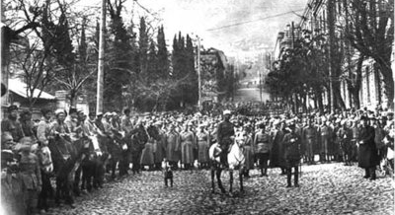
OCCUPATION OF GEORGIA BY THE BOLSHEVIK RUSSIA’S RED ARMY (FEBRUARY 25, 1921)

Georgia was then merged with Armenia and Azerbaijan to form the Trans-Caucasian Soviet Federalist Republic, one of the republics of the former Soviet Empire.
Guerilla resistance in 1921-1924 was followed by a large-scale patriotic Uprising in August, 1924. General Konstantine (Kote) Abkhazi, General Nestor Gardapkhadze and Colonel Kaikhosro (Kakutsa) Cholokashvili were the most prominent guerilla leaders.
On April 9, 1991 the independence of Georgia was restored when the "Act about the Restoration of State Independence of Georgia" was adopted by the Supreme Council of the Republic of Georgia.

Army

In the Ministry of Defence of the Democratic Republic of Georgia worked many famous Georgian Generals and Officers: Gen. Kote Abkhazi, Gen. Giorgi Kvinitadze, Gen. Giorgi Mazniashvili, Gen. Alexandre Andronikashvili, Gen. Varden Tsulukidze, Gen. Alexandre Chkheidze, Gen. Nestor Gardapkhadze, Gen. Zakaria (Shakro) Bakradze, Gen. Leo Kereselidze, Colonel Kakutsa Cholokashvili, Colonel Parnaoz Karalashvili, Colonel Elizbar Gulisashvili, Colonel David Vachnadze, Colonel Solomon Zaldastanishvili, Colonel Svimon Tsereteli, Colonel Erekle (Eko) Tsereteli, Colonel Rostom Muskhelishvili, Colonel Dimitri Chrdileli, etc. But, unfortunately, the National Army of Georgia has not a proper favour of the Menshevik Government of Zhordania. Main role was given to the troops of Georgian Mensheviks - the so-called “People’s Guard”. The commanders of this military group was completed by the diletantes.
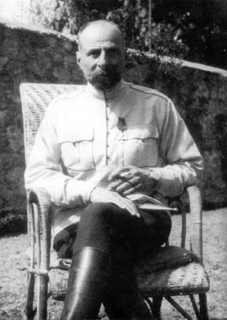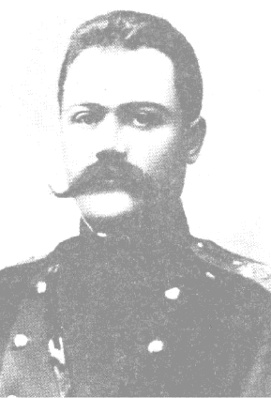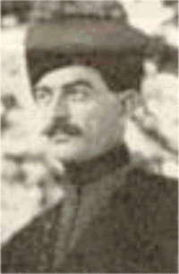
GEN. GIORGI KVINITADZE, GEN. KOTE ABKHAZI AND COL. KAKUTSA CHOLOKASHVILI

On 1918 was founded the Tbilisi Military School. The head of this school was a distinguished Georgian military figure, Colonel Alexandre Chkheidze (later Major General of the Polish Army).

Education, science and culture

Important educational, cultural and scientific centers of the Democratic Republic of Georgia included: the Tbilisi State University (TSU), the Military School in Tbilisi, Gymnasiums in Tbilisi, Batumi, Kutaisi, Ozurgeti, Poti and Gori, the Pedagogical Seminary in Gori, the Pedagogical Seminary for Women, the State Museum of Georgia (Tbilisi), the State Theatres in Tbilisi and Kutaisi, Tbilisi State Opera Theatre, Tbilisi State Academy of Art, the Union of Georgian Writers, the Public Libraries of Tbilisi and Kutaisi, the Physical Observatory in Tbilisi, the Central Scientific Archive of Georgia, State Scientific Council of Georgia, Central Botanical Garden in Tbilisi, Botanical Gardens in Sokhumi, Batumi and Bakuriani, etc.
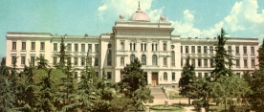
TBILISI STATE UNIVERSITY (TSU) AND THE LOGO OF THE UNIVERSITY

Main newspapers of DRG were: "Sakartvelos Respublika", "Sakartvelo", "Ertoba", "Samshoblo", "Sakhalkho Sakme", "The Georgian Messenjer" (in English) and "The Georgian Mail" (in English), etc.
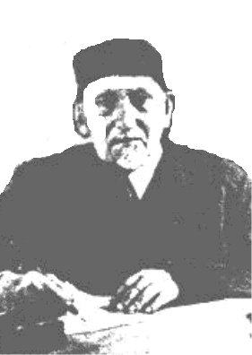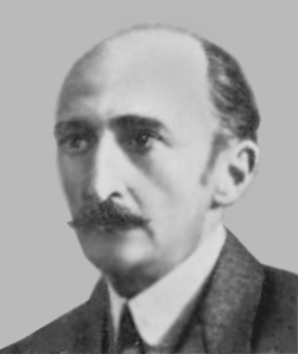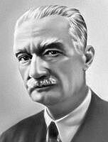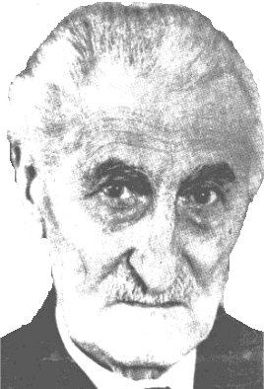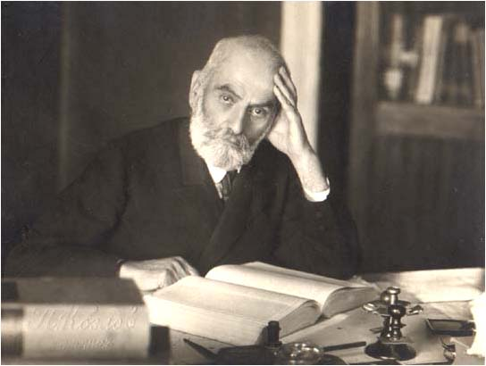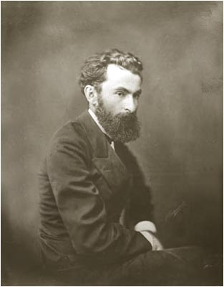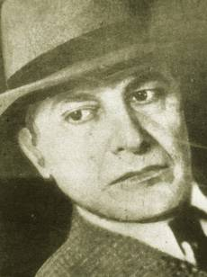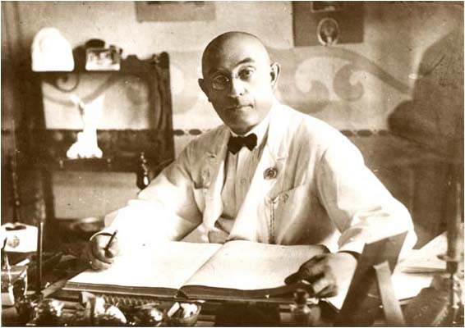
PROF. EKVTIME TAKAISHVILI, PROF. GRIGOL TSERETELI, PROF. IVANE JAVAKHISHVILI, PROF. MIKHEIL TSERETELI, PROF. PETRE MELIKISHVILI, NIKO NIKOLADZE, GRIGOL ROBAKIDZE AND ZAKARIA PALIASHVILI

Outstanding representatives of Georgian culture and science were: Niko Nikoladze, Vasil Barnovi (Barnaveli), Konstantine (Kote) Makashvili, Niko Lordkipanidze, Konstantine Gamsakhurdia (father of the first President of the Republic of Georgia in 1991-1993, Dr. Zviad Gamsakhurdia), Pavle Ingorokva, David Kldiashvili, Grigol Robakidze, Shalva Amirejibi, Ekaterine Gabashvili, Tedo Sakhokia, Shalva Dadiani, Ioseb (Soso) Grishashvili, Galaktion Tabidze, Zakaria Paliashvili, Meliton Balanchivadze (George Balanchine’s father), Vano Sarajishvili, Alexandre (Sandro) Akhmeteli, Gigo Gabashvili, Mose Toidze, Iakob Nikoladze, David Kakabadze, Alexandre Tsagareli, Petre Melikishvili, Ivane Javakhishvili, Andria Benashvili, Andria Razmadze, Nikoloz (Niko) Muskhelishvili, Shalva Nutsubidze, Giorgi Akhvlediani, Luarsab Andronikashvili, Vakhtang Muskhelishvili, Alexandre Aladashvili, Grigol Tsereteli, Ekvtime Takaishvili, Zurab Avalishvili, Giorgi Gechtman, Mikheil (Mikhako) Tsereteli, Sargis Kakabadze, Zakaria Kanchaveli, Dimitri Uznadze, Konstantine (Kote) Amirejibi, Solomon Kurdiani, Solomon Cholokashvili, etc.

Industry and Agriculture

The Manganese Industry in Georgia (Manganese of Chiatura) had very great importance for European Metallurgy (about 70% of the manganese industry of the world in 1920s-1940s).
very important are Georgian mineral waters ("Borjomi", "Nabeglavi", "Sairme", etc.).
Important were also the Ports of Poti, Sokhumi and Batumi.
Georgia is a traditional agrarian country with well-developed Gardening, Viticulture and Wine-making (Georgia is a classical country of viticulture and wine-making).

References:
- "Legal Acts of the Democratic Republic of Georgia (1918-1921)", Tbilisi, 1990 (in Georgian)
- I. Tseretelli, "Separation de la Transcaucasie et de la Russie et Independance de la Georgie", Paris, Imprimerie Chaix, 1919 (in French)
- P. Surguladze, "The international importance of the independence of Georgia", Istanbul, 1918 (in Georgian)
- P. Surguladze, "Georgia as the independent country", Istanbul, 1918 (in Georgian)
- D. Ghambashidze, "Mineral resources of Georgia and Caucasia. Manganese industry of Georgia", London, 1919
- K. Salia, "The History of Georgian Nation", Paris, 1983
- Al. Manvelichvili, "Histoire de la Georgie", Paris, 1951 (in French)
- Z. Avalishvili, "The Independence of Georgia in the International Politics of 1918-1921", Paris, 1923 (in Russian)
- K. Kandelaki, "The Georgian Question Before the Free World", Paris, 1951
- G. Kvinitadze, "My answer", Paris, 1954 (in Georgian)
- Jan V. Nanuashvili, "What everyone in the Free World should know about Russia", Vantage Press, New York - Washington - Hollywood, 1973
- V. Tevzadze, "The memoirs of the Georgian Officer".- J. "Iveria", No 32, Paris, 1988 (in Georgian)
- N. Matikashvili, M. Kvaliashvili, "Cadets".- J. "Iveria", No 32, Paris, 1988 (in Georgian)
- O. Janelidze, "From May 26 to February 25", Tbilisi, 1990 (in Georgian)
- G. Mazniashvili, "The Memoirs", Batumi, 1990 (in Georgian)
- L. Urushadze, "Bolshevism-Menshevism and the Democratic Republic of Georgia (1918-1921)", 2nd edition, Publishing House "Ena da Kultura", Tbilisi, 2005, ISBN 99940-23-56-X (in Georgian, English summary)
- R. Tsukhishvili, "The English-Georgian Relations (1918-1921)", Tbilisi, 1995 (in Georgian, English summary)
- ”Kartuli Idea – The Georgian Idea” by Dr. Levan Z. Urushadze.- http://www.geocities.com/levan_urushadze_98/Georgia.html , 2005, ISBN 99940-0-490-5
This Electronic Book is created by Dr. Levan Z. Urushadze (Tbilisi, Republic of Georgia)
levzur@mail2scientist.com
- Dr. Levan Z. Urushadze. All rights reserved
http://www.geocities.com/levan_urushadze_98/DRG.doc

