1
2
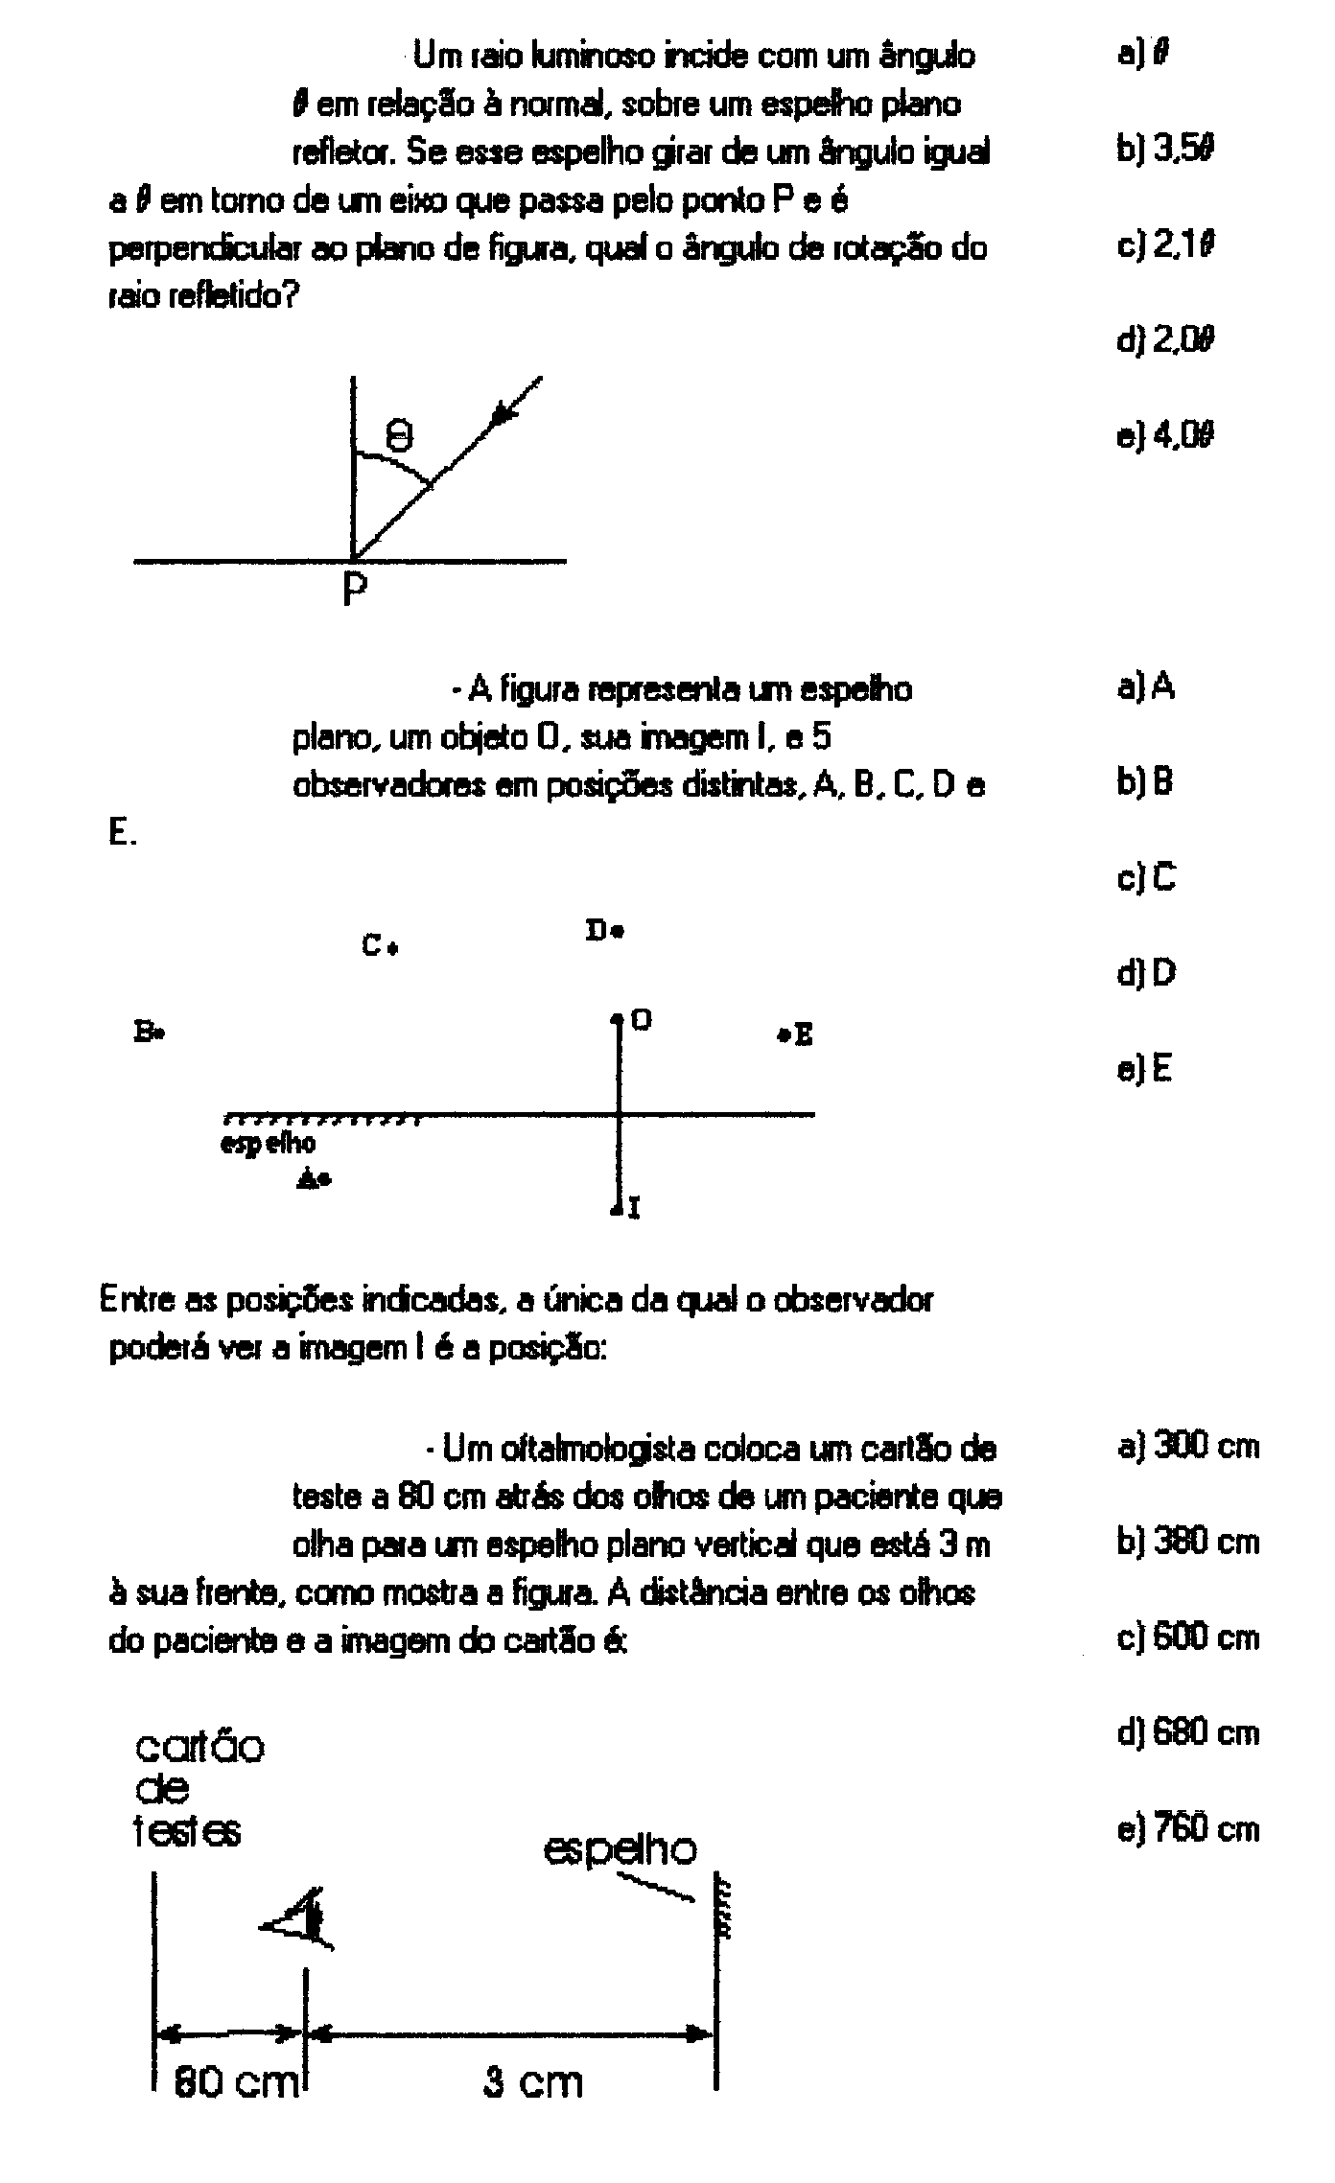
3

4
5
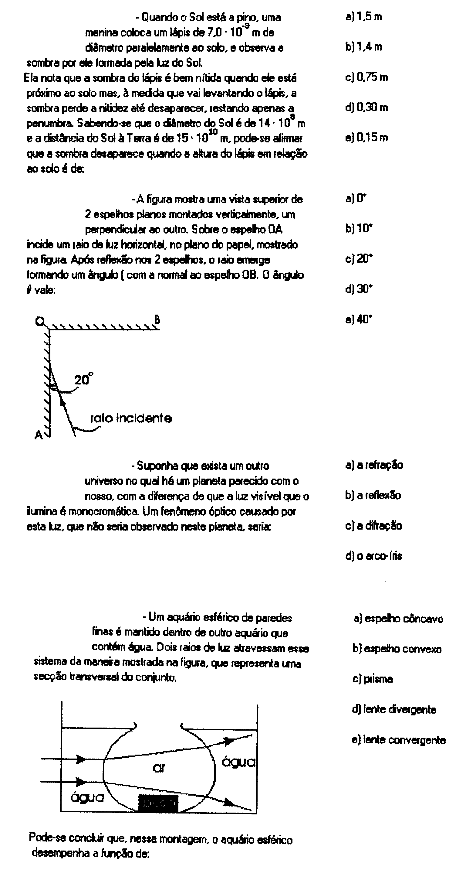
6
7

8
9
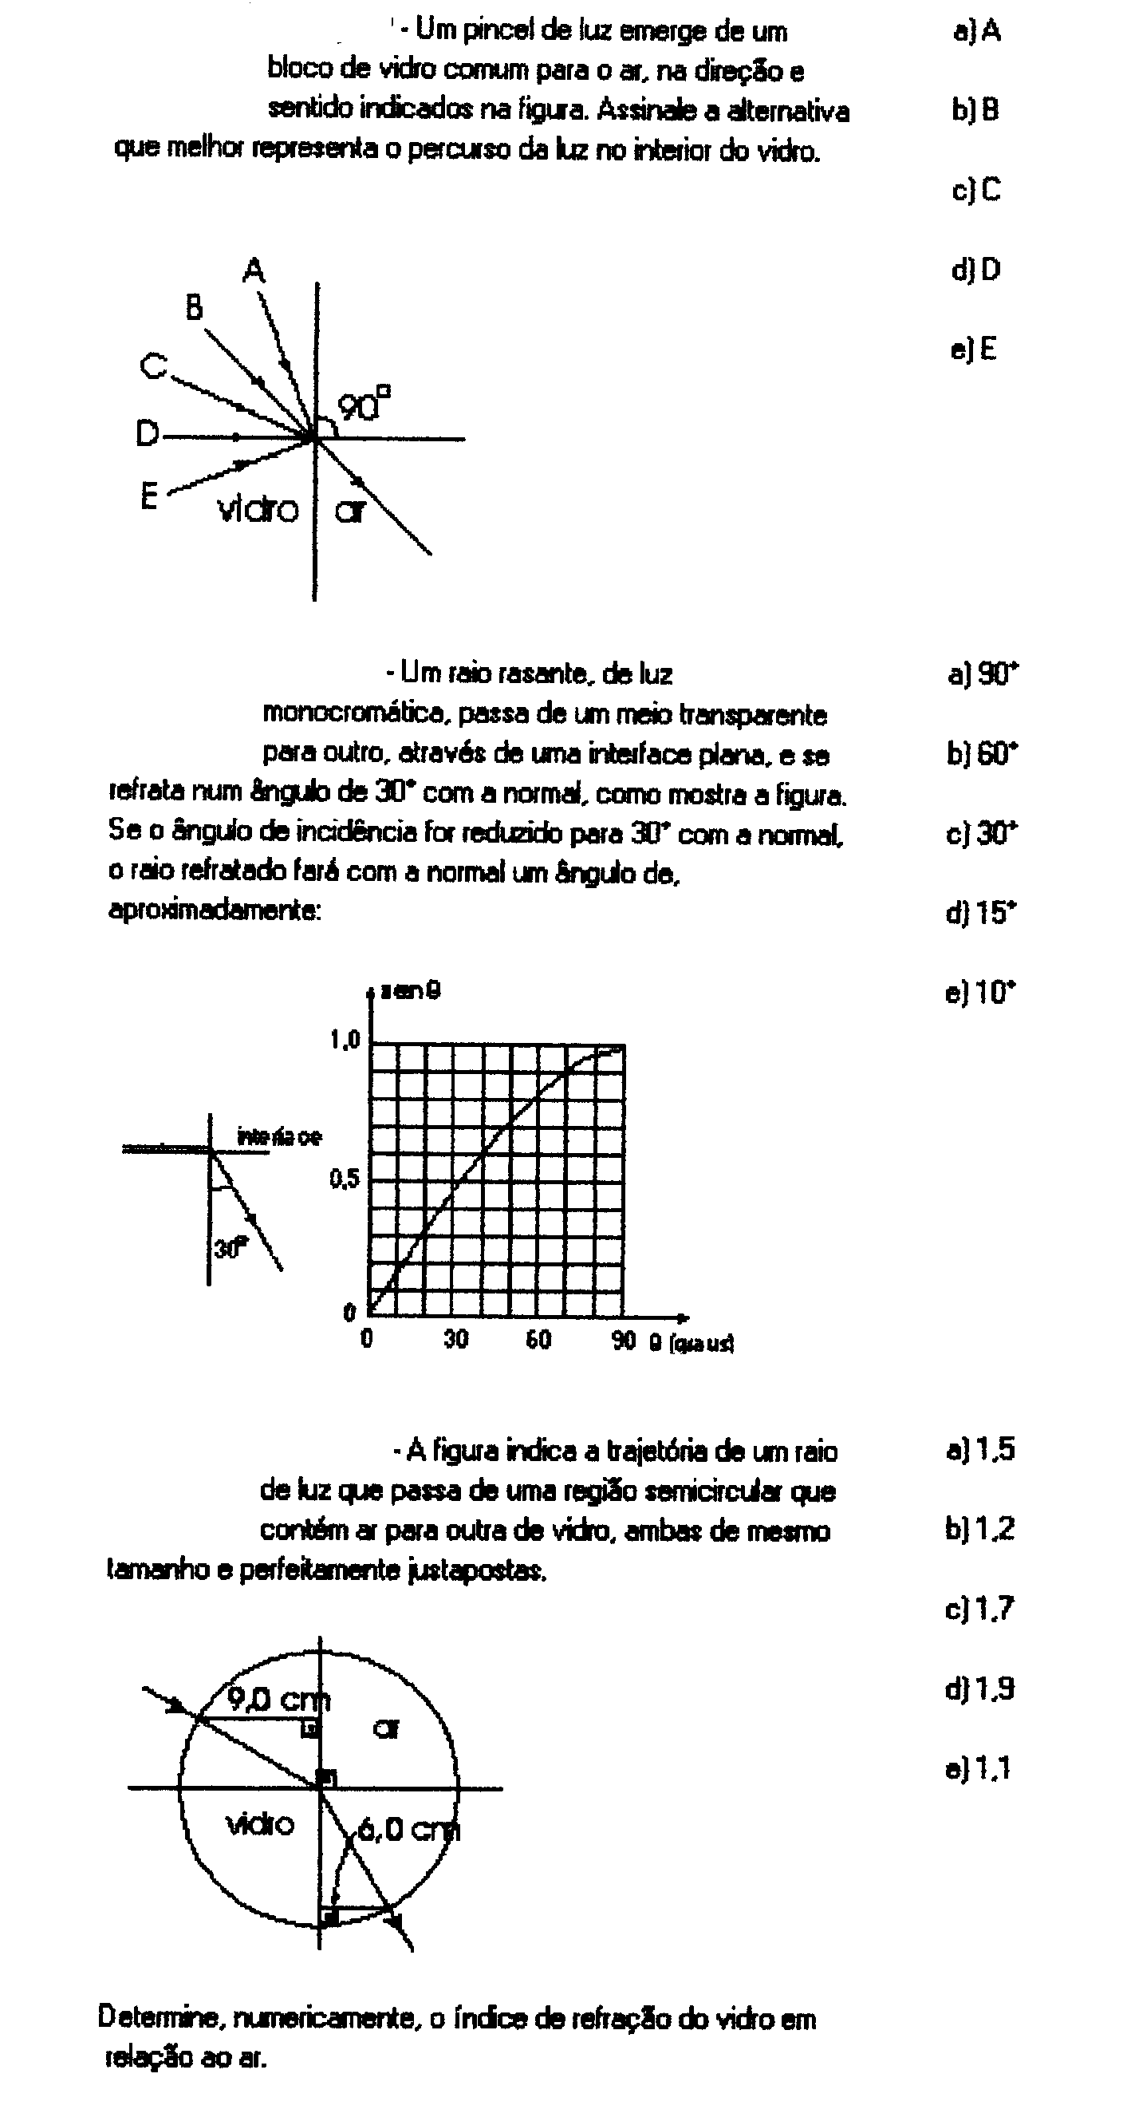
10

GABARITO
1- d 2 - d 3 – d 4- c 5 – c 6 – d 7 - d 8 - c 9 - d 10 - a

