Wave Behavior and Sound Test Review Sheet

Identify: Peak(s), Trough(s), Crest(s), one full wavelength, Amplitude, Wavelength/Period
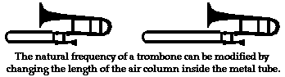
In the diagram above, identify: rarefaction and compression.
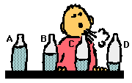
The trombone slide position that should produce the highest pitch?

Which bottle in the above diagram will have the lowest pitch? _____
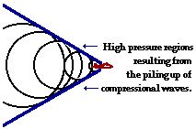
In which item or location are you most likely to observe a vibration (anti-node)? (Nodes cannot occur at a wall, pressure barrier, or fixed end.)
The diagram above is an example of a Sonic Boom.

- Difference between Beating Frequency vs. the Doppler Effect
- Waves do not transport matter.
- There is no air in space to for the wave to travel.
- Particles in a transverse wave transporting energy from east to west can move both northward and southward.
- Particles in a longitudinal/compression wave transporting energy from left to right move back and forth in a leftward and rightward direction.
- Which type of wave do fans in a stadium produce when they stand up and sit down? Ans. Transverse Wave
- How must the fans in a stadium move in order to produce a longitudinal stadium wave? Ans. Left to right or side to side
- sonar device = Longitudinal waves

MATH: Two notes that have a frequency ratio of 2:1 are separated by an octave. A note that is an octave lower than middle C (256 Hz) is _______.
MATH: A kid on a playground swing makes a complete to-and-fro swing every 2 seconds. That means he/she has a 2 second Period. Frequency can be found using the following formula: Frequency=1/Period. The frequency of swing is _________.
MATH: A kid has a mass of 90 kilograms and a height of 1.33 meters. While swinging on a bigger swing, he/she has a period of 5.0 seconds The child's frequency is ________ Hertz.
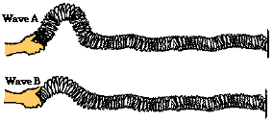
Mr. Corder attaches a slinky to the wall and begins introducing pulses with different amplitudes. They will strike at the same time
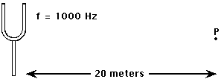
MATH: The time required for the waves (the speed of the sound wave in air is 340 m/s) to travel from the tuning fork to point P is __________.
While hiking through a canyon, you let out a scream. An echo is heard off a nearby canyon wall 340 meters away. (The speed of the sound wave in air is 340 m/s.) How long before you hear the echo?
MATH: The Beating Frequency is the difference of two frequencies played together. Two tuning forks with frequencies 440 Hz and 437 Hz are played together. What is the Beating Frequency?

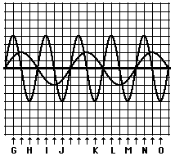
Constructive Interference is when waves of similar amplitude signs add together. Destructive Interference is when waves of different amplitude signs cancel out.
Constructive interference is found at points: G J M N
Destructive interference is found at points: H I K L O
Of all the labeled points in the standing wave above, destructive interference occurs at point(s): A, E, and F

