Data Set I: Vapor Pressure of Water at Various Temperatures – Graphs
Generated by Excel – A Linear Regression Is Determined

Temp | Press
(°C) | (mm Hg)
0.00 | 4.580
5.00 | 6.543
10.00 | 9.209
15.00 | 12.788
16.00 | 13.634
17.00 | 14.530
18.00 | 15.477
19.00 | 16.478
20.00 | 17.535
21.00 | 18.650
22.00 | 19.827
23.00 | 21.068
24.00 | 22.377
25.00 | 23.756
26.00 | 25.209
27.00 | 26.739
28.00 | 28.349
29.00 | 30.044
30.00 | 31.823
31.00 | 33.696
32.00 | 35.663
34.00 | 39.899
36.00 | 44.563
38.00 | 49.692
40.00 | 55.324
45.00 | 71.882
50.00 | 92.511
55.00 | 118.030
60.00 | 149.370
65.00 | 187.550
70.00 | 233.710
75.00 | 289.100
80.00 | 355.110
85.00 | 433.620
90.00 | 525.770
95.00 | 633.910
100.00 | 760.000

Data Set I: Vapor Pressure of Water at Various Temperatures – Graphs
Generated by TI-83 Plus – A Linear Regression Is Determined

 | 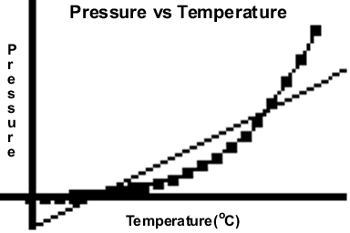  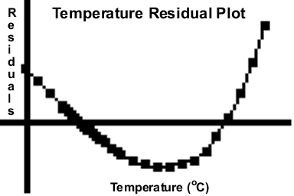
  Temp | Press
  (°C) | (mm Hg)
  .00 | 4.580
  5.00 | 6.543
  10.00 | 9.209
  15.00 | 12.788
  16.00 | 13.634
  17.00 | 14.530
  18.00 | 15.477
  19.00 | 16.478
  20.00 | 17.535
  21.00 | 18.650
  22.00 | 19.827
  23.00 | 21.068
  24.00 | 22.377
  25.00 | 23.756
  26.00 | 25.209
  27.00 | 26.739
  28.00 | 28.349
  29.00 | 30.044
  30.00 | 31.823
  31.00 | 33.696
  32.00 | 35.663
  34.00 | 39.899
  36.00 | 44.563
  38.00 | 49.692
  40.00 | 55.324
  45.00 | 71.882
  50.00 | 92.511
  55.00 | 118.030
  60.00 | 149.370
  65.00 | 187.550
  70.00 | 233.710
  75.00 | 289.100
  80.00 | 355.110
  85.00 | 433.620
  90.00 | 525.770
  95.00 | 633.910
  100.00 | 760.000

Data Set I: Vapor Pressure of Water at Various Temperatures – Graphs
Generated by Excel and the TI-83 Plus – A Quartic Regression Is Determined

 | 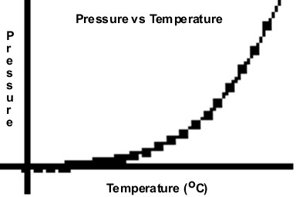  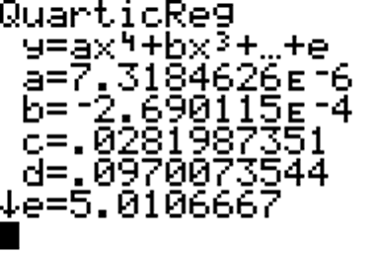
  Temp | Press
  (°C) | (mm Hg)
  0.00 | 4.580
  5.00 | 6.543
  10.00 | 9.209
  15.00 | 12.788
  16.00 | 13.634
  17.00 | 14.530
  18.00 | 15.477
  19.00 | 16.478
  20.00 | 17.535
  21.00 | 18.650
  22.00 | 19.827
  23.00 | 21.068
  24.00 | 22.377
  25.00 | 23.756
  26.00 | 25.209
  27.00 | 26.739
  28.00 | 28.349
  29.00 | 30.044
  30.00 | 31.823
  31.00 | 33.696
  32.00 | 35.663
  34.00 | 39.899
  36.00 | 44.563
  38.00 | 49.692
  40.00 | 55.324
  45.00 | 71.882
  50.00 | 92.511
  55.00 | 118.030
  60.00 | 149.370
  65.00 | 187.550
  70.00 | 233.710
  75.00 | 289.100
  80.00 | 355.110
  85.00 | 433.620
  90.00 | 525.770
  95.00 | 633.910
  100.00 | 760.000

