Graphs

Graphs are made by graphing one variable which is allowed to change value and a second variable that changes in response to the first. The variable that is allowed to change is called the independent variable and the variable that changes in response to the change of the independent variable is called the dependent variable.

The independent variable is plotted along the x-axis and the dependent variable is plotted along the y-axis. When a title is given to the graph, the dependent variable is given first and the independent variable is given second. For example, a graph titled Displacement vs Time would have the displacement plotted on the y-axis and time plotted on the x-axis. The displacement and time data would be found in a data table and the independent variable values would be in the first column with the dependent variable values in the second column.

Graphs are used to determine the relationship that exists between two variables, the dependent and independent variable. You must be very careful when interpreting your graph. Nearly any set of points can fit a straight line! This can result from using a very limited sampling of data or because experimental error is much too large.

This tutorial will cover the curves of graphs that you are likely to encounter in physics and chemistry.

The following graphs and the data needed to generate the graphs can be found at Excel Tutorial. Also, Graph Types is worthwhile checking out.

A Straight Line

The first graph is the simplest of all graphs, a straight line passing through the origin. When the graph is a straight line passing through the origin, the two variables or quantities are directly proportional.

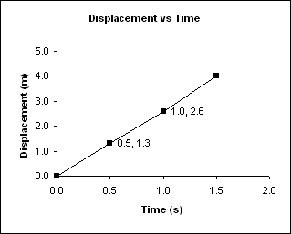

Figure 1

When two quantities are proportional, this means that a change in the independent variable (Time) brings about a change in the dependent variable (Displacement). Mathematically this is represented by:

D α T

where D is the displacement, T is the time, and α represents “proportional to”.

When two quantities are directly proportional, the graph is a straight line passing through the origin. It also means that whatever happens to the independent variable, the dependent variable changes in exactly the same manner. For example, in the graph above, if the time is doubled, the displacement is doubled, if the time is reduced by one-half, the displacement is reduced by one-half.

To determine the slope of the graph, m, calculate the change in y (Δy) and divide it by the change in x, Δx. For the graph above, the slope is given by:

m = Δy/Δx = (y₂ – y₁)/(x₂ – x₁)

and the slope m will have units associated with it.

For example,

m = Δy/Δx = (y₂ – y₁)/(x₂ – x₁) = (2.6 m – 1.3 m)/(1.0 s – 0.50 s) = 2.6 m/s

Remember, if the units do not cancel, you must rewrite the units as m/s. This unit you may or may not recognize as the units for speed or velocity.

Changing the symbols in the equation for the slope gives:

v_{ave} = Δx/Δt

Do not confuse the Δx in the equation above as it is sometimes used to signify the change in displacement as Δt represents the change in time.

It is worth noting that in Figure 1, the straight line represents a change in the two quantities but the change is always the same. Do not confuse this with a horizontal straight line which indicates no change whatsoever.

A Parabola Around The Y-Axis

When the graph is a half parabola passing through the origin, the dependent variable varies directly with the square of the independent variable.

Figure 2

To determine the slope of the graph for points (2) and (3):

m = Δy/Δx = (y₂ – y₁)/(x₂ – x₁) = (2.0 m – 0.50 m)/(2.0 s – 1.0 s) = 1.5 m/s

To determine the slope of the graph for points (3) and (4):

m = Δy/Δx = (y₂ – y₁)/(x₂ – x₁) = (4.5 m – 2.0 m)/(3.0 s – 2.0 s) = 2.5 m/s

The increasing slope indicates that the object is moving faster and faster because the displacements are increasing by a larger amount than the times.

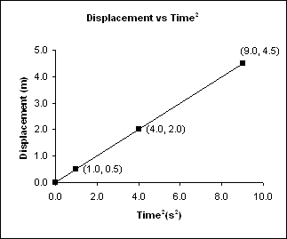

Figure 3

When two quantities are directly proportional, the graph is a straight line passing through the origin. It also means that whatever happens to the independent variable, the dependent variable changes in exactly the same manner. For example, in the graph above, each time squared value is twice as large as the displacement.

A Parabola Around The X-Axis

When the graph is a half parabola passing through the origin, the square of the dependent variable varies directly with the independent variable.

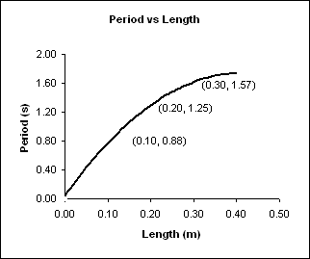

Figure 4

To determine the slope of the graph for points (2) and (3):

m = Δy/Δx = (y₂ – y₁)/(x₂ – x₁) = (1.25 s – 0.88 s)/(0.20 m – 0.10 m) = 3.7 s/m

To determine the slope of the graph for points (3) and (4):

m = Δy/Δx = (y₂ – y₁)/(x₂ – x₁) = (1.57 s – 1.25 s)/(0.30 s – 0.20 s) = 3.2 s/m

The decreasing slope indicates that as the length becomes longer, the period gets larger by a smaller amount.

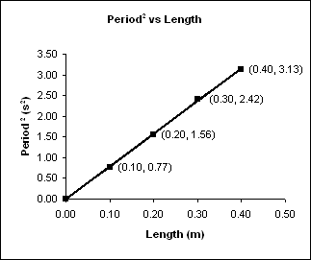

Figure 5

When two quantities are directly proportional, the graph is a straight line passing through the origin. It also means that whatever happens to the independent variable, the dependent variable changes in exactly the same manner. For example, in the graph above, each time the length is doubled, the square of the time is doubled.

A Hyperbola

When the graph is a hyperbola, the product of the independent variable and the dependent variable (P × V) equals a constant. In this particular example, P × V = k, which would be 60.0 atm × 20.0 mL or 1.20 x 10³ atm•mL. Pressure and volume are said to be inversely proportional, meaning that as one increases, the other decreases to keep their product a constant.

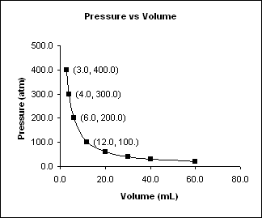

Figure 6

To determine the slope of the graph for points (2) and (3):

m = Δy/Δx = (y₂ – y₁)/(x₂ – x₁) =
(200.0 atm – 300.0 atm)/(6.0. mL – 4.0 mL) = -50. atm/mL

To determine the slope of the graph for points (3) and (4):

m = Δy/Δx = (y₂ – y₁)/(x₂ – x₁) =
(100.0 atm – 200.0 atm)/(12.0 mL – 6.0 mL) = -17 atm/mL

The decreasing slope indicates that as the volume becomes larger, the pressure decreases. To maintain a constant product, k, if the volume doubles, the pressure must decreases by one-half.

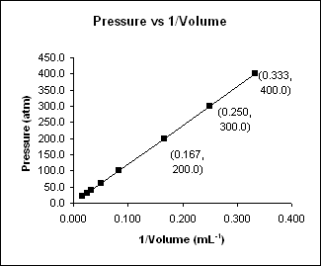

Figure 7

When two quantities are proportional, the graph is sometimes a straight line. It also means that whatever happens to the independent variable, the dependent variable changes in exactly the same manner. For example, in the graph above, each time the quantity (1/Volume) is doubled, the pressure is also doubled.

This analysis may seem to be an overkill but it is extremely valuable when collecting experimental data. Book data is usually “perfect” or “ideal” data and the associated graphs contain very little error. However, in the real world when collecting data, there is always human error and limitations due to the equipment used for measuring. Straight lines are usually pretty easy to identify but parabolas and hyperbolas can be tricky. Parabolas and hyperbolas many times are identified by their alternate graphs.

Characteristics of a Good Graph Drawn With Ruler and Graph Paper

- Graphs are done on graph paper.

- When making a scale:

  - Your scale should be easy to interpret.

  - One square or tic mark could represent 1, 2, 5, 10, …

  - A graph unit represents a unit of 1, 10, 20, 100, 0.1.

  - The scale should not change along an axis.

  - You can, however, use two different vertical (y) axes, with different scales for each one.

  - Your data should not be clumped in one region of your graph; you should scale your graph so that your data is distributed across each axis.

  - Leave room on your paper for axis labels, numbers, graph title, etc.

- Use a ruler or straight edge to draw your lines and axis.

- The dependent variable is usually plotted on the y-axis and the independent variable is plotted on the x-axis.

  - Put tick marks on the axes and corresponding numbers below the tick marks.

- Label what the axes represent by including the measurement and its units.
For example: Time (minutes), Distance (mm), etc.

- The reader should know what the graph is about by reading the title. Repeat the axis labels (ex: Distance vs. Time), without the units.

- Data points should be represented clearly, with easy to distinguish symbols.
Characteristics of a Good Graph Drawn With Excel

Check out the Excel Tutorial.

