Linkstur News

Volume 8, Issue 5 July 03, 2005
http://www.linksturs.com

The Rematch

Battle of Champions
Is this Déjà vu or what? In the first A/B match of the year, the featured pair was none other than the two people who appeared in the 2004 Championship match. Tom Convery, last years A division Champion and ultimate league champ went up against Tom Dushkewich, the 2004 B division champ. Their last meeting could only be described as a blowout. This time, the results were very different.


We meet again

Tom D. had to win the 9th hole in order to tie the front, and with the help of a stroke, he did just that. The tables were turned on the back nine and Tom C. was forced to win the 18th in order to tie the back and he also rose to the occasion. When the smoke cleared, the match finished as dead even as you can get with both players winning 3 holes, losing three holes and tying three holes on the front and back.

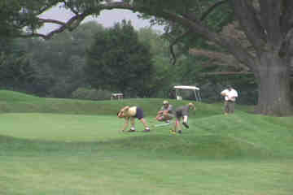
Action on the Green

The A/B Results
The A division captured 14 of 21 points with one match still not turned in as of the writing of this rag.

George Ripley shot his worst round of the year against a persistent Roman. Making good use of the 9 strokes George had to give up, Roman wins the front nine by 2 and manages a win on the back by 1 hole where his 9 was good enough to tie George’s 8 (with a stroke).

Sean jumped all over the slow starting Kevin when he won 5 out of the first 6 holes. Sean wins the front nine by 5. Kevin tried to rally on the back, but was only able to squeak out a tie. Sean wins 2 ½ points.

Bob and Vince made up their match the following Saturday. Both shot mediocre rounds, but Bob managed to take away 2 points despite Vince winning the front by one.

Ryan Wheeler (who must be related to Dan) only seems to shoot sub-90 rounds when no one is around. Ryan shoots the low round of the week with an 83, but was still unable to sweep Joe McLaughlin. Joe made good use of 3 out of the 4 strokes he was given to tie Ryan on the front. But Ryan’s 38 on the back was more than enough to take 2 ½ points.

In another great match up, Dan Taggart had to give a whopping 17 strokes to the struggling Mike Brychcy. Despite all the strokes, Dan was able to win the front nine by 2. Mike started shooting well on the back nine and forced Dan to win 2 out of the last 3 holes to only lose the back by 2 and tie for overall. Mike and Dan split in a well-fought match.

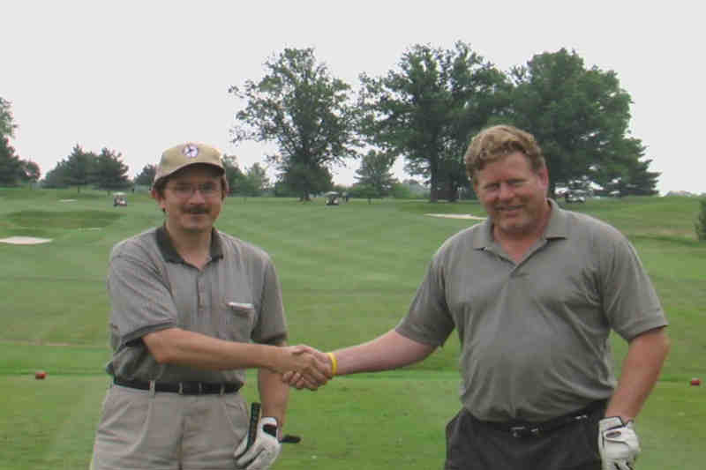
All smiles BEFORE the match

And last but not least, John Koehler was able to beat the crap out of the vacant spot and shot his best round of the year in the process by 10 strokes. Just goes to show you he hasn’t learned how to sand bag yet. (We’ll talk later).
George Hamilton is still on vacation and will have the opportunity to turn a card in against Carl Hansen before the next scheduled match.


This week’s guest photographer

Closest to the Pin Winners
(Jeffersonville)
Front: NOBODY
Back: Kevin

Closest to the Pin Holes
(Spring Hollow)
Front: 8
Back: 18

Thanks
Thanks to everyone who helped to organize the outing last Sunday while I was away and especially Kevin Stevenson for taking his new camera with him to take some shots of the action.

Handicaps and Pairings for Spring Hollow
1st Group
Carl (18) vs. Bob Welc (19)
George H. 28 vs. Kevin (27)

2nd Group
Ryan (19) vs. John Koehler (24)
Tom D. (26) vs. Joe (28)

3rd Group
Tom C. (12) vs. George R. (16)
Vince (24) vs. Mike (36)

4th Group
Sean (18) vs. Dan (19)
Vacant (36) vs. Roman (24)

Remember: next game day is July 17th, at Delcastle. Be ready to tee off at 9:30 am. Call the course at
(302) 995-1990 if you require directions.

