Linkstur News

Volume 7, Issue 2 May 15, 2004
See http://www.linksturs.com (for late-breaking Linkstur news)

Great weather at Moccasin

A beautiful day to start the year which saw only half the members show up for the kick off match of the year. Scheduled trips to Myrtle Beach and other locations, unexpected overtime and even one serious accident had 10 members MIA.


The Indian overlooking the 17th hole

Max, the professional driver

Opening day for the league has always brought bad luck to at least one new Linkstur (either accidental or planned) and this year was no exception. Friday night before the first match, Bob Welc gets a call. “Hey Bob, how ya doing?” It only took a second to recognize the distinctive voice of Max McHenry, returning to the league after a 2-year hiatus. “Not bad” I replied. “What are you up to?” “I’m in a bathroom in Philadelphia waiting for some ice,” Max tells me. Then he asked, “it’s not a good thing when your skin starts falling off, is it?” It turns out that the retired truck driver turned limo driver was doing a run in Philly when his car started overheating. So what does career driver do? You got it, he decides to open up the radiator cap and proceeds to get doused with steaming hot water all over his right hand and arm.

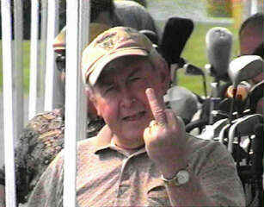
Max has no problem with his LEFT hand

Needless to say, Max was one of the no-shows on opening day. He eventually did decide to seek professional help (not for the burns, but for the removal of the cap) and is expected to make a full recovery. Hopefully, he’ll be well enough to make the second match, but will probably have to make up the first match at a later date when the bandages are removed and some skin starts growing back…yuck.

Standbys to the rescue

Thanks to Larry and Rick for showing up to round out the field to an even dozen. With all the people missing, it was nice to be able to field at least 3 foursomes, which wouldn’t have been possible without some help from a few standby players

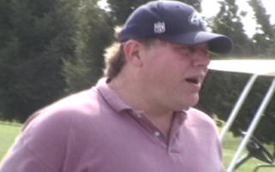
Rick Dolbin, a one time Linkstur

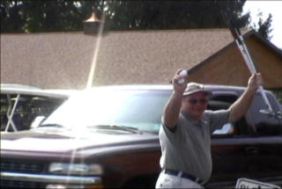
Larry, whose last name is unknown for security reasons

The match that never was

It seems that there was a lot of confusion with all the people missing and the foursomes getting shuffled around. Two new guys, George Hamilton and Terry Feeney were paired up. They said they both had a good time and enjoyed playing with each other and at the end of the round they went to turn in separate cards assuming both their playing partners were among the MIA. Turns out that in all the confusion, Bob neglected to tell them that their match was actually against each other.

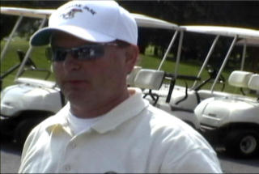
George Hamilton…….no relation

Fortunately, they played the round as if they WERE actually playing each other.

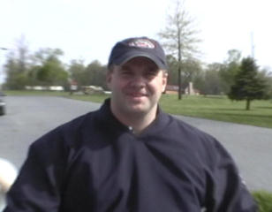
Terry Feeney’s first match proved to be an experience

Closest to the Pin Winners (Moccasin Run)

Front: Roman Hrycushko
Back: Bob Perks

Closest to the Pin Holes
(Pilgrims Oak)

Front: 8
Back: 17
A-Division Summary
Sweeps week

Three out of five matches in the A division resulted in a sweep.

Returning champ, Bob Welc, Carl Hansen and Tim Brown will all start season 7 with a 3 point disadvantage after having been swept by Roman, Dan Taggart and Bob Perks respectively. Even though Bob and Roman both started off the year with a par on the first hole, Bob never could get anything going as Roman handled him easily, taking the front by 3 and the back by 2.

Carl and Dan played each other in a makeup match with pretty much the same results. Carl loses the front by 3 and even though he shot 4 strokes better than Dan on the back 9, still loses it by 1.

Bob Perks showed up on game day to turn in a card and claim a closest to the pin. Tim made up his match on Mothers Day, only to find out that in one of the closest matches, he also fell victim to sweeps week. Even though Tim tied Bob on the front and actually beat him by 3 strokes on the back, he too would start the year pointless.

George and Terry, in the match that was-but wasn’t, had a nail biter to start the year. George started off winning the first three holes, but Terry comes back over the next 5 holes to tie up the front, only to lose the 9th and the front nine. The back nine went back and forth with the lead changing three different times until the 18th when George makes a great par to tie up the back and take half a point. George wins the overall for a total of 2 ½.

Tom and Sean knew they would be in Myrtle on Saturday so they played their match before they left. Tom took the front nine by 2, but thanks to three wins in a row on the back, Sean wins the back nine by one. Tom winds up with the front and overall for two points.

B-Division Summary
Sweeps Continue

Four out of five of the B division matches ended in a sweep.

Both Mike Brychcy and Tom D. got off to a slow start after a long winter. Trading holes the whole front nine it was even after 8 holes, but Tom pars the 9th to win the front by one. The back nine was a different story with Tom winning the first 5 holes in a row and winds up winning the back by 5. Tom takes all three points.

As sweeps week continues, Doug Perks didn’t seem to have as much rust on his irons as Ram Shan as he wins 7 holes on the front to take the front by 5. Doug didn’t let up on the back as he won 8 out of 9 holes in a match were there was only one hole tied the entire round. Doug takes three points and gives Ram some tokens to the driving range.

Vince Caligiuri and Ed Scott went out to play a week after the match to make up their round. Tied up after 4 holes, Ed wins 3 out of the last 5 holes to win the front by 2. Not realizing that there wasn’t a bar in the clubhouse, Vince has a flash of brilliance and wins the last 4 holes in a row to take the back by 5 and the overall for a total of 2 points.

Rob Johnson and Kevin Stevenson both missed the first match but turned in separate cards. Kevin was only one hole up after the first four holes, but went on to win the next three in a row, closing Rob out on the front. On the back, Rob was one up after six holes, but Kevin came back winning 2 of the last 4 holes to win the back by one and take the overall.

And last, but not least this late breaking news…. Max McHenry is alive and (almost) well. Wearing protective gear to shield his bare and shedding skin from the sun, he braved the elements to make sure he turned his card in before the next match. I guess he heard about those rumors of finding a replacement for him. Not only did he manage to play an adequate round, he also managed to take three points from first year golfer, Ron Bovee.

Email Addresses:

A few of you have had your email bounced back to me, particularly Rob Johnson and Tom Convery. It would be a good idea if everyone who is new this year would send me an email at bobw@linksturs.com to verify your email address. Remember, email is the primary source of communication in the league. It is important that we have an accurate address on file and that you check your email often, particularly before a match. And please take the time to respond to your mail.

Handicaps and Pairings for
Pilgrims Oak
1st Group
George H. (22) vs. Tim B. (18)
Ram S. (36) vs. Ed S. (27)

2nd Group
Bob W. (17) vs. Carl H. (18)
Doug P. (27) vs. Rob J. (26)

3rd Group
Tom C. (16) vs. Guest. (X)
Vince C. (26) vs. Tom D. (30)

4th Group
Roman (24) vs. Bob P. (20)
Max (29) vs. Kevin (24)

5^{h} Group
Sean (22) vs. Dan (22)
Mike B. (35) vs. Ron B. (36)

This weeks Quotes:
Eighteen holes of match play will teach you more about your foe than 18 years of dealing with him across a desk. ~Grantland Rice

Golf appeals to the idiot and the child in us. Just how childlike golfers become is proven by their frequent inability to count past five. ~John Updike

It is almost impossible to remember how tragic a place the world is when one is playing golf. ~Robert Lynd

Remember: next game day is May 29th, at Spring Hollow. Be ready to tee off at 10:30 am. Call the course at 610-948-5566 if you require directions or check your e-mail for directions that Bob Perks will be sending out before each match.

