LinkStur News

Volume 6, Issue 3 June 14, 2003
See http://www.linksturs.com (for late-breaking LinkStur news)

Inaugural Match At Delcastle

Another raw damp day with the temperatures hovering around the low 70’s and the threat of thunderstorms set the stage for the LinkStur’s inaugural match at the Delcastle Golf Course in Delaware. The course was in great condition with challenging pin placements and high rough contributing to some ‘slow’ play. Bob Welc would like to remind everyone that there is a ‘5 minute’ rule when searching for lost balls. Construction work on I-95 caused some players (Steve) to miss their original start time but everyone managed to tee off without a hitch. The general consensus among the players (especially Ken Harris) was that this looks like a course that is worth keeping in the future rotation.

Call Him Mr. Hospitality
Living only a ‘stones throw’ away from the course, Ken Harris (A-Division) was ‘kind’ enough (surely not smart!!) to invite all of the LinkSturs back to his house for an ‘Open Bar’.
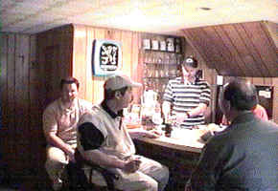
Ken Harris concocts a ‘special brew’ for seasoned drinker Vince Caligiuri.

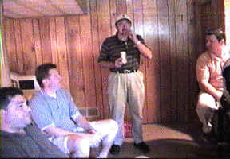
Mike Brychcy entertains a captivating crowd with one of his Bob Welc impersonations. Gene Carter and Ron Jones argue whether Bob really inhales while Pete Ciliberto ponders the situation.

Ken won rave reviews for his bartending skills from the thirsty golfers. The LinkSturs would like to extend a ‘hearty’ thanks to Ken Harris for his ‘hospitality’.

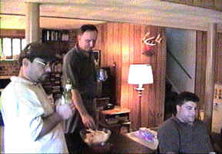
Tom Dushkewich tries to ease the pain after a tough day with the putter. Pete’s still pondering…………

Makeup Matches
The league ‘brain trust’ recognizes the unseasonably ‘lousy’ weather we have had over the last month but would like to urge all players with outstanding matches to attempt to make them up before our next match at Fox Hollow.

Closest to the Pin Winners (Delcastle)
Front : Steve Margetich
Back : Roman Hrycushko (2nd)

A-Division Summary
Ken Harris uses local knowledge and five pars to take 3 points from Bob Welc. Dick Blystone and Bob Perks hook up in a playoff preview and split their match Ron Jones gets off to an early start and takes 2 points from Roman Hrycushko. Gene Carter dazzles ’02 Champ Dan Hatton with nine pars and three birdies and takes 3 points.

B-Division Summary
Ram Shan shows improvement from his first match but it wasn’t enough to stop Vince Caligiuri from taking 3 points. Mike Bergen records 5 pars and 1 birdie but it was only good enough for a split with a rejuvenated Doug Perks. Mike Brychcy took advantage of Tom Carroll’s sprained ankle to take 3 points. Steve Margetich took advantage of a ‘bad putt day’ by Tom Dushkewich to take 2.5 points.

Handicaps and Pairings for Blackwood
1st Group
Pete C. (17) vs. Dick B. (14)
Mike Be. (24) vs. Mike Br. (35)

2nd Group
Herman E. (15) vs. Roman H. (21)
Tom C. (36) vs. Steve M. (27)

3rd Group
Ken H. (22) vs. Bob P. (19)
Doug P. (28) vs. Jim K. (28)

4th Group
Ron J. (17) vs. Dan H. (19)
Ram S. (36) vs. Tom D. (32)

5^{h} Group
Bob W. (19) vs. Gene C. (10)
Vince C. (25) vs. Matt D. (24)

Closest to the Pin Holes (Blackwood)
Front Nine: Hole # 8
Back Nine: Hole # 13

Remember: next game day is June 28th, at Fox Hollow. Be ready to tee off at 9:00 am. Call the course at (215)-538-1920 if you require directions.

