

The University of Liverpool
The Management School

E-Business Strategy and Systems

MSc Project

The Southeast Asian crisis and the IMF

An assessment of the recovery of the principle countries involved in the 1997 SE Asia Crisis and the influence or not of the IMF in their recovery.

Project No: FM-MSc projects2006-1

Project Final Report

By

Philip Daley

Date: 8/9/2006

Supervisor: Professor Fred Mahoney
Abstract

The Asian financial crisis of 1997 was arguably the worst global economic disaster since the Great Depression of 1929. With billions of dollars lost, millions unemployed, several heads of state deposed and global financial instability, this paper seeks to examine how the Asian Tiger regions grew so spectacularly within the 1990s yet failed so dismally from 1997 onwards. Could the crisis have been averted or marginalised through more effective planning and improved international aid or were these economies doomed to fail from the beginning? This paper focuses upon both economic indicators and objective analysis to explain the underlying rationale behind the crisis, how it spread, and an analysis of how the main participants of the crisis have recovered from 1997 onwards.

Furthermore, this paper questions the role and validity of the IMF as the major economic body sought to deal with the matter and the financial and policy implications of their involvement within the crisis.

Keywords

Asian financial crisis, contagion, macroeconomic, microeconomic, World Bank, IMF, George Soros, Dollar, Won, Baht, Rupiah, Thailand, South Korea, Indonesia, Malaysia.
Acknowledgements

I am indebted to Professor Fred Mahoney for his support and discussion through the entirety of this project’s tenure. His input and dedication to the project was immeasurable and I am extremely thankful for his involvement.
Contents

1. The Asian Miracle
1.1. How did Asia achieve such substantial growth? Page 7

2. The end of the Asian ‘miracle’: Beginnings of a financial crisis
2.1. Early warning signals – Page 13
2.2. The crisis begins – Page 18
2.3. Causation of a crisis – Page 21
2.4. Contagion – Page 31

3. The Asian financial crisis: Government and IMF responses
3.1. A chronological account – Page 36
3.2. IMF Response – Structural Adjustment Packages – Page 39
3.3. Government and IMF Programmes – Criticism and Short-Term effects – Page 49

4. East Asian recovery – A present day perspective – Page 56

5. The IMF: What does the future hold? – Page 87

Website References – Page 92
Bibliography – Page 94
Appendix A: Self-Assessment – Page 98
Introduction

The Asian financial crisis (sometimes referred to as East Asian or Southeast Asian crisis) began in June 1997 in Thailand and within weeks and months had spread rapidly to neighbouring countries. The effects of the crisis were monumental, bringing about a deep recession in the area, rising unemployment, industrial breakdown and social dislocation. The Asian ‘Miracle’ had, in the space of weeks and months, completely collapsed. Years of strong growth, high foreign investment, rising employment levels and encouraging economic prospects were seemingly washed away within weeks, as recession and instability set in.

How on earth did this happen?

The question, much like the nature of the topic itself is a minefield of opinion. Academics argue over whether key economic indicators (Such as foreign debt growth vs. GDP growth, appreciating currencies, employment figures and Short vs. Long term reversible capital inflows) had shown noticeable adverse trends in the run up to the crisis. The consensus is that, although some economists had expressed concern (Krugman 1994), the majority had simply (and retrospectively incorrectly) assumed that it was ‘business as usual’ in Asia, and a slowdown in exports (to name just one factor) would not pose any residual danger to what had been from 1990-1996 one of the highest growth regions in history.

To this day, economists still differ over the true determinants of the crisis. From unsound macro and microeconomic policies, the role of speculative hedge funds, the lack of a regulatory framework within many of the countries involved, the value of pegged exchange rates, political circumstances, investor confidence and more. This paper analyses all of these factors and more, offering a diverse range of opinion from pre-eminent economists, academics and politicians of the time.

Having examined the key factors behind the crisis, this paper then analyses the ‘contagion’ of the crisis and the rescue packages instigated by the IMF at the time, including a discussion of the controversies these policies emanated within the global economic community upon implementation (or lack thereof) by the principal countries involved. An analysis of the recovery of these countries (up until 2006) is detailed, with a brief speculation of future trends offered.

To conclude, an evaluation of the role of the IMF within the crisis and the future relevance of the organisation is questioned, with arguments both for and against the introduction of a new regulatory body to deal with future economic crises.
1. The Asian Miracle

  - How did Asia achieve such substantial growth?

The growth of the Asian ‘Tiger’ nations in the late 1980’s until 1997 was staggering. Many of the Asian countries involved had managed to reinvent themselves from rural economies to mass free market havens for overseas investors, and all within the space of a decade – the term ‘miracle’ certainly seemed apt.

During this period, many of the major Asian countries had undergone significant structural changes within the banking, manufacturing and property sectors. Asian governments began to ape the western free-market practices and began, for the first time in their history, to welcome large quantities of foreign capital to be invested into their markets. The immediate effects of this change were phenomenal, with double digit GDP growth becoming commonplace, year on year from 1990 to 1996 (See Table 1.1). Similarly, Export growth increased at an even greater rate (Table 1.3). Thailand, for example, grew at an average of 18.9% year on year from 1990 to 1995; China also grew at 19.4% with Singapore reporting an average increase of 17.8% within this period (McLeod and Garnaut 1998).

Other economic indicators similarly prescribed a rosy outlook. Other than Vietnam, almost every other Asian country had controlled (albeit high) inflation rates (Table 1.2). Given the rate at which GDP was rising and unemployment falling, however, this was not considered precipitous of future risk, and was largely attributed to rising property prices within Asia, sustained upon future growth.
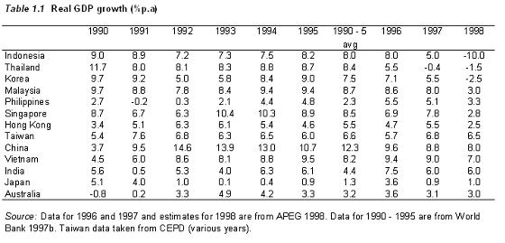
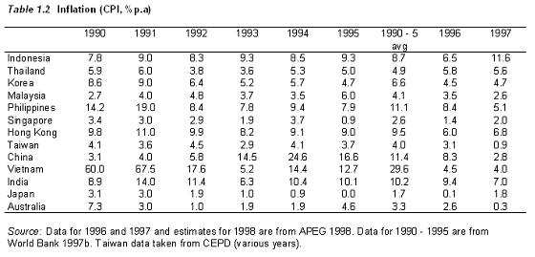
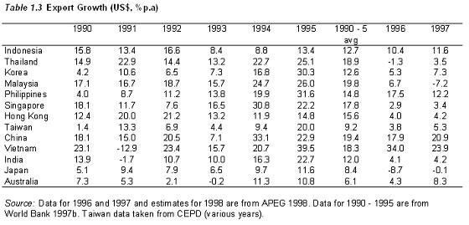

The region was seemingly invincible and Thailand was often cited as the ‘epitome of stable growth’ (Khoman 2000) during this time. Economists remarked of Thailand’s sound macroeconomic management. The World Bank called Thailand the fastest growing economy of the decade (Butler 1997), including it in the group of ‘high performing Asian economies’ (World Bank 1993). The IMF also predicted that by the year 2020 Thailand’s economy would grow to be the eighth largest in the world, surpassing France. Inflation was low, the government budget was in surplus and the balance of payments was controllable. Investment soared and unemployment was virtually unheard of (Khoman 2000). Within thirty years, Thailand would transform itself from a small, rural economy to one larger than France; riding the fast track of financial liberalisation seemed to be an understatement.

The situation was similar for many other Asian nations of the time, many of whom grew even more rapidly than Thailand. However, other than the ‘opening of the floodgates’ to private capital inflows, what else can be attributed to the rapid growth of these nations?

A World Bank study (1993) and other subsequent studies (Campos and Root 1997, Ito 1997, 2000b) have examined the role (and success) of Asian economies in managing their economic development process from the late 1980s onwards. According to this literature, the ‘Asian miracle’ was based on the following factors:

- A stable macroeconomic environment
- High saving and investment rates
- High quality human capital (Good education and a high literacy rate)
- A merit based bureaucracy
- Low income inequality (decreasing poverty)
- Export promotion
- Successful Industrialisation
- The volume of foreign direct investment (FDI) and associated transfer of technological know-how

These factors are outlined by Ito (2000) below.

Stable Macroeconomic environment

Ito found that macroeconomic management by Asian nations had been strong up until the run up to the financial crisis. Inflation was controllable, monetary policies were prudent and fiscal deficits were contained. In addition to this, many East Asian countries, once they had reached a high economic growth phase, recorded fiscal surpluses – a sure sign of wellbeing for growth countries.

High Savings and Interest Rates

Asian countries were also noted for high savings rates, with typical household savings rates of around 30%, sometimes rising to 40% in countries such as Singapore. High savings rates combined with high investment ratios made it possible to achieve rapid economic growth without incurring current account deficits financed through foreign capital.

High-quality human capital

Asian economies have, for a long time, had educational systems rivalling those of the UK and USA. Literacy rates are exceptionally high and secondary school enrolment is seen as paramount to many within the region. In comparison to other industrialising countries, there is no shortage of skilled workers needed to fill key roles within growth companies, and this has allowed the region to industrialise much more quickly than other economic growth regions of the past.

Merit based bureaucracy

Many of the Asian countries have civil service systems based upon a meritocracy. The best workers are given the best jobs, with little political persuasion as part of the selection process. This has allowed the Asian economies to grow at a much quicker rate than other regions as there is no misallocation of human resources, leading to a more efficient civil service system for all.

Low-income inequality and decreasing poverty

During the ‘miracle’ years from the end of the 1980s, there was a large increase in ‘middle-class’ families and improved salaries throughout the area. According to a World Bank Study, Absolute poverty declined rapidly during this period.

Export Promotion

Export promotion has been a key economic development within Asia. It earns foreign currencies that are needed to import natural resources, parts for assembly and capital goods. As domestic markets are relatively small for many countries (China excluded), exports into foreign markets are of vast importance. Since the 1960s Asia has adopted an aggressive export policy whilst managing to protect local industries through their change from textile goods right through to high-end electronics.

Successful Industrialisation

Traditionally, any major economic area that has had sustained growth for decades (Japan from 1950 to 1973, South Korea from 1980 to 1995 etc) has undergone significant changes in its industrial structure. Korea and Taiwan followed Japan in its industrial transformation from light industries to heavy and chemical industries, to electronics, then high-end electronics. Through a composition of foreign inflows and industrialisation, countries such as Singapore and Hong Kong have benefited immensely during this period.

Foreign Direct Investment and Technology Transfer

The majority of Asian economies have succeeded in attracting foreign direct investment. Singapore, Malaysia and Thailand were the early successes, with China and Thailand following a path of accelerated development by these means. These countries tended to control the choice of which industries were to be promoted. They encouraged foreign firms not only to establish assembly plants, but also to bring in parts production with them. Firms have been willing to invest into technological capabilities and managers have actively bought into these changes, as such the speed of technology transfer has been rapid, making newer industrial plants immediately successful.

As can be seen, the Asian ‘miracle’, although predicated upon large foreign capital inflows, also had a number of strong regional economic and social factors leading to its success. The Asian region has, historically, been quick to adapt itself to new technologies and practices, this, combined with a strong and skilled workforce has allowed the region to grow at abnormal rates from the late 1980s till 1997.

By 1996 the Asian ‘miracle’ was still in full flight. Economic indicators were still prescribing a strong financial outlook and the rise of the Internet had given Asia a global outlook (along with many top computer scientists). The future looked bright, yet within 12 months, Asia would be on its knees, with the worst financial collapse in almost 70 years.

How did the ‘miracle’ crumble so quickly?
2. The end of the Asian ‘miracle’: Beginnings of a financial crisis

2.1 Early Warning signals

Retrospectively, academics have since wondered if there was sufficient evidence as far back as 1994 pointing to the beginnings of a financial downturn in Asia.

The answer seems to be that there was some evidence leading towards a slowdown in Asia, yet this was either disregarded or ignored, and in some cases deliberately removed from summit meetings by major IMF officials.

Paul Krugman, then an MIT economist, published the first cautionary paper about a potential slowdown in Asia in 1994. In his paper ‘The myths of Asia’s miracle’, he contended that Asia's economic growth had historically been the result of capital investment, leading to growth in productivity. However, total factor productivity had increased only marginally or not at all. Krugman argued that only growth in total factor productivity, and not capital investment, could lead to long-term prosperity, stating “it is likely that growth in East Asia will continue to outpace growth in the West for the next decade and beyond. But it will not do so at the pace of recent years”

Other papers similarly advised caution. Lau and Park (1995) published a paper attacking the vulnerabilities of some Asian countries, with particular reference to Thailand and the Philippines. The paper focused upon two major areas: stock of short-term liabilities (including portfolio investment) relative to reserves and the Interest rate differential between domestic and foreign currency-denominated loans. The paper also asserted that the dependence upon short-term foreign capital inflows was risky and that there was an inadequate level of foreign exchange reserves for supporting short-term capital outflows (see Graphs below, taken from Lau, L.J 2000).

Thailand

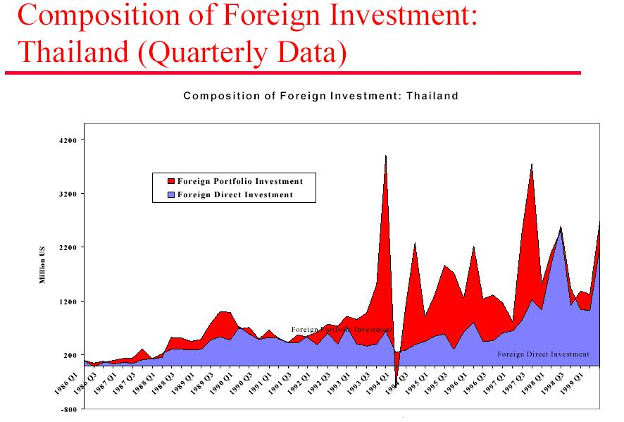

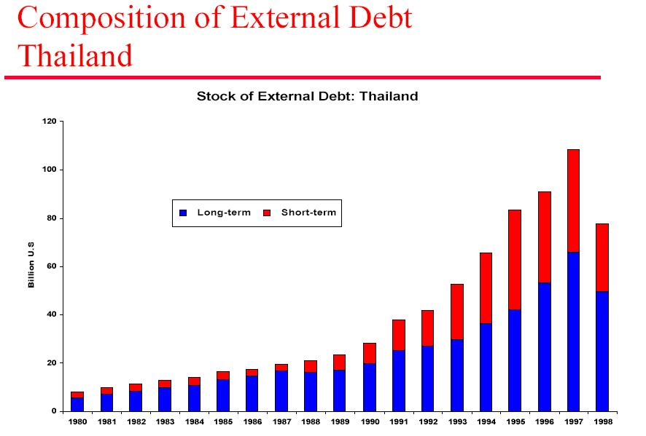
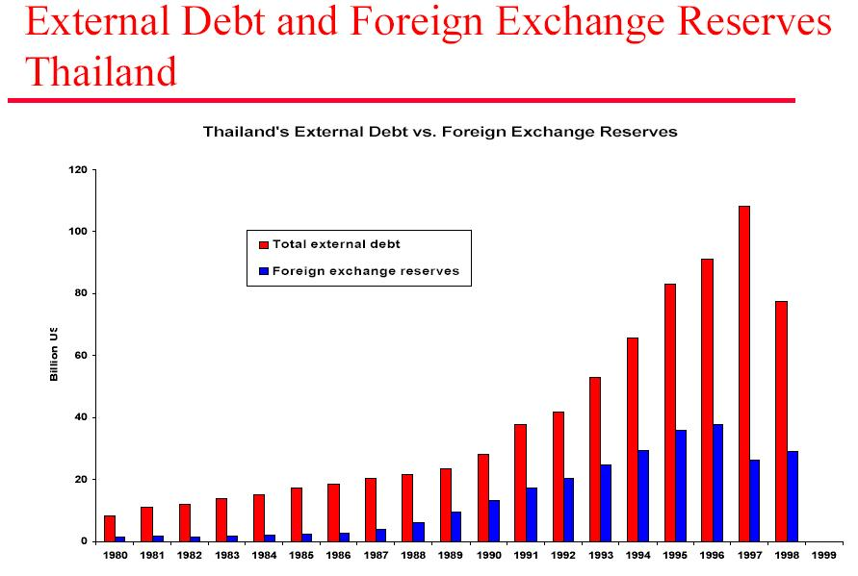

South Korea

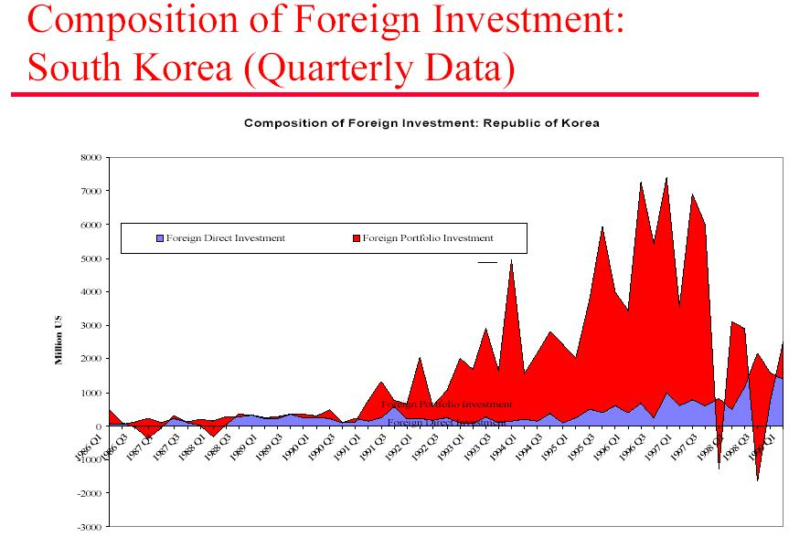

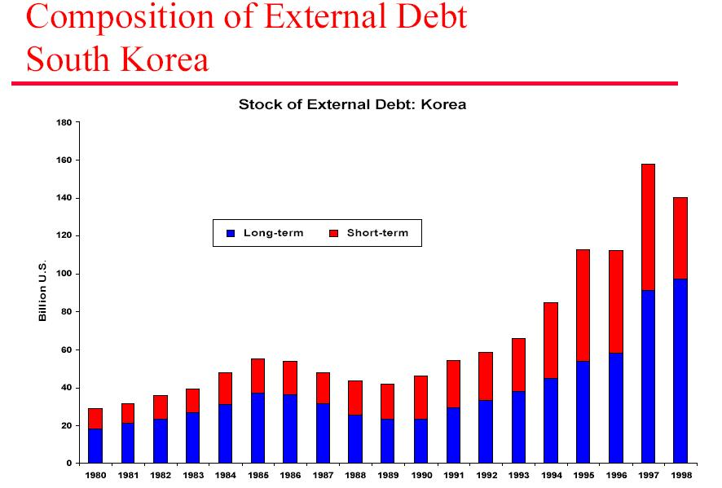
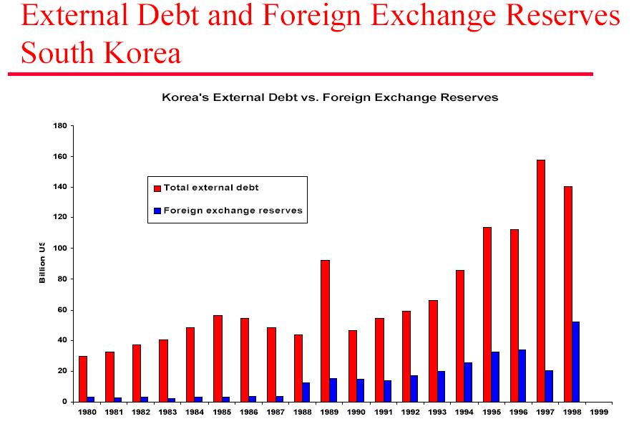

As can be seen, Thailand and South Korea appeared to be in a real mess. These countries had allowed vast quantities of reversible short-term capital inflows to come into the country without any real levels of foreign exchange reserves to rely upon. Their position was very unstable indeed. The ratio of FDI to Portfolio investment was very low indeed, another warning sign. However, some of these indicators were obvious from the late 1980s onwards, prompting the question: How did these indicators go undetected for so long?

It seems as though the majority of academics and economists undervalued the importance of financial indicators such as the ones shown above. Those who spoke of these factors were in the minority, and there is little work prior to 1997 (other than those stated here) warning of a downturn in the area. The question posed is: Why?

One of the reasons put forth is that economists simply did not know the full extent of the problems within the region. This could potentially be true, but the argument is unpersuasive. With so many academics and economists in the world, how did so few notice the underlying difficulties faced by several Asian nations?

Confidence is an extremely important ‘intangible’ asset in global economics, especially with regards to the stock market mechanism. Billions of dollars have been lost due to a lack in confidence in global markets, as such; it is entirely conceivable that despite warning signals, it was in the region’s interest to downplay these factors, irrespective of the long-term implications they may cause. However, if these factors were knowingly being omitted from publication, who was behind the secrecy, and what did they have to gain?

Host countries clearly had a key part to play. If the world suddenly became aware that the situation in Thailand was not entirely as strong as once thought, the reaction would be obvious and rational – investors would call their money back and invest in other markets. This would pose a major problem for countries such as South Korea and Thailand, who were not ready for large-scale capital outflows. As such, it was in their interests to ‘ignore’ the worrying ratios, and focus upon double-digit growth ratios over the past decade to increase investor confidence, and that, is exactly what they did.

Using the IMF as a mouthpiece, in the face of what was now becoming an obvious sign of stagnation, the situation was still being described as rosy. Indeed, at a 1996 summit commenting upon Asian economic growth, an IMF report was doctored at the last minute. A report warning of a slowdown in growth was removed in favour of even more superlatives about the fantastic growth the region had brought about. As Bullard et al (2000) stated: “Thailand's financial crisis was at least three years old before it dramatically received global attention with the de facto devaluation of the baht on 2 July 1997. It cannot be said, however, that the International Monetary Fund (IMF) was particularly worried. Indeed, as late as the latter half of 1996, while expressing some concern about the huge capital inflows, the Fund was still praising Thai authorities for their "consistent record of sound macroeconomic management policies”. Clearly, there were major problems on the horizon.

Academics have since blamed the IMF for having their ‘head in the sand’ in relation to obvious economic slowdowns, and in my opinion, with just cause. As the de facto global economic body, the IMF should have spoken out honestly when it became apparent that the situation was going to deteriorate. By lengthening this period, this only prolonged the period of unrest that was to follow.

2.2. The crisis begins

On July 2nd 1997, the Thai government announced that the national currency, the baht, would be floated. To casual observers, this was of little significance, however to the individuals controlling vast pools of investment for the entire region, this was big news. For years, the Thai Baht (and many other regional economies) had utilised ‘pegged’ exchange rates. These rates offered were ‘pegged’ to the US Dollar and for years had stabilised the region’s trade and economic policies. A few weeks later, Indonesia also agreed to float their currency, the Rupiah. Investors began to question the stability of these markets and distress signals soon went up.

Within days and weeks, sound judgement was thrown aside, replaced by a pure psychology of escape. Institutional investors claimed back their money from the region’s stock exchanges as ‘all controllers of liquid capital, including domestic actors, began behaving like spooked wildebeest on the Serengeti’ (Robison et al, 2000).

In the weeks and months that followed, several countries in Southeast Asia endured devaluations in their currencies averaging over 50%; declines in stock markets were even higher. Millions of workers and managers were fired as a result of the slowdown. Growth rates began to stagnate and in late 1997 they became negative in Malaysia, Thailand and Indonesia (Robison, op cit).

Soon after, it seemed the entire region had begun to suffer. Investors began to question the stability of other regional economies, and similarly began to remove much of the institutional money, such as pension and mutual funds from the stock markets. Governments did not have sufficient enough funds to battle private sector cash withdrawals, the markets had simply become too powerful. The region soon went into economic meltdown.

So were ‘pegged’ exchange rates to blame? The discussion has polarised many economists and academics to this very day. Certainly, the change from a fixed to floating exchange rate mechanism provided a ‘trigger’ for the economic turbulence, but was this the main reason behind the crisis?

According to a paper by Bensaid and Jeanne (1997) then yes. They contend that a ‘fixed or highly stable exchange rate regime is inherently vulnerable to speculative attacks, particularly when there are expectations that devaluation is likely (as occurred in Thailand and other countries from the mid 1990s – See Graph 2.1 below, taken from Lau, L.J 2000).

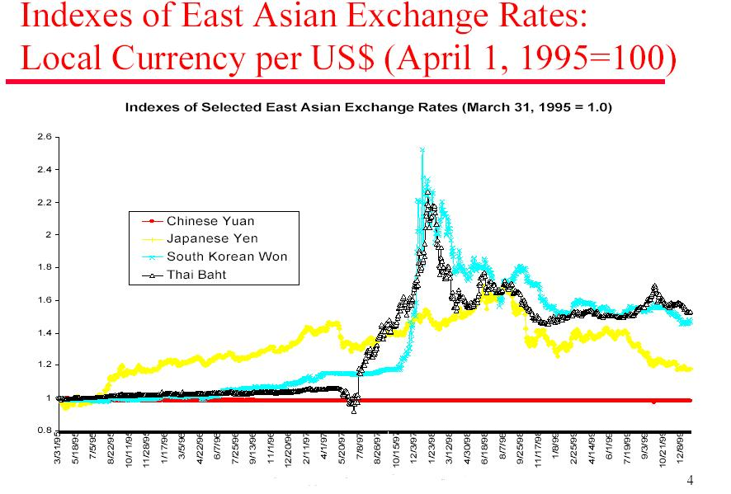

Other papers, however, disagree with this view. “It would be incorrect to draw the simple conclusion that the big problem was the peg to the US Dollar. It was the smart thing to do and worked rather well as long as the dollar was weak. This gave Thai and other regional importers a competitive edge, especially against producers based in Japan” (Winters 2000).

However, when the dollar appreciated in value, the peg went from being a blessing to a curse. Thailand’s exports became more expensive and began to weaken. Currency traders began to notice the sharp rise in Thailand’s current account deficit, and began to act. At this point, traders became convinced that Thailand was in trouble, and they began to bet with their own resources that they were right (Winters, op cit).

Clearly the ‘pegged’ exchange rate system had many flaws. Although the mechanism stabilised many of the region’s economies, it had major implications and problems when dealing with the appreciation of the dollar and the vicissitudes of global economic purchasing power throughout the 1990s. By 1997, Thailand had begun to run up a vast current account deficit and could no longer adhere to the pegged exchange rate. As soon as Thailand (and Indonesia) began to float their currencies, the problems were magnified and exacerbated even further, leading to financial collapse.

Clearly the exchange rate mechanism was a contributing factor to the downfall of many Asian nations from the 1990s onwards, but there were many other policies and structures that facilitated the demise of these countries from 1997 onwards. These factors are outlined below.

2.3 Causation of a crisis

Despite the crisis occurring only 9 years ago (at time of writing - 2006), there has been an incredible amount of research and evaluation put into identifying the rationale behind the crisis. How did the crisis start? What the factors that contributed towards it? Of these factors, which were the most important? How did the crisis spread? There have been over 100 academic papers written on the topic and countless books written about the subject and the rationale behind dealing with crises, economic development and more. Often research has been based around the similarities (or lack thereof) between the Asian crisis of 1997 and the Mexican Peso crisis of 1994. Although, the Mexican crisis is beyond the scope of this paper, it is interesting to note that the same errors being made in 1994 were also prevalent in 1997. It seems that history really does have a habit of repeating itself, and lessons are rarely learnt.

Having assimilated the views of many eminent economists and academics, the causes of the crisis can be broadly grouped into two major groups; Internal factors and external factors.

Internal factors

Connected lending

One of the major factors leading to the decline in Asian economies in the 1990s was the lending of vast quantities of capital to well connected government ‘cronies’. This ‘connected lending’ ensured that well connected bank directors, managers and their related businesses were given vast sums of money despite the ‘attendant dangers of concentration of credit risk and lack of arms-length credit decisions’ at the time (Goldstein 1998).

It has been argued that the dark side of the Asian model has always been its ‘exclusionary politics, nepotism, corruption and the blurred lines between political and economic power. Umblically linked to the state are key families, members of the armed forces and various individuals who have built huge conglomerates and become fantastically wealthy [in the process]’ (Winters, op cit)

Others disagree, however, about the severity of ‘crony capitalism’ during this period – “It is quite possible that in some instances, access to credit was based more on connections than on soundness of investment proposals, but putting the blame on ‘crony capitalism’ as a major determinant of a massive crisis is an oversimplification” (Islam 1999).

Perhaps so, but evidence has shown that major companies, including the South Korean chaebol (a selection of the largest Korean conglomerates) received vast amounts of questionable funding from the late 80s onwards. In times of high growth, this was of little significance, however, in times of crisis, it is yet another factor leading towards a global economic slowdown.

Lack of public disclosure

Transparency of financial affairs is taken for granted within the western world, despite notable exceptions (See Enron), accounting procedures and taxation policies are stringent and efficient. As many of the Asian countries had recently transformed themselves from rural economies to fast track capitalists, it seemed as if they simply forgot to adhere to western accounting methods, and this would ultimately cost them dearly.

Combined with ‘crony capitalism’ much of the area’s economic activity was simply not being reported. There were few banking regulations, and new banking licences were being handed out without almost any consideration towards the reliability of these parties. Simply put, the quality of public disclosure was shocking. In 1997 the Bank for International Settlements Annual Report contains a missing entry for Thailand’s share of Non-Performing Loans (NPL) in the banking system for 1996. Estimates of NPL’s by outside analysts tended to be on the order of two to three times larger than the past published official figures. In South Korea, the discrepancy between official and private estimates of NPL’s was even larger still (Goldstein op cit). Whatever was happening, very little was being formally reported, placing a great strain on the region’s economic affairs throughout the 1990s.

Financial Sector liberalisation

The various elements of financial liberalisation can be broken down into many sub-components: the reduction of barriers to entry for banks and financial institutions, deregulation of interest rates, the promotion of new financial markets and the liberalisation of external finance. During the 1990s, the region underwent a rapid and endemic charge towards free market financial liberalisation, and results were staggering.

Investors from all over the world began to invest in Asia. Buoyed by high interest rates and high growth, billions of dollars poured into the region both as Foreign Direct Investment (FDI) and Portfolio investment. Many of the regions growth strategies began to depend upon this foreign investment as a future basis for further growth. For a while this seemed like a sound strategy, however, as investors began to start questioning the regions’ economic growth, the situation soon became untenable.

During the early 1990s, most of the flow of foreign capital was invested into the region as Foreign Direct Investment. FDI is often cited as being a strong and viable form of investment, as it signifies a long-term commitment to a region and its people. However, as the 1990s wore on, many financial institutions began to attract more risky capital inflows, those of the reversible kind – Portfolio investment. In 1993, the Bangkok International Banking Facility (BIBF) was set up. The facility accommodated purely foreign denominated loans and brought in billions of dollars to the country and the region. The idea was that the area needed as much investment as possible, irrespective of the short-term implications, a very risky strategy indeed. The growth of short-term portfolio investment soon began to overshadow traditional FDI, and rapidly became more than these countries could handle. Foreign reserves were no-where near large enough to deal with capital outflows and Investors became more powerful, leaving the region in a very precarious position, as market power took over.

During the 90s capital inflows clearly became excessive. There was simply too much short-term investment coming into the region without the long-term commitments needed to suffer them. Although the capital was needed to combat the rising capital account deficits of the balance of payments, there was still too much ‘hot money’ coming in. As such, the region was highly susceptible to outside forces, such as Investor confidence, which would later ultimately bring the area to its knees.

In July 1997, Investors began to get their money back. Seemingly at once, they all called their investments back, leaving the region unable to cope. Foreign reserves were not enough to combat the private sector borrowing, and Thailand descended into chaos, leading to the floating of the Baht on July 2nd.

By now, the situation became clear. The rising amounts of risky short-term portfolio investment had cost Thailand dearly. Thailand had learned the hard way that countries need to prepare well for capital account liberalisation, the results of which were devastating.

However, the situation was the same for many other Asian Tigers. The area had borrowed too many loans with maturities that were too short and in the wrong currency. They had misread the powers of markets and confidence and the implications of excessive borrowing. Before they could do anything to remedy the situation it was too late; countries began to crumble as financial collapse set in.

Thailand has now learnt that ‘financial liberalisation and maintenance of a fixed exchange rate mechanism are incompatible’ (Khoman op cit). Market turbulence has now began to question the ‘desirability of capital account liberalisation’ that occurred during the 1990s within the region and the actors that actively engaged in the promotion of these initiatives.

As can be seen, the rising amounts of short term reversible capital being invested into the region during the 1990s was a key factor in the crisis that was to occur from 1997 onwards. These changes fundamentally transformed the structure of the regions economic policies and banking initiatives, leading to much greater power being wielded by foreign institutional investors, many of who cared not for the welfare of the region and entirely upon the welfare of their own pension funds. This presented an entirely new ‘Moral hazard’ that the region was simply not ready for, one with lasting and dangerous implications for Thailand and the entire region and a key cause of the economic crisis that soon followed.

Financial system weaknesses

One of the major problems faced by Asian nations in the 1990s was an incredible lack of supervision within financial markets. With billions of dollars of investment flooding into the region, safeguards were needed in order to regulate the quantities of ‘hot money’. In many cases, these simply did not exist. According to the 1997 Annual Report of the Bank for International Settlements (published only one week after the floatation of the Thai Baht) the region’s financial sector was very fragile indeed. The report stated that the banking fragilities in Asia were the result of violent asset price cycles driven by an excessive expansion of bank credit. The report also stated that the freedom of monetary policies had been lost due to the rising importance of foreign portfolio investment and foreign debts. In short, the region had lost control of corporate governance, or indeed, never held it at all. ‘Although financial reforms were introduced during the 1980s and 1990s, enforcement of the financial sector did not keep pace. Inadequate banking supervision together with poor assessments of financial risks largely contributed to the sharp increase of credit towards unproductive investments [during this period]’ (Griffith-Jones et al 1998).

In addition to this lack of supervision, there was a distinct lack of procedures for many banking operations. ‘The procedure for resolving bad debts was unclear. The bankruptcy laws were inadequate in the sense that it was difficult for creditors to decide on collective actions, exercise collateral rights or foreclose, or take over management of the company. Instead it was quite usual for banks just to exhibit forbearance on de facto defaulted loans, waiting for better times’ (Ito 2000, op cit).

Non-performing loans soon became a big problem for the region. Indeed it has been argued (Ito and Pereira Da Silva 1999) that these loans became one of the largest indicators of vulnerability from autumn 1996 to May 1997, attracting the later selling attacks against the Baht. Indeed, the financial weaknesses of Thailand and the region would haunt Asia for many years to come.

Political problems

“In nearly every economic crisis, the root cause is political, not economic”. The words of a senior minister within the Singapore administration, Lee Juan Yew in 1997 (Chowhury and Paul 1997).

Although the major problem was, in my opinion, largely economic, there is no doubt that political parties behaved in a manner that could only be described as ‘destructive’ during the 1990s and in the immediate wake of the crisis. In retrospect, some of the political decisions of the time were almost absurd, either the leaders of the region really did not understand the dimensions of the problems they faced, or they believed that blaming others would be more productive. Either way, their actions were extremely irresponsible and irrational, further lengthening the period of unrest within the community at the time.

Take for example, the Indonesian response to the crisis. In August 1997, Indonesia announced that it planned to build the world’s longest bridge, connecting Sumatra to Malaysia. The project, unsurprisingly, belonged to one of President Suharto’s daughters. Malaysia also refused to cut back on its ‘mega-projects’ that involved plans to build the world’s biggest dam and longest building (having already built the tallest). Indeed, despite rapidly deteriorating conditions in Thailand, the Thai armed forces insisted on delivery of what they claimed was Southeast Asia’s first aircraft carrier, built in Spain, and costing $250m (Winters, op cit).

What on earth were they thinking?

Sadly, this was not the worst of it. In late 1997, the Malaysian Prime Minister, Dr. Mohamad Mahathir, blamed the crisis on an ‘international conspiracy of Jews’ who, he implied, were upset to see Muslims prosper economically. Rather a strange comment considering the crisis began in Thailand, but indicative of the completely irrational behaviour of the time.

Other leaders were similarly perplexing. Bambang Trihatmodjo, one of President Suharto’s entrepreneurial children, opened up a bank, accepting deposits from thousands of Indonesian citizens, and then loaned a big chunk of those deposits to his own company – one that happened to be highly unprofitable despite generous government protections. The practice was of course highly illegal and against Indonesian law, but then who was going to arrest the President’s children? When Mr. Bambang’s institution eventually appeared to be shutting down, he protested vociferously. With a newly found respect for the rule of Indonesian law, he challenged the minister of finance and the governor of the central bank. The essence of his claim? That he was being treated unfairly since ’90 per cent of banks within the country did the same thing’. Observers gasped at the audacity of the situation and the fact that it had ever been allowed to occur (Winters, op cit).

This tragic story, multiplied countless times across Asia, captures in a nutshell how billions and billions of dollars in bad debt and unprofitable investments could be accumulated into a massive economic bubble set to burst, and how political factors were a major contributing factor to the economic crisis that followed.

Having analysed the key internal factors of the crisis, the major external causes of the crisis are documented below.

External factors

Current account deficit

‘One of the major causes that triggered the crisis was the large deficit in the current account of the balance of payments in all the affected countries. The magnitudes of the deficit differed, ranging from 3.5% of GDP in Indonesia to 8% in Thailand by the end of 1996’ (Islam op cit).

This deficit, in laymen’s terms, meant that the Asian ‘tigers’ had build up a large amount of foreign debt during their boom years. In the case of Thailand, they began to owe a lot of money to foreign banks. This was of course combated through excessive short-term capital inflows, which would later prove ruinous. As a discussion of the current account deficits has already been made, the deterioration of the current account balance is explained below.

Export Slowdown

The increase of the current account balances of many tiger regions was largely attributed to a slowdown in export growth, which was particularly sharp in 1996 and persisted right into 1997. In Thailand, for example, exports practically ran flat (0.5% increase) in 1996, after rising by 23% in 1995. In South Korea, merchandise exports grew less than 4% in 1996, a big change from the 30%+ rates of years earlier. In Malaysia, Indonesia and the Philippines an export slowdown was also in evidence. According to the IMF, the export slowdown was attributable to temporary factors such as a decline in worldwide trade and an inventory glut in the global electronics industry. However, these factors began to raise doubts about the long-term future of the Asian export machine, and tempered somewhat the seemingly endless optimism of the 1990-1995 period.

Overproduction

“The Asian crisis is a crisis not of over consumption, as was the case in Mexico in 1994, but of overproduction” (Griffith-Jones op cit). The boom in bank loans was channelled towards investment rather than consumption. This overinvestment (higher than 35% of GDP is the case of South Korea and Thailand) led to overproduction. When the worldwide slowdown in trade began to start in 1996, this meant that a large proportion of electronics, automobiles, petrochemicals and lumber were left on the shelf. The Asian region had millions of stocks that were not being exported into Western economies, and this cost them dearly. “The United States may have been a logical candidate to absorb a healthy share of emerging Asia’s exports. However, the US was on its way to a current account deficit in 1997 of almost $170bn, and there was a growing protectionist backlash beginning” (Farrow 1997).

A number of external factors also seem to have contributed towards overproduction. Among others, the depreciation of the Yen against the dollar in 1995, coupled with the Chinese devaluation in 1994 hit the competitiveness of East Asian countries hard. Due to the ‘pegged’ exchange rates of many of the Asian countries, this meant that there was upward pressure on real exchange rates, leading to uncompetitiveness in global markets. Exports fell dramatically.

As exports fell, so did the inward capital for these goods. This led to a liquidity problem and rising unemployment, perfect factors for the economic meltdown that occurred soon afterwards. Clearly, overproduction was a major determinant of the economic crisis throughout the region.

Foreign Market Players

The debate over whether international investors were to blame for the 1997 crisis still rages unabated to this very day. Many prominent economists have blamed speculative hedge funds and their ‘risk-free’ market algorithms for the crisis. In truth, this is only half of the story.

In a world of integrated financial markets, portfolio investors such as mutual funds or hedge funds tend to look upon a region or a sub region as a single market. The problems confronted in one country may prompt them to pull out of the entire region or sub-region in a herd reaction. Net portfolio inflows of $12bn in 1996 rapidly turned into net outflows of $4bn in 1997. As these outflows were almost entirely based within the private sector, there was nothing the region could do. ‘This exposes the fragility of the argument that portfolio investment should not be a matter of concern’ (Islam, op cit).

Other than the behaviour of investors after the crisis however, there has been debate over whether investors such as George Soros knowingly tried to create a bust within the financial markets of the region prior to the floating of the Thai Baht in 1997. I find scant evidence supporting this view. Indeed, Rob Johnson a former Soros employee explains how Soros may have lead the attacks on the baht, and others followed – “Well, there is a very rational process going on in the financial markets. It goes kind of like this, "I know I'm not that smart. But I know Soros is. So I'll watch what he's doing, and I'll go along for the ride." They're drawing inference from his actions that he knows something”

In my opinion, George Soros and other investment banks simply aped one another. A sharp drop in confidence led to further attacks on the baht and more portfolio outflows leaving the country. This was, in my opinion, a natural and rational reaction leading to a self-fulfilling prophecy of financial collapse, and not a malignant or malevolent doctoring of global markets, as some academics, and political leaders of the time have hypothesised.

Despite this, the role of International investors clearly played a large role in the downfall of the Thai Baht.

This paper will now discuss how the problems spread from Thailand to neighbouring countries, and how a fully-fledged crisis set in.

2.4 Contagion

One of the most interesting aspects of analysing the Asian financial crisis is in examining exactly how the crisis spread. How did some countries undergo significant upheaval, whereas others were left relatively unscathed? How did the crisis spread so quickly and leave such a devastating wake?

Clearly, there were many fundamental differences between countries less affected and those who felt the full brunt of the collapse. China is a good example. Unlike Thailand and South Korea, China did not experience excessive capital inflows during the 1990s. As such, China’s growth was almost entirely dependent upon Foreign Direct Investment, with very little portfolio inflows. In addition to this, China also had very little foreign debt (See Graphs below – taken from Lau 2000). As such, when the crisis did set in, the country did not have any international creditors to pay, nor did it have a speculative stock market to battle. Although there may have been a small drop in exports from China, they were left relatively unscathed.

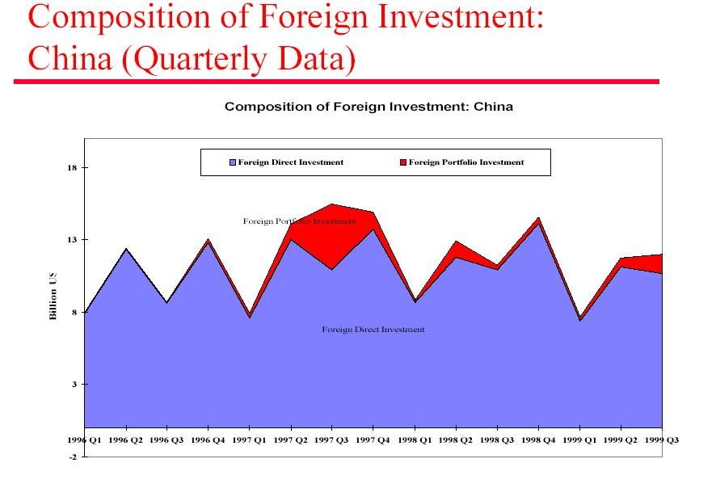

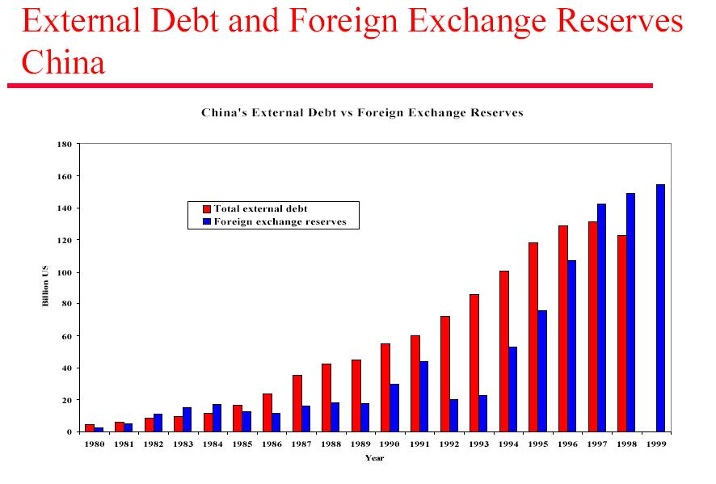
This helps to explain some of the fundamental differences between the Asian countries. However, it does not explain how similar countries (such as Korea and Indonesia – pegged exchange rates, large capital account deficits, vast foreign debt) began to experience the same problems as Thailand so soon.
It is interesting to note that empirical evidence has shown that contagion has typically been greater during times of turbulence than more in tranquil times. Evidence by Calvo and Reinhart (1996) also suggests that contagion usually operates more on a regional basis than global lines, at least within the short term. This of course makes perfect sense and helps explain how other countries became ‘infected’ only weeks after the collapse of the Thai Baht.

Many notable academics have noted that a fall in bilateral trade could have led to the contagion of Thailand’s problems. That is, if Thailand is suffering, it’s imports and exports will also be affected, with the knock-on effects of spreading the same troubles to other Asian nations. In theory, this is a cogent analysis, however, a deeper look at bilateral trade statistics shows otherwise (Goldstein and Hawkins 1998).

Table 2.1 Bilateral trade shares with Thailand (1996)
Exports to Thailand (as a % of total exports)
South Korea | 2.0
Indonesia | 1.8
Malaysia | 4.1
Philippines | 3.8
Singapore | 5.7
Taiwan | 3.1
Hong Kong | 1.0
Source: IMF, Direction of Trade Statistics Yearbook 1997

As can be seen, the share of exports from these countries to Thailand is so low that it could not possibly have led to contagion on the scale that was later seen.

So if bilateral trade wasn’t the main reason behind the contagion of the crisis, then what was?

One school of economic thought is known as the ‘Wake up’ Hypothesis. This contends that the events in Thailand acted as a wake up call for international investors, who, having seeing the Thai markets crumble, quickly realised that many other regional markets exhibited similar characteristics (deficits, Interest rates, etc). Once ‘awoken’, these investors quickly decided to pull their money out, leading to vast capital outflows as seen in Thailand propagating throughout the region. I find this hypothesis to be highly persuasive. This also helps explain the herd mentality behind investor decisions and the role of confidence and first mover advantages within global markets. Interestingly, it also shows a macroeconomic dependency upon game theory within the global institutional investment markets and the role of first mover advantage. In short, even if George Soros had read the situation incorrectly, it wouldn’t have made any difference; investors still would have followed him and the crisis would still have occurred – a dangerous reliance upon outside financiers and investor confidence indeed.

Another theory behind contagion derives from the competitive dynamics of devaluation. This holds that ‘as one country after another in a region undergoes a depreciation of its currency, the countries that have not devalued experience a deterioration of competitiveness, which in turn makes their currencies more susceptible to speculative attacks. In short, what was an equilibrium exchange rate before competitor countries devalue is not likely to remain an equilibrium rate after the fact’ (Goldstein, op cit).

This theory explains how regional devaluation can lead to uncompetitiveness, and in the right circumstances, financial collapse as later occurred.

Another factor put forward by Perry and Lederman (1998) is that the crisis-induced slowdown in Asia has contributed to the weakening of primary commodity prices leading to downward pressure on economies dependent upon exporting these goods. This explains how difficulties within South Korean banks had effects as far reaching as Russia and Brazil, and is a major reason behind the contagion of the crisis.

The rationale behind the rapid contagion of the crisis is of course a collection of all of these factors and more. The lesson learnt is that ‘even countries with strong fundamentals [strong growth, unemployment etc] are not immune from the global effects of contagion’ and the newfound power of international investors (Lau 2000, op cit).

The crisis soon spread. After the devaluation of the Baht on July 2nd 1997, Thailand requested ‘technical assistance’ from the International Monetary Fund. Six days later, the Malaysian central bank intervened to protect its currency, the ringgit from speculation. On July 11th the Philippine peso was devalued and only a week later the IMF announced that it would make more than a billion dollars available to the Philippines to remove pressure on the peso. The IMF action was the first use of the body’s ‘emergency funding mechanism’ within the region.

Unfortunately, it would not be the last.
3. The Asian financial crisis: Government and IMF responses

3.1 A chronological account

Only six days after the IMF had announced the billion-dollar package deal to the Philippines, the Singapore dollar began to decline. The Malaysian Prime Minister Mohamad Mahathir unsurprisingly blamed ‘rogue speculators’ for causing the economic upheaval. The blame was a little better researched than his previous tirade against Jews, but still underlined the shortsightedness of his tenure as leader.

On August 8th Thailand agreed to adopt tough new measures proposed by the IMF in return for a $17 billion loan from the body and other Asian nations. As a result, the Thai government closed 42 ailing finance companies and imposed tax hikes as part of the IMF's ‘insistence on austerity’. In October, the Thai finance minister resigned and the government soon collapsed. Prime Minister Chaovalit was replaced by Chuan Leekpai. The economy stabilised almost immediately.

Almost a month later, Indonesia requested help from the World Bank and IMF after the Rupiah fell by almost 30%. As a result, on October 31st Indonesia agreed to a $40bn loan package with the IMF. Much like in Thailand, the Indonesian government agreed to close 16 of its banks whilst promising many more reforms to come. The region’s troubles had begun.

By November, the crisis had already spread to South Korea. On 21st of the month South Korea requested IMF aid. Only a day later, under fire from Korean nationalists, the country’s President Kim Young Sam apologised on national television for the ‘humiliating’ IMF loan request, but stressed that the loan would be in the best interests of the country going forward. Many disagreed and riots were rampant. By December 3rd 1997, South Korea had agreed to a $57bn bailout package with the IMF, the single largest loan to any country since the crisis began. American President Bill Clinton called for ‘tough medicine’ for South Korea to combat its troubles, the situation, however, was about to get worse. Two weeks after the $57bn ‘bailout’ was announced, a new President was appointed. Kim Dae Jung became the first opposition party leader to become elected and within days the South Korean Won hit new lows. How did it all go so wrong?

In a keynote speech given in Helsinki on January 7th 1998, World Bank chief economist Joseph Stiglitz broke with orthodoxy and became the first notable economist to question the ‘Washington Consensus’. The consensus refers to the liberalisation and free market practices of the tiger nations adopted from the early 1990s onwards. The speech left the academic world polarised, as a new wave of ‘finger-pointing’ set in.

A day later, Indonesia leader President Suharto announced his yearly spending plans including 15 major programs, the majority of which, unsurprisingly, happened to be undertaken by members of his own family. Only two days later, under fire from the IMF and criticism at home, Suharto agreed to scrap these plans and vowed to focus upon cutting expenditures and foreign debt in the future. Quite a turnaround considering his track record of nepotistic indulgences. Even more strangely, on Jan 15th he agreed to a new loan deal with the IMF essentially agreeing to eliminate the country’s monopolies and state subsidies. Clearly President Suharto was a changed man.

Not for long. By March, the IMF announced that it was delaying $3bn of the $40bn loan package going to Indonesia, citing Suharto’s ‘unwillingness’ to keep to the terms of the deal. Suharto protested vehemently claiming that the IMF’s reforms were ‘unconstitutional’. Worse still, on March 11th 1998, Suharto once again won the general election and was sworn In for a seventh five year term as President. The country was in a mess.

By May, a student revolution was underway. Indonesian teens took to the streets to protest against rising prices and the corrupt Suharto administration. At a ‘peaceful’ protest, six students were shot dead and Suharto’s parliamentary allies quickly called for his resignation. They soon got their wish. On May 21st 1998, Suharto resigned as President of Indonesia after 32 years in office. His former Vice President Jusuf Habibie succeeded him. A day later, International aid was immediately put on hold until the new administration was ‘stabilised’.

By the end of June, the IMF announced a fourth agreement with Indonesia. The pact led to additional fuel subsidies plus 4 to 5 billion dollars being invested into the country’s infrastructure.

However, by this time, the IMF was already coming under considerable academic fire. Economists blamed the IMF packages for exacerbating the problems within the region, not marginalising them. On July 28th, the IMF agreed to ease the conditions of their $57bn aid package to South Korea. The package had been blamed for ‘rising unemployment and overburdened welfare programs’ leaving the country in chaos.

By this stage, the crisis had spread as far as Russia and with devastating consequences. In March of 1998, Boris Yeltsin abruptly sacked his entire cabinet; Russia soon began to suffer, and requested IMF aid.

Malaysia, however, took a different route. Instead of taking IMF aid, they agreed to adopt defensive macro and microeconomic measures in order to combat inflation, unemployment and more. The ringgit was moved from a floating exchange rate to a fixed exchange rate in line with the US Dollar (3.8 ringgit to $1). Capital controls were imposed and various agencies were set up to maintain financial prudence from 1998 onwards. In September 1998, Prime Minister Mohamad Mahathir finally endured a long power struggle with the deputy PM Anwar Ibrahim, as he and his allies were unceremoniously kicked out of the Malaysian cabinet. Anwar and Mahathir had for some time bitterly disputed the policy implications of the crisis and the potential reforms needed (Shiraishi 2005). Anwar advocated an IMF led structural package whilst Mahathir was a proponent of a Malaysian economic stimulus package, without the need for IMF involvement. Mahathir got his wish and would stay in power until October 2003, making him one of Thailand’s longest ever-serving political leaders having begun his tenure in 1981.

The support packages advocated by Asian countries clearly differed in many ways. Despite the protestations of Anwar Ibrahim (who was later arrested for corruption and sodomy – although Amnesty International have since questioned the fairness of his trial), Malaysia remained the only major country hit hard by the crisis to refuse IMF aid.

As for the other countries involved, they received over $100bn in IMF aid, a staggering amount. The IMF aid packages for Thailand, Indonesia and South Korea are discussed in more detail below.

3.2 IMF Response: Structural Adjustment Packages

The debate over the IMF’s involvement in the Asian financial crisis consists of over 100 academic papers, hundreds of books and countless newspaper articles. Still to this very day, the IMF’s involvement within the crisis is being analysed and evaluated. Indeed one of the remits of this paper is to find just that – What exactly was the IMF response to the crisis? How effectively did their SAP’s tackle economic stagnation? Indeed, how did countries that did not use IMF programmes combat their problems? How did these results differ to the IMF led aid programmes? What were the differences between aid packages from country to country?

An outline of the IMF-led aid packages and their differences relative to Thailand, South Korea and Indonesia are examined in greater detail below.

Thailand

The initial program of economic reform was first instigated in Thailand on 20th August 1997. The program of reform featured:

- Financial sector restructuring – Focusing on the identification and closure of unviable financial institutions, intervention in the weakest banks and the recapitalisation of the banking system.
- Fiscal measures – To correct the public sector deficit and to support the necessary improvements in the country’s current account position, roughly 3% of GDP would be used to financially restructure Thailand’s economy.
- A new framework for monetary policy would be introduced. This included a new managed float for the baht.
- Structural incentives to increase efficiency and innovation leading to an improved civil service and other initiatives to invite foreign capital back to the region.

On November 25th 1997, Thailand and the IMF, in the face of a larger than expected depreciation of the Baht agreed to tackle the problem using new measures, these included:

- Additional measures to maintain the public sector surplus at 1% of GDP
- The establishment of a specific timetable for implementing financial sector reforms and the acceleration of plans to protect the weaker sectors of society

Three months later, further amendments were drawn up. The amendments were designed to speed up the restructuring of the financial system including the privatisation of many banks. Fiscal policy targets were also slightly amended leading to an adequate availability of credit to the economy whilst still maintaining a tight monetary policy stance in support of exchange rate stability.

The program was again modified in a letter of intent on May 26th 1998. Priority was given to minimising any further decline in the economy and bringing about an early recovery through improved confidence within financial markets within the country. The modified program called for:
- Cautious reductions in interest rates and somewhat higher monetary growth rates
- Adjusting the fiscal target by increasing the public sector deficit target to 3% of GDP in view of the larger current account surplus in order to minimise any further decline in the economy
- Implementing greater social security policies to improve life for millions of Thai citizens
- Strengthening the legal framework for corporate restructuring including reform of the much maligned bankruptcy act
- Continuing financial sector reforms including the design of new strategies to strengthen the finance company sector and resolving the status of 4 intervened banks.

In August 1998, yet another letter of intent was instigated. This built upon previous policies and aimed to speed up and improve bank restructuring and the creation of a supervisory body. A corporate debt restructuring advisory committee was also set up. Thailand’s economy was also restructured to attract further foreign direct investment into the country. Later that year, the public sector deficit rose to almost 5% of GDP with fiscal measures designed to stimulate domestic demand through well-targeted investment projects. Finally, a monitoring system was set up, with the specific intention of policing credit bureaus and agencies to ensure that the same problems that plagued the country in 1997 would not recur.

Thailand and the IMF hoped that these measures would effectively tackle the growing financial problems within the region. Indeed, a forecast for Thailand was published on the IMF website, underlining the positives to be taken from the package. The figures were as follows (Taken from the IMF official website):

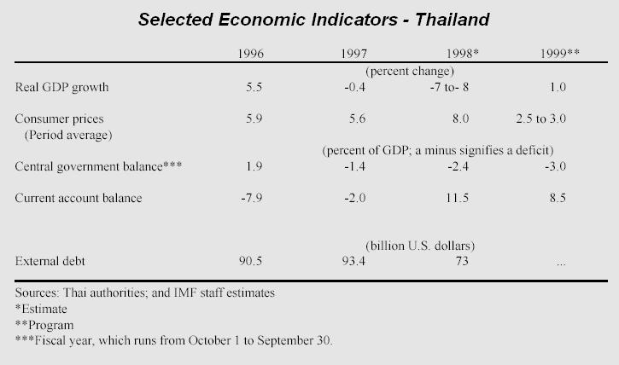

Although GDP growth would fall dramatically in 1998, it was hoped that it would actually begin to grow in 1999. More importantly, external debt would be virtually eradicated by the beginning of the new millennium. The package seemed to promise a significant medium term improvement for Thailand, with strong fundamental changes to their economy leading to more solid investment projects coming in. The future seemed bright.

Indonesia

The first letter of intent between Indonesia the IMF outlined many notable economic reforms, these included:

- Financial sector restructuring – Much like Thailand, the IMF sought to close what it deemed as ‘unviable’ financial institutions, including banks, building societies and more.
- Structural reforms were set up. These reforms attempted to improve the visibility and transparency of the Indonesian financial system including the dismantling of monopolies and the expansion of a privatisation program, policies that were desperately needed in the corrupt, nepotistic Suharto cabinet.
- Stabilising the Rupiah through tight monetary policy and a flexible exchange rate policy.
- Fiscal measures equivalent to roughly 1% of GDP to facilitate external adjustment and to provide resources to pay for financial restructuring. These measures included the cutting of many questionable expenditures, the removing of government subsidies, VAT exemptions and more.

Despite many political troubles within the country and sharp declines in the Rupiah, on January 15th 1998 the Indonesian government announced an acceleration of the aid program. The amendments included:

- The cancellation of 12 infrastructure projects and the revoking or discontinuation of privileges for many Suharto allied companies.
- Further bank and corporate sector restructuring including the creation of a framework for creditors and debtors to deal on a voluntary, case-by-case basis. The Indonesian Bank Restructuring Agency (IBRA) was also set up to guarantee bank deposits and credits.
- Limiting the monopoly of the national marketing board (BULOG) to rice and deregulating domestic trade in agricultural produce

Despite these measures, however, the Rupiah continued to slide and on April 10th 1998, another letter on intent was signed.

The letter focused upon the quick stabilisation of the Rupiah. It was hoped this could be attained through stronger monetary policies undertaken by the Indonesian government. The IBRA was also given the remit of taking over weak banks and enforcing international laws. In addition to this, six major state enterprises were privatised, with a further 7 to be privatised the following year. The letter was designed to enhance the credibility of the program whilst improving the lives of millions of Indonesian citizens. Indonesia continued to work closely with the IMF and World Bank during this period.

However, by June, Indonesia was facing a social backlash. Millions were living below the poverty line, and urgent action was needed. In a memorandum of financial policies published on June 24th 1998, Indonesia announced that it was increasing social expenditure to a level equivalent to around 7.5% of GDP. The provision of food and medical supplies had come before economic prosperity, and although this set Indonesia back somewhat, it was a policy that simply had to be introduced. In addition to this, a financial sector advisory committee was set up, and bank restructuring was continued.

On July 29th 1998, the Indonesian Debt Restructuring Agency (INDRA) was officially launched. The agency aimed to remove restrictions on debt-equity conversions, providing tax breaks for companies, streamlining procedures used to bring foreign direct investment into the country and establishing a framework used to facilitate corporate restructuring within the region. In September later that year, the government also introduced the Special Commercial court for bankruptcies and built further upon the voluntary restructuring of corporate debt. Commodity prices were also stabilised, allowing food and drinks to be more freely available for those in desperate need of these goods.

In October, further plans for bank recapitalisation were introduced. These included reopening viable banks and reaching financial settlements on the repayment of liquidity support. The Jakarta Initiative Task Force was also set up to encourage the initiation of negotiations between corporate debtors and their creditors.

By November, the situation seemed to have improved. Indonesia announced that it would be further enhancing the social security net, including doubling the monthly allocations of rice to the country’s poorest citizens. The country also announced plans to support this increase through a substantial increase in rice growing and production. Fiscal monitoring was heightened, ensuring that much of the budget was not misappropriated and a bank recapitalisation process was underway meaning that many banks could reopen as early as January 1999. The future seemed bright.
An outline of the forecasts for Indonesia (by the IMF) is shown below:

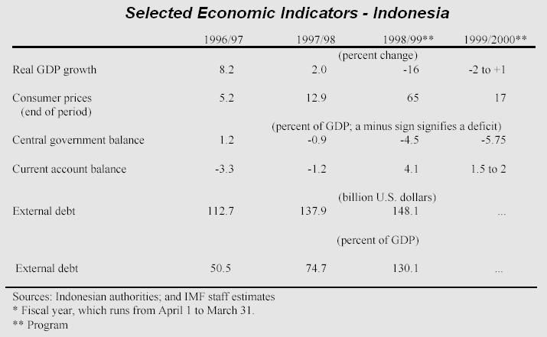

It was hoped that although the 1998/99 years would be very costly, the IMF supported programme would result in real GDP growth from 2000 onwards. In addition to this, the current account balance would no longer show a deficit, leading to future prosperity within the region.

South Korea

One of the major problems faced by South Korea was the mass interference between governments, banks and conglomerates such as the Korean chaebol. The well-connected heads of these companies were given preferential credit over perhaps more deserving clients. The scale of this ‘crony capitalism’ was vast and a major component of the downfall of South Korea once the financial crisis set in. As such, the IMF structural aid package needed to assess these factors and provide a long-term solution to the country’s problems.

The package for in 1998 assumed a 2.5% growth rate for the year and was based upon:
- Comprehensive financial sector restructuring including the introduction of a clear and firm exit policy for financial institutions. The operations of 9 insolvent banks were suspended and all commercial banks with inadequate capital were required to submit plans for recapitalisation.
- Fiscal measures equivalent to roughly 2% of GDP were outlined in order to fund these measures.
- Efforts to dismantle the nontransparent and inefficient ties between government, banks and conglomerates would be pursued. Auditing procedures and disclosure standards were also introduced.
- Trade liberalisation measures were enforced. This removed any trade-based subsidies given to Korean firms.
- Capital account liberalisation measures were implemented to open up the Korean money, bond and equity markets to capital inflows, and to liberalise foreign direct investment within the country.
- Labour market reforms were introduced and key financial and economic data would be published internationally.

In December 1997 the program was intensified and accelerated. The South Korean Won appeared to be in real trouble as short-term creditors called back their collateral. In an attempt to battle these measures, the government announced a further tightening of monetary policy and the abolition of the daily exchange rate band. Capital account restrictions to foreign investors within the Korean Bond market were lifted in an attempt to persuade overseas investors back into the country. Restructuring plans for the financial sector were implemented, including the establishment of a high-level team to negotiate with foreign creditors to reduce the recourse of Korean banks in the short and medium term. Trade liberalisation measures were also speeded up including the binding of a WTO sponsored financial services agreement as agreed with the OECD.

However, South Korea did not appear to be picking up quickly. In a letter on intent on 7th February 1998, the country’s macroeconomic framework was revised with growth projected at around 1% for the year, down 1.5% from the 1997 targets for the year. Despite this, Korea had made significant ground in reducing its short-term loans or extending them over a longer period. The letter also included many additional measures to be undertaken:

- Targeting a fiscal deficit of around 1% of GDP for 1998 to accommodate weaker economic activity
- Increasing the range of financial instruments available to Korean companies and investors including appropriate mergers and acquisitions legislation and procedures.
- Introducing many measures to combat and improve corporate transparency, including director roles, shareholder accountability and more.

By May the situation had become confusing. On one hand, a significant improvement had been made with regards to resolving Korea’s external financing crisis. However, on the other hand, it seemed as if the economic outlook for South Korea was becoming weaker. With this in mind, on May 2nd, Korea announced yet another letter of intent. These measures included:

- The accommodation of a larger fiscal deficit of around 2% of GDP to strengthen the social safety net.
- The formation of an appraisal committee including international experts to evaluate the recapitalisation plans of the foreclosed banks within the country.
- The formation of international procedural ‘best practices’ being introduced within the financial system.
- Further liberalisation of the capital account.

Despite these measures, however, a recession soon set in. In July, the Korean government announced a further easing of macroeconomic policy. The provisions included:

- The accommodation of a larger fiscal deficit equivalent to 5% of GDP to combat recession and for social aid.
- Measures to bolster the social expenditure plan.
- The introduction of a World Bank sponsored framework for corporate restructuring to facilitate debt workouts and to minimise the use of ‘rescue’ loans.
- The further improvement of financial sector restructuring and capital market development.

By November 1998, Korea had decided to spend a large proportion of its 1999 budget on local and national reforms. This including the doubling of public works programmes and an unemployment insurance scheme. Privatisation measures were also implemented.

An outline of the IMF forecasts for the aid package is shown below:

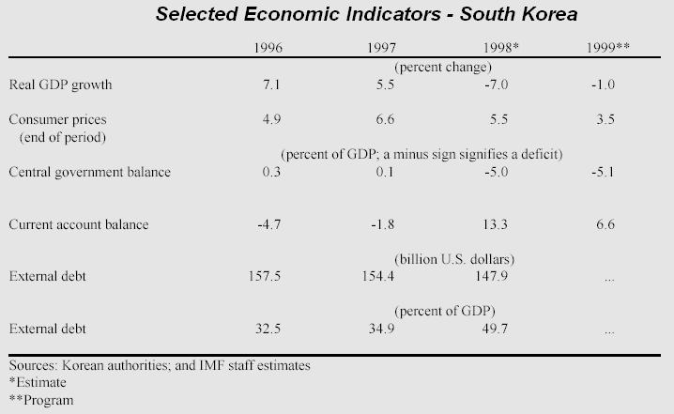

GDP growth was expected to take a real downturn in 1998, but would hopefully rise considerably in 1999 and onwards. However, other than this, the economic forecasts did not look rosy, it would be some time before true growth would be recorded and key economic indictors would be reversed.

All in all, these three countries alone borrowed over £100bn of International aid, a staggering amount. Details of the financial breakdown are shown below (again taken from IMF website):

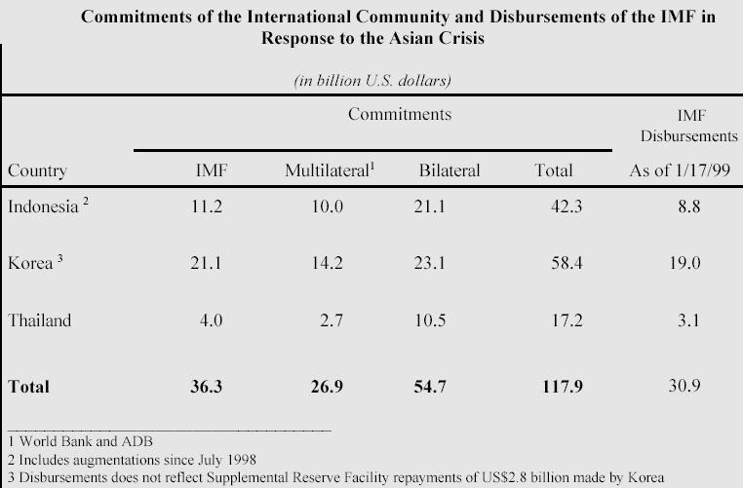

This was only a small part of the problem. The IMF would also later bail out countries such as Russia and Brazil whilst the USA received over $3bn from the Federal Reserve Bank of New York in order to tackle their problems. What began as a small regional setback soon became a worldwide crisis, as recession and stagnation set in.

3.3 Government and IMF Programmes: Criticism and short-term effects

Only weeks after the inception of Thailand’s IMF-led structural aid plan, critics began to take sides. On one hand, IMF acolytes believed that the SAP’s would stabilise the region’s economies and bring about lasting long-term economic reform. On the other hand, however, a vast quantity of well-known academics and economists began to tell a different story – that these countries were and would continue to be in the doldrums for a long while, irrespective of the IMF initiatives being introduced. Indeed, criticism of IMF policy is now increasingly ubiquitous: ‘It is now [widely] recognised that the International Monetary Fund… unwittingly exacerbated the East Asian crisis in crucial ways’ (Jomo, 2000). Perhaps so, but is important to question the validity of these claims and the intangible effects these aid packages may also have had in order to make a true evaluation of the significance or lack thereof of IMF policy during this period and thereafter.

It has been argued that the IMF ‘failed to recognise the nature of the underlying problems, misdiagnosing the situation and insisting on the wrong policy responses’ (Jomo, op cit). The IMF policies also undermined confidence in affected Asian financial systems by demanding the closure of certain financial institutions, inducing the subsequent recessions within the region. Another critique of the IMF aid packages focuses upon the ill-advised prescription of ‘strong medicine’ by the IMF. Harvard economist Jeffrey Sachs (1997) contends that the rationale behind the crisis was simply a short-term cash flow problem and that the countries involved were simply the victims of the growing power of international markets. He argues that ‘there is no fundamental reason for Asia’s financial calamity except financial panic itself’ and that the economic situation prior to the crisis was sound. Radelet and Sachs (1998) also stress this theme concluding that the crisis ‘is a testament to the shortcomings of international capital markets and their vulnerability to sudden reversals of market confidence’. The obvious problem with this line of argument is that market blindness should certainly not be confused with a state of prosperity. As discussed at length earlier in this paper, there were many warning signs that were seemingly undetected, in some cases for many years, it is therefore important to distinguish between perceived economic strength and actual economic indicators in the run up to the crisis. Indeed empirical work by Goldstein and Reinhart (1998) on more than 120 banking and currency crises in emerging markets over the past 25 years has revealed that interest rate spreads and credit ratings have typically been relatively poor predictors of these crises, further questioning the strong ‘fundamentals’ of the tiger nations from the late 1980s onwards.

Another criticism is based around the notion that the IMF is no longer needed as an international body to facilitate the current floating exchange rate system. A paper by Shultz, Simon and Wriston (1998) states that ‘The IMF is ineffective, unnecessary and obsolete…. Once the crisis is over we should abolish [them]’. The crux of their paper is based around their belief that the financial markets have evolved to a level that essentially renders many of the pre-existing remits of the fund defunct. In many cases, this is entirely true. The original responsibility of the IMF when it was set up at Bretton Woods after World War II was to promote and facilitate international trade and the restructuring of global economies. Through the nature of globalisation, the fund, by 1997, had become the de facto international economic body, dealing with many wildly differing problems. The problem with the paper above is that it fails to distinguish between exchange rate mechanisms and the true remit of the fund, that is, in times of difficulty, the fund can offer conditional financing to countries badly affected through economic crisis; precisely the perceived ‘tonic’ needed for East Asian in the latter half of 1997. Goldstein (1998) argues that without access to such funding, countries would respond to external deficits with ‘larger deflations and greater resort to competitive depreciations and trade and exchange controls’. He also states that policy changes and reform had to be administered through an international body, as multilateral and bilateral economic talks would ultimately prove untenable, stating that ‘If the IMF (warts and all) didn’t already exist, something a lot like it would have to be created’.

Yet another criticism of the IMF is that it exacerbated the financial crisis by prescribing excessively tight monetary policy and fiscal policies and by mandating the closure of many banks and other financial institutions. Then World Bank chief economist Joseph Stiglitz (1998) contends that because the tiger nations did not have serious fiscal imbalances before the crisis and because bank closures can lead to a credit crunch, the IMF’s recommendations have made the contraction deeper than it needed to be. The argument over banking closures is a highly polarising topic of debate. On one hand, whilst critics such as Stiglitz have a point that the closure of many banks did seem to have an adverse effect on troubled economies, the case for keeping insolvent banks operative is anything but convincing. ‘If clearly insolvent banks are allowed to continue operations they are likely to “gamble for resurrection” by taking on even higher risks, adding significantly to the public sector tab’ (Goldstein 1998). Indeed Goldstein argues that one of the errors made by the IMF in Indonesia is that if did not close enough banks: ’16 banks closed accounted for only 5% of total banking assets. The trick to restoring confidence is to convince the public that all of the bad banks have been resolved and that the ones remaining open are solid’. Indeed in a study of 24 countries that experienced systemic bank restructuring Dziobek and Pazarbasioglu (1997) found that the countries that were quickest to diagnose the problem, assess their losses and restructure their banking systems were generally the ones experiencing the better recovery patterns from the crisis. This argument flies in the face of work undertaken by Radelet, Sachs and Stiglitz and truly underlines the difficult ‘no-win’ situation the fund was in when dealing with the magnitude and polarity of the problems faced.

The situation very much resembles the ‘chicken or egg’ syndrome. The problem being that closing down banks is deemed necessary for long term financial development, however, in the interim, the closure of many of these banks leads to unemployment, poverty and further problems. What is the best policy to adopt? Can a real financial turnaround really be achieved without the necessary systemic reforms? Conversely, even with these reforms in place, do they really have any depth if millions of citizens are living below the poverty line? Economists such as Robert Wade (1999) and many others have chosen to side against the IMF, but I find much of this criticism unfair. In many cases the IMF acted with the best interests of promoting long-term prosperity within the region. Perhaps some of their measures would ultimately prove to be incongruent with the short-term development of the tiger nations, however, it is easy to criticise the fund retrospectively, especially when the orthodoxy of opinion sides against them.

A further complaint held against the IMF is that the fund has either been too intrusive in the policies it has recommended to the crisis countries, or alternatively that is has not been intrusive enough. Feldstein (1998) has taken the too-intrusive position. He argues that ‘The IMF’s recent emphasis on imposing major structural and institutional reforms as opposed to focusing on balance of payments adjustments will have adverse consequences in both the short term and the more distant future’. He contends that the IMF has inappropriately moved away from its original mandate of balance of payments adjustments into unchartered territories of which it is not qualified to comment upon. However, this argument is again unpersuasive. How could confidence in Thailand be lifted without the need to shut down insolvent banks? Could South Korea really have improved investor confidence without removing many of the high debt to equity ratios of its chaebols? Could Indonesia have really recovered without banking reform and concrete signals that it is prepared to ‘curtail inefficient infrastructure projects and to rein in the worst cases of “crony capitalism”? (Goldstein 1998). I somehow think not and find arguments against this view distinctly weak.

There is no doubting that from an early stage, the IMF had decided that fiscal austerity would be a key part of all of the structural aid packages given to affected countries. Indeed, the vast loans given to these nations from the IMF were not seemingly spent on government spending, so what exactly what the money for?

McLeod and Garnaut (1998) argue that the ‘mere announcement that the government now had more than $40bn extra at its disposal was hoped to dissuade the markets from further speculation against the Rupiah [In Indonesia]. Yet there was no attempt to convince them that the government had decided to defend any particular exchange rate: officially, the policy was still to float’. So where did the money go?

McLeod contends that the money was never properly allocated, stating that ‘there was simply no coherent strategy for using these funds…. [Later causing] considerable damage to the IMF’s credibility’.

As can be seen, there is significant debate over the true short-term effects of the IMF’s structural aid packages. For the most part, I believe that the IMF just about got it right. The crisis underlined the real differences between classic balance of payments problems and a full capital account crisis. It may well have been that the IMF were not fully prepared for a crisis of the magnitude that was seen, however, very few were. In my opinion, the IMF acted in a way to secure the longer-term development of the tiger region at the expense of a short-term solution. Many such as Sachs may disagree with this view, claiming that the crisis was a classic ‘bank run’, however, I disagree. The problem was much more than just a ‘bank run’. Short-term reversible capital inflows may have been an important factor leading to the crisis, and the collapse may have exhibited many notable characteristics of a typical bank run, however, this is only half of the story.

The fact remains that Thailand, Indonesia and South Korea, despite strong ‘fundamentals’ in the run-up to the crisis, had significant structural and regulatory weaknesses that in the long term had to be dealt with. In my opinion, the IMF decided to deal with these weaknesses at the right time, despite the significant outpouring of criticism from eminent academics and economists upon commencement of the programmes. Furthermore, I suspect that further down the line, many academics will look back at the IMF programmes and reconsider their previous militant stance against the fund, despite the obvious political issues many of these writers still exhibit.

The issue of Malaysia is also a topical debate. Many papers have attacked the Malay response to the financial crisis as being too simplistic and based upon rudimentary economics, whilst not addressing many of the problematic factors that caused havoc within Indonesia, Thailand and South Korea. However, I believe it is important to stress the key differences between these countries and Malaysia before commenting upon the situation. In my opinion, Malaysia did not exhibit many of the corrupt practices of Indonesia, or much of the ‘crony’ capitalism of Korea. Its banking infrastructure was simply not as strained as Thailand’s. Despite the many shortcomings of the Malaysian cabinet, I personally believe that the Malay government chose the right option at the time, as vast loans would not have solved the country’s problems at the time or within the medium to long term and structural reforms were maintained by the Malaysian government, without the need for IMF involvement.

This paper will now focus upon a more up to date measurement of economic recovery for the region, to see whether the IMF programmes have indeed aided the affected countries within the long term.
4. East Asian Recovery: A present-day perspective

Measuring the significance of the IMF’s aid packages based solely upon short-term events conveys a rather blinkered view of international economics and the prospects of the region from 2006 onwards. For this reason, this paper will now analyse how those affected economies have recovered from 2000 right upto the first half of 2006.

Thailand

In order to effectively measure the true recovery of Thailand (and the three other main countries) from 2000 onwards, five important measurements have been utilised. Firstly, GDP rates for every year up till 2006 are included. Second, unemployment rates are measured on a year-by-year basis, with a discussion of why and how their movements are occurring. Thirdly, a measurement of short-term debt as a percentage of total external debt is shown. Similarly, external debt is measured against foreign reserves, in the hope of finding much sounder indicators than those for the 1990-1997 period aforementioned. To conclude, the region’s trade balances are re-examined, measuring imports against exports from 1990 onwards.

GDP

Having suffered terribly from the crisis that first hit the region in 1997, Thailand had historically low GDP rates from 1997-2000. However, from 2001 onwards, the statistics have begun to rebound, with Thailand showing significant improvement into 2006, with strong forecasts for 2007.

Figures from a recent World Bank report (2006) show that Thailand rebounded in 2001 to post a GDP growth percentage of 2.2%. This may be low in comparison to many other growth regions; however, this was a strong precursor for a much brighter economic outlook from 2001 onwards. Indeed, from 2000-2006, the area grew at more than 4.5% per year, in many cases by over 6% per annum. A graph of these results is shown below:

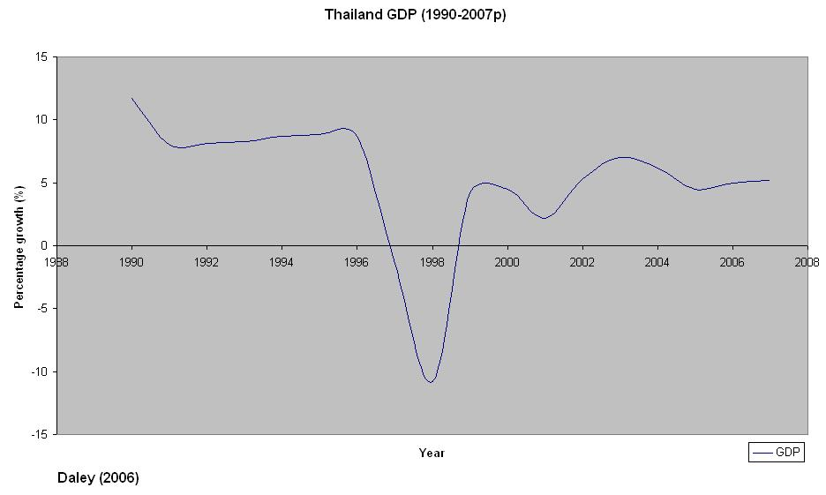

As can be seen, Thailand has recovered tremendously from 2001 onwards. With 2007 projections of 5.2% GDP growth, the future now looks very promising for Thailand. Given that the IMF’s structural plans are now in place, the country should not experience any of the 1997 woes that haunted the country and the region as a whole. As such, provided economic policies remain sound, Thailand should continue to grow at a solid pace.

Unemployment

One of the major drawbacks of the IMF structural aid packages was the inherent long-term bias of the plans. As already mentioned, these countries, alongside the IMF, decided to adopt a long-term strategy for redevelopment, at the cost of some important short-term factors such as unemployment and poverty. Unemployment reached record highs during the 1997-2000 period, however, from 2001, the situation, much like the rebound in GDP growth, seems to have changed for the better.

In 2001, The Thai unemployment rate was 3.3%, however, by 2002 this had fallen to 2.4%, a large decrease. Continued working initiatives led to a drop of 0.2% in 2003 and a further fall in 2004. By 2005, unemployment reached only 1.8% in Thailand – a very strong figure. Similarly, a poverty headcount has shown a sharp decrease in those citizens living below the poverty line, with further decreases expected.

Short-term debt as a percentage of Total external debt

A major part of the IMF initiatives were to restructure much of Thailand’s short-term debt. Through honest and open dialogue, Thailand managed to renegotiate a significant amount of its short-term debt into longer maturities with the country’s creditors. This allowed Thailand some well-needed ‘breathing room’ to implement social aid plans and other important restructuring proposals.

A graph of short-term debt as a percentage of total external debt is shown below:

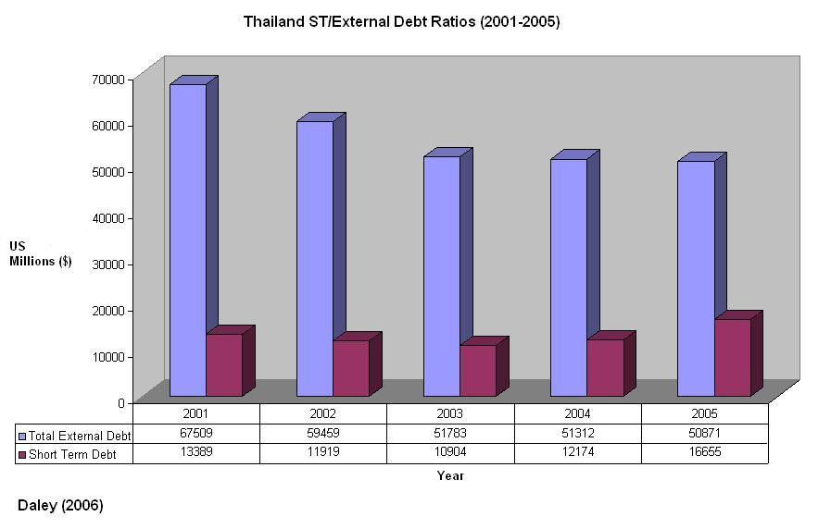

As can be seen, Thailand has significantly improved its short-term debt ratios in comparison to the excessive 1990s figures. Despite a small downturn in 2005, there does not seem to be anywhere near the excessive reliance upon risky short-term debt that was exhibited during the 1990s. As such, it appears that Thailand is beginning to rebuild itself based upon sound economic projects and strong returns on investment, very strong signs for recovery.

External debt vs. foreign reserves

One of the underlying problems of the Asian financial crisis was that external debt began to dwarf the foreign reserves of almost every Asian country, including Thailand. As such, when investors began to speculate and began to remove their pension and mutual funds from the country’s markets, the system simply couldn’t cope. Foreign reserves were not vast enough to deal with the problems, leading to stagnation, recession, unemployment and poverty, a complete financial collapse.

The figures from 2000 onwards however, begin to show a notable recovery. Since 2001, Thailand has increased its foreign reserves by over 50%, a very large figure indeed. However, during this time, total external debt has also fallen considerably, as the stats below show:

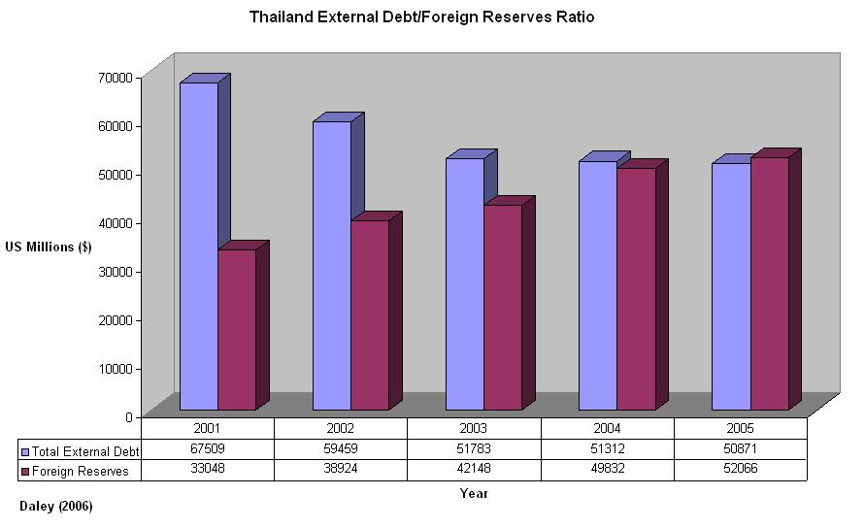

As can be seen, Thailand has managed to save money in terms of foreign reserves, but has also managed to pay off many of the country’s creditors too. This shows an extremely strong recovery from the 1990-1999 period, and is arguably the strongest indictor of and precursor to future success from 2006 onwards.

Trade Balance

From the early 1990s Thailand and the Tiger region itself had begun to run up large trade deficits. Imports far exceeded exports, leading to vast deficits within the country’s economy, resulting in negative trade balance figures for much of the decade.

However, since 1996, the situation seems to have changed, as seen in the graph below:

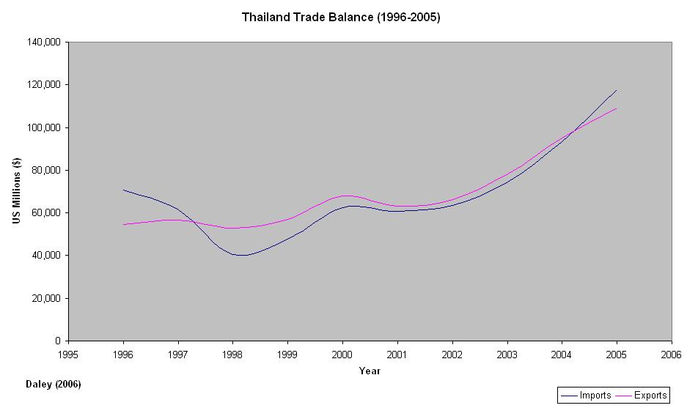

As can be seen, the Thai government have made good progress since 1996 in combating the trade deficits of 1990-1995. From 1997 till 2004, Thailand has reported trade surpluses every year, a very strong sign of economic wellbeing. However, in 2005, Thailand reported a trade deficit of £8bn, and current World Bank projections for 2006 and 2007 report similar deficits of around $9bn per year (World Bank 2006). Of course not all countries can be balance of payments ‘winners’, and an increase of imports was probably inevitable given the 7-year long run of trade surpluses. Despite this, however, Thailand must focus upon improving the competitiveness of its exports and must address the growing import figures that have lead to troublesome 2006-7 projections for the country.

Trade balance notwithstanding, however, the situation in Thailand has considerably improved since the Asian crisis of 1997. Almost every important financial and economic indicator has shown a notable improvement, and there seems to be no legitimate reason for this not to continue as the country further strengthens its development projects.

Indonesia

One of the major drawbacks to the IMF supported program in Indonesia was the unlikely reliance upon the Indonesia cabinet to ensure that they met the key targets of the IMF consultancy body. Problems seemingly began from day one, as political troubles surfaced. However, as the Indonesian government began to adopt the IMF policies, the economic horizon began to change for the better, as evidence by the sharp rise in GDP within the period.

GDP

Figures from the World Bank report (2006) show that GDP increased by 3.8% in 2001, a strong increase from the 1997-99 figures. A year later, GDP rose by 4.4%, again indicating economic wellbeing. In 2003 GDP was almost 5%, and by the beginning of 2006, the figure had reached 5.5% with a further projection of 6.2% growth in 2007.

Clearly, judging solely from GDP growth rates, Indonesia has managed a substantial recovery from its 1997-99 nadir, indicating that the IMF structural aid packages have in fact proved highly successful. A graph of the country’s GDP growth from 1990-2007 is shown below:

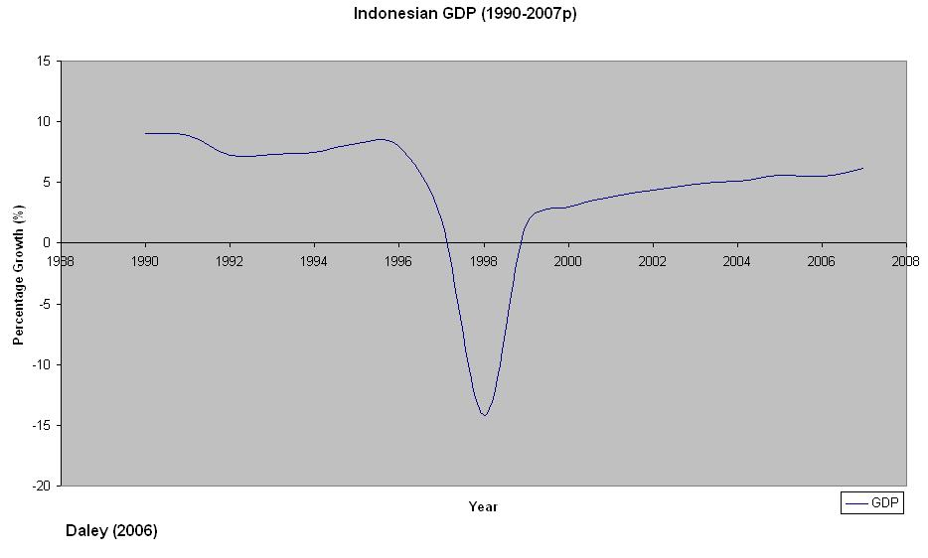

As can be seen, the collapse of the Indonesia markets in 1997 was monumental. However, since 2000, the Indonesian Rupiah has begun to stabilise and the country has started to get back on its feet. The future now looks very positive for Indonesia, as 2007 projections underline - Indonesian GDP should continue to rise or stay at a consistently high level for the foreseeable future, a very positive outlook.

Unemployment

Unemployment in Thailand has fallen noticeably over the last 5 years, and upon first inspection of the statistics one may have assumed that this would also be the case for Indonesia. Unfortunately it is not.

Unemployment has actually increased within the five-year period 2000-2005 from 8.1% in 2000 to a projected figure of 10.6% in 2006, a substantial increase of 2.5%. However, this can largely be attributed to two factors; the after effects of the Asian Tsunami, and the noticeable change towards a more service based economy than ever before. At this juncture, one is willing to believe that these factors and the restructuring of the economy have lead to such poor unemployment figures. However, there is certainly a question mark hanging over these rates for the foreseeable future, and they must be effectively tackled in order for real growth to be continued.

Total external debt as a percentage of GDP

Indonesia, much like Thailand suffered tremendously from spiralling external debts and short-term reversible capital outflows. Towards the end of the 1990s, external debts were at dangerously high levels in comparison to GDP. However, much has changed. From 2001, Indonesian authorities have managed to keep external debt at manageable levels, whilst simultaneously increasing GDP during this period. A graphical representation of the statistics is shown below:

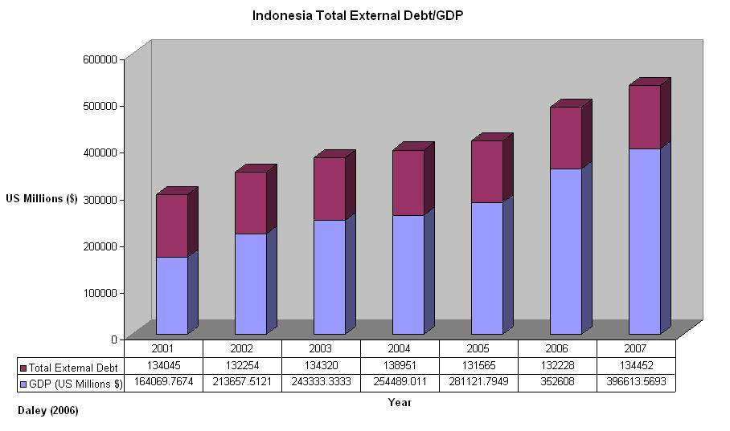

External debts seem to have changed very little since 2001; however, GDP has increased substantially over this period. This indicates that the country is fiscally responsible and has managed to improve its economic project selection greatly from the 1997 period. This underlines the strong recovery made by Indonesia from 2001 onwards.

External debt vs. foreign reserves

Much like Thailand, by the mid 1990s Indonesia had already run up incredible amounts of external debt. The effects of this were of course exacerbated by the extremely insufficient quantities of foreign reserves held. However, it was hoped that the IMF aid packages would remedy this, and that by the mid 2000s, these rates would be much more stable and in line with IMF targets. Unfortunately, this does not seem to have been the case.

Statistics show that total external debt and foreign reserves has largely remained at the same 2001 levels for five years running. A graph of these findings is shown below.

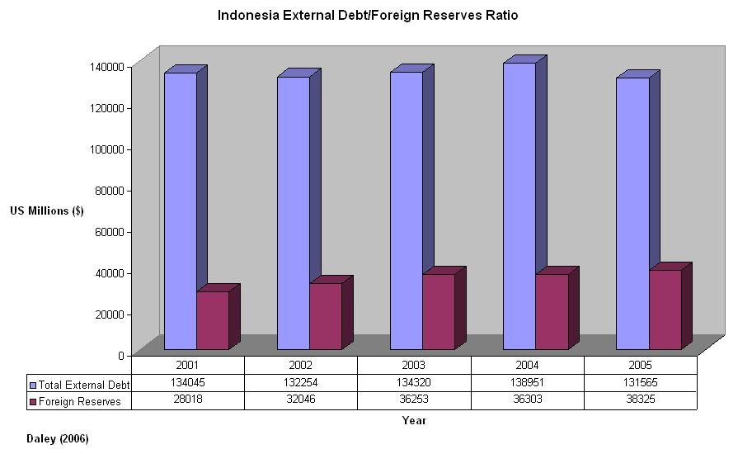

Few conclusions can be drawn from this graph as very little progress has been made over the past 5 years in tackling the problem. This is still a key problem faced by Indonesia and one that must be tackled urgently if Indonesia wishes to continue its economic growth.

Trade Balance

Since 1997, Indonesia has made great strides in improving its trade balance. Indonesia has reported trade surpluses equating to over $20bn year on year from 2001-2005: a vast amount, and a strong indication of future success should the trends continue. A graph of the Indonesian trade balance from 1997 onwards is shown below:

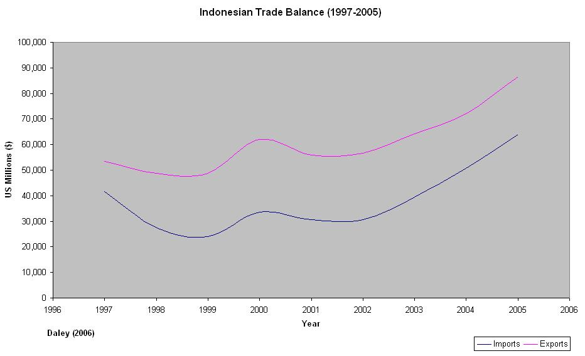

According to World Bank projections for 2006 and 2007, Indonesia’s trade surplus is destined to grow even further – a very positive outlook for future growth. Interestingly, Indonesia, much like Thailand, has seemingly begun to advocate and revert back to mercantilism in order to combat their macroeconomic difficulties. How long this policy will be sustainable for is open to debate, however, these nations are certainly reaping the rewards of managing to contain a trade surplus for at least the past 5 years.

Indonesia has also recently announced that it is repaying half of its outstanding obligations under the Extended Fund Facility (EFF) of the IMF. This figure, totalling almost $4bn in real terms is a vast amount of money to repay early, leading us to believe that Indonesia must be confident of maintaining it’s own balance of payments issues within the foreseeable future. Managing Director of the IMF, Rodrigo de Rato has initially commended the Indonesian government, stating, "Indonesia's intention to make a partial repayment of EFF obligations ahead of schedule reflects Indonesia's strengthening macroeconomic fundamentals and improved balance of payments position." Perhaps the situation has improved, there is no doubting that GDP has increased dramatically since 2001, however, there are still many question marks hanging over Indonesia, and Thailand, for one, seems to be at a much more advanced stage of redevelopment. The next few years will be crucial for Indonesia; they must ensure that people go back to work and that external debts are sufficiently marginalised in order to welcome back western investment. Only then, can the country really begin to get back on its feet and finally get over the lingering after effects of the 1997 financial collapse.

South Korea

South Korea received over $58bn in International Aid from 1997 onwards. As a condition of this loan, Korea was instructed to dismantle many of its chaebols and introduce a more rigorous and robust regulatory framework for both microeconomic and macroeconomic policies. These initiatives were designed to rid Korea of it’s ‘connected lending’ and introduce a more efficient and fair way of assignment projects and government funds.

GDP

During the period 1997-1999 South Korea underwent one of the biggest recessions of it’s lifetime. GDP fell by over 6% and the country fell into financial ruin.

However, the results since 2000 have been staggering. In 2001 GDP rose by 3.8%. A year later GDP hit a decade-high level of 7%, and South Korea was already being hailed as ‘back on its feet’. 2003 results, however, tempered these claims, despite being a robust 3.1% increase upon the previous year. In 2004, GDP rose 4.6%, 4% in 2005 and 5% in 2006. Forecasts for 2007 show a 4.8% increase in real GDP, very stellar results indeed. A graph of these findings is shown below:

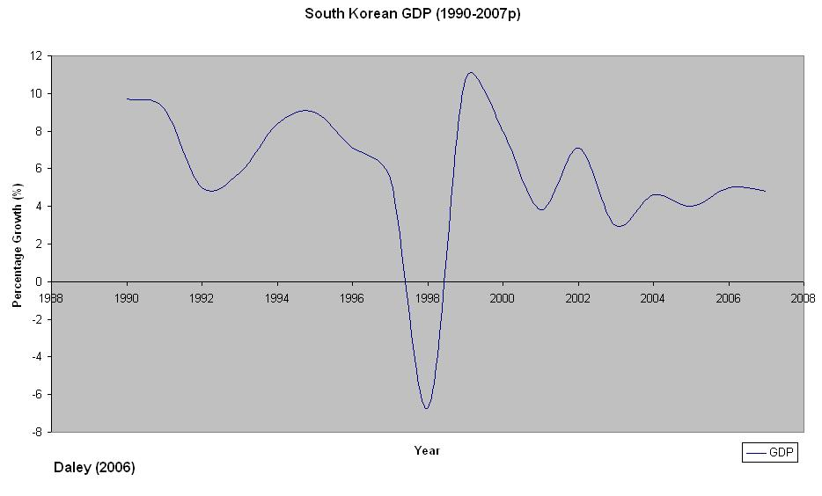

As can be seen, much like Indonesia and Thailand, Korea suffered terribly from 1997-1999. During this period, Korea underwent negative growth, and unemployment skyrocketed. However, from 2000 onwards, the situation seems to have improved substantially. Economic prospects for the region are strong, and GDP should continue to rise at strong levels for the foreseeable future.

Unemployment

Unemployment has been left relatively unchanged from the period 2000-2005. Unemployment in 2000 was 4%, decreasing to around 3.5% for the next three years. In 2005 only 3.7% of Korean citizens were out of work. All in all, there has been a small, yet noticeable decrease in unemployment over the past 5 years, perhaps more importantly there is very little volatility within the job market, further strengthening confidence within the country.

Short-term debt as a percentage of Total external debt

As already documented earlier in this paper, South Korea (along with Thailand) had considerable problems managing their short-term debt. Vast sums of government monies were being misallocated, especially into the coffers of the Korean conglomerates, as such, Korea experienced significant troubles in relation to Non Performing Loans (NPLs). As a by-product of this, Korea was forced to borrow more, at shorter maturities to bridge the gap. Months later, when speculators attacked, Korea was in real trouble, and was forced into depreciation of the Korean Won, leading to financial peril. As a result of this, the IMF initiated plans based around orderly debt workouts and the supervision of greater banking regulations, limiting the scope of ‘crony capitalism’ for the 21st century.

The hope for Korea was that these attempts would successfully rid the country of more dangerous short-term outflows, in favour of safer, more reliable loans with longer maturities, and at the time real progress was seemed to have been made.

However, a further look at the statistics from 2001 shows an entirely different picture altogether. From 2001-2005 not only has total external debt risen, but short-term maturities have also increased, a very bad sign indeed. A graph of these figures is shown below:

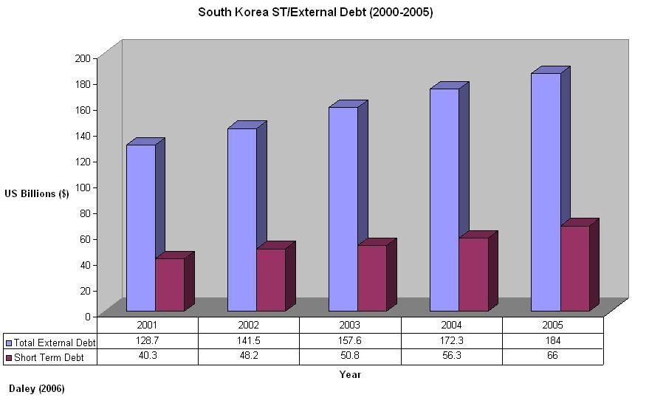

Whichever way these findings are construed, the results do not seem pretty. GDP has increased markedly, and unemployment has fallen, yet total external debt has actually risen – Why does Korea still need to borrow so much? One argument could be that these figures are indeed the result of short-term loans back in 1997, which are now deemed long-term. However, this is unpersuasive as five years of almost identical statistics show a different story.

Perhaps Korea is focusing upon fiscal measures to secure nationwide prosperity before paying back international creditors. The argument is logical and certainly congruent with the IMF’s fiscal initiatives. However, one would assume that should this be the case then unemployment would have fallen much lower than it actually has as social aid is being catered for. This does not seem to have occurred. Perhaps the underlying factor is the capital-intensive nature of Korea’s exports and manufacturing sectors. Korea is a major player within the car and electronics industries, and as such is a highly capital-intensive country. This would also help to explain the relatively high ratio of external debt and short-term debts that have been building up over the past 5 years.

External debt vs. foreign reserves

The ratio of external debt to foreign reserves is a very important statistic. A large portion of the blame for the 1997 Asian crisis can be pointed towards those countries who allowed excessive short-term reversible capital inflows to pile up whilst ignoring the importance of having vast foreign reserves to prop the markets up should anything unforeseen occur. Both Korea and Thailand in particular, had significant difficulty in managing this balance and paid dearly for their mismanagement of the economy.

Since 1997, Korea has promised to regain its fiscal and monetary policy strength. It has tightened up interest rates and stabilised the Won whilst also promoting social initiatives at the same time. Since 2001, Korea has successfully managed to bolster its level of foreign reserves, leading to a much greater ratio of reserves to debt than ever before. The results of which are shown below:

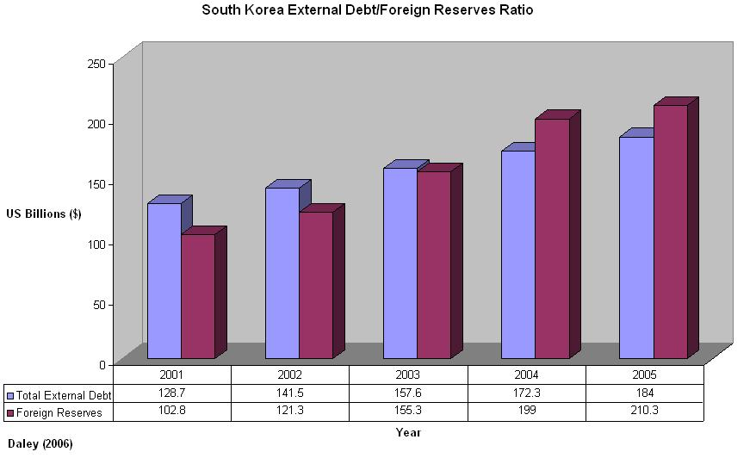

Much like Thailand, Korea has done an exceptional job of retaining its foreign reserves whilst still being able to manage a positive balance of payments figure – a strong indication of future success. It seems as if Korea has learnt from its mistakes and now has sufficiently large foreign reserves to be able to focus upon the repayment of external debt, as hypothesised earlier.

Trade Balance

South Korea’s trade balance has changed markedly from 1990 to 2005. From 1990 up till 1997, Korea posted trade deficits every year, damaging the economy greatly within the global market. However, it seems as if the IMF and South Korean response to the financial crisis has fundamentally transformed the nature of Korea’s imports and exports policies for the better. An outline of Korea’s trade balance from 1990-2005 is shown below:

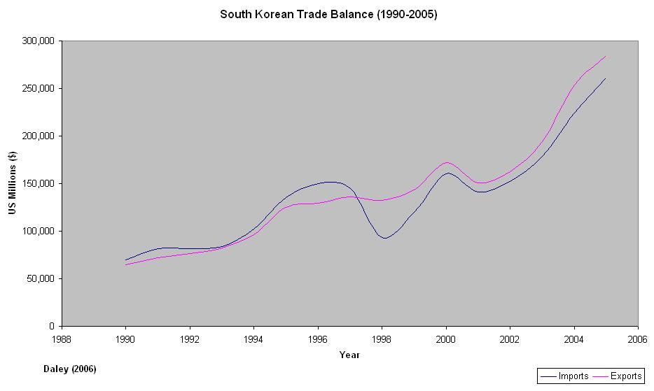

Korea is now reporting strong trade surpluses and is beginning to grow its international trade at record levels. World Bank projections for 2006-7 are unavailable at this time, but will almost certainly prescribe a similarly rosy outlook for the next few years.

As such, Korea has done an excellent job of restructuring its economy whilst saving enough to be able to report a trade surplus and a surplus of foreign reserves relative to total external debt. Much like Thailand, the future seems very bright for Korea.

Malaysia

As the only one of the four countries analysed not to have undertaken an IMF led package, it is interesting to compare the recovery of Malaysia in comparison to those who did receive IMF aid.

GDP

Despite undergoing a noticeable stagnation in 1998, Malaysia remains the only country of the four being analysed not to have reported a negative GDP figure throughout the entirety of the financial crisis, as shown below:

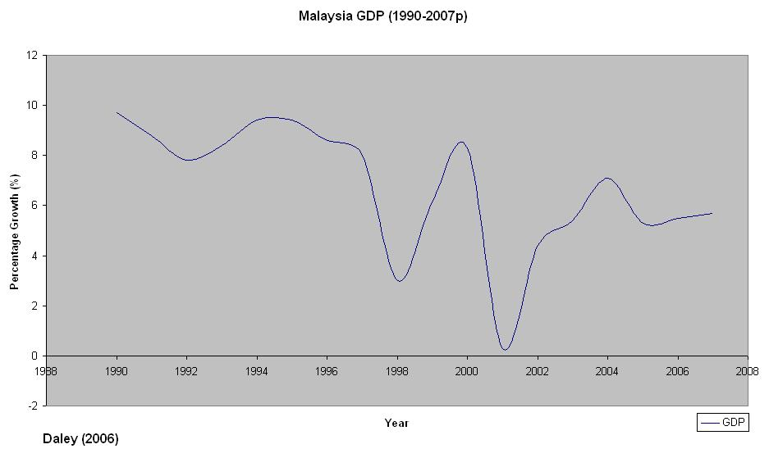

Interestingly, even at the height of the crisis in 1998, Malaysia did not suffer nearly as badly as many of the other countries involved. The country actually received its worst downturn in 2001, a full 3 years after the zenith of the crisis for most countries, a rather perplexing result when taken at face value.

A deeper look into Malaysia’s financial makeup, however, helps to explain the sudden downturn in 2001. The simple fact is that ‘The US is Malaysia’s biggest export market, especially for the electrical and electronic goods that account for around 60 percent of the country’s exports. If the US economy slows much more than envisaged, the current export-led growth momentum could be severely affected’. The terrorist attacks of 9/11 caused mayhem and panic both socially and economically within the US market, ultimately leading to a similar downturn within the Malaysian financial system, resulting in such a disappointing drop in GDP for the year.

For advocates of the Malaysian response, or indeed IMF critics, the statistics show that Malaysia was indeed correct in its course of action, and was right to resist the temptation of IMF aid packages. This argument is of course all conjecture; it is impossible to estimate how Malaysia would have recovered with an IMF led aid package, but it remains an interesting topic of debate.

The graph seems to tell its own story; Malaysia was weakened in 1998, but then bounced back in 1999 before undergoing a sharp decline in 2001. Fortunately, since then the country seems to have improved with 2007 projections of 5.7% growth underlining the successes made thus far in the rebuilding process.

Unemployment

Unemployment rates have remained almost identical since 2001. In that year the government reported that 3.7% of citizens were out of work. The figure remained at 3.5-3.6% for the next three years, showing little volatility. This shows that unemployment is not a festering problem and that it can be reasonably expected to improve slightly within the medium term.

Short-term debt as a percentage of Total external debt

As Malaysia did not accept vast loans from the International community, it’s total external debt remains relatively low and stable. Similarly, short-term debt was not as big a problem in Malaysia as it was in Thailand, Indonesia and Korea; as such it has not experienced troubles quite as sharp as these nations. The statistics for Malaysia are shown below:

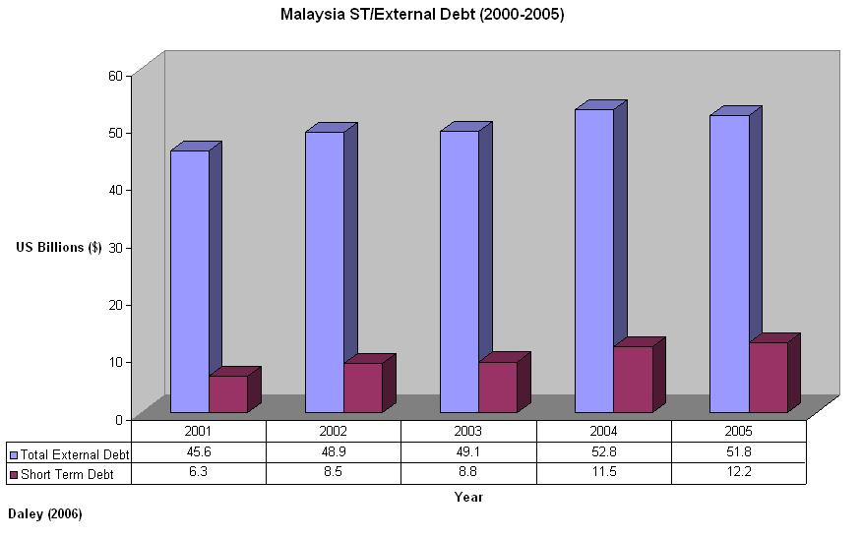

Again, the stats prove relatively worthless. Malaysia still has a vast quantity of external debt and has actually increased the ratio of short-term/long-term debt. However, given the strong economic backbone of Malaysia, the statistics are not too perturbing. Malaysia needs to decrease its external debts and the ratio of short-term to long-term debts within this field. However, given that it was the least affected of the Asian nations during the crisis, there is no immediate danger to alter these amounts, especially considering the relatively small monetary amounts being discussed.

External debt vs. foreign reserves

As already mentioned, as a by-product of turning down IMF support, Malaysia has successfully managed to keep its total external debt down to a manageable size. During the period from 1998-2006, Malaysia has also managed to increase GDP and decrease unemployment, both solid indicators of financial success for the long term. However, perhaps the most important ratio when analysing the propensity for history to repeat itself is the relation of external debt to foreign reserve capital.

Traditionally, Malaysia has performed admirably in this category, especially in relation to Korea, Indonesia and Thailand, and Indeed a look at the statistics for 2006 show an even greater improvement:

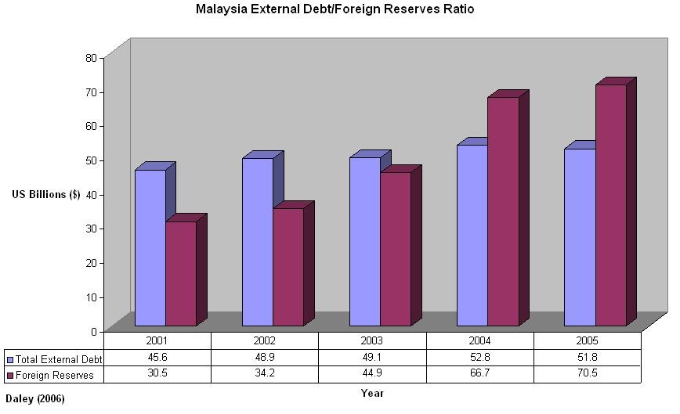

Despite starting off from a much higher level of reserves to debt than Thailand and Korea, Malaysia has successfully managed to increase total debt only incrementally, whilst managing to increase foreign reserves vastly. This has led to a significant surplus of foreign reserves that could now perhaps be reallocated to social initiatives and further economic restructuring.

Trade Balance

From 1990 to 1997, Malaysia managed its trade balance extraordinarily well. For almost every year, Malaysia managed to balance imports and exports whilst reporting marginal surpluses seemingly every other year. The results of the 1997 disaster, however, seem to have radically improved the country’s trade balance, which has grown further over the 1997-2005 period, as evidenced below:

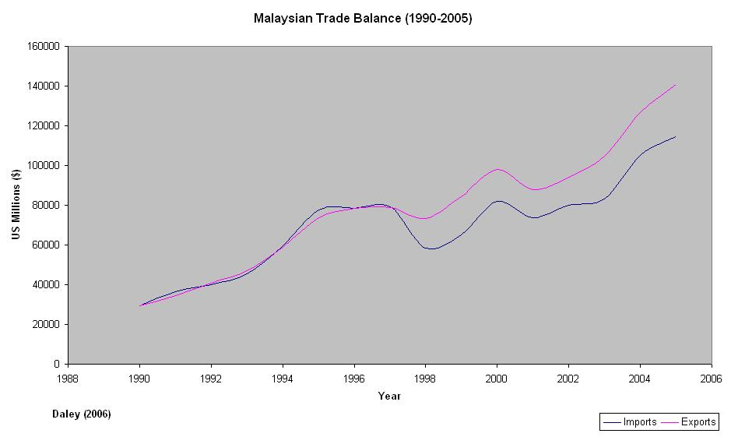

Projections for 2006 and 2007 prescribe an even brighter outlook for Malaysia – a trade surplus of $37.6bn in 2006 and over $40bn in 2007 (World Bank 2006), underlining the significant restructuring efforts of the Malaysian government from 1997 onwards.

Within the next 5 years Malaysia will begin to combat and eradicate much of its external debts leading to a more highly profitable current account and a larger balance of payments surplus than ever before. As such, from an investment standpoint, Malaysia certainly seems to be an attractive region for funding, and will continue to be so for the foreseeable future.

The Future

Having analysed the 4 major countries involved within the crisis, and their subsequent recoveries from 2000-2006, the resurgence of the region has been nothing short of excellent. Economic prospects for 2006 remain strong with 2007 projections prescribing a similarly positive outlook.

Regional GDP has grown significantly since the beginning of the crisis. Whilst the majority of Asian countries underwent negative growth in 1998, many of these nations bounced back only two years later, and have continued to do so ever since. This is shown below:

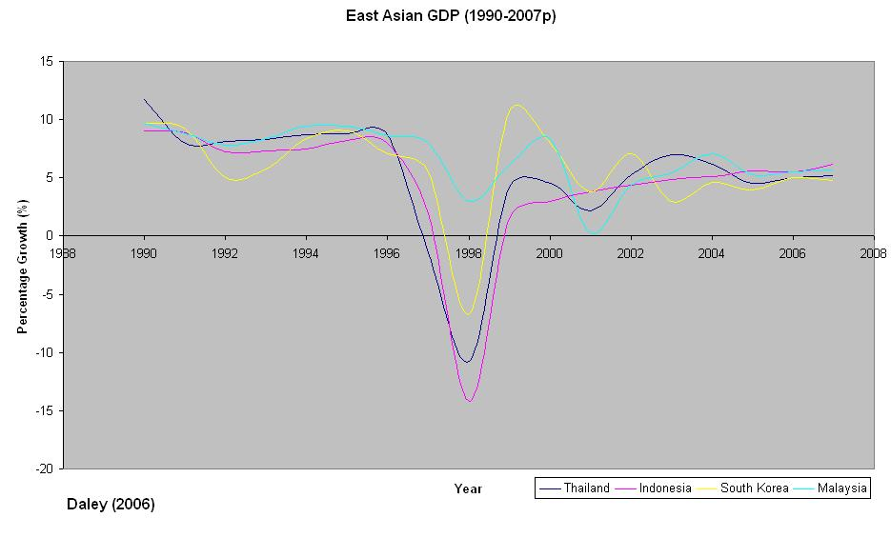

Most countries hit hard by the crisis are now reporting GDP growth of around 5% year on year, very strong results indeed. Unless another disaster should occur, regional GDP will continue to rise or remain constant for at least the next three to four years, very good news for international investors within the region.

Evidence also points to the changing shift from portfolio investment to foreign direct investment within the region. FDI in East Asian went up from $49bn in 2004 to over $77bn in 2005. At the same time, Portfolio investment has fallen by 14bn and 12bn per year over this period (World Bank 2006). Maybe these countries really are beginning to learn from their mistakes, a complete turnaround from only 9 years ago.
Trade balances have also improved markedly since 1997. Whilst most of the Tiger region reported trade deficits from 1990-1997, almost every nation is now reporting surpluses, with Malaysia reporting considerable growth within this area, as evidenced below:

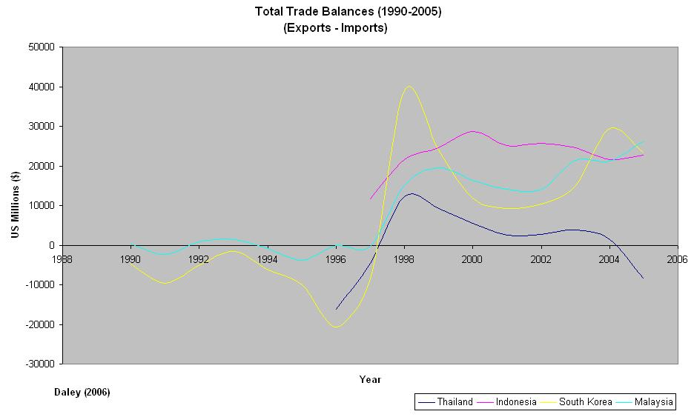

Indonesia, Korea and Malaysia have rebounded excellently since 1997. However, the same cannot be said for Thailand, who reported a trade deficit in 2005, and are likely to do so again in 2006 and 2007. Despite this, the Tiger region overall has improved its trade balance significantly from 1997 onwards.

Post-Crisis Evaluation

Having analysed and evaluated the post-crisis development of the 4 major countries involved, it is interesting to see which of the countries involved have performed best since the adoption of IMF aid plans or governmental restructuring (in the case of Malaysia). In order to evaluate this more effectively, a measurement system has been used based upon the five major areas of analysis. A scale of one to five has been used to underline the key differences within the region’s recovery since 1997, these ratings are:

- Regression
- No change
- Average recovery
- Strong recovery
- Excellent recovery

Each country has been allocated one of these ratings based upon the five key area of improvement (or regression), with a total score given. The results of which are shown below:

 | THAILAND | INDONESIA | KOREA | MALAYSIA
GDP | 4 | 4 | 4 | 3
UNEMPLOYMENT | 5 | 1 | 4 | 4
EXTERNAL/ST DEBT | 4 | 4 | 2 | 4
FOREIGN RESERVES | 5 | 2 | 5 | 5
TRADE BALANCE | 2 | 5 | 4 | 5
TOTAL | 20 | 16 | 19 | 21

As can be seen, the recoveries of the tiger nations from 1997 have been very different indeed.

GDP has improved in every country, with most growing at a strong rate. However, unemployment has varied massively between Thailand (Unemployment at 1.8%) to Indonesia (10.6%) underlining the key differences between the two country’s recoveries from 1997 till the present day.

Short-Term debt as a proportion of external debt has improved strongly in Thailand, Indonesia and Malaysia whilst Korea still has significant difficulty in combating this problem. Foreign reserves have also improved dramatically for three of the four countries (Thailand, Korea and Malaysia); however, Indonesia has not improved its foreign reserves position at all since 1997, a negative sign for the future.

Finally, every country except Thailand has managed to successfully improve its trade balance position within the past decade. In order to sustain the country’s strong growth thus far, Thailand must ensure that it increases the competitiveness of its exports and decreases its reliance upon imports within the near future.

It is interesting to note that the one country that did not receive IMF aid (Malaysia) has had the strongest recovery from the crisis, further strengthening the view that the Malaysian response to the crisis was indeed appropriate and correct.

Further recovery measurements

Yet another gauge of how regional stock markets have improved is shown below (Taken from World Bank 2006):

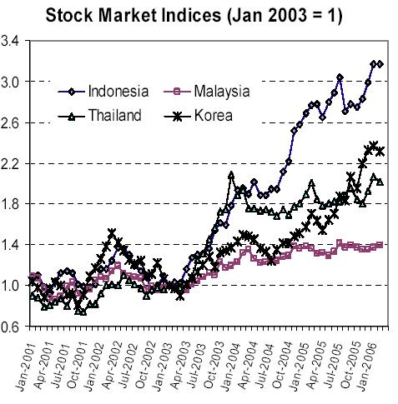

As can be seen, the stock market has increased in all four major countries being analysed, Indonesia in particular, has shown a marked improvement within this field.

Another area of improvement has been in the region’s Non Performing Loans. As discussed earlier, South Korea in particular had undergone significant restructuring in order to remove many of its misallocated projects in an attempt to reduce its numbers of NPL’s. Fortunately, the region has undergone significant changes since 1997, and is now reducing these loans at a record pace, as evidenced below (World Bank 2006):

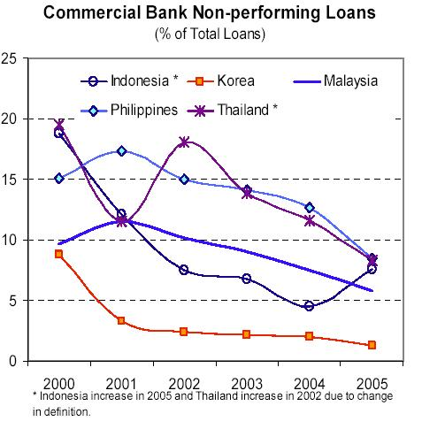

As noted earlier, foreign reserves have also largely increased within the region. Almost every single nation has now recognised the importance of having enough foreign reserves to meet external debt, and those who have not already matched or exceeded their external debt to foreign reserves ratio will begin to do so within the next 3 to 5 years. A graph underlining the sweeping changes the crisis has brought about is documented below:

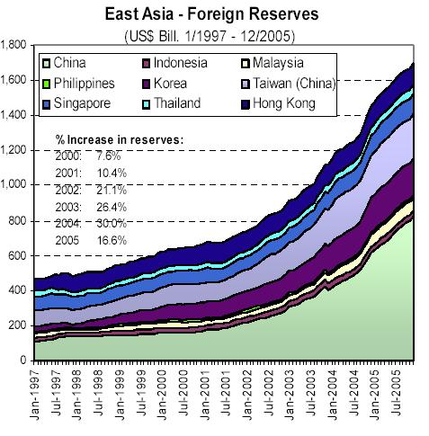

Lastly, and perhaps most importantly, the Debt to equity ratios of the region have improved immensely from 1997 to 2004 (See Graph below, World Bank 2006).

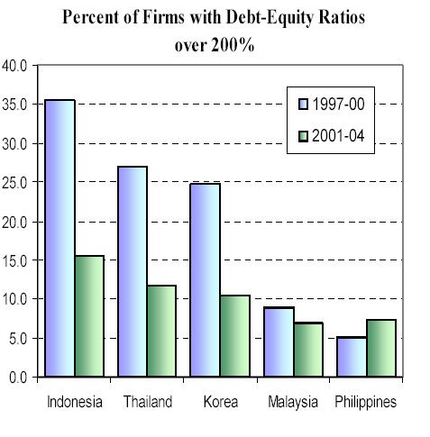
As can be seen, the 1997-2000 levels of debt-equity were far too high. The region has successfully managed to restructure itself in order to deal with this problem and has reported very robust results.

Clearly, the East Asian region has recovered excellently since 2000. Almost every measure of economic and social indicators seems to underline this fact, and the situation looks extremely bright for Asian from 2006 onwards.

In retrospect, it appears that the policies undertaken by Thailand, Korea and Indonesia and Malaysia were indeed appropriate for the medium and long-term. Malaysia did not suffer quite as acutely as many of the other countries, and simply didn’t need the full IMF package that the other parties received. Conversely, for those countries that took IMF aid, the remedy has promoted a long-term stability within the region and has facilitated the strong growth rates documented within this chapter.

The economic prospects for the region are once again strong. Only nine years after the breakdown of the region and the despair felt throughout the world, the area has managed to implement sustainable economic and social policies and has combated the root causes of the troubles in a pragmatic way. The speed at which the area has recovered has been nothing short of remarkable, and growth forecasts continue to be strong.

Could this be yet another Asian ‘miracle’?
5. The IMF: What does the future hold?

According to the majority of post-crisis opinion, not a great deal.

“I was chief economist at the World Bank from 1996 until last November, during the gravest global economic crisis in a half-century. I saw how the IMF {responded}. And I was appalled.” (Stiglitz 2000)

“Today's IMF is not likely to solve any crisis. It is more likely to cause new ones.” (Wall St Journal, 1998)

“The IMF mishandled the Russian reforms… The IMF (in common with others) failed to foresee the Mexico crisis in 1994 and the Asian crises in 1997.” (Sachs, 1997)

“The IMF is ineffective, unnecessary and obsolete…. Once the crisis is over we should abolish [them]” (Shultz, Simon and Wriston, 1998)

Pretty damning stuff, and indicative of the high pressure the IMF was under at the time. However, almost a decade on, has anything changed? Have these critics begun to rethink their initial stance on the crisis? Should the IMF really be abolished? What really is the future role of the IMF?

One of the most interesting sideshows to the crisis was the build-up of pro and anti-IMF opinion. On one-hand economists such as Stiglitz, Sachs, Feldstein et al were highly critical of the IMF and the policy ramifications they advocated. On the other hand sceptics of IMF finger pointing, such as Rudi Dornbusch, an MIT economics professor, claim that the IMF were not to blame stating that "The Asian economies [weren’t] the same as Latin America's, they were even more corrupt and wasted even more capital”.

The immediate arguments levied against the IMF were based around inappropriate policies, the IMF being too intrusive, or indeed not intrusive enough in dealing with the crisis and that the IMF, further from marginalising the crisis, actually exacerbated it. Furthermore, critics stated that the IMF was ineffective when dealing with large-scale currency crises and ill equipped to meet the growing needs of international capital markets.

Critics such as Stiglitz went even further, attacking the very fabric of the fund itself: “The older men who staff the fund--and they are overwhelmingly older men--act as if they are shouldering Rudyard Kipling's white man's burden. IMF experts believe they are brighter, more educated, and less politically motivated than the economists in the countries they visit. In fact, the economic leaders from those countries are pretty good--in many cases brighter or better educated than the IMF staff, which frequently consists of third-rank students from first-rate universities. (Trust me: I've taught at Oxford University, MIT, Stanford University, Yale University, and Princeton University, and the IMF almost never succeeded in recruiting any of the best students.)” (Stiglitz 2000)

Another criticism put forward by Stiglitz was that the Fund was not accountable to anyone but itself, and that the secrecy of the body left them fundamentally flawed when dealing with problems of any magnitude within the public domain. “Critics from the right, such as Martin Feldstein and George Shultz, joined Jeff Sachs, Paul Krugman, and me in condemning the policies. But, with the IMF insisting its policies were beyond reproach--and with no institutional structure to make it pay attention--our criticisms were of little use. More frightening, even internal critics, particularly those with direct democratic accountability, were kept in the dark.” (Stiglitz 2000)

Stiglitz was not alone. In 1998, South Korea sent a statement to the United States Secretary of Treasury, Robert Ruben stating that “The Asian Development model, while containing some of the key elements which gave rise to the current crisis, also contains the very dynamic elements which made the ‘miraculous growth’ over such a short period…. The IMF policy regime however, has overlooked… the positive and dynamic elements in its virtual blanket disavowal of the Asian economy. It may therefore be necessary for Asian nations to build a body…. Which can serve as an Asian Monetary Fund”

At the time there was a real movement towards the formation of such a fund. It was argued that the IMF was not giving enough back to Asia and that the new Fund could save the region money. The Asian Monetary Fund (AMF) would be built upon the region’s large savings surplus and a more thorough understanding of the region’s macroeconomic environment than the IMF ever hoped to offer. The Asian Monetary Fund would have core financing from subscriptions by member governments – ‘the fact that pledges of $100 billion were quickly secured in August 1997 suggests that sizeable sums would be forthcoming’ (Wade, 1999).

However, despite the plans of 1997 gaining some significance, the AMF was later quashed ‘amid US and IMF fears of the creation of an IMF counterpoint in Asia.’

This of course, led to more criticism being hurled at the IMF; not only did the Fund ‘tragically misdiagnose the initial problems in Asia’, it actively worked against the formation of a body designed to stop them ever occurring again. Or so the critics said.

However, by the start of the new millennium, things had begun to change. Many of the regional economies began to prosper again, and Asia began to slowly get back onto its feet. Critics of the IMF’s aid plans began to evaporate, the AMF was soon forgotten, as the ‘Asian miracle’ seemed right back on track.

So what are the lessons of the crisis, and how have the IMF fared?

In my opinion, the IMF got it just about right. The recovery of the region from 2000 onwards has been nothing short of remarkable, ultimately proving that the IMF plans were appropriate and correct within the medium to long term.

Critics will still point to the many errors that the IMF have made from 1997-2006 and claim that the fund has no relevance, that is it out of date, out of touch and should still be abolished. However, without the IMF could the countries involved have turned around their economies in less than a decade? In my opinion, absolutely not.

To this, critics will almost certainly point out the Malaysian response (and that according to my own ratings it has recovered more so than any other East Asian nation), however, the problems were so very different in Malaysia that a comparison based solely upon my ratings is not a fair indication of country-by-country growth. In any case, each of the other three countries (with the possible exception of Indonesia) have recovered excellently since 2000, as the IMF’s plans have finally come to fruition.

The IMF was, and still is, an easy target to criticise. Much like the WTO were blamed for the breakdown of the Doha convention in 2002, the IMF has been blamed for seemingly everything that went wrong from 1994-2002. The true fact of the matter is that if the IMF did not exist, the Asian region would be in a much worse situation that it finds itself today.

As the de facto manager of the global economy, the IMF is under immense pressure to achieve results first time, all the time. This is not always possible, and when it is not, a flurry of academics and economists rush to take sides against the fund. Criticism is seemingly ubiquitous for the IMF, yet despite hundreds of papers attacking the fund’s stance in 1997 (and very few advocating a similar aid package), the results speak for themselves.

East Asia is now back on track, with unemployment down, GDP rising and large-scale trade surpluses, the future is very bright. The IMF has played a key role in the restructuring and development of the region and in my opinion, deserves many of the plaudits for the whirlwind turnaround that has occurred. Far from being rendered obsolete, the Fund has now cemented its role as the global economy body and should now build upon its achievements within Asia and continue to prescribe sound economic and social policies irrespective of the misplaced criticism prevalent during the 1997-1999 years.

Website References

General

- http://www.sunsonline.org/trade/other/martinAsia1.htm
- http://en.wikipedia.org/wiki/Asian_financial_crisis
- http://www.federalreserve.gov/boarddocs/testimony/19971113.htm
- http://newton.uor.edu/departments&programs/AsianStudiesdept/general-crisis.html
- http://www.pbs.org/wgbh/pages/frontline/shows/crash/
- http://www.worldbank.org/knowledge/chiefecon/articles/wea21/index.htm
- http://www.mala.bc.ca/~soules/media301/globe04/nelson.htm
- http://www.j-bradford-delong.net/Comments/East_Asia_Limits.html
- http://www.globalpolicy.org/socecon/bwi-wto/stiglitz.htm
- http://www.imf.org/external/pubs/ft/fandd/1998/06/imfstaff.htm
- http://www.j-bradford-delong.net/Comments/Tyson_teachin.html
- http://www.fas.org/man/crs/crs-asia2.htm
- http://hir.harvard.edu/articles/892/

USA

- http://secretary.state.gov/www/statements/1998/980201b.html
- http://web.worldbank.org/WBSITE/EXTERNAL/COUNTRIES/EASTASIAPACIFICEXT/EXTEAPHALFYEARLYUPDATE/0,,menuPK:550232~pagePK:64168427~piPK:64168435~theSitePK:550226,00.html

IMF

- http://www.imf.org//np/speeches/1998/012198A.HTM
- http://www.imf.org//np/speeches/1998/012298.HTM
- http://www.imf.org//np/speeches/1998/021398.HTM
- http://www.imf.org//np/speeches/1998/030698.HTM
- http://www.imf.org//np/speeches/1998/040298.HTM
- http://www.imf.org//np/speeches/1998/050498A.HTM
- http://www.imf.org//np/speeches/1998/061998.HTM
- http://www.imf.org//np/speeches/1998/062398A.HTM

Anti-IMF

- http://www.imfsite.org/recentfin/crisis.html
- http://www.ifg.org/imf_asia.html
- http://www.mtholyoke.edu/acad/intrel/usimf.htm
- http://www.wsws.org/articles/1999/oct1999/econ-o23.shtml
- http://www.mindfully.org/WTO/Joseph-Stiglitz-IMF17apr00.htm
- http://www.brettonwoodsproject.org/art.shtml?x=15742
- http://www.twnside.org.sg/title/sick-cn.htm
- http://www.bos.frb.org/economic/nerr/rr1998/q2/litt98_2.htm
- http://hir.harvard.edu/articles/892/

Singapore

- http://www.mas.gov.sg/resource/download/Present4_files/v3_document.html

Thailand

- http://www.shaps.hawaii.edu/fp/asean/fm02.html

Hong Kong

- http://www.info.gov.hk/hkma/eng/speeches/speechs/david/speech_280598b.htm
- http://www.info.gov.hk/hkma/eng/speeches/speechs/joseph/speech_160699b.htm
- http://archive.salon.com/news/feature/2000/04/18/imf_fightclub/print.html

Bibliography

- Bensaid, B. and O. Jeanne (1997) – The instability of fixed exchange rate systems when raising the nominal interest rate is costly, European Economic Review, Vol 41, No. 8, pp. 1461-1478.

- Bullard, Nicola et al (2000) – Taming the tigers – The IMF and the Asian Crisis, Focus on the Global South and CAFOD economic reports.

- Butler, Steven (1997) – ‘It was too easy to make money’, US News and World Report, July 28, p.42.

- Calvo, Sara and Carmen Reinhart (1996) – Capital Flows to Latin America: Is there evidence of Contagion? In Private capital flows to emerging economies after the Mexican crisis, ed. By Guillermo Calvo, Morris Goldstein and Eduardo Hochreiter. Washington Institute for International Economics.

- Campos, Jose Edgardo, and Root, Hilton L. (1997) – The Key to the Asian miracle: Making shared growth credible, Washington D.C., Brookings Institution.

- Chowhury, Neel and Anthony Paul (1997) – Where Asia goes from here, Fortune 24, November.

- Dziobek, Claudia and Ceyla Pazarbasioglu (1997) – Lessons from systemic bank restructuring: A survey of 24 countries, IMF working paper No. 97/161, Washington: International Monetary Fund (December)

- Farrow, Maureen A. (1997) – Asia Unravels, Investment research, Toronto: Loewen, Ontdaatje, McCutcheon Limited.
- Feldstein, Martin (1998) – Refocusing the IMF, Foreign Affairs (February).

- Goldstein, Morris and John Hawkins (1998) – The origins of the Asian Financial Turmoil, Reserve Bank of Australia Research discussion Paper 980, Sydney Reserve Bank of Australia (May).

- Goldstein, Morris (1998) – The Asian Financial Crisis: Causes, Cures and Systemic implications, Institute for International Economics, Washington D.C.

- Griffith-Jones, Stephany, Jaques Cailloux and Stephan Pfaffenzeller (1998) – The East Asian Financial Crisis: A Reflection on its Causes, Consequences and Policy Implications. Institute of Development Studies, University of Sussex.

- Islam, Azizul (1999) – The Dynamics of Asian economic crisis and selected policy implications, United Nations Economic Commission for Asia and the Pacific, UNU Policy perspectives No.2, pp 49-74, United Nations University Press.

- Ito, Takatoshi (1997) – What can developing countries learn from East Asia’s growth? Annual World Bank Conference on Development Economics, p. 193-200.

- Ito, Takatoshi and Luiz Pereira Da Silva (1999) – The credit crunch in Thailand during the 1997-98 crisis. Theoretical and Operational Issues of the JEXIM Survey. EXIM review (19) 2: 1-40.

- Ito, Takatoshi (2000) – Growth, Crisis and the future of economic recovery in East Asia, The International Bank for Reconstruction and Development, Oxford University Press.

- Jomo, K.S (2000) – Crisis and the developmental state in East Asia, Routledge.

- Khoman, Sirilaksana (2000) – The Asian Financial Crisis and Prospects for Trade and Business with Thailand, Macmillan press.

- Krugman, Paul (1994) - The Myth of Asia’s Miracle, MIT press.

- Lau, L.J and Park, J. S (1995) – Is there a next Mexico in East Asia? Project LINK, World Meeting, Pretoria, South Africa, 1995.

- Lau, L.J (2000) – The East Asian crisis: A retrospective look, Dept of Economics, Stanford University, USA.

- McLeod and Garnaut (1998) – East Asia in Crisis: From being a miracle to needing one, Routledge.

- Perry, Guillermo and Daniel Lederman (1998) – Financial vulnerability, Spill over effects and Contagion: Lessons from the Asian Crisis for the Latin American and Caribbean regions. Washington, World Bank.

- Radelet, Steven and Jeffrey Sachs (1998) – The Onset of the Asian Financial crisis, Cambridge MA, Harvard Institute for International Development (February).

- Robison, Richard et al (2001) – Politics and Markets in the wake of the Asian Crisis, Routledge, London.

- Sachs, Jeffrey (1997) – Power Unto Itself, Financial Times (11 December)

- Shiraishi, Takashi (2005) – The Asian crisis reconsidered, RIETI Discussion Paper Series 05-E-014, Centre for Southeast Asian studies, Kyoto University, Japan.

- Shultz, George, William Simon and Walter Wriston (1998) – Who needs the IMF? Wall Street Journal (3 February).

- Stiglitz, Joseph (1998) – Macroeconomic dimensions of the East Asian crisis. In Financial Crises and Asia, ed. By Robert Chote. London: Centre for Economic Policy research.

- Stiglitz, Joseph (2000) – The Insider: What I learned at the World Economic Crisis, The New Republic 17th April 2000.

- Wade, Robert (1999) – Discussion: Asia, in Global Financial Turmoil and Reform, ed. by Barry Herman, United Nations University Press, 1999.

- Wall St Journal (1998) – Editorial: The IMF Crisis, Wall St Journal, 15th April 1998.

- Winters, Jeffrey (2000) – The financial crisis in Southeast Asia, Routledge, London, pp.44-50.

- World Bank (1993) – The East Asian Miracle: Economic Growth and Public Policy, New York, Oxford University Press.

- World Bank (2006) – East Asia Update: Solid Growth, New Challenges, March.
Appendix A: Project Self-Assessment

1. Quality of the Project

The objective of this project was to analyse and evaluate the recovery (or lack thereof) of four of the major countries involved in the Asian financial crisis of 1997. I feel like I have met, and exceeded the remit of the project, with especial regard to the objective data used (to document the recovery of the region from 2000-2006) to formulate my opinions. I feel that I have used a wide range of subjective opinion and have assimilated both data types effectively in order to reach conclusions that may not have been as easily made without such work.

From the beginning of my project, I decided to tackle the nature of the topic head on and write in a style that suits my personality. In doing so I hope to have created a project that is both readable and academically sound. I have aped many traditional PhD style references, and the structure of my work is largely set out in this manner. I have read many different books and papers and feel like my work has improved because of this. I have also spent hours sifting through a multitude of web pages (some of which were of no use) in order to supplement much of the material I have gained through more traditional means (i.e. books and papers from the library).

I am particularly proud of my research findings from 2000-2006. Finding detailed statistical information for this period was not an easy task, and collating the information from disparate sources, and then into graphical format was very time consuming. However, I feel like my research has unearthed key trends that (as far as I am aware) have not yet been analysed anywhere. As such, I feel that I have added to the research community, hopefully leading to further study within the topic area.

I have enjoyed the topic and nature of the Asian financial crisis and can only hope that this shows within my work.

2. Personal Development

The duration of the project has been arduous and time consuming, but has taught me that within a relatively short space of time, real research can be undertaken and good work can be achieved.

From a personal standpoint, the project has augmented my economics knowledge and reinforced my interest in the subject. I am now considering studying for a PhD in International Trade, with special relevance to Asian economics from the 1980s onwards.

3. Project Management

WEEKS | [1-2] | [3-4] | [5-6] | [7-8] | [9-10] | [11-12] | [12+]
Period Start Date(s) | 16/06/2006 | 30/06/2006 | 14/07/2006 | 28/07/2006 | 11/08/2006 | 25/08/2006 | 06/09/2006
Assimilation of sources
Introduction to project
Stage 1: Prevailing market conditions
Stage 2: How did the crisis begin
Stage 3: Why did the IMF intervene
Stage 4: ST effects
Stage 5: Analysis of ST effects
Stage 6: LT effects
Stage 7: Analysis of LT effects
Stage 8: Conclusion
Stage 9: The Future: The IMF's role
Stage 10: References and Bibliography
Stage 11: Presentation
 |  | No task undertaken/task finished
 |  | Task being undertaken
Management of the project has largely been good. I have kept an up-to-date record of all of my achievements and findings in a log-book, including many library book references, plans for different chapters and many website references that I later used as part of my paper. I met with my project supervisor on a weekly basis and discussed much of the theoretical basis of the project with him. My prototype schedule is shown below:

As the project began to flow, I began to adopt a different approach to that of my progress schedule. As such, my weekly schedule was slightly different to the one I had planned. Referencing and a Bibliography was undertaken on a week by week basis, and I managed to fill a lot of objective work into a short period of time from weeks 11-12. Otherwise the schedule remained relatively on course, and I feel my time management skills were strong throughout the duration of my project.

4. Progress Impediments

Logistically, I feel that I had sufficient time, material and wherewithal to complete the project to my best ability. I managed to take 12 books out from the University library, and many of these were highly useful when analysing divergent opinions. However, when analysing the recovery of the Tiger nations from 2000-2006, I found very few sources of information. This is largely based around the fact that there has been very little research work undertaken into the longer-term effects of the crisis. I hope that my paper may potentially be used in future for other students and academics to utilise in order to build upon my findings.

Overall I feel like I have delivered a solid project offering diverse opinion from many of the world’s greatest academics whilst still being able to add my own thoughts, untainted by bias of any kind. I have enjoyed the project and the discussions emanating from many of the topics of discussion with my supervisor, fellow students and members of my family. I hope that my project remains interesting to read and that further work is undertaken to build upon the findings I have made.

Krugman, Paul (1994) – The Myths of Asia’s miracle – Online version: http://web.mit.edu/krugman/www/myth.html
http://www.pbs.org/wgbh/pages/frontline/shows/crash/interviews/johnson.html
Timeline and quotes taken from http://www.pbs.org/wgbh/pages/frontline/shows/crash/etc/cron.html
Statistics for this graph (and for every other hereafter) are taken from http://www.imf.org/external/np/sec/pn/2000/pn00110.htm, Estimates and Projections taken from World Bank (2006), other statistics taken from McLeod and Garnaut (1998)
1996-2000 data taken from http://www.adb.org/Documents/CERs/THA/2001/Tha_cer104.asp, 2001-2005 data assimilated from World Bank (2006)
Data for 1997-2000 taken from http://www.adb.org/Documents/CERs/INO/2003/ino0106.asp, 2001-2005 Data taken from World Bank (2006)
Mercantilism is the 18th century notion of gaining wealth through the expansion of exports and the contraction of imports, leading to a trade balance surplus.
Press release given on 22nd June 2006 - http://www.imf.org/external/np/sec/pr/2006/pr06139.htm
Trade data from 1990-2000 taken from Korean Statistical Information System - http://kosis.nso.go.kr/eng/index.htm, 2001-2005 data taken from World Bank (2006)
Taken from http://www.adb.org/Documents/Books/ADO/2001/mal.asp in 2001
Data taken from World Bank (2006)
Data for Thailand and Indonesia was unavailable from 1990-1997; as such these entries remain blank with a post 1996 statistical interpretation offered.
“The KCTU proposal”, document presented at KCTU-FKTU meeting with the United States Treasury Secretary Rubin, 1st July 1998.
http://www.brettonwoodsproject.org/art.shtml?x=236006

