Philip Lee

Alchemy was the process of turning base metals, such as iron, into such precious metals, like gold and silver. Alchemy was also used to create potions to heal those of disease, and tinctures, to magically imbue armor with special powers. Alchemists were usually priests, that worked by involving the Christian religion with their science. Alchemists believed that everything in nature was composed of various "elements," these being: iron, lead, water, smoke, straw, bacon, nuns and condiments. Each of these elements, they thought, could be transformed into gold simply by dipping it into a complicated solution of animal secretions. The most sought transmutation of all alchemists was the Philosopher’s Stone, which could bring immortality, change base metals, and cure disease. Humans were considered to be made up of four "humors" or "fluids" which, when balanced properly, kept the person alive quite nicely. If they were out of balance, the unthinkable would happen.
Blood: Blood was considered the fluid of happiness.
Bile: Bile, as the term today even implies, controlled anger. An overflowing amount of bile caused tantrums, angry fits, rag Alchemists were usually priests, that worked by involving the Christian religion with their sciences, jealousy and other defects.
Phlegm: Phlegm was the fluid of lethargy. It was thought to be the thickest, slowest humor and therefore related to indolence, lethargy, and slowness.
Black Bile: Black bile caused depression. It competed with Blood for the stability of the person's general demeanor
Understandably, the study of alchemy was abandoned early in the Middle Ages because no one could stand the smell of the laboratories, and was not resumed again until the Mongols and Arabs had discovered it, and when finally Renaissance scientists invented nose plugs.

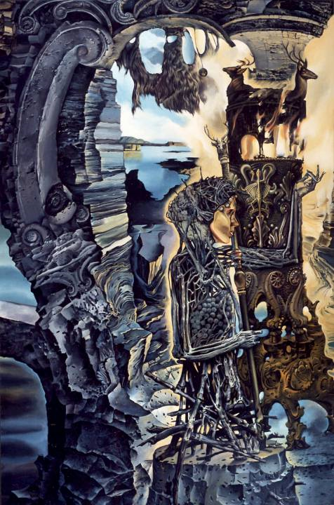

Philip Lee
Works Cited

Renaissance Alchemy. 5 April 2005. <http://www.crystalinks.com/alchemy.html>

Alchemy. 5 April 2005. http://www.tesarta.com/www/resources/library/alchemy.html

Medieval Latin Science: Alchemy. 5 April 2005. <http://web.bilkent.edu.tr/Online/www.english.upenn.edu/jlynch/Frank/Contexts/alchemy.htm>l

