- Insert the Oracle 8i CD into your CD drive. After a few seconds, you should select Install/Deinstall products from the following screen:

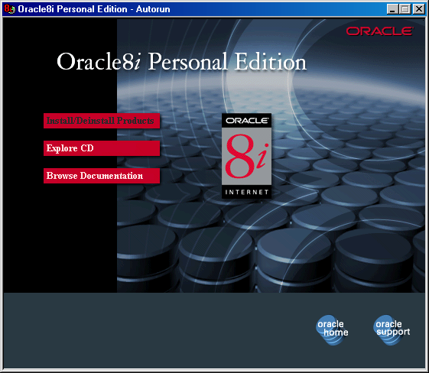
- You should now select the Next tab from the following screen:

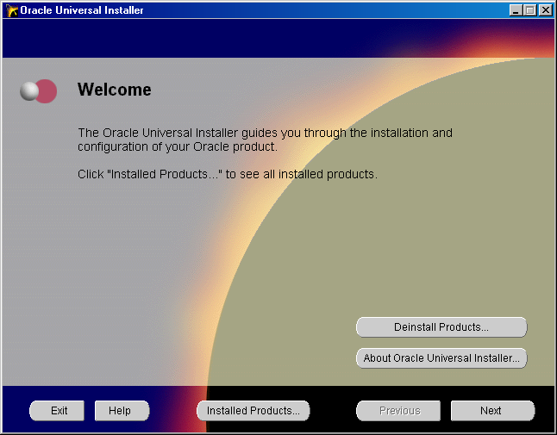

- Which will progress you to the following screen, where you should select the Next tab, as everything should be OK. The only change you might need to make is changing your CD Drive letter to something other than D:

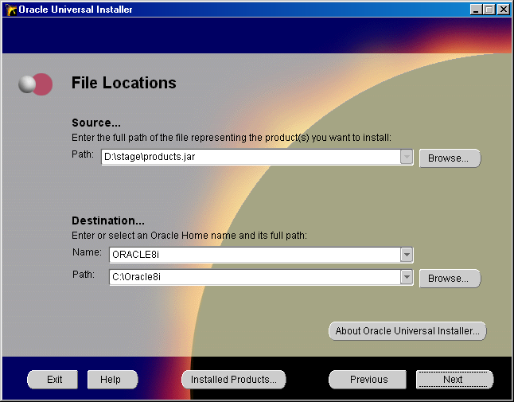
- On the next screen (after a window appears for a few moments and loads product information), once again, click on the Next tab, as we are going to perform a Typical Installation.

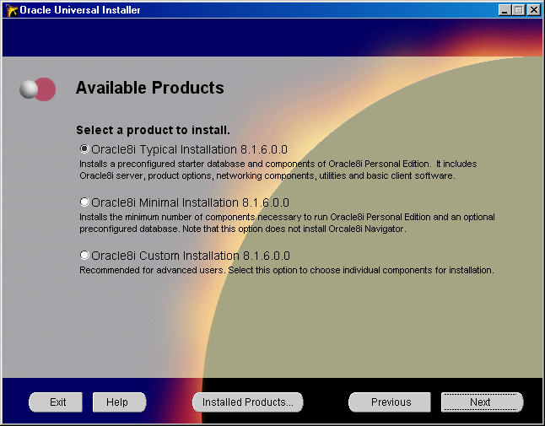
- On the next screen (After yet another pause for the Oracle Installer to gather some information), you are going to enter the Global Database Name, and the SID (Yes, you’ll learn more about these in the DBA Class starting on September 25, so be patient). For our database, call it ORCL, by entering ORCL in the Global Database Name field (Don’t bather entering a domain name, that doesn’t concern us). Notice that this will be duplicated in the SID field, which is perfectly fine. Once done, press the Next tab to continue.

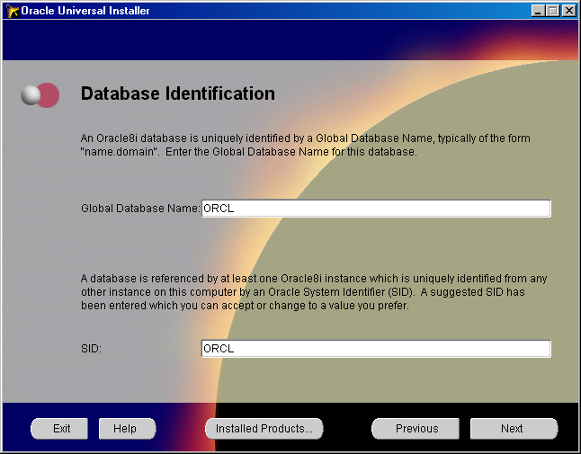

- After another brief pause, you’re presented with a long list of things for Oracle to install. Everything is going as planned, so click on the Install tab to start the actual installation. Feel free to look at the list of components being installed, we’ll be talking about some of them in a few weeks.

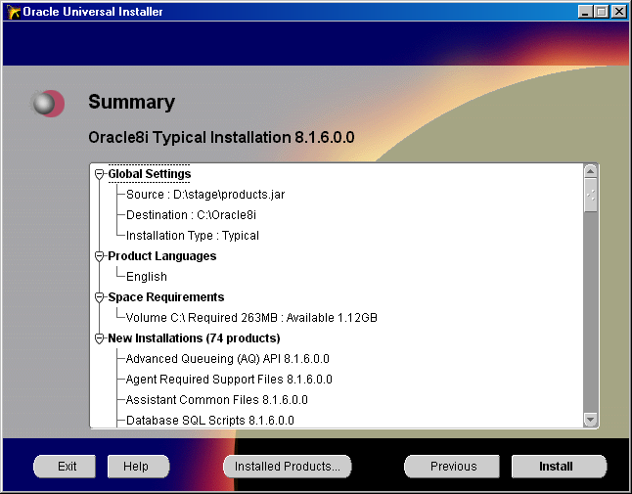
- Your CD drive should be whirring, and your hard drive light should be active, letting you know that files are being written to your hard drive. At this point and time, remember that patience is a virtue. On my setup, which is a 500 Mhz. Pentium III, 128 Mb. RAM, 13 Gb. Hard disk drive (Only 2.1 Gb. Free, thanks to Napster), the process took about 25 minutes.

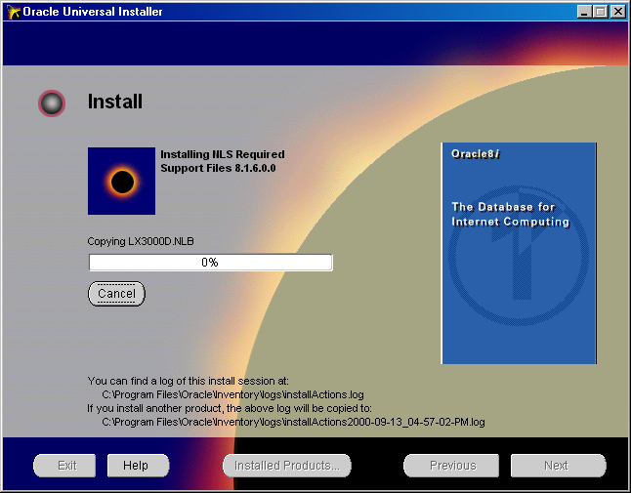
- Once all files are installed, a Database Creation process is started. This process is essentially copying some files from your CD, and creating a database for you with the name you specified (ORCL), and running several scripts against the new database.

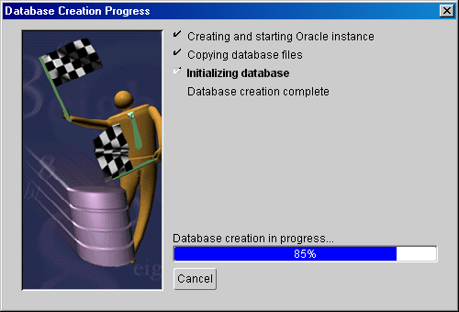

- After the database has been created, you are presented with important username and password information concerning your database. Write this information down, and click on OK to continue(These will make much more sense once we start the Database Administration class).

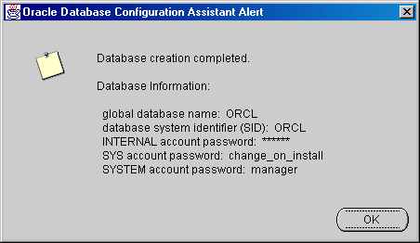
- Congratulations. You’ve created an Oracle RDBMS. As you’ll notice, you’ll need to press the Exit tab, and reboot your computer for the installation to be 100% complete. Also, don’t forget to reboot your computer.

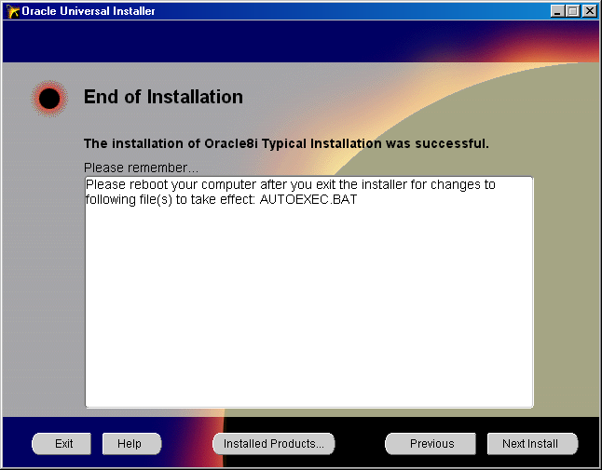
- After we’ve exited the Oracle Installer, and rebooted our computer, let’s see if we can log into Oracle. You’ll first need to start the database before you can access it, and don’t forget to shut it down before you shutdown your computer. Start the database by accessing Programs -> Oracle 8i -> Database Administration ->Start database.
You should see the screen below, and you should also see the Oracle Database icon (Stacked blue disks) in your system tray (Near the time, in the very lower right hand corner of your display). Click on OK to continue.

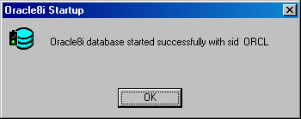

- Now, let’s see if we can access our database. Let’s log into Sql*Plus. You start Sql*Plus by accessing Programs->Oracle 8i ->Application Development -> Sql*Plus. In a few seconds, you are presented with a login screen. Most Oracle databases have a user named Scott, with a password of Tiger, so log into the database with the information below. Leave the Host string fields empty, as we haven’t defined a listener for this database, but an entry in the system registry will point Sql*Plus to the proper database.

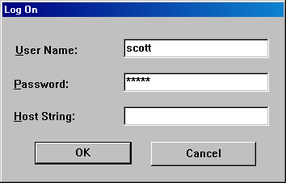

- Within a few seconds, you will be connected to the database, and you can now perform some of the SQL magic we’ve covered in class.

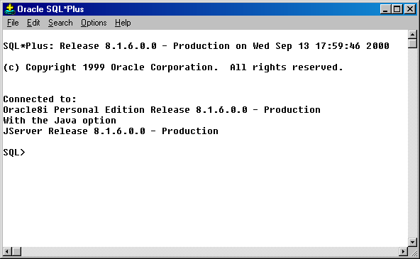

- Don’t forget to shut down your Oracle database before shutting down your computer. Programs -> Oracle 8i -> Database Administration -> Stop database does the trick.

