- Click on the link below, and save the file (crttables.sql) somewhere on your hard drive. Remember where you put this file, you’ll need that information in a few minutes.
Click here to download crttables.sql, and save as on your hard drive (Save the file to the C:\Oracle8i subdirectory).

- Login into SQL*Plus, using username scott, password tiger, and leaving the host string blank. Make sure you’re started your database first, otherwise, you won’t be able to connect, and you’ll receive a TNS error. Remember, you can start your database by accessing Programs -> Oracle 8i -> Database Administration -> Start database.
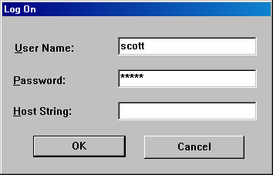

- Once you’re logged into Oracle, from the SQL*Plus prompt, you’ll need to remember where you saved the crttables.sql file. From within SQL*Plus, enter @C:\{Subdirectory where you saved the crttables.sql file}\crttables.sql to execute the script, as shown below (In the example below, I saved the script to the C:\Oracle8i subdirectory):
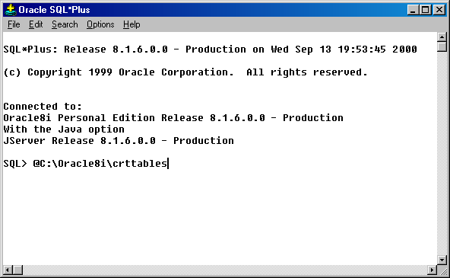
- In a few minutes (OK, probably about 30 seconds), your tables will be created, and populated with data, identical to those tables and data used during the class. To verify everything went as expected, perform the following to verify the EMP table contains 14 records:
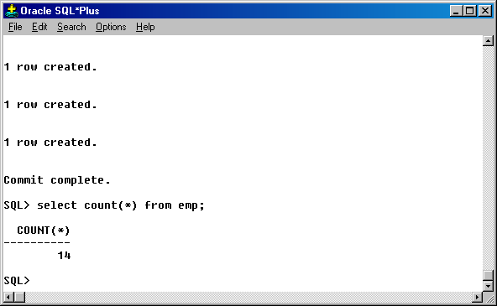

- You are now ready to use the exact tables we use in class for practice, or to reinforce some of the lessons we’ve covered. Have fun,

