Look at LUCKY
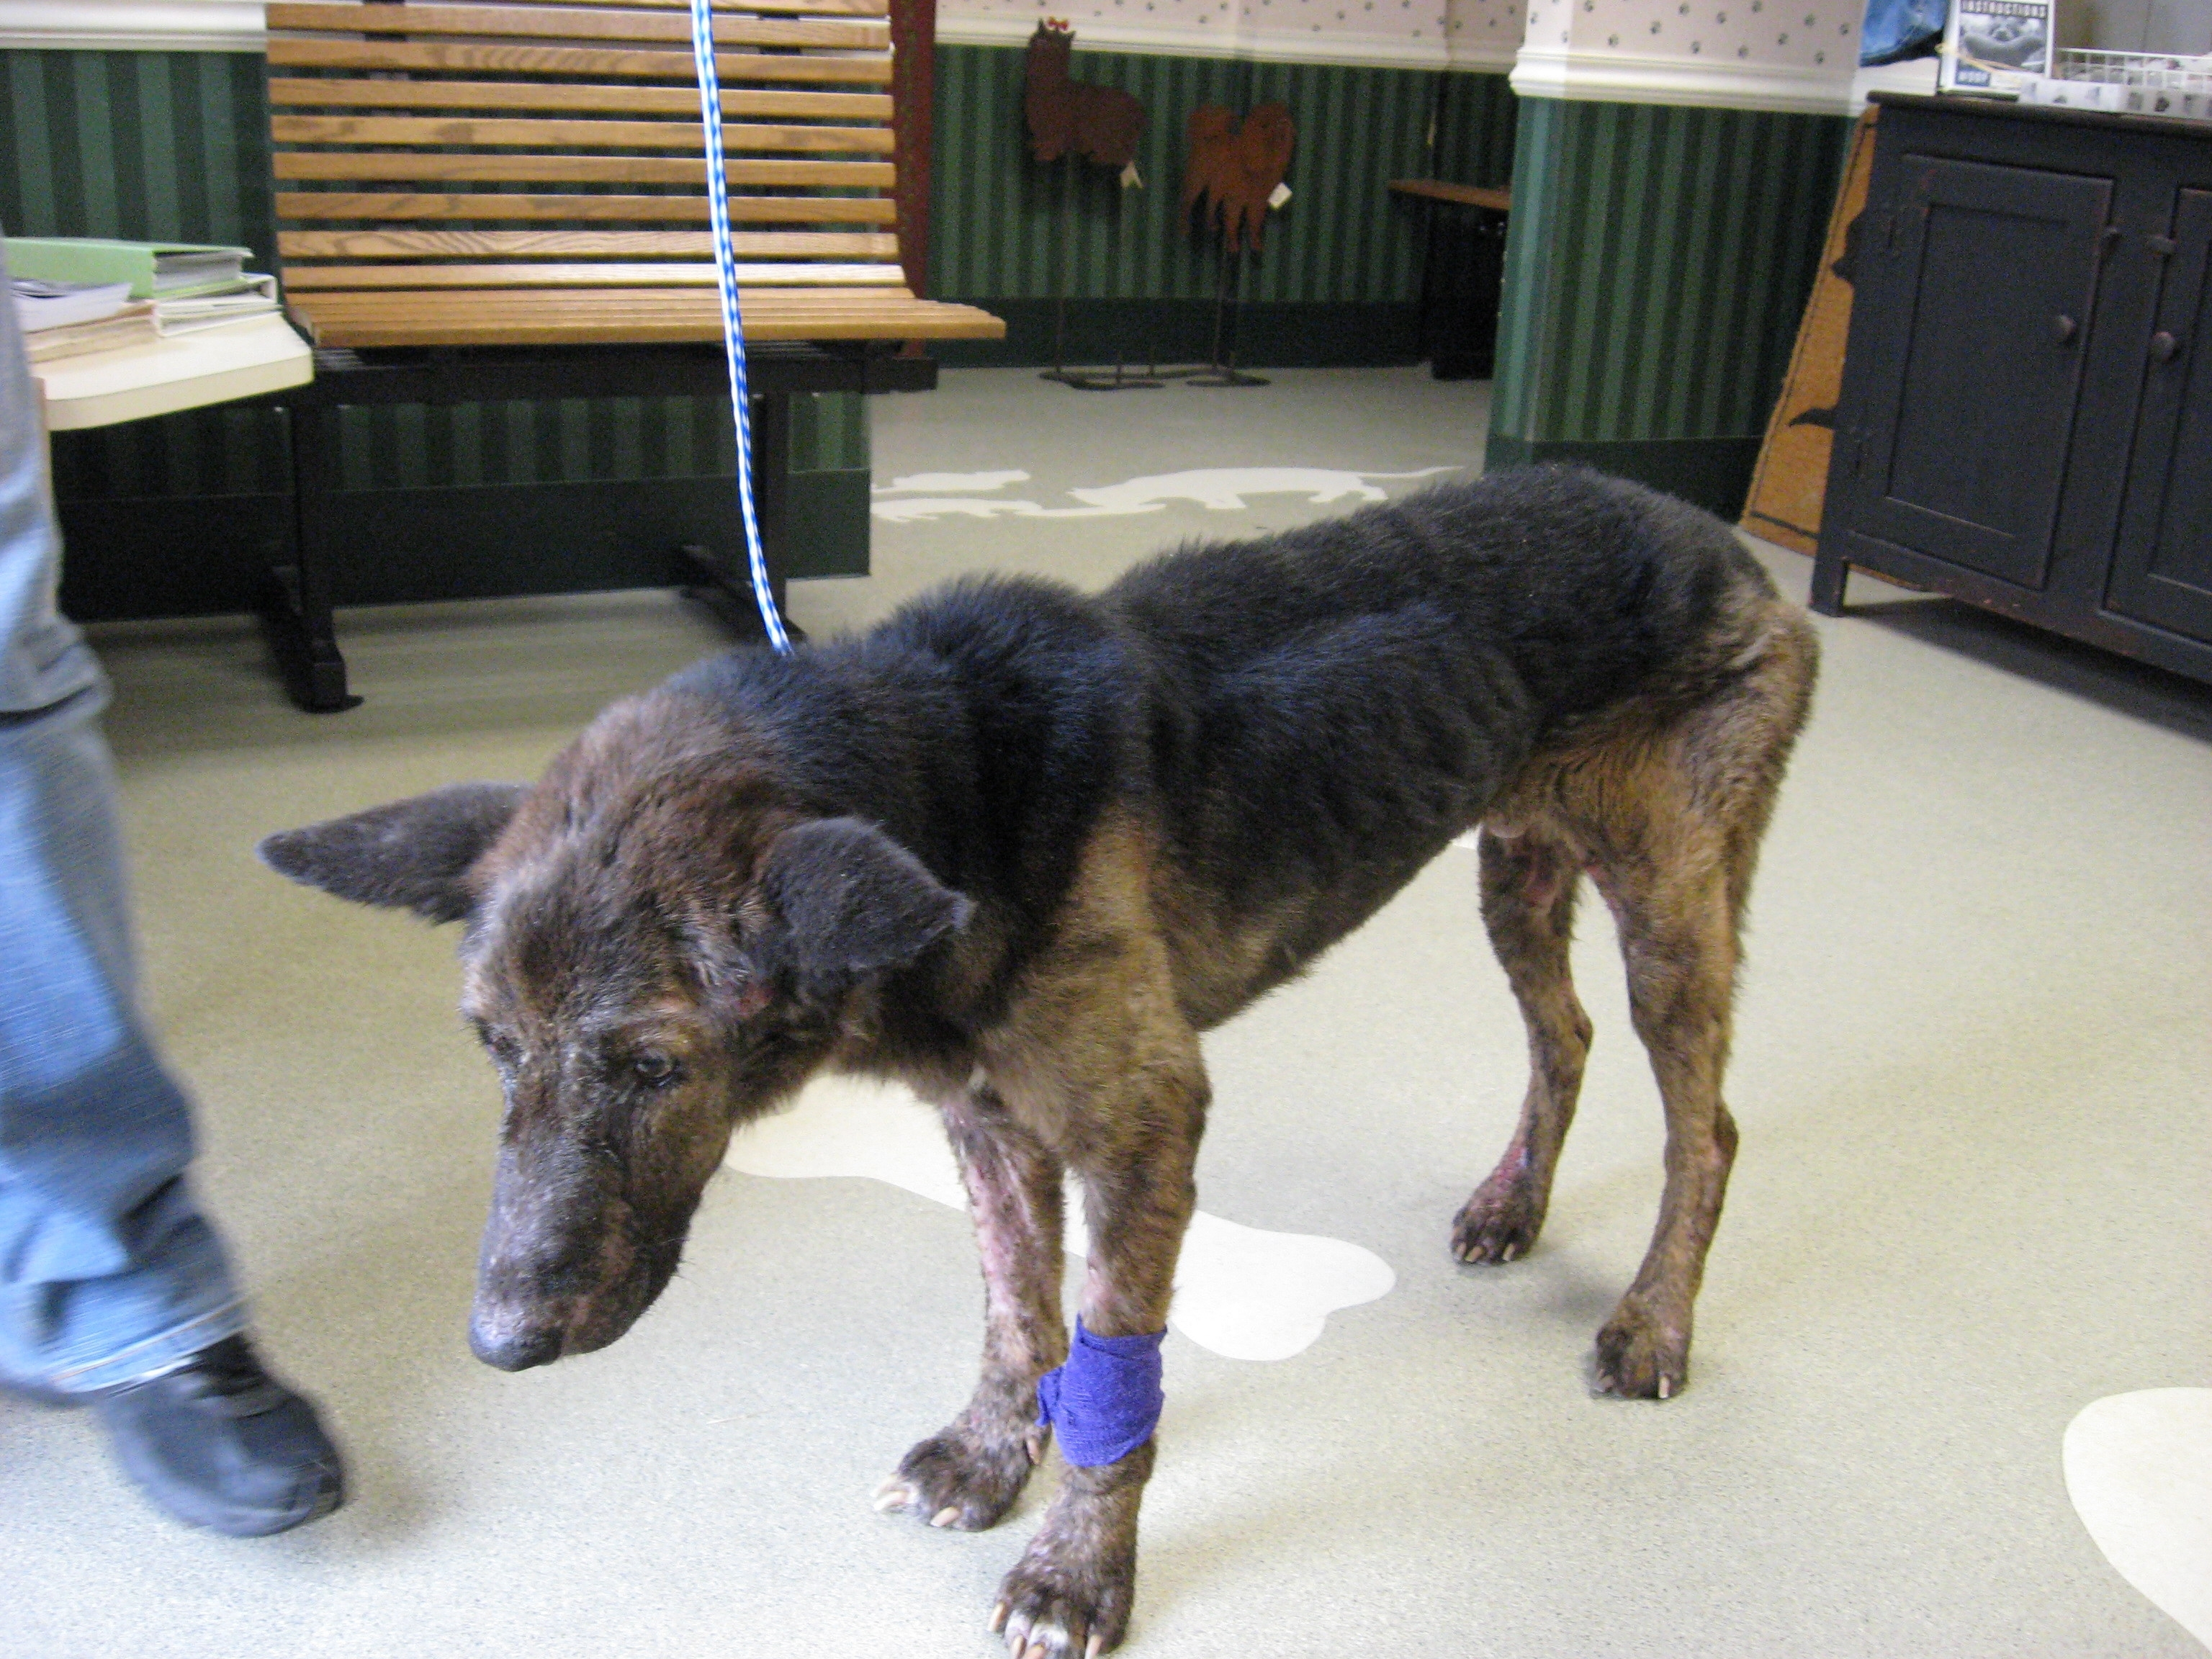
This boy was found in Trader Joe’s parking lot in Westport. Look at this guy….. how sad he looks to have been abandoned at his age. Just put out on the streets! The dog was found weighing just 27 pounds. He’s a very sweet dog and is still a bit unstable on his paws but hopefully he will build up strength.
His current medical bills are $1300 and the overnight stay at the emergency vets is another $700 so we’re up to $2000.
Please send your tax deductible donation to New Leash On Life, P.O. Box 171 Stratford, CT 06615 and together we can help Lucky recover and know love again.

