Keep in mind we pack in and out everything we need, so on this hike, lightweight gear pays off handsomely!

Weather: avg. inner canyon temps: high 55º, low 35º, but be prepared for lows of 15º, highs of 70^{o *}
Schedule and Travel Info/ Arrivals/Departures
Friday | Dec 26 | Arrival Day  Bob & Matt fly Loveland to Vegas
Saturday | Dec 27 | Hike In, to Bright Anglel Camground
Sunday | Dec 28 | Hike to Indian Garden Campground
Monday | Dec 29 | Hike Out
Tuesday | Dec 30 | Departure Day / Travel back

Meals (Green meals are on the trail)
Friday Supper
Saturday Breakfast | Hikers breakfast with "rimmers"
Saturday Lunch
Saturday Supper
Sunday Breakfast
Sunday Lunch
Sunday Supper
Monday Breakfast
Monday Lunch
Monday Supper | Hikers back for supper with "rimmers"
Tuesday Breakfast

Group packing list (things we’ll have shared within the group)
Item | Comments | Who’s bringing it
Navigational Stuff
Map of itinerary with water sources | One for each hiker | Jim
Moleskin
Water filter | Need at least two | Sturms  Dale
Water treatment tablets | Sturms have some
Cook stoves | Need at least three | Sturms  Dale
Cooking pots and pans
Hot drink cups
Plate/Soup bowl type for eating
Small scubbing pad |  | Sturms
Toilet Trowels |  | Sturms - 2
First Aid Kit | Need at least two | Sturms
Compass |  | Sturms
GPS |  | Dale
Tents | Enough for all hikers | Sturm - sm 2 man  Sturm - 2 man  Dale - 2 - 2 man  Dale - buying 3rd 2 man
Ground cloths | Are these worth the weight?
Sleeping bags | should be for as low as 15º; so 0º bag or you can make combo of bag + fleece blanket, or bag + warm dry xtra clothes | Dale - covered
Mattress pad | This is a trade off between weight and sleeping well enough to enjoy the hike... | Who has extras?
Stuff to bring and disperse at rim:
water
gatoraide
high energy food
salt
lunch food
salty snacks
empty re-sealable bags for trash
matches
toilet paper
trash bags

Individual packing list (each hiker needs to get a hold of these, but ask around/share...)
Item |  | Comments
"The Ten Essentials"
1. Navigation -- Map, compass, GPS |  | (this is needed by group, not all)
2. Hydration --
3. Nutrition
4. Sun protection -- sunscreen, sunglasses, hat, lip balm |  | (some of this can be shared)
5. Insulation -- hat & gloves, jacket, layers
6. Warmth -- lighter/matches; stoves & fuel
7. Illumination -- headlamp, flashlt, batt.
8. First Aid -- bandages, knife, medicine, duct tape, zip ties
9. Shelter
10. Whistle
Hiking Boots
Socks |  | Don't skimp here. I (Jim) have extra heavy cushion smartwool from REI ("Mountainering" grade)
Backpack (frame)  keep weight low and closer to back |  | Who needs this? Who has extras?  Sturm - Amy  Sturm - Matt  Sturm - Kent  Dale - has one  Jim - 21.5 cm.  Erin - 19 cm.
Nalgene / water bottle
Hat
Sunglasses
sunscreen
lib balm
Personal Stuff:
Toothpaste, shampoo, etc
Toilet Paper
Trash Bags
Safety Stuff:
Whistle
Flashlight
Batteries / extra batteries
Signal mirror
Pocket knife
Crampons |  | Jim is looking into this...
Clothing:
Use lots of layers
Shorts
Light t-shirt
Fleece jacket or equivalent
Rain gear |  | Who needs these Who has extras?
Layers of warm clothing – quick dry & wicking materials are best
Gloves or mittens
Long underwear (not cotton (for dryness))
Optional stuff:
camera (extra batteries)
bandana
hand warming pads
space blankets

Meals

List from the National Park Service:
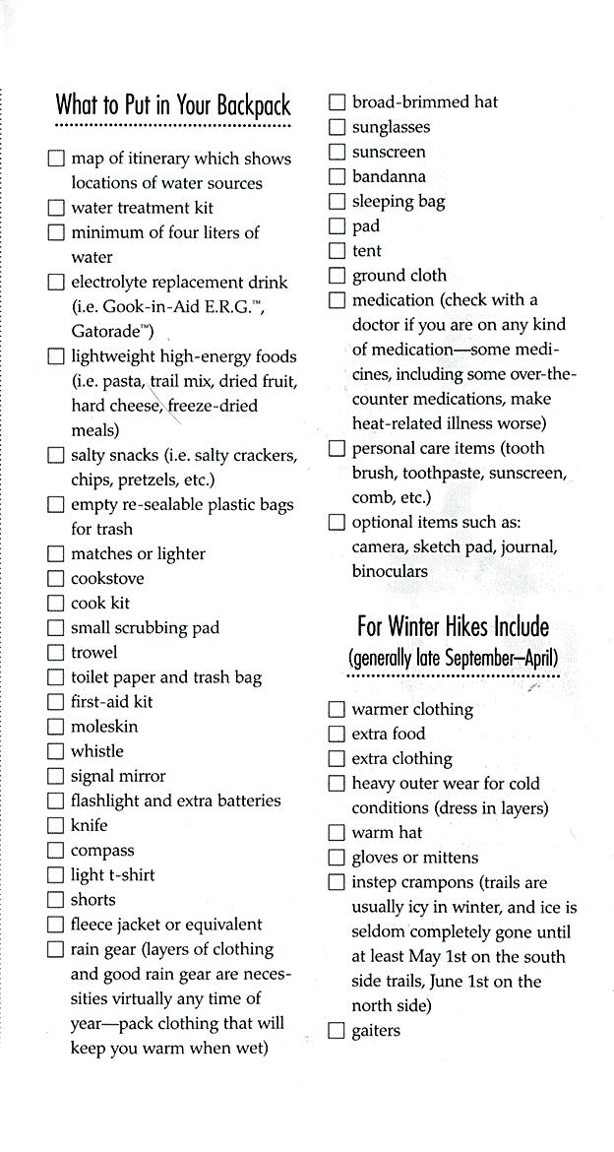

Climate info:
I got my info from http://www.wrcc.dri.edu/cgi-bin/cliMAIN.pl?az4335
Dig more from here: http://www.drought.unl.edu/dm/source.html

