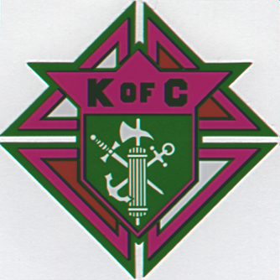
EIGHTH ANNUAL
ST. BERNADETTE K. OF C.
COUNCIL 7355

“Blind Bogey
Four-Man Scramble
Golf Tournament”

Colonial Acres Golf Course
Date: Saturday, October 24, 2004
Shotgun Start
Tee Time: 8:00 AM ONLY

• Closest to Hole Contest
(#2)
• Birdie Hole
(#5 and #14)
• Putting Contest
(50/50)
• 1st Hole -N- One Prize
($200)

Flight Prizes Per Team
“CASH”
Low Gross $280
1st Place $280
2nd Place $200

Most Courageous Team
$60

Entry Fee:
$50.00 Per Person
Includes Cart, Long Drive Contest, Lunch
and Drinks
First 40 paid-up Players
Mulligans $2.50 each
(one per each team member)

_
TEAM REGISTRATION FORM

Name 1. Phone # Name 2. Phone #
Name 3. Phone # Name 4. Phone #
Please Make Checks Payable to K.C. Council #7355

Please Make Checks Payable to K. C. Council # 7355

For More Information Contact:
Colonial Acres Golf Course at 868-5051
Harold LeRay at 868-1175, John Bergeron at 868-0350,
Woody Louviere at 876-1592 or Cullen Boudreaux at 876-7055

