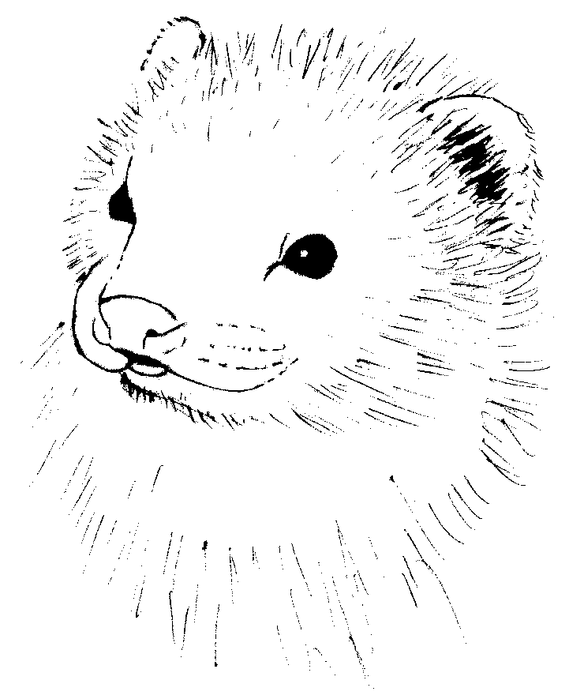
Ferret PAWS (NZ) Inc

New Zealand Ferret Protection and Welfare Society Incorporated

P O Box 91716, Auckland Mail Centre, Auckland

Ph: (09) 630 7520

E-mail: FerretPAWS@hotmail.com
www.geocities.com/ferretpaws_nz

APPLICATION FOR MEMBERSHIP

Name: ………………………………………………………..………………………..
Address: ……………………………………………………………………..…………..
…………………………………………………………………………………
…………………………………………………………………………………
Occupation: ………………………………………………………………………………....
Phone No: Home: ………………………. Work: …………..……………..
Mobile: ………………………. Fax: …………………………
E-mail: ……………………………………………..…………………………………..
No. of Ferrets and/or Ferrets Names: ………………..………………..………………………………
…………………………………………………………………
Type of Membership (circle one):

 | Annual Subscription
Family | $25
Single | $20
Child (<13) | $10
Organisation | $25
International | $25

Name to appear on membership card (up to 15 characters): …………………………………..……..
Are you able and willing to provide temporary care for rescued ferrets?: Yes/No

How would you like to receive routine correspondence? Post/E-mail

Signature: ………………………………………… Date: ………………………….

Privacy Act

The information provided on this form will be used to enable the Society to communicate with it’s members. This information is also required for the Register of Members required by Section 22 of the Incorporated Societies Act, and may be disclosed to the Registrar of Incorporated Societies if required by the Registrar. All present and past members have rights of access to, and correction of information stored about them.

