

Cinco de Mayo is Spanish for the Fifth of May. It is a holiday celebrated on May 5th by Mexicans, and Mexican-Americans. Cinco de Mayo honors the victory of a Mexican army over the French army at the Battle of Puebla on May 5, 1862. The Mexican army, led by General Ignacio Zaragoza, won the battle, even though the French force was better armed and much larger. Emperor Napoleon of France had sent troops to Mexico to conquer the country. The Mexicans won at Puebla, but the French later gained control of Mexico City. In 1866 and 1867, France withdrew its troops from Mexico because many Mexicans did not like the French being there. The United States didn't like the French there either. The French pulled out. Cinco de Mayo is celebrated in many different areas. Whenever and however it is celebrated, it is a celebration of Mexican history and heritage.

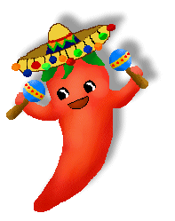

Vocabulary Words

Mayo – May
Bailes - Dances
Comida – Food
Globos – Ballons
Puebla – Site of Mexican battle
México – Mexico
Cinco – Fifth, Five
Las Vacaciones – Holidays
Fiesta – Party
Sombrero – Hat

Otras Palabras (Other words)
El Ejército – Army
La Victoria – Victroy
La Batalla – Battle
Verde - Green
Rojo - Red
Blanco - White
Risa - Laugh
Maracas – Small musical intruments
Música - Music
Piñata – Paper Mache animal with candy or treats inside


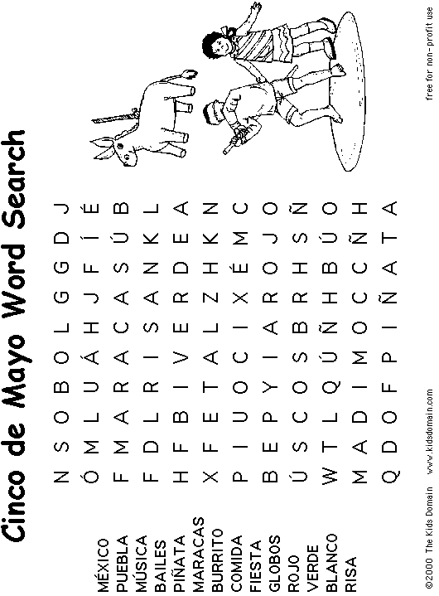

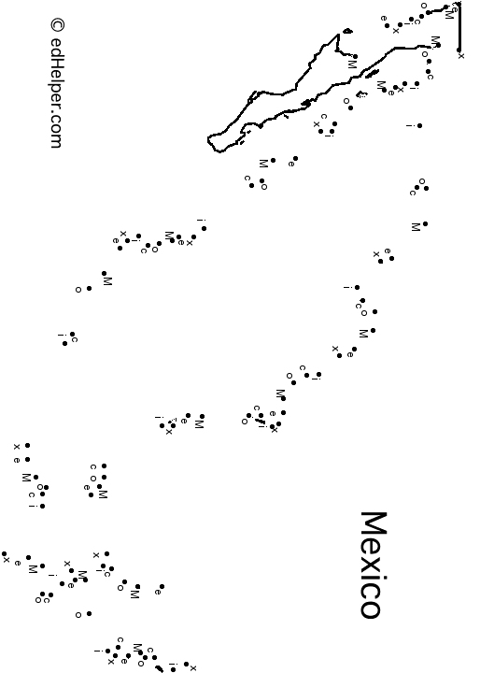

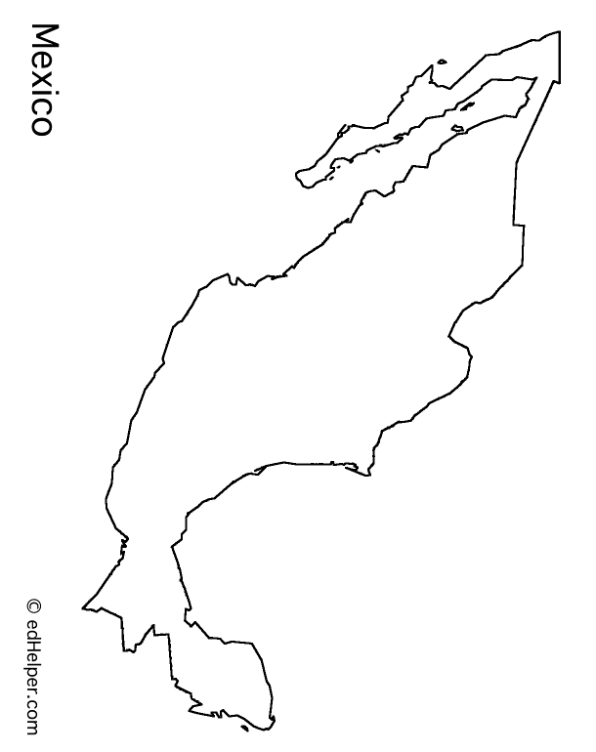

Vocabulary and Culture Quiz

Vocabulary

Mayo
A. Mars
B. Mai
C. March
D. May

Bailes
A. Dances
B. Bails of hay
C. hanging, colorful container holding candies, fruits, and toys
D. A party

Comida

A. A Mexican holiday
B. A party
C. A dance
D. Food

Globos
A. Piñatas
B. Ballons
C. Foods
D. Parties

Puebla
A. A house
B. A village
C. Site of important Mexican battle
D. People
México
A. The country to the north of the U.S.
B. The country to the south of the U.S.
C. An Island to the east of the U.S.
D. An Island to the south of the U.S.

Cinco
A. 5
B. 4
C. 8
D. 3

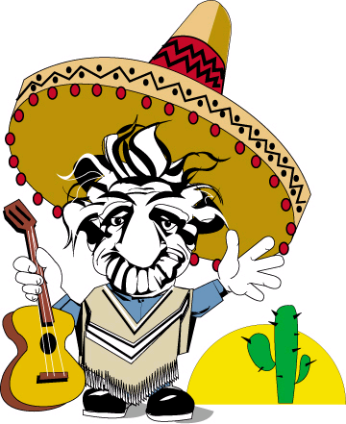
Las Vacaciones
A. Victories
B. Foods
C. Holidays and Vacations
D. Vacuums

Fiesta
A. Food
B. Victory
C. Hat
D. Party

Sombrero
A. Glove
B. Hat
C. Pants
D. Shirt

Culture Quiz

1. Cinco de Mayo
a. is a holiday in Mexico b. is on the fifth of May
c. is celebrated in France d. both a and b
2. The French Army
a. fought Mexicans in Puebla b. wanted to leave Mexico in 1862
c. won the Battle of Puebla d. none of the above

3. Mexicans celebrate Cinco de Mayo
a. on the new year b. on the fourth of July
c. on the fifth of May d. none of the above.
4. Cinco de Mayo is a day to
a. celebrate their independence b. to celebrate Mexican heritage and history
c. move to another country d. none of the above.


The Mexican Flag
Colors: Green, White, and Red
