The Straight Shooter

October 2007

his Wench’. I wish to thank all of you who arrived at 5:30 PM to help set up the buffet and dining room. Special thanks to Betty Ma for organizing the birthday cakes, to ‘hubby’ Bill for helping greet members, and Diana Post for her purchase. My apologies if I have forgotten someone.

A HUGE thanks to Donna Chase. Donna is responsible for the marvelous new Birthday Cards; she designed them and arranged the printing of some. Donna works for ALONZO Printing, so special thanks goes to them for their generosity.

Our next dance on Saturday, September 29, is “Golden Oldies” with party girl DJ, JAMIE, who will be mixing new with the old. So come along and join us at Barrett for a trip down memory lane.

Please note: Two of our dances, October 20 and November 3, will be at a new hall, the Community United Church in San Carlos, directions for which are on page 6. Barrett is unavailable due to their annual Melodrama.

Don’t forget to renew your membership; otherwise you’ll be paying the non-member price of $10.00.

New Year’s Eve – Glitz at the Ritz on the Riviera”, there will be prizes, surprises and our usual ‘fabulous floor show’. Get your reservations in early: the form is included in this publication.

Our Editor, Joyce Shannon, just keeps getting better and better; I think you’ll all agree that the Shooter contains lots of interesting reading.

Cheerio for now,
Anni

Cheerio,
Anni

Letter from the Editor: Page 4 gives you a close up look at Betty Ma and pictures and story about Mike Sullivan.
I welcome ideas for articles. Email me at joyce@dancinshamrocks.com
Joyce Shannon, Editor

P.O. Box 4966 E-mail: quicksteppers@yahoo.com
Foster City, CA 94404 Website: countryquicksteppers.com



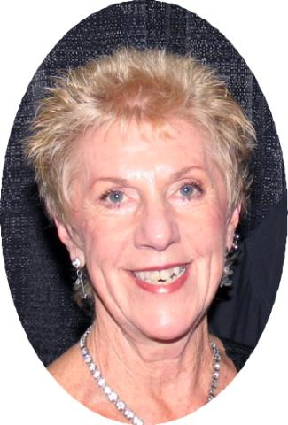
A Note from Anni:
Anni Wunderlich - President

Hi Everyone:
I hope you’re making the most of this beautiful autumn weather, I know I am.
Our “Back to School” dance on September 1 with the Principal, DJ Duke Gary Clayton, was a blast and Gary played a good mix of dances which kept the floor filled; Gary was accompanied by his beautiful wife, Janet. We had missing board members, plus a book sale, so I would like to thank John Gallo, Joyce Shannon, Bernie Feinberg, John Swanson, and my husband Richard, for all their help.
September 15 was our 20th BIRTHDAY BASH, with a pirate theme, and our DJ was the King, Neil Hale. This year we decided to have a potluck dinner rather than catered, and I received several positive comments about the potluck, those that commented said that they preferred it. Neil did a super job, and he and Linda dressed for the part, they really were the ‘Pirate and

INSIDE THIS ISSUE
2 | Line Dance Lessons & Socials
3 | Biography
4 | Articles
5 | Club News
6 | Quickstepper September Dance Schedule
7 | NY Eve Flier & Reservation Form
8 | Ad & Puzzle

San Jose
STRAIGHT SHOOTER October 2007 Page 2
Diana Ward (650) 359-2599 E-mail: didi8854@aol.com
Thursdays 9:00 – Daly City Fridays 8:30 am – Daly City Intermediate – 151 Lake Merced Dr Intermediate – 101 Lake Merced Dr
Thursdays 3pm – Pacifica Comm Ctr 540 Crespi Dr at Hwy 1 – Pacifica First Sunday Dance 1 to 4 pm
Thursday 7:30pm – Brisbane 1555 Crystal Springs Rd
High Intermediate/Advanced San Bruno

Michael Barr (530) 824-6888
E-mail: webmaster@michaelandmichele.com
Website: www.michaelandmichele.com For registration, call 650-522-7440
Wednesday Evenings – San Mateo Beginner – 7:30
2720 Alameda de las Pulgas The Next Step – 8:30

Jeanette Feinberg (650) 755-8049 E-mail: jmf720@aol.com

Monday Evenings – Daly City Wed 9 to 10am – San Bruno
Beginner – 7:00 to 8:00 pm Easy Intermediate
Intermediate – 8:00 to 9:00pm San Bruno Senior Center
1555 Crystal Springs Rd
–-

Jamie Hogan (650) 207-1902
Web: silvercreekdjanddance.com
E-mail: silver_creek@prodigy.net
Masonic Center, Menlo Park
2nd Friday’s

Evelyn Khinoo (650) 325-6913 E-mail: ekhinoo@sbcglobal.net
Tuesdays 7 to 9pm – Palo Alto Thursday Evenings – Redwood City
Intermediate/Advanced Beginner – 7:00 to 8:10 pm
Lucie Stern Center Intermediate/Advanced – 8:20 to 9:30pm
1305 Middlefield Rd 1400 Roosevelt Ave
Red Morton Community Activities Bldg

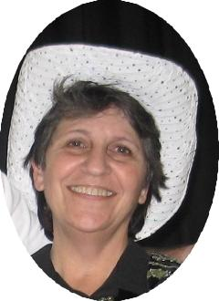
John Bowen mel98bow@mindspring.com 650-359-7448
New Session Starts June 4th
Daytime Line Dancing – Redwood City
Beginner – 9:00 to 10:05 am Veterans Memorial Senior Center
Continuing – 10:15 to 11:30am 1455 Madison Ave, Redwood City
650-780-7270

Hedy McAdams – Website: www.danceadventures.com – phone 650-325-3371
Friday & Tuesday – Daytime Classes Tues & Wed Evenings – Line Dance & Couples
9:30-10:45 Basics/Beginners & Open Dancing (Salsa, Texas 2-step, West Coast Swing, NC 2-Step)
10:45-11:45 Styling & Execution 7-8:15 Basic/Beginners 8-9:15 Intermediate
Cubberly Auditorium All Saints Episcopal Church
4000 Middlefield Road, Palo Alto 94303 Corner Waverly & Hamilton, Palo Alto 94301

Mike & Joyce Shannon (408) 378-7096
E-mail: info@dancinshamrocks.com Website: www.dancinshamrocks.com
Mondays 7 to 9pm & Wednesdays 2 to 4pm – San Jose
4th Saturday Line Dance Social 7:30pm @ Hyde Middle School - Cupertino
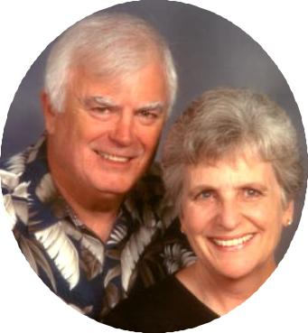

San Mateo
Daly City
&
San Bruno

Menlo Park

Palo Alto
&
Redwood City

Redwood City

Palo Alto

San Jose
&
Cupertino

Daly City

Brisbane
Pacifica
San Bruno

Country Hustlers
Danville – 8:00 pm
Check website for
dance information
www.countryhustlers.com

Cactus Corners
@ The Grange
743 Diablo Road
Danville
Dances – 1st Friday & 3rd Saturday
7:30 - 11:00 pm
www.cactuscorners.com

Boots ‘n’ Buckles
Fridays – 8 pm
At Swiss Park
5911 Mowry Ave
Newark

bootsnbucklesdanceclub.com

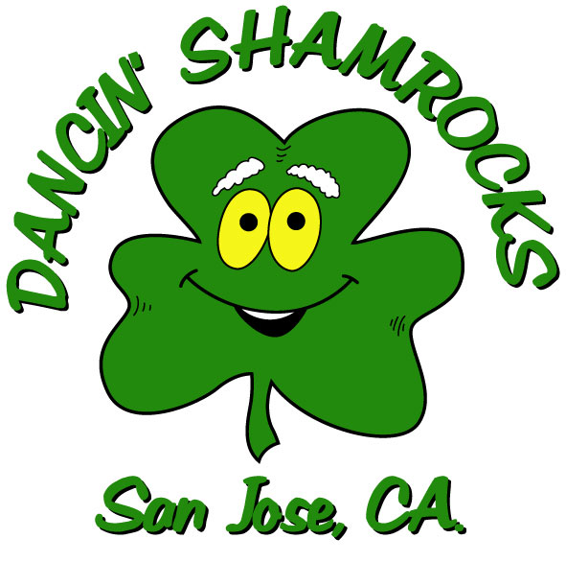
Matt & Carol Kirkpatrick (650) 359-2103
Fourth Friday Dance
Pedro Point Firehouse Pacifica – 8 pm
E-mail: Coastlinctrydncr@aol.com
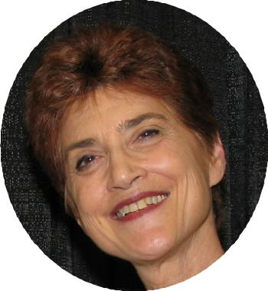
Updated
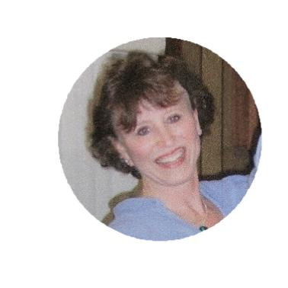
Updated

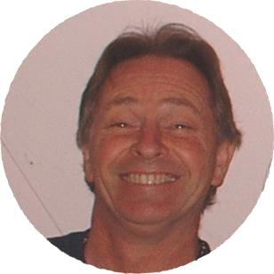



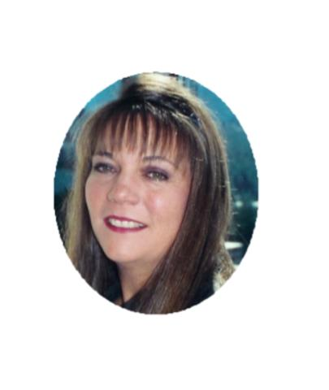

STRAIGHT SHOOTER October 2007 Page 3
Welcome our New Board Member Betty Ma, Treasurer

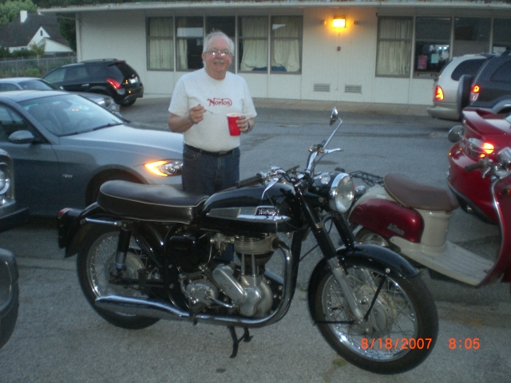
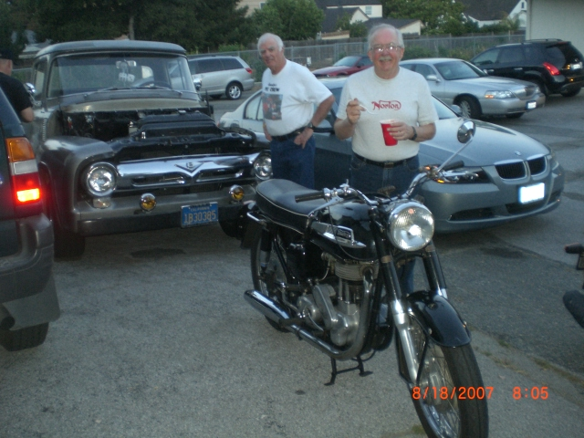

Mike Shannon &
Mike Sullivan
looking at Fred’s truck
and Mike’s motorcycle.
Mike bought the bike in Swindon, England while he and Andrea were on a trip celebrating their 25th wedding anniversary in 1994. Mike was looking for a bike to buy and wanted to travel to Oxford, but ended up staying at a “Pub” in Swindon. The newsstands were open so he picked up a newspaper and found an advertisement for the “Norton”. The owner was a lawyer who bought the bike in order to obtain the license plate, which had a special meaning to him “LGL911.” It seems in England that once you own a license plate you can put it on any vehicle you own. The license plate is now on a Porsche 911 & the lawyer was trying to sell the bike; Mike was happy to take it off his hands. It took over a month to get it shipped to the States.

Mike joined a “Norton Owner’s Club” and was Vice President for 3 years; President for 3 years and editor of the newsletter for 3 years. He is currently secretary of the approximately 170-member club, which encompasses owners from San Luis Obispo to Oregon.

Mike has owned a motorcycle since his freshman year in college; currently owns 4 motorcycles & 3 mopeds. This hobby takes up most of his time; he doesn’t hunt & fish anymore.

The Norton Club has a Highway Clean Up Sign near Alice’s Restaurant – located near the intersection of Woodside Hwy 84 & Skyline Hwy 35. The club cleans up an area a mile north and a mile south of the sign 5 times a year.
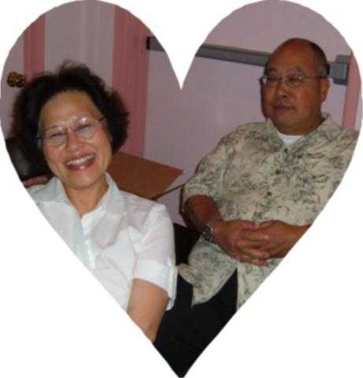
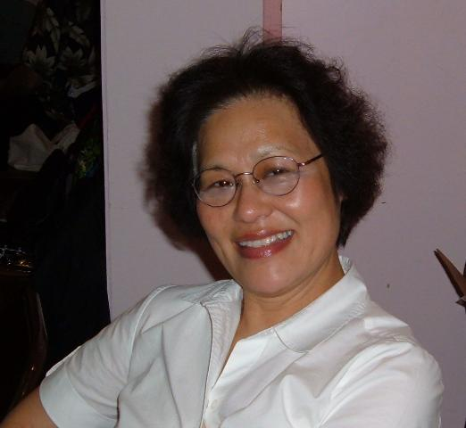
Betty Ma is our new treasurer and she has brought our club a bonus – “Bill”, her husband who is helping greet our members at the dances. Betty was born in China, grew up in Hong Kong and came to the U.S. when she was a teenager. She attended City College of S.F. and is currently working as a Financial Consultant at Wells Fargo Bank.
Betty retired from B of A in 2001 after working 28 years. She met Bill at CCSF and they have been married over 34 years and they have 2 sons. She loves to travel and that’s why she keeps working.
Betty found out about a Line Dance class at SSF; she tried it and has loved it ever since. Her first instructor was Diane Montgomery; then took classes from John Bowen & Jeanette Feinberg. She likes the funky & fast dances. Her favorites are: Amazing, Overload & Come Tomorrow.

Mike Sullivan & Motorcycle at Hot August Nights

Did you get a chance to see Mike in his “Leather pants” and his motorcycle at Quickstepper’s Hot August Night Dance?

Mike owns this 1961 Norton, Model 50, 350cc, Single Cylinder

Below is the story of how Mike became the owner of this unusual motorcycle.

STRAIGHT SHOOTER October 2007 Page 4
Book Sale & Back to School Dance

San Bruno Senior Center Fund Raiser by Diana Ward
Tina, Frank, Shirley, Jeanette & I (Diana) would just like to take a moment to thank each and every one (105) of the dancers who came out in force to support The San Bruno Senior Center Fund Raiser Line Dance and Auction. We had quite a mixture of areas from Santa Rosa, Benica, San Jose, Cupertino, San Mateo, San Francisco, Hayward, Livermore, Danville, even Sharon & Harry Emmett drove down for it, and of course, lots of San Bruno and Daly City dancers. It was wonderful to see so many of my friends from around bay area. Between the entrance fee, the 50/50, and the Auction and Jeanette Feinberg's former Employer Bank of America who doubled what we raised, the center received a check for over $3,500, which will be used to help the seniors at the center.
So, those of you who went home with treasures from the auction, think about the help you gave when you purchased that treasure and know that you put a warm meal or helped with something extra that a needy senior really appreciated. We thank you from the bottom of our hearts for helping us raise the funds, and hope it makes you feel as good as it does us. With all the government cuts, it has been very difficult on the center and the employees were so very grateful to have the funds to help more seniors. You all did great, thank you one and all….
Diana Ward, Tina & Frank Beare, Shirley Cohn, Jeanette Feinberg.
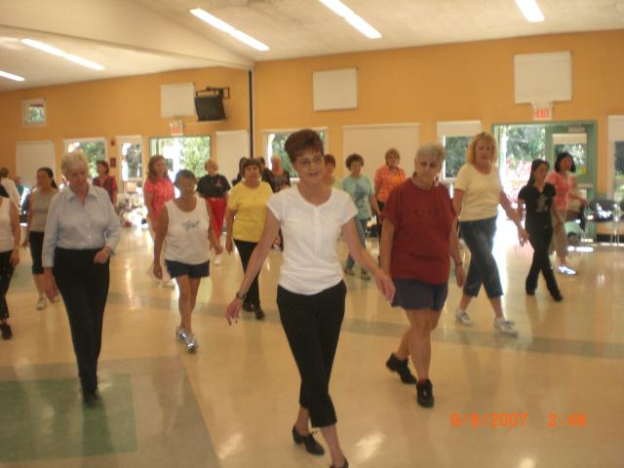
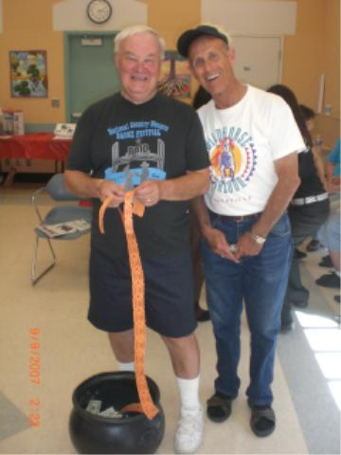
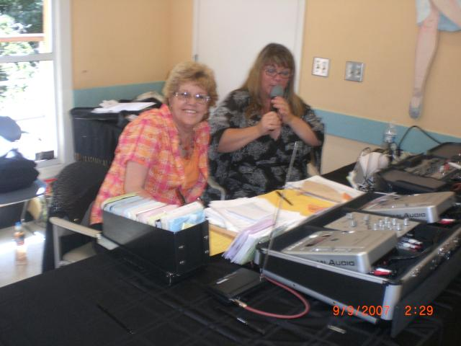
Jeanette taught “Country Girl”
JaJa, Barbara, Jeanette
Richard & Bernie
Tina & Diana
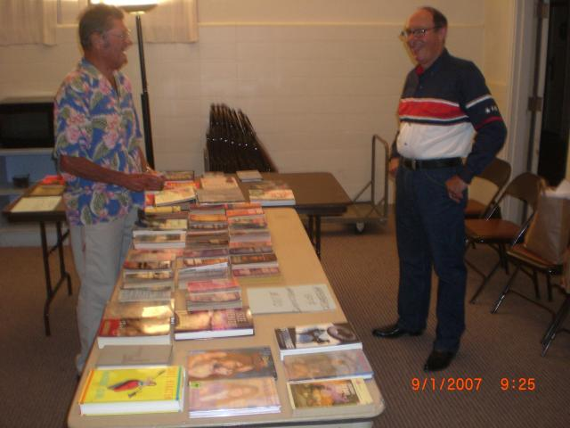
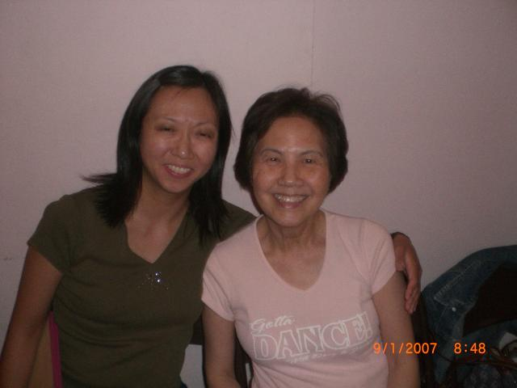
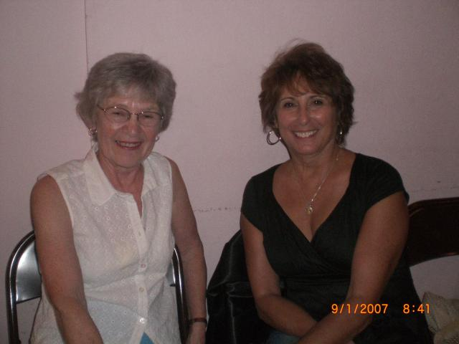
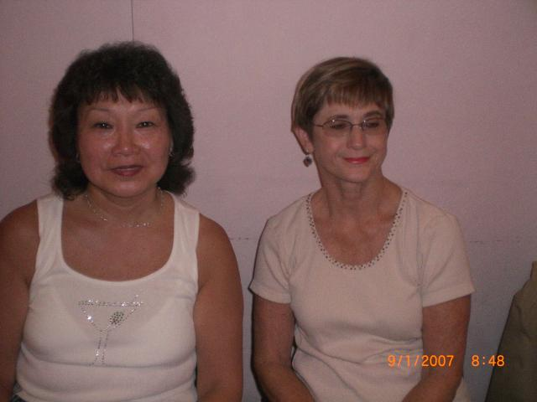
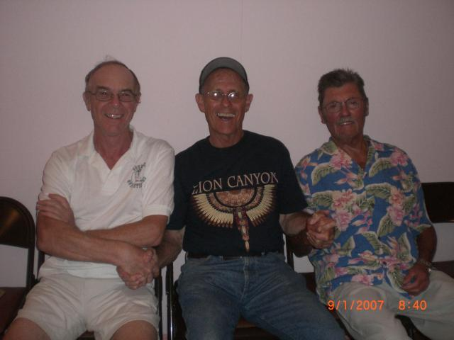
Thank you Richard & John
Happy Birthday to our members celebrating milestone birthdays.
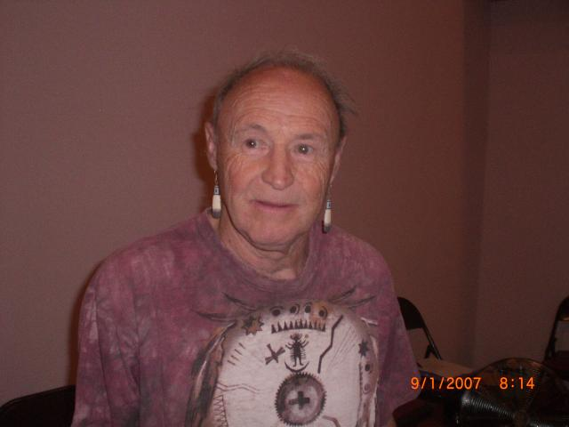
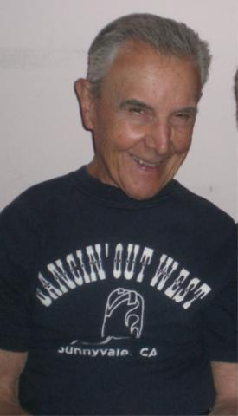
Harry turned 75
in September.
He just got his
“Ham” license &
travels to Missouri
several times a year to teach Karate

Carl will be “80” on Oct 25th. He sold his windsurfing equipment & bought a hard kayak.
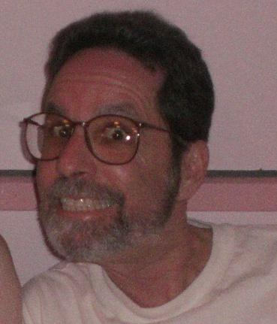
Tod hits the big….
60

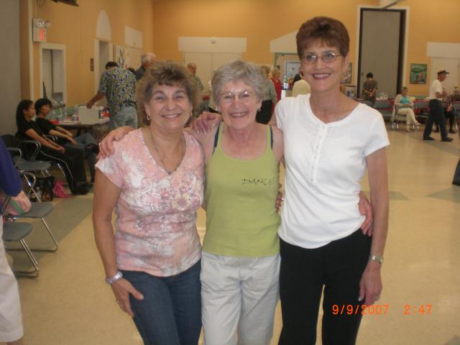

STRAIGHT SHOOTER October 2007 Page 5
CQS BOARD 2007-0008
President: Anni Wunderlich
Vice President: Sara Watson
Secretary: Jan Hanway
Treasurer: Betty Ma
Membership: Diana Post
Membership: Donna Case
Marshal: Jim Wicklund
Marshal: Mike Shannon
Web Coordinator: Belinda Cheng
Shooter Editor: Joyce Shannon
August 2007 Income Expense
Month Summary
Admission $ 926.00
50/50 121.00
Membership 504.00
Hall Rental $ 400.00
DJ 510.00
Shooter 133.36
PO Box Rental 125.00
Flyers, Env, Stamps, Refreshments 85.72
Month Totals $1,551.00 $1,254.08

Bank Balance $1656.91 + Cash $120

CD Balance $9,275.53
October Birthdays
Glenn Wiegand 10-5
Rich Cadena 10-7
Helene Swanson 10-7
Fran Varady 10-8
Dorothy Lee 10-12
Julie Aquilina 10-16
Vickie Newman 10-19
Jocelyn Liu 10-20
Judy Lindquist 10-21
Shirley Cohn 10-23
Carl Grame 10-25
Mike Hansen 10-26

50-50 Winners
Sept 1: Mike Shannon, Bev Benson, Vickie Newman
Sept 15: DJ Neil Hale, Judy Lindquist, Denny Harris, &
Ken Muksean (visitor from Laos)
Second Saturday Charity
4th Annual Workshop & Dance
November 10, 2007
12:30 to 10:30
Benefiting: Shelter Network
Twin Pines - 1223 Ralston Ave, Belmont
$30 if you register before Oct 27th
Presented by Heart Dance – John & Gina
mel98bow@mindspring.com
Pick up Registration Form at Quickstepper Dances

Check out our Website www.countryquicksteppers.com
Classes - Photos
Videos - Polls
DJ Playlists - Videos
Club Info - Newsletters
Club Calendar - Links

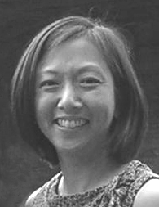


Happy 20th Birthday Quicksteppers
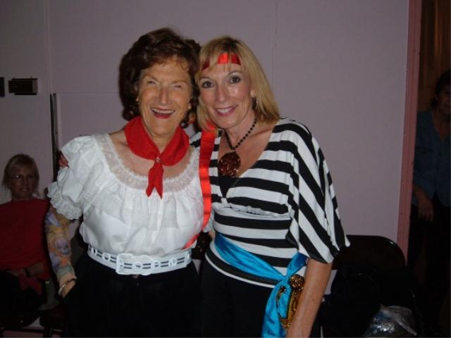

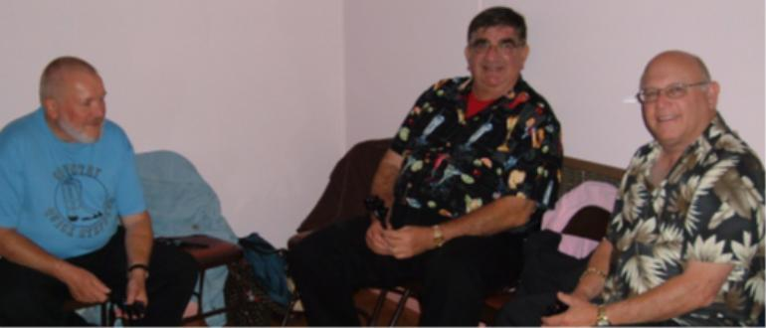
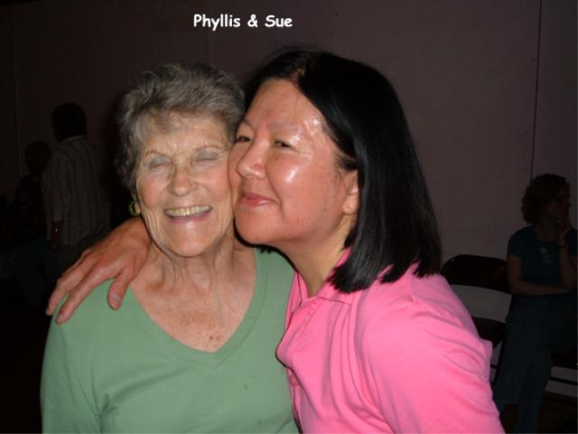
Russ, Ron & Steve

Phyllis & Sue

Lorraine & Linda
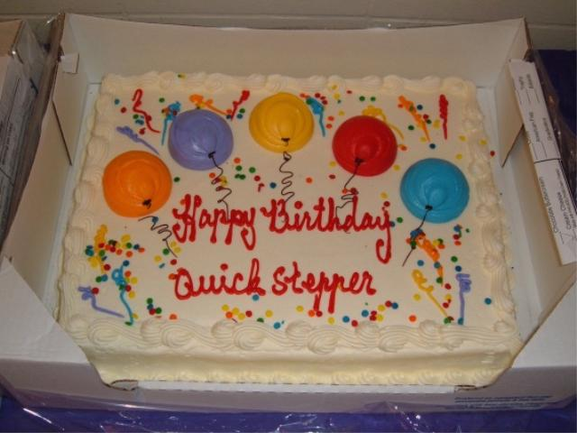
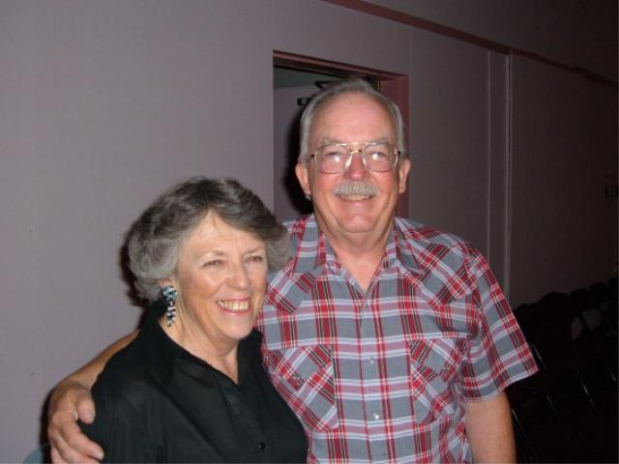
Andrea & Mike
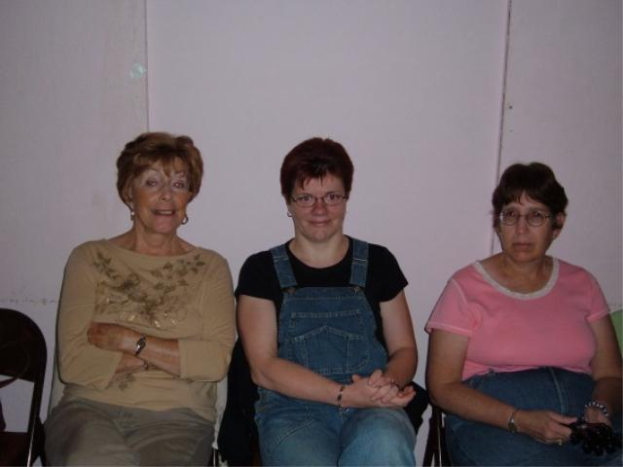
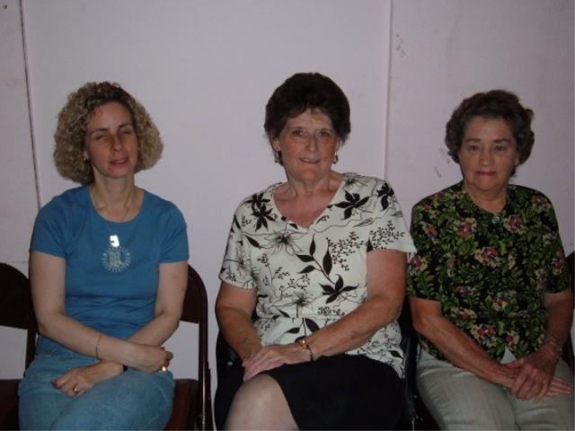
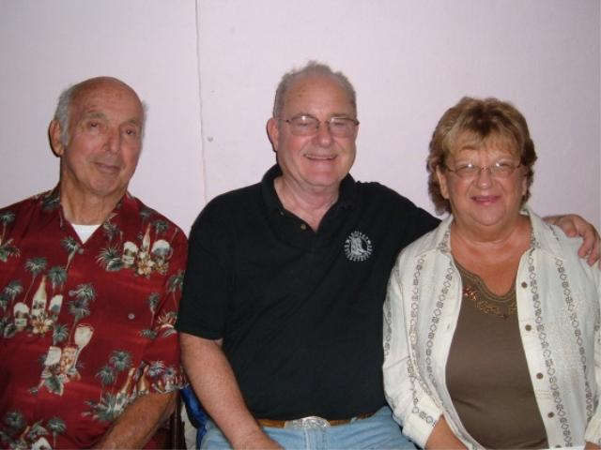
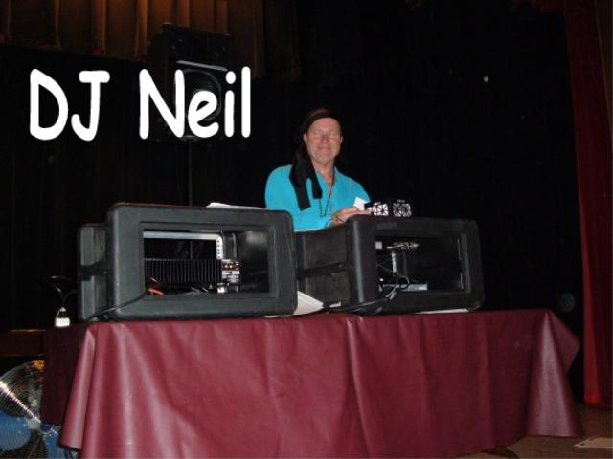

Lee, Jennifer, Frances

Vickie, Glenda, Eleanor

Sonny, Gary, Helen

Anni & Sara
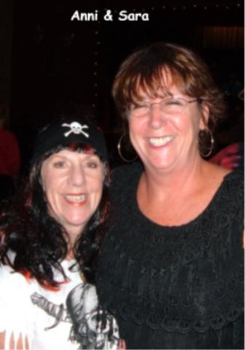

STRAIGHT SHOOTER October 2007 Page 6

DANCE SCHEDULE – COUNTRY QUICKSTEPPERS

Oct 6th “Rubber Duckies Reunion”

DJ – Gary Clayton
Barrett Community Center

Belmont

Time: 7:30 to 10:30 pm Members $8.00 Non-Members $10.00
==========================================================
Oct 20th “Oktoberfest”

DJ – Neil Hale
Community United Church
1336 Arroyo Ave
San Carlos 94070

Time: 7:30 to 10:30 pm Members $8.00 Non-Members $10.00

New Location
Directions

Directions to Barrett Community Center: 1835 Belburn Drive, Belmont 94002
From 101: take Ralston exit; go west & cross El Camino. Continue for 1½ miles & turn right on Avon, Left on Belburn.
From 280: Take Ralston exit and travel east. Cross The Alameda de las Pulgas, Left on Avon, Left on Belburn.
Directions to Community United Church, 1336 Arroyo Ave, San Carlos
From 101 going north: Take Whipple Ave #409 (Left); Right on El Camino; Left on Arroyo
From 101 going south: Take Holly Exit #411; Left on El Camino; Right on Arroyo
From 280 Take the Edgewood Road exit and travel east. Turn Left onto the Alameda de las Pulgas, continue north along the Alameda, Right on Brittan Ave, Left on Laurel, Left on Arroyo.

For Information on other Dance Venues visit these websites:
www.countryquicksteppers.com www.linedancefun.com http://groups.yahoo.com/group/bayarealinedancing/

COUNTRY QUICKSTEPPERS
STRAIGHT SHOOTER October 2007 Page 7

Fourth Annual

“GLITZ AT THE RITZ
On the Riviera”

New Year’s Eve
Monday, Dec. 31st
At .. Twin Pines in Belmont

8:00 pm – 12:30 am

DJ’s EVELYN & DENNY
Prizes…
Surprises…
Floor Show…

Bring a fancy hors d’oeuvre to share

Members $16 Non-members $20 Non-dancers $16
Reservation Form for NY Eve 2007
Cut & send with your nonrefundable check to: Quicksteppers NY Eve Party
PO Box 4966
Foster City, CA 94404

Or… Give this form & nonrefundable check/cash to a Board Member
Name: ___________________________________________________________
Number of reservations_________ Amount: $___________

WORD ANGLES
Country Quicksteppers
P O Box 4966
Foster City, CA 94404

Countryquicksteppers.com
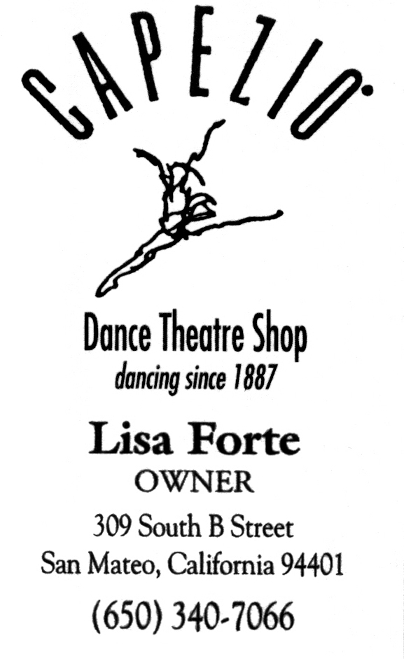
This is a Word Search with Angles. Determine the answer to each definition below, then
look for it in the diagram. Each answer in the diagram has at least one right angle, so that
while it may start out reading across, it will then make a right angle and read up or down.
Or it may start out reading up or down and then make a right angle and finish left to right.
A word may make more than one right angle; words are not formed on the diagonal. Once
you have circled all the answer words in the diagram, circle the remaining letters. Anagram
these letters to spell out something that helps give you closure.
L | A | V | Z | E | L | C | N
G | P | A | P | R | O | T | U
N | A | E | S | T | C | E | I
I | L | M | O | P | O | R | P
D | D | A | C | L | I | B | A
P | E | N | A | R | V | E | R
O | W | L | W | A | I | N | G
G | R | E | C | R | D | I | A

Pop the question _ _ _ _ _ _ _
Certain celebration _ _ _ _ _ _ _
Excellent purchase _ _ _ _ _ _ _
Family member _ _ _ _ _
Absolutely furious _ _ _ _ _
Fictional monster _ _ _ _
Keep from danger _ _ _ _ _ _ _
Volcanic overflow _ _ _ _
Move like a toddler _ _ _ _ _
Annual reference book _ _ _ _ _ _ _

