Counter-tracking techniques for the Reconnaissance Platoon
By Spc William A. Ball

Since reconnaissance platoons do not typically have the firepower to take on a pursuing force, counter-tracking techniques are an important part of avoiding detection by, and breaking contact with, enemy troops. Some of the techniques of counter-tracking are simple and should be practiced by all ranks. More advanced techniques will require the squad or platoon leader to maneuver his patrol in such a way as to loose a tracker. Some of these more advanced techniques could be made part of SOP while others will only be used at the discretion of the patrol leader.

One of the most basic techniques that everybody should observe is picking up litter. Litter left on a trail can give the tracker useful intelligence on his intended pray such as troop discipline, morale, and if the unit is well supplied. Litter can also indicate how recently a patrol passed through an area. These reasons make it essential for all ranks to carefully pick up litter on patrol and at hide sites.

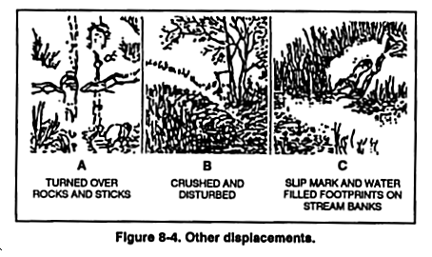 | The last man in a patrol formation should have the responsibility of brushing out footprints after a patrol crosses soft ground and replacing displaced foliage (fig. 8-4, Sniper Training Manual). He should also be responsible for sterilizing the hide site and picking up litter the patrol leaves behind.

“When being tracked by an enemy tracker, the best bet is to either try to out distance him or double back and ambush him” (Combat Skills of the Soldier, 3 Aug. 1984). The following techniques should be studied by the squad and platoon leaders of a reconnaissance platoon to throw potential trackers off the trail, increase the distance from the tracker or maneuver to ambush him.

A reconnaissance patrol can use the cut-the-corner technique is used when approaching a know road or trail. About 100 meters from the road, the team changes its direction 45 degrees to the right or the left. When the team gets to the road, they leave a visible trail in the direction of the deception for a short distance or the road. The tracker should believe the team “cut the corner” to save time. The team backtracks and carefully moves on the road without leaving a good trail. Once the desired distance is achieved, the patrol changes direction and continues movement (fig. 8-8, FM 23-10 Sniper Training Manual). | 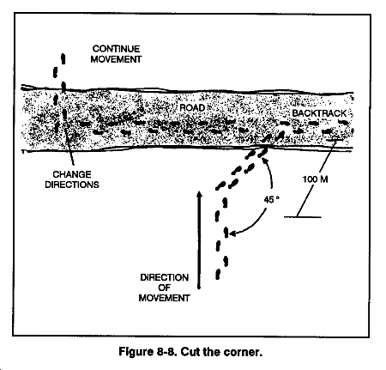

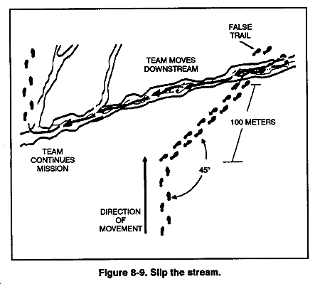 | The slip the stream technique is used when a patrol is approaching a know stream. It is preformed in much the same manner as the cut-the-corner technique except the team wades downstream some distance before getting back on the primary route (fig. 8-9, FM 23-10 Sniper Training Manual).  Robert Rogers , of U.S. Army Ranger History, states in his standing orders to his rangers, “If somebody’s trailing you, make a circle, come back onto your tracks, and ambush the
I folks that aim to ambush you.” To employ the double-back or fishhook technique, first the patrol has to have a good led. Then the patrol circles back and sets up the ambush. The configuration, near ambush or far ambush, does not matter nearly as much as that it
I is executed quickly. The patrol ambushes is pursuers and then withdraws to another ambush site. This increases the distance between the patrol and the pursuing force by causing it’s tracker to be more cautious (fig 8-11, FM 23-10 Sniper Training Manual).  Leading your tracker through a known | 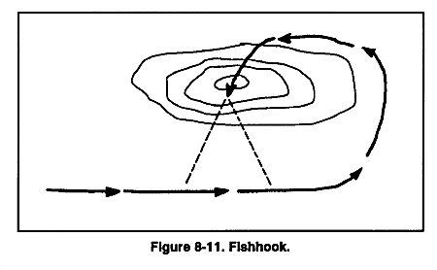
TRP for artillery is another good method. A Linear TRP is best. Pass through the first grid location and run to the second. As soon as you reach the second TRP call for fire and leave the area. (Ultimate Sniper, 1993.)

Booby traps are the final method I have to offer for loosing a tracker. Simple booby traps that can be quickly and easily place are best, nothing elaborate. Probably the simplest and quickest to place would be the tripwire-grenade. If a booby trap is used then the location of the device must be reported as soon as possible so friendly troops can avoid it.

Not only can these methods be used to loose a tracker but to break contact with any pursuing force. Ambushes, artillery, and booby traps will make the pursuer think twice about just how much he wants to catch you. He’ll move more slowly and cautiously if he doesn’t give up all together. That is the reconnaissance patrols chance to escape.

⎯⎯⎯⎯⎯⎯⎯⎯⎯⎯⎯⎯⎯⎯⎯⎯⎯⎯⎯⎯⎯⎯⎯⎯

Resources

“FM 23-10 Sniper Training Manual.” Washington D.C.: U.S. Department of the Army. 17 August 1994.

“FM 21-75 Combat Skills of the Soldier.” Washington D.C.: U.S. Department of the Army. 3 August 1984.

Plaster, John. “The Ultimate Sniper”

