The Reconnaissance Mission
By Spc William A. Ball

Reconnaissance is a mission undertaken to obtain, by visual observation or other detection methods, information about the activities and resources of an enemy or potential enemy, or about the meteorlogic, hydrographic, or geographic characteristics of a particular area.

The reconnaissance platoon is organized, equipped, and trained to conduct reconnaissance and limited security tasks for its parent battalion. The platoon's primary mission is to provide battlefield information. The reconnaissance platoon also assists in the tactical control, movement, and positioning of the battalion's companies and platoons. The reconnaissance platoon is employed under battalion control, but it may be detached for a specific operation. The reconnaissance platoon can be tasked—
- To conduct zone reconnaissance.
- To conduct area reconnaissance.
- To conduct route reconnaissance.
- To screen within the platoon's capability.
- To conduct surveillance of critical areas of concern.
- To link up and conduct liaison.
- To guide maneuver forces.
- To conduct chemical detection and radiological survey and monitoring.
An area reconnaissance is directed effort to obtain information concerning the terrain or enemy activity within a prescribed area, such as a bridge or other features that are critical to operations. A reconnaissance element, given the mission of conducting an area reconnaissance, obtains the required information by reconnoitering the location or area or by maintaining surveillance over the location. Based on METT-T, the platoon leader assigns the task of conducting an area reconnaissance to individual squads or he may use the entire reconnaissance platoon. When using individual squads to conduct an area reconnaissance, the platoon leader or platoon sergeant locates with a squad or selects a position from which the actions of the squads can be controlled. A reconnaissance patrol uses long-range and short-range observation and surveillance when executing reconnaissance. Other methods can be developed as long as the fundamentals of reconnaissance are applied. Single or multiple R&S teams can be used with either method. The security measures are based upon the situation. The major actions required of an area reconnaissance are: movement to and occupation of the ORP, leader's reconnaissance, actions at the objective, and withdrawal and dissemination of information.

Occupation of the Objective Rally Point.
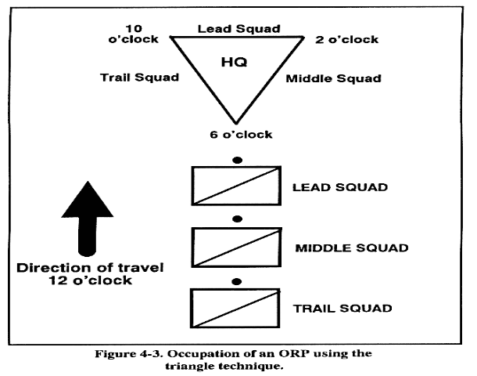
Before the reconnaissance begins the platoon or squad sets up an Objective Rally Point (ORP). The ORP is where the unit will make its last minute preparations such as recamoflauging, weapons inspections, removing optical equipment from rucksacks and lining up rucksacks for hasty removal in the event contact is made with the enemy. The ORP could also be used as a cache site if the patrol leader decides he wants to take the whole patrol on the reconnaissance of the objective. After the reconnaissance the unit will return to this location to disseminate the intelligence that was gathered.

When occupying the ORP the patrol leader picks a location that is out of sight, sound and small-arms range of the objective. The leader looks for a site that has cover and is well concealed, and that will be defendable for a short period of time. Everyone in the unit most know the technique for establishing the ORP so it can be done quickly and with minimal noise.

Actions on the Objective.
Once the objective has been pinpointed, designated elements conduct the reconnaissance. The reconnaissance elements view the objective from as many locations as necessary. Movement in and around the objective must be cautious and slow. The security elements, if separate from the reconnaissance elements, occupy a position that, if necessary, allows placement of direct or indirect fire on the objective. The reconnaissance patrol leader decides how in-depth the reconnaissance will be. A thorough and accurate reconnaissance is important. However, avoiding detection is equally important. Two techniques for conduction reconnaissance are long-range observation and short-range observation.
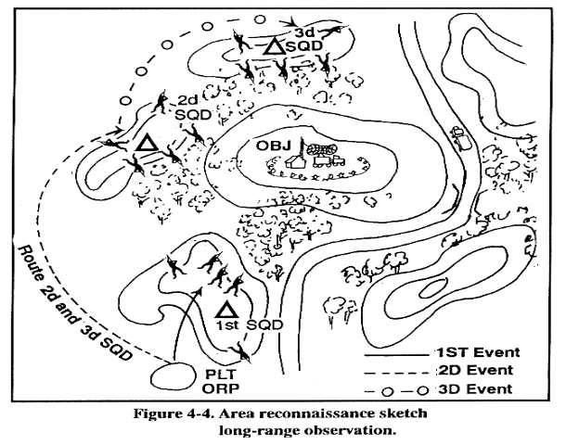
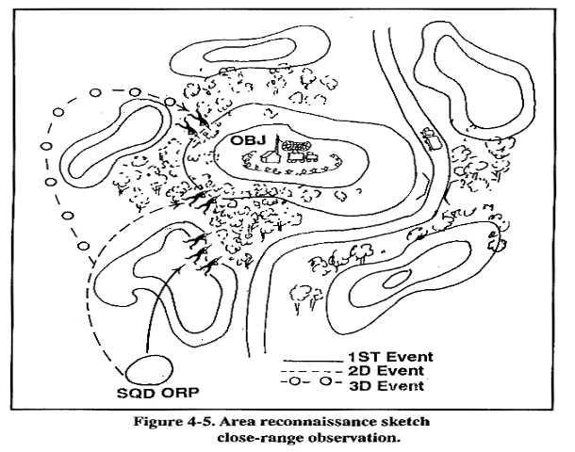

Withdrawal and Dissemination of Information.
Once reconnaissance is complete, the reconnaissance and security elements move back to the ORP or a rendezvous point. Security elements remain in position until the reconnaissance elements depart the objective area. Once all elements arrive in the ORP or rendezvous point, element leaders debrief the soldiers and move to the center of the perimeter to give the information to designated recorders. Recorders write down information and make/collect sketches of the objective. Element leaders disseminate the information obtained to the soldiers. This ensures that everyone has the information and, if necessary, can relay the information back to battalion. If the platoon leader wants to increase the security of the platoon, he can move the platoon to another location (normally one terrain feature away) or disseminate during move.

