

Limited Registration Contract

Date: ____________________________

The Undersigned Fully understands and agrees that the purchase of the within described dog is for the purpose of a family Pet ONLY and the dog is not to be used for breeding or Conformation. He/she may be used for Agility, juniors and/or obedience. The undersigned further agrees that they are to send a copy of certificate from a veterinarian, as proof that the said dog has been Spayed/Neutered to the Seller prior to the puppy being 7 months of age. Furthermore, it is agreed by Buyer that the said dog is to be socialized in Public and if at all possible attend puppy classes to prevent said dog of becoming “Aggressive” and that unless said dog is well socialized and has attended Puppy classes no Warranties against behavior problems are given by Seller. The Buyer agrees to provide adequate and necessary vaccinations and good health care for the life of the pet while in their possession.

The Seller hereby certifies that the within described dog is healthy and free from disease, and guarantees said health for a period of Two Years against Genetic Defects from the date of this Agreement. Should a Genetic Defect arise within said time, the Buyer has the option to 1. Ask Seller to pay for Vet Costs, up to a maximum of the purchase price of the dog or 2. Return the Dog for a Full refund of Purchase Price. Furthermore, It is understood that Cocker Spaniels have Breed Disorders such as but are not limited too Cherry Eye and/or Ear Infections. Buyer Accepts all medical responsibly should any Breed Disorders arise.

It is further understood and agreed that if the Buyer(s) with in the first 30 (thirty) days does not desire to keep the said dog, it shall be returned along with it’s papers to the Seller in a good and healthy condition and the purchase price will be refunded, unless other arrangements are made. UNDER NO CIRCUMSTANCES, shall the said Dog be offered for Sale or given away to ANYONE, for the entire life of the dog, until the Seller has been contacted and approves of such.

As it is understood by the Buyer that the said dog is being sold as “pet quality”, no further guarantees are being offered other than immediate Health status.
The Seller of the said dog shall have the prerogative of re-evaluating the said dog, if requested by the Buyer. In the event said dog is considered breeding quality or conformation quality, this agreement shall become null and void and a new agreement shall be in effect. IT IS AGREED THAT ONLY THE SELLER SHALL HAVE THE AUTHORITY TO RE-EVALUATE SAID DOG.
Breed: Cocker Spaniel A.K.C. No.________________ Sex:___ Born:____________

Color:_________________________________________________________

Sire: __________________________________________________________

Dam: _________________________________________________________

Name: ____________________________________ Tattoo: _______________

Other Identifying Marks: _________________________________________

Other Comments:

Selling Price:_______________ Paid by:______________________________

WE HAVE READ AND AGREE TO THE ABOVE AGREEMENT. ANY VIOLATION, INFRACTION AND/OR BREACH OF THIS CONTRACT WILL CONSTITUTE THE IMMEDIATE RETURN OF SAID DOG AND HIS/HER AKC PAPERS SIGNED OVER TO THE BREEDER WITHOUT A REFUND TO THE PURCHASER.
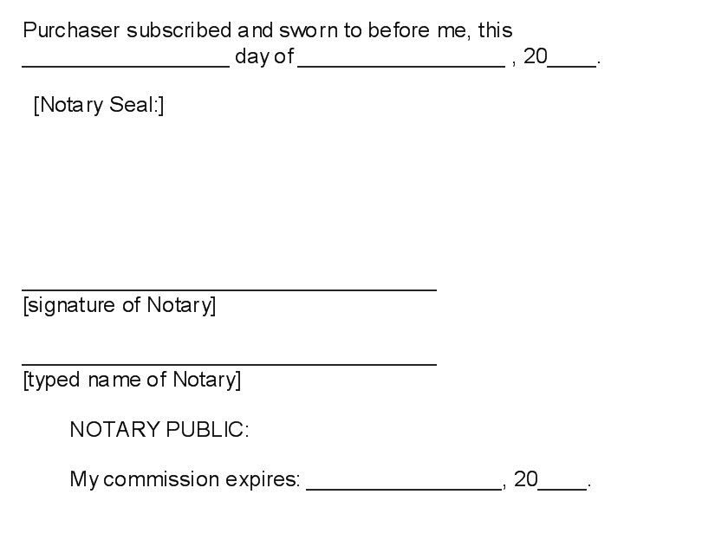

Seller

Name: Shelia A. Coke
Address: 516 Dial Mill Rd.
Oxford, Georgia 30054
Phone: 770-728-0336 or 678-283-3792

____________________________________
Signature

Purchaser

Name: _______________________________
Address: ______________________________
_____________________________________
Phone: ________________________________

____________________________________
Signature

