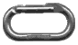Cirque Creek, Hollyford Road and The Marian Valley
By Murray Judge

Cirque Creek offers two long routes on Crosscut and the various routes on Christina. In summer, park opposite the creek on the Upper Hollyford road and ford the Hollyford to the scree slopes, or walk down the road from Homer Hut. (20 min)

Crosscut 2316m
Lindsay Stewart Buttress: Lindsay Stewart, Don Stewart, Harold Jacobs April 1967. Takes the prominent rib from Cirque Creek to the West Peak generally following the crest of the rib. The rock is shattered and dangerous in places.
Dislocation Arete: Athol Abrams, Chuck Schaap, Jon Waugh Mar 1968. Takes the rib right of the Lindsay Stewart buttress to the middle peak. One of the first routes to be given a name, on account of an unfortunate accident.
East Ridge: Bill Gordon, Ralph Miller, Bill Blee 1955. At the head of Cirque Creek climb straight up, climb left, up again then traverse right and up to the col at the base of East ridge which is followed to the summit of the East Peak.
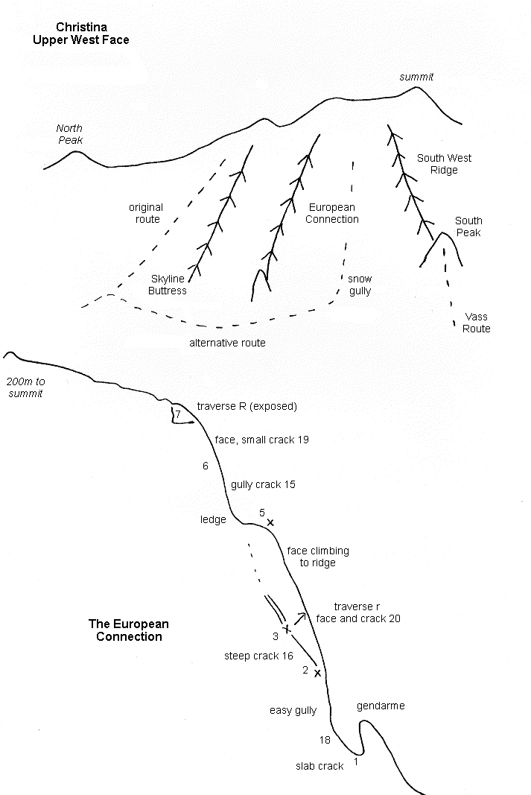

Christina 2502m
North Peak: Graham McCallum, Ralph Miller Dec 1962. Follow the rock buttress from the upper Cirque Creek, on the left side of a gully, crossing to the right and up a snow couloir higher up to gain the North Ridge. (reasonable rock , but grassy.)
Gully to North Peak: Merv English (solo) Nov 1976. A 1200m snow gully on the northwest Face of the North peak from the upper Cirque Creek.
Standard Route: Bob Sinclair, Ken Roberts, Harry Slater, George Moir, Bill Grave 1926. (First Ascent of peak). Climb tussock and scrub to reach the track below a large vertical bluff. Sidle right up steep slopes crossing three chasms, climbing up to cross the second at its head and descending to cross the third. Follow easy slopes to the ridge north of the summit.
Skyline Buttress: Austin Brookes, Roger McCurdy, Bev Noble, Rod McLeod 1974. The Buttress is approached by sidling down from high on the Standard Route.
The European Connection: Greg Aimer, Dave Brash, Jurgren Besswenger Jan 1990. A ridge and face route on the skyline as seen from Homer Hut, on the rock spur west of the south west ridge of Christina. (7 pitches up to grade 20) There is an easier variant missing the grade 20 pitch, stick to the main chimney crack instead of traversing right

Christina from the Hollyford Road
South West Face: Bill Gordon, Ralph Miller, Dal Ryan 1957. Climb the south side of a prominent gut above Lyttle's Flat, to scree and snow slopes up to the col just north of the Summit.
South Face to South West Peak: Howard Laing, Murray Jones 1966. Climb up a large shingle fan, then a gut leading to the foot of the South Ridge. Follow the rib on the true left of the gut, then up a small glacier to the col north of the South West Peak and a snow-field to the summit.
Dave Vass Dec 1989.(solo) From the bottom of Lyttle's Flat climb a gully onto the ridge just left of the rock scar. Follow the ridge to the first rock band, ascend the prominent white buttress on the left of the rock band, move up right keeping to good rock. Join the ridge at a short corner and cheval, continue to the South West Peak, descend to the col and then up a snow gully to join the South West Ridge on the right.
South Ridge: Murray Jones, Harold Jacobs Mar 1966. Climb up the shingle to a waterfall which drops out of a prominent west facing gut, easily climbed on the north side. Early season avalanche danger from the hanging glacier can be avoided by crossing to slabs on the true right. A steep band is crossed in the central section and the rock deteriorates towards the summit
East Ridge: Ron Dickie, Harold Jacobs Feb 1964. From Camera Flat cross the river and climb a large fan, going round to the right and up a gully then across a small spur. Descend to a second gully, moving diagonally right into the big gully which is followed to the snow-fields, then cross to the Marian Face and back to the ridge beyond the East Peak.
East Peak: Bill Gordon, Morrie Davis, Duncan Wilson, Lloyd Warburton 1954. Commence as for 3.11, following the broken ridge to the East Peak.

Marian Valley
Cross the Hollyford by the swing bridge and follow the track for one and a half hours through the bush to Lake Marian. (The ridge starting just beyond the bridge was climbed to above the bluffs by Milton Bardsley and Ian Cameron in Jan 1964).

Christina 2502m
Bill McLeod, solo 1980. On first reaching Lake Marian head up directly to the Marian Bluffs. Climb a short scrubby wall right of a small gut, gaining the terraces above. Continue up the grassy slopes and ribs, tending left at the top to avoid rock walls. The travel on these bluffs is made easy by plentiful stout snow-grass. The snow-slopes above give simple access to the East Ridge which is gained well above the East Peak with a straight forward approach to the summit.
Austin Brookes, Archie Simpson 1965. Up the bluffs and snow directly above Lake Marian to the upper Marian Ridge.
Bill Gordon, Ralph Miller, Gerry Hall-Jones 1955. (First traverse of Christina). From the top of the highest snow-grass slope beyond the lake climb up and sidle left around a waterfall basin to a gendarme at the foot of the summit snow-slopes.

Crosscut 2316m
East Face: Ralph Millar, Bob Cuthill, Lloyd Warburton, Duncan Wilson, Gerry Hall-Jones 1955. From the last tussock slope at the head of the lake go left to a broad ledge then right up a snow-field to the east Ridge of Crosscut.
Marian Buttress of Crosscut: Harold Jacobs, Murray Jones Dec 1965. The prominent buttress seen from the lake. Good climbing with some poor rock lower down.
East Face: Ron Dickie, Ken Hamilton, Noel Wilson Feb 1968. Takes the East Face to the East Peak of Crosscut.

Lyttle Falls
To reach the Upper Marian Valley follow the stream at the head of the lake till the falls are in sight, then climb to the top of a large shingle fan. Climb a gully to ledges which lead round to the top of the falls. There is a bivy rock just at the top of the waterfall giving limited shelter and some larger rocks with overhanging sides above the small lakes. First climb to the upper valley was made on the left side close to the waterfall itself: Len Kitson, Peter Robinson 1955.
Crosscut can be climbed up the bluffs beside the waterfall. Further up the valley the route to the Barrier Crosscut Col takes the left of two quartz bands slanting up the cirque wall below Crosscut.

South Face of Barrier 2051m
Mortensen Whiston: Richard Mortensen, Neal Whiston. Traversed to the terrace below the face from the Barrier Crosscut Col to climb a line near the col.
Clark Gabites: Bruce Clark, Geoff Gabites Dec 1974. Takes the only continuous crack line from the head of the Upper Marian to the ridge, 600m of good climbing. The route starts on the left side of the lower cirque wall.
Denz Judge: Bill Denz, Murray Judge Feb 1977. Traversed across from the Col (very broken and difficult), the route takes a narrow right slanting ramp then directly up to the ridge on excellent rock.
Hillary Jones: Peter Hillary, Murray Jones Dec 1976. A direct line through the lower cirque wall finishing 100m from the summit.

South Face of Marian 2109m
Herron Hyslop Whiston: Phil Herron, Ken Hyslop, Neal Whiston 1975. From the Upper Marian climb the slabs below the South Face of Sabre and traverse on steep slabs to the foot of the face. The route takes a left slanting groove starting from the centre of the face, five points of aid.
South East Face: Murray Jones, John Fantini. Takes the same approach and up the small face beside the Marian Sabre col.

Marian Sabre Col
The Marian side of the Col has been descended. (eight abseils, not recommended).

South Face of Sabre 2167m
The Big Corner: Stu Allan, Bill Denz Feb 1978. Climb the slabs to below the Marian Sabre Col, traversing into the face with two points of aid through an overhang then 300m up the corner to the notch on the West Ridge (14 with a few points of aid). This route is usually climbed up the crack directly below the big corner to a traverse to the right end of the overhang, free through the overhand (18). The big corner goes free at 17 ( Andy Mcfarlane, John McCartney 1996)
Natural Progression (20) Allan Uren, Greg Beisly Jan 1997. Starts further right than above route, up slabs moving left then back right to the R end of the big roof (18). From the base of the big corner move out left onto the arete and follow this to the West Ridge
Fisher Mcleod: John Fisher, Bill McLeod Mar 1987. Begin up the central slabby country to the first steep wall. A weakness tending left, right then left wends its way through this steep section without difficulty. The second wall is climbed directly by a prominent hand crack and corner, (two pitches, 16). Above the corner follow a shallow arete which divides the Big Corner from the rest of the face. An overlap band is climbed on the prow (17) then a short distance to the summit. Twelve pitches on perfect rock.
Original line: Allan And Murray Jones 1971. A line up the centre of the face starting on the right of a buttress, five pitches to a steep band (18, jamming through an overhang) move up and left around a second band then up easier ground to the summit. 20 pitches.
Campbell Howard: Andy Campbell, John Howard 1973. A line right of the original line joining the East Ridge above the Gendarme.
South East Face: Archie Simpson, Bill Stevenson, Peter Barry Jan 1966. From the snow-slope just below the gully up to the Sabre Adelaide Col climb the slabs to join the East Ridge above the Gendarme.

Sabre Adelaide Col
This col offers the only good route from the Upper Marian to Lake Adelaide. Climb the slabs and snow above Lyttle Falls to the small glacier. The last 100m to the col can be difficult if the snow gully is cut off. (Two easy abseils on descending to the Upper Marian). Descend the route described from Phil's Bivy to the Sabre Adelaide Col.

Lyttle 1896m
Cross the subterranean outlet from Lake Marian and climb the steep bluffs on the eastern side of the valley.
First Ascent: Bob Smith, Dick Ferris, Ivan O'Brien 1934

Peak Northwest of Lyttle:
First Ascent: Dick Ferris, Arch Smiley, Pat Lynch 1935.

Gunn Basin Track
Cross the wire bridge below Murray Gunn's camp and follow the track (now overgrown) through the bush to the tussock basins below Lyttle.

Lyttle 1896m
Lyttle from the east: Bruce Banwell, Dick Wood, Ron Webster1958.

Gunn 2051m
First Ascent: Bob Cuthill, Denise Schonyan 1959.

Gifford 2158m
North East Ridge: First Ascent, Alister McDonald, Ken Hamilton Oct 1955. Start just below the junction of Caples Creek with the Hollyford, climbing up through the bush to the North East Ridge and the East Peak.

