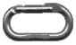Mount Somers
By Murray Judge 1997

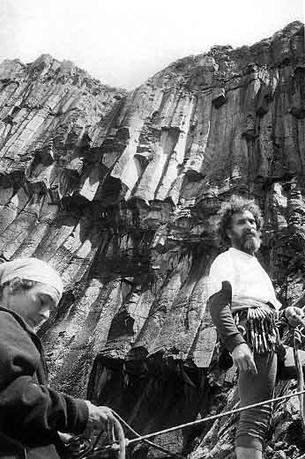
Wayo Carson and Dave Brash below Waterfall Wall

Character
Tumbling down the north side of Mount Somers are huge columns of rhyolite which form one of the best climbing areas in Canterbury. The routes are long and sustained outings up grooves and aretes up to three pitches high. Over the past two years these, together with andesite pinnacles lower in the valley, have been developed mostly by a small group of Oamaru climbers. There are now over 60 routes, grades 9-25, with potential for many more.
<! History The late summer of 1995 saw a revival of exploration with several excellent routes emerging. On The FarSide Andrew Macfarlane and I climbed a 3-pitch route front the waterfall stream to the left of the waterfall, Once a Jolly Swagman, 16, 20. The last pitch takes a steep groove a few metres from the waterfall, mostly 16 with one harder move at the top and has become a popular outing with visiting climbers. The groove to the right of the top pitch, right beside the waterfall, is Where's My Jolly Jumbuck 19, or 21 if the crack is climbed directly. The groove to the left of Swagman is The Longest Hardest Climb 21, and left of this again Andrew Macfarlane led the shallow groove of The Far Side of Never 21, starting through an overlap. The two desperate-looking grooves to the left have not yet been attempted. The four metre high block which formed the overhanging fingerjam start to Pain and Pleasure fell off during the summer, creating a new start to this route and producing some difficult moves up to the start of the groove on the left: The Contortionist 22, which I led in March. To the right of the waterfall is the steepest and cleanest area of rock at Mount Somers. In December Judge, Carson and Dave Brash climbed a 3-pitch route from the beach at the bottom of the waterfall through the curving headwall. Tsunami has pitches of 15, 16 and 24 with Carson leading the sustained final pitch on superb rock, giving one of the best pitches in the area. On The Fortress Chris Burtenshaw, Sean Waters and Grant Piper combined their efforts to climb the crack right of Hotline to Jim. It is Psychological Trauma 24, climbed without any bolts. Further left Macfarlane climbed the arete of Black Velvet Sin 17 and I climbed the slab to the left: Mississippi Mud Cake 16 both requiring a minimal amount of crack cleaning. There are five or six long curving lines to the left; the first gives a 45 metre groove of sustained grade 20: Banana Split by Murray Judge, and after some prolonged cleaning sessions the others will produce good long lines. The West Pinnacle has three new routes by Dunedin climbers Sash Nukada and Jason Crichton. Two finish on the shoulder at the start of the Ridge Route: Same, Same but Different 17 and Fresh Start Dude 22. A short slab to the right lead by Wayo Carson, Zephyr 15 also finishes at this belay. On the boulder below is Nameless Girl 16 by Nukuda. The pyramid-shaped pinnacle above the hut has a grey slab at its right-hand corner with two routes, Zesty 23 by Judge and Feisty 25 by Wayo Carson, both short but probably the best quality rock on the Pinnacles. The leaning pinnacle above has two short routes: Bart's Climb 10 by Geoff Mclennan and High Step 21 by Tim Green. On the ridge above the Central Pinnacle Chris Burtenshaw, Sean Waters and Grant Piper developed three crags, finding some good crack lines with fourteen climbs all done on natural protection. Mount Somers still has large areas of undeveloped rock and should see several more higher grade routes over the coming year. !>

Access
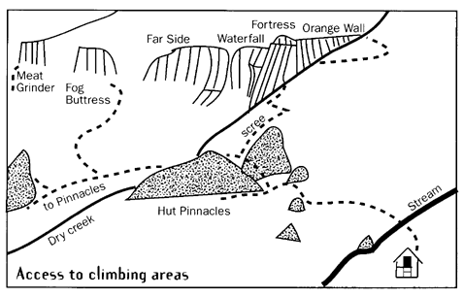
The track to Pinnacles Hut starts from the Sharplin Falls car park, turn off the Geraldine to Darfield road 5Km north of Mount Somers Village (10Km south of the Mount Hutt Skifield entrance) at the Stavely sign, follow the road across the bridge and turn right to the Falls.
The track climbs steeply for the first half an hour over Dukes Knob before dropping back down to the stream bed above the falls. Follow the stream for 40 minutes then take the sidling path to Pinnacles Hut, about 2 hours or 3 for a slow party. Pinnacles Hut has 19 bunks but is often full over summer weekends and is popular with school parties. The climbs start 10 minutes above the hut, 25 minutes to the Orange Wall.

The Orange Wall
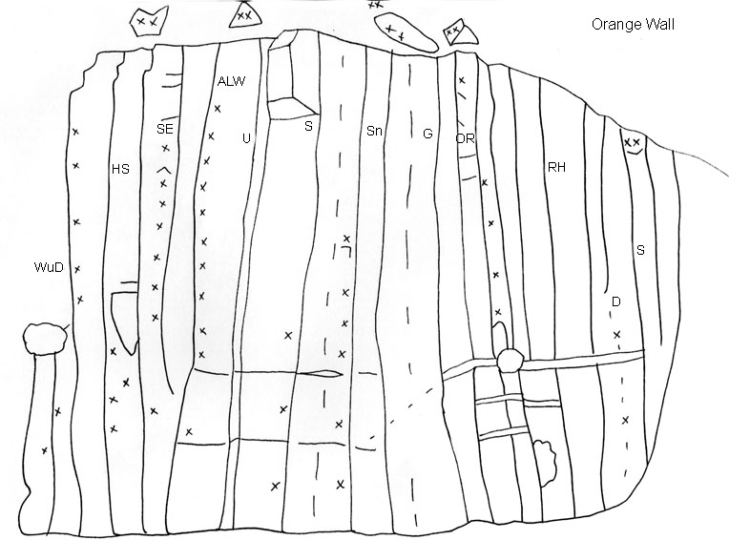
What's Up Doc? 19 Murray Judge '94
Climb the slab and curving crack to the bushy ledge and up the upper wall.
Have you been Stung? 19 Murray Judge '94
Climb the shallow arete and layback the left side of the block, then directly up to the top.
Steady Eddie 23 Murray Judge '94
Has been climbed by traversing left at the fourth bolt and back right at the seventh, a direct ascent would be much harder.
A La Weta 25 Murray Judge '94
A sustained line keeping to the arete, climbed with two rests.
Uno 21 Andrew Macfarlane '94
A sustained route cleaned and climbed by Andrew on his first visit.
Skate 22 Murray Judge '94
Thin bridging up to the superb finger crack.
Snapper 25 Murray Judge '94
The double cracks. One attempt with two rests. Red-pointed by Wayo Carson March 1997.
Groper 23 Jay Kinsman '94
The left facing corner, jamming and some fine bridging towards the top, Jay finished the route and Andrew Mcfarlane followed in the rain.
Orange Roughy 16 Murray Judge '94
Start at the foot of the Orange Wall going up and right to the hand traverse onto the arete.
Red Herring 16 Murray Judge '94
The groove right of Orange Roughy.
Dogfish 15 Wayo Carson '94
Past two bolts and up a thin crack.
Sardine 15 Murray Judge '94

The Fortress
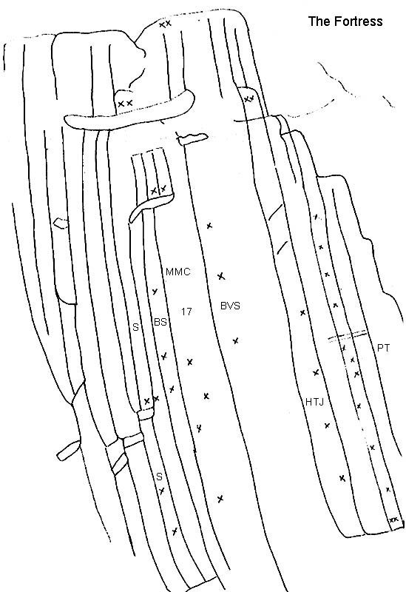
Scimitar 14,21,16 Murray Judge '94
Banana Split 20 Murray Judge, Wayo Carson '95
Traverse left at the second bolt, 45 metres, take a good sized rack of gear up to #2 friend. Rap to the start or down to the Beach.
Mississippi Mud Cake 17,16 Murray Judge '95
Climb the slab then the shallow crack to the belay ledge. Move right and climb a short second pitch to the next belay.
Black Velvet Sin 18 Andrew Macfarlane '95
More than a pitch in length, so needs a belay at half height.
Hotline to Jim 17 Andrew Macfarlane '94
A long and pleasant arete, either scramble up from the bottom or abseil from the top to start. (some say its 19)
0800 Butch 23 Tony Pine, Murray Judge '98
The long groove to the right of HTJ
Psychological Trauma 24 Chris Burtenshaw, Sean Waters, Grant Piper '95
The most obvious corner three metres right of Hotline, good moves, the upper wall above the break and arete are loose.
Crackline right of the broken arete 8,13,19 Stuart McConney, Brian Davia '95
The second pitch is a 35 metre crack with a short third pitch on the upper buttress (7m).

The Waterfall Wall
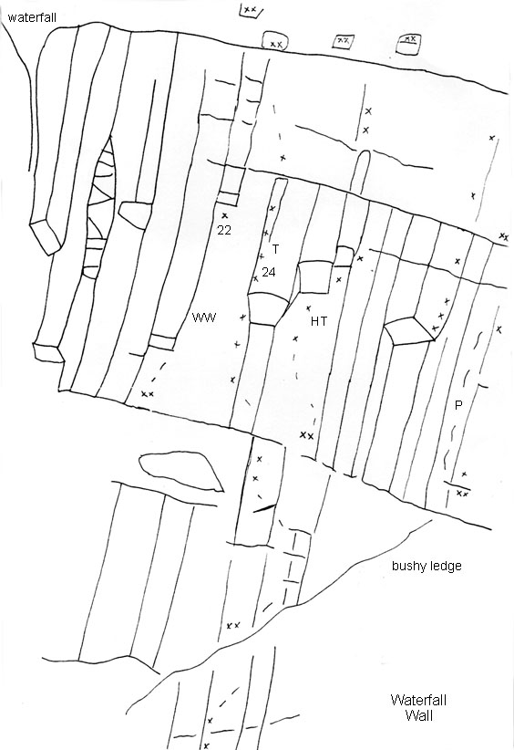
Wailing Wall 22 Murray Judge, Andrew Macfarlane '94
Best approached by abseil, climb the right facing corner to the roof with a wide bridge to pass this.
Tsunami 16,15,24 Wayo Carson, Dave Brash, Murray Judge '95
Three pitches starting off the "beach" at the foot of the waterfall, climb the slab to a belay on the bushy ledge, go left and up a short slab and back right onto a short buttress. The third pitch takes the steep wall to the top, eight bolts. (Three raps back down).
Hang Ten 25 Wayo Carson '97
Abseil to the Tsunami belay and clinb directly up to the triple roof, some wild moves through the overhangs.
Pipeline 23 Murray Judge '97
Abseil to the belay, layback up the crack as high as possible, clip the bolt and reach for the holds. Step to the left to start the top section.

The Far Side
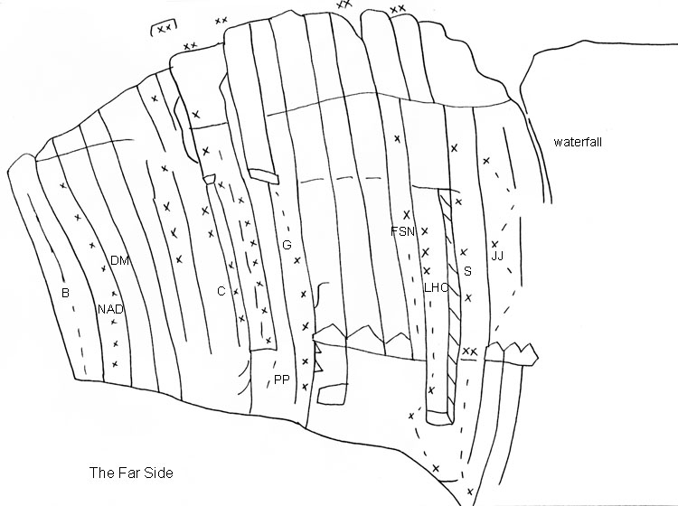
The Far Side Buttress 19 Jay Kinsman '94
The crack up the centre of the buttress.
New Age Deceit 21 Andrew Macfarlane '94
Some 'Scottish' style bridging to reach the upper groove, use 3 bolts on right.
Dubious Means 24 Andrew Macfarlane, Murray Judge '94
A fine bridge with some tricky finger work makes the crux.
The Contortionist 22 Murray Judge '95
The start was easier before the block fell out, bridge and chimney in the groove then move left at the roof and left again on the upper wall.
Pain and Pleasure 24+ Murray Judge Aug '94.
(Formerly called Weta). The finger crack has fallen off but the rest of the route is still as hard, lead with three rests.
Gecko 21 Murray Judge '94
Up a bridging groove to the roof, step right to the crack and hand traverse back left above the roof then up a shallow corner.
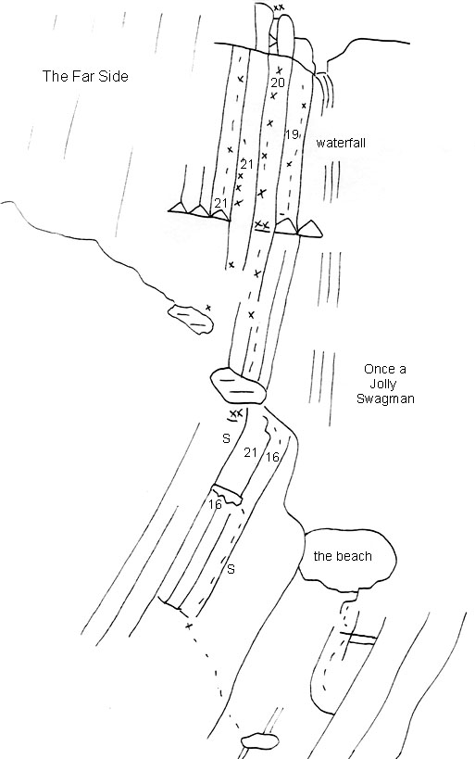
The Far Side of Never 21 Andrew Macfarlane '95
Pull through a small roof into the groove, using the three bolts on the right.
The Longest Hardest Climb 21 Murray Judge '94
Abseil in, climb up right of the roof and up the shallow crack to the ledge before traversing left to the groove.
Once a Jolly Swagman 16,16,20 Murray judge, Andrew Macfarlane '95
A popular three pitch route close to the waterfall, start at the pool and scramble up left to a single bolt belay, climb the easy groove to the break and hand traverse left to the upper groove (original line) or continue up the groove and traverse at the top.
Pitch two crosses the bushy ledge to a layback start, tending right up the cleanest rock to a step left at a bolt.
Pitch three follows a superb groove to the ledge and left up broken blocks.
It can be descended in two rappels but probably safer to make three and avoid the swing under the waterfall.
Where's My Jolly Jumbuck? 19 Murray Judge '95
Starts from the last belay of Swagman, traverse right and up the next groove to rejoin the route at the ledge, Andrew Mcfarlane followed directly up the crack at (21).
Koala in a Coolibah Tree. 21? Sam Bossard '95
A finger crack from the start of the hand traverse on pitch one of Swagman.

East Pinnacle
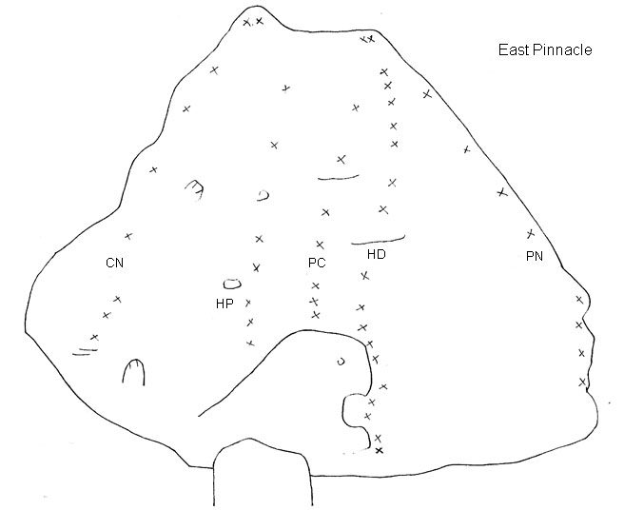
Crunchie Nuggets 16 Wayo Carson '94
Move right up the lower wall then follow the arete.
Hokey Pokey 19 Murray Judge '94
Start up the ramp then straight up a short wall on small holds.
Pixie Caramel ?? Murray Judge '94
Up the ramp and around right to a shallow groove.
Hound Dog 20 Murray Judge '94
Climb the front of the doggie flake, with lots of quickdraws!
Perky Nana 16 Toby Judge '94
Bridge the lower wall and step up onto the arete, climb a slab to the top.

Central Pinnacle
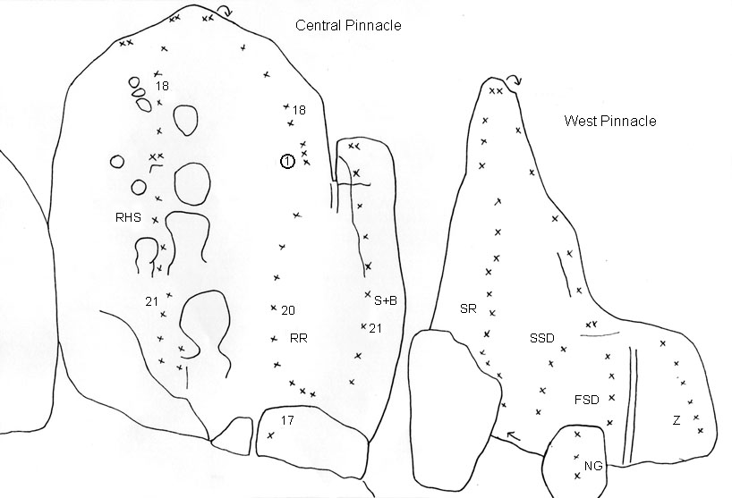
Rocky Horror Show 21,17 Andrew Mcfarlane, Murray Judge '96
Climb into the bottom of the first scoop, traverse L below a roof and up the overhanging pillar on the left of the scoops.
Rocky Road 17,20,18 Murray Judge '94
Exciting climbing on the steep second pitch, even when the holds stay on!
Send the Bill 21 Murray Judge '96
Right of RR to the shoulder, second pitch of RR to finish.

West Pinnacle
Soap on a Rope 17 Pete Illingworth '94
Starts behind the small pillar near the stream.
Same, Same but Different 17 Sash Nukada '95
Finish at the belay on the shoulder.
Fresh Start, Dude 22 Jason Crichton '95
Just left of the water streak.
Zephyr 15 Wayo Carson '95
A bit of a breeze
Cloak and Dagger 14 Murray Judge '94
On the back of the Pinnacle, four bolts to the abseil point.
Nameless Girl 16 Sash Nukada '95
A short arete on the boulder.

Hut Pinnacle
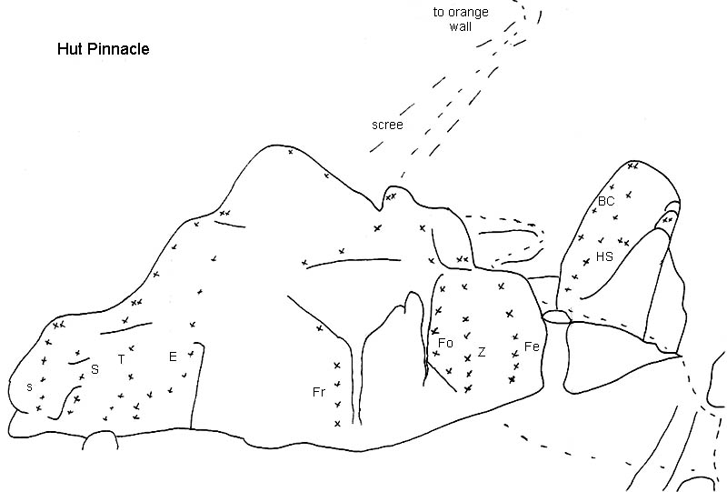
Strong 16 Murray Judge '94
Silent 17 Murray Judge '94
Type 17 Murray Judge '94
Eh 22 Murray Judge '94
Frisky 19 Murray Judge '98
Foxy 22 Tom Riley '98
Zesty 23 Murray Judge '95
a fine climb on small holds.
Feisty 25 Wayo Carson '95
another fine climb on small holds.
Bart's Climb 12 Geoff McLennon '95
On the slanting pinnacle up to the right.
High Step 20 Tim Green '95.

Christian Principals Crag
The prominent crag on the ridge above the East Pinnacle
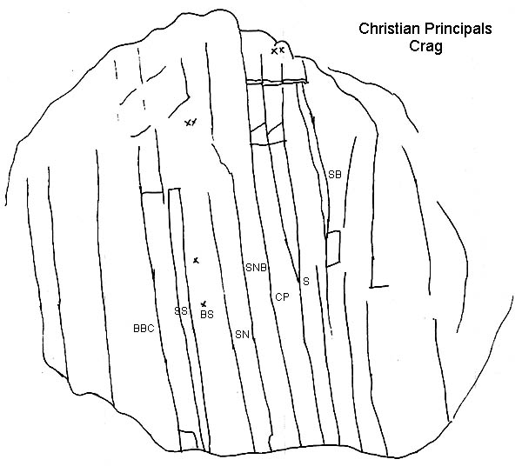
Bring back the cane Murray Judge '98
crack to the left of the groove
Sunday School Felching 16 Chris Burtenshaw '95
climb tge cracks in the groove to the left of the broad arete.
Buns of steel 19 Murray Judge '98
two bolts on the broad arete.
Screams in the Night 17 Sean Waters '95
takes a small sharp arete then moves onto a wall on the right with an obvious crack system, loose at the top.
Sleeping with the Nasty Boys 16 Sean Waters '95
Takes the left hand of the two prominent ribs in the centre of the crag.
Corporal punishment 16 Tom Riley '98
the right arete, tending R at the top
The Staircase 17 Chris Burtenshaw '95
Starts up the groove capped by a small roof and takes the roof at a small bush on the right.
Six of the Best 17 Murray Judge '98

The Meat Grinder Wall
100 metres up the hill is a short crag with two prominent ribs in the middle.
A Springtime Festival in Autumn 17 Sean Waters '95
Takes a very blunt arete split by a crack, to a wall above with an obvious crack system.
Spare Rib 14 Chris Burtenshaw '95
Two metres right of above, takes the left hand of the central aretes.
Misty Mountain Hop 17 Sean Waters '95
Four metres to the right, takes a broad arete with a groove.
Porno Star 16 Chris Burtenshaw '95
Round the corner to the right, the right hand of the two grooves.

Fog Buttress
On the ridge above the West Pinnacle (across from the Far Side Crag).
Terrible Tales of Teenage Angst 20 Sean Waters '95
Yummy finger crack and the arete on the right, loose at top.
Parthenope 16 Chris Burtenshaw '95
Scrumptious hand crack.
Bucket of Fino 16 Grant Piper '95
Two metres right, starts in a prominent groove then right to bush at the top.
Foggy Notion 15 Sean Waters '95
Two corners to the right is a groove on the upper wall. Starts right of a roof and goes up left of another small roof.
Watch the Itchy Gobo Blow 13 Chris Burtenshaw '95
Takes a small arete on the lower half of the wall to a ledge.
Scuttle 13 Sean Waters '95
Takes the arete to the right.

Maiden's Relief Stream
The pools over the first saddle on the track above pinnacles hut (15 Mins). Climb up the track beside the waterfall and traverse in to a short wall, climb down to the stream at the top of the falls.
un-named 14 Murray and Bronwyn Judge '96
Four bolts up the slab
un-named 12 Murray and Bronwyn Judge '96
Just round to the right 4 bolts.

Honey Comb Rock
Over the saddle from Pinnacles Hut, follow the track down past where it crosses the stream and look up and left, Honeycomb Rock has some delightful solid juggy moves.
Bit of a Buzz 17 Tony Pine '97
3 bolts to belay on left.
un-named Murray Judge May '97
Start in an alcove, swing R and up to the top overlap. 3 bolts.

Woolshed Creek
the cliffs above Honeycomb Rock
un-named 19 Murray Judge, Tony Pine, Sam Brooks '97
The thin arete towards the right end of the upper tier of cliffs, 5 bolts to belay.

