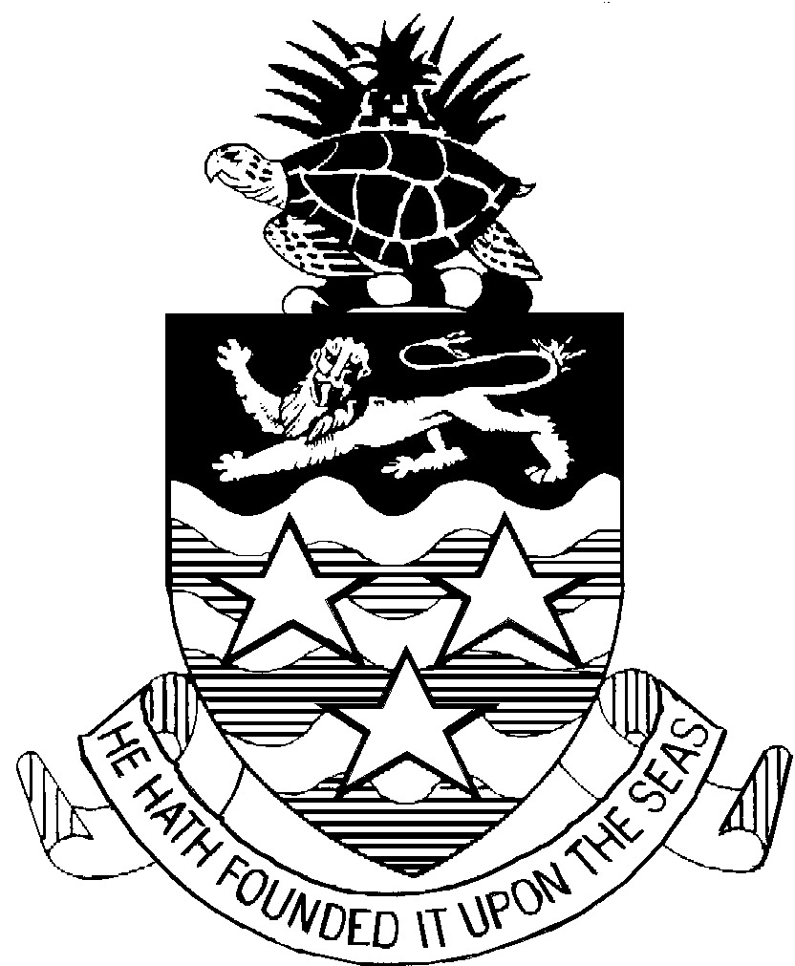

CAYMAN ISLANDS

DEPARTMENT OF AGRICULTURE

INFORMATION

FOR THE IMPORTATION OF PLANTS & PLANT PRODUCTS

The Department of Agriculture requests your co-operation with respect to the importation of fruits, vegetables and plants. The Department wishes to inform you that the Plants Law, 29 of 1983, requires that a plant Import Permit must be obtained from the Department prior to the importation of any plant or plant product into the Islands.

- A written application to obtain this Import Permit must be made on a form supplied by the Department in advance of procuring the consignment for importation.

- Applications will be processed within 72 hours of receipt of fully completed forms.

- 48 hours notice be given to the Department of Agriculture prior to the landing of such imports.

- The requirements for entry as stated on the Import Permit must be met, absolutely.

- The "Plants" are subject to inspection by the Chief Agricultural and Veterinary Officer or any person authorised by him.

- Cut flowers, fruits and vegetables or any plant product for consumption must be free of soil, pest, disease or signs of pest damage. Pre-treatment with harmful or poisonous chemicals is not recommended.

- Specific pre-treatment conditions are required for the importation of plants for propagation. You are advised to contact the Department of Agriculture for more information.

Your co-operation in the above matters would go a long way in assisting the Department with its efforts to control the introduction of pests and diseases into the Cayman Islands.

