Attention : Perodua Management,

I used to be one of the satisfied Perodua customers. I own a Perodua Kenari and I’m still a proud owner of it. When Perodua launched its latest Myvi, I decided to book 2 cars, one for my brother and another for me. I was very impressed with the design and its features.

I went to several Perodua showroom’s around to compare the benefits and deals which was given. Upon further research I discovered a showroom which offered me a good deal and I immediately book 2 Myvi’s from the company. In fact, I also introduced a few of my friends to booked from the company which was:

RODA KAYANGAN SDN BHD.
L1-11 & 12, Block B, Jalan TK 1/11D,
Taman Kinrara,
Section 1, Bt. 7 1/2, Jalan Puchong, 58200, KL.

When I arrived at this branch, I met with the top sales person stated at the time, which was Peter Cheah. After explaining and briefing me with the Myvi, we agreed on some benefits and deals he could give me. The terms are as follows =

- RM 300 discount
- Free Astro
- Free Sandblast
- Free steering lock
- Full petrol tank
- Free sunblock

He promised me that he could give me these “freebies” and I believed his word as he was the top salesman at that time. He also told me that if he should resign he would designate his collogues to give me these freebies. He wrote the list in the showroom itself behind the official receipt.

I was informed that the car will arrive in 1-3 months. After 3 months, they delayed me by saying that the production of the car is insufficient and I needed to wait for another 1-2 months. I had patiently waited for the next 1-2 months, and they said that I need to wait again.

I was already unhappy with this, and after several complaints, the car finally arrived and I was to settle the payments and procedures on 17th Dec 2005. When I went to the showroom, the salesperson, Peter Cheah was no longer working there.

Another sales person served me and I signed the agreements and follow the procedures as usual. When we asked to settle the “freebies” the sales person could not answer us and he informed his branch manager about this matter.

I waited for some time and Mr. K.S Low, which is the manager of the branch, finally came and talked to us about this issue. Mr. Low was rude to me as a customer and asked to wait several times.

I request to get this offer which was agreed between the sales person and me as a customer because that is why I booked the car from this particular branch. There are plenty of Perodua showrooms near my area which I could have gone to. Mr. K.S Low did not listen and try to solve the situation and even threatened to delay my delivery by giving the example as below:

(Mr. Low's example)
There are two customers. Customer A and customer B. Customer A gets some discount while Customer B buys at the full price. When the car arrives if I’m the salesman who should I give first?

I was very upset with such example which was totally unrelated to my situation. In fact this was voiced this out in front of my father and my brother who was at the showroom at that time. He also disrespected me and asked why I did not ask Peter Cheah to sign behind the official receipt to clarify that it was an offer given by him.

I find this is ridiculous and he is being very rude to me as a customer. It was supposed to be a clear trust and understanding between me as the customer and the salesperson which was the representative of the company. Once again as I have mentioned, Peter Cheah was the top salesperson at that time. This is not how it was supposed to done, I am just a customer and I have even booked a few cars from this branch.

I would like to express my dissatisfaction towards the manager, Mr. Low which was not professional at all in handling this matter. I would like the attention of Perodua Management and proper personnel of RODA KAYANGAN SDN BHD to resolve this issue immediately and propose to me a reasonable solution. This has been a very unpleasant experience for me as a customer and I have lost trust in this branch and the management team.

Please investigate this issue as this is very unfair to me as a customer to receive such unprofessional attitude from Mr. Low (manager of RODA KAYANGAN SDN BHD.).

Below are some attachments of the documents.

Front view of the recipt.
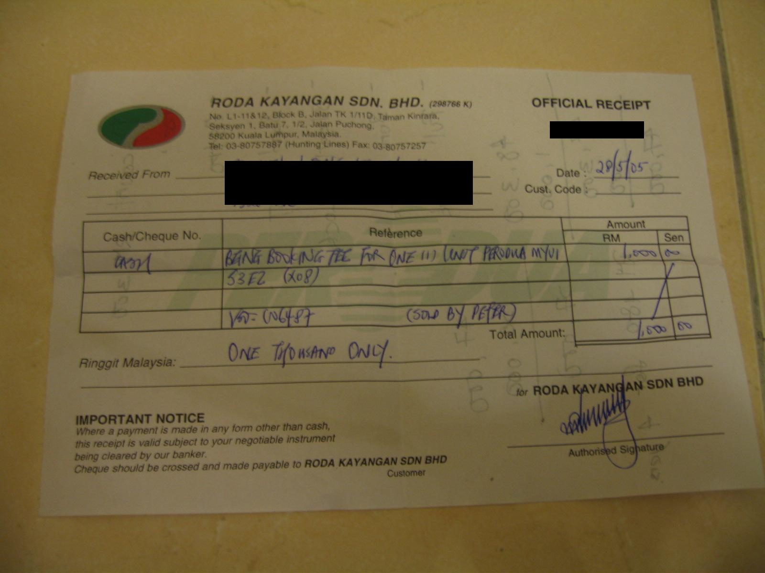

Back view of the receipt. (Wrote by peter)

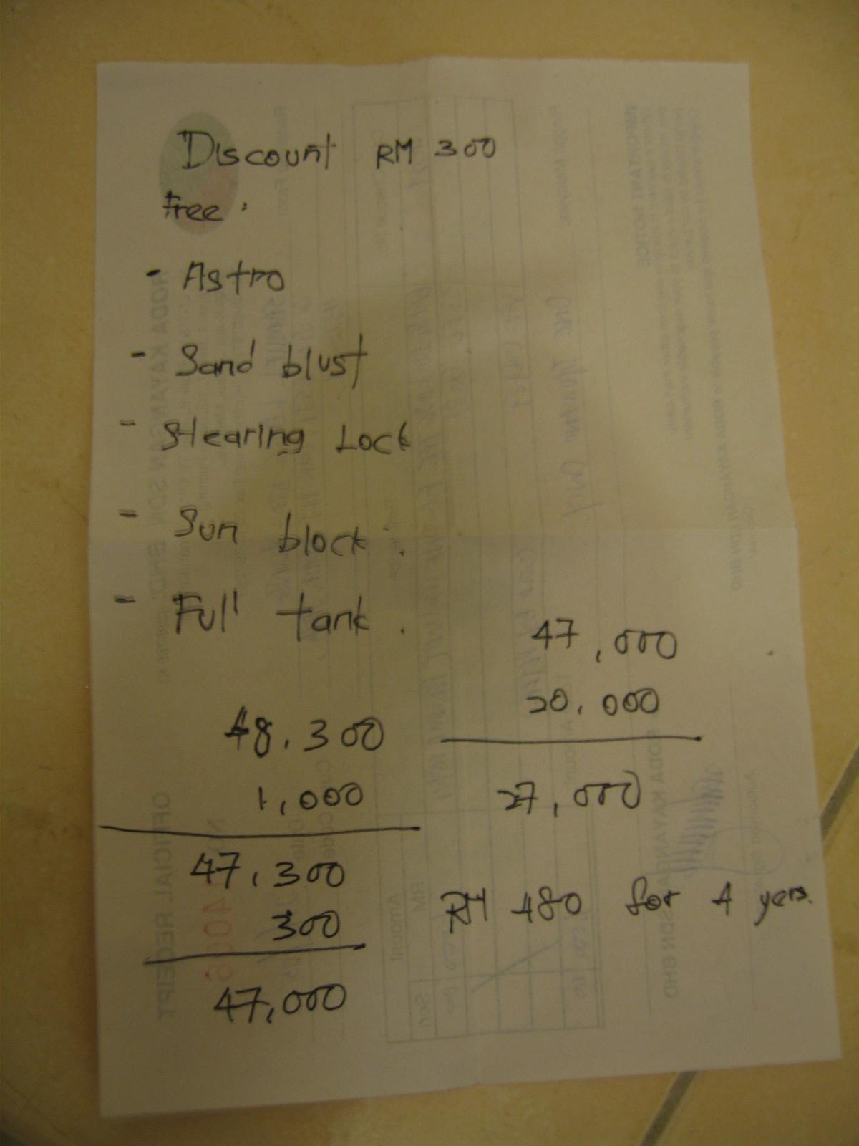

Peter’s name card (Clearly shows he’s working as a representative of RODA KAYANGAN)

