Gopysh Gopalakrishnan

3, Welcome Nagar, Porur, Chennai - 600 116
Tamil Nadu, INDIA.
Phone: +91(44)22520874.
E-Mail: gopysh@hotmail.com
Home: www.geocities.com/gopysh

Presently in Dubai - +971 50 3520278

Personal Information

Indian, Born on 12th June 1974, Male, Single

Objective

To architect Information Technology solutions capitalizing on Internet and cutting-edge technologies to provide competitive advantage.

Technical Skills

Internet
HTML, Java, JavaScript, VBScript, Active Server Pages, ActiveX, IIS, Certificate Server. Index Server, Transaction Server, Site Server. Windows DNA.

OS Platforms
Windows NT 4.0 (MCSE), Windows 9x, Novell lntranetware 4.11 (CNA), UNIX (UnixWare / SCO), Windows 2000 series and Solaris 2.6 / 7

Backend Databases
SQL Server 6.5(MCP), MS - Access, Sybase 4.0, Oracle 8.0 (on NT / SCO Unix / Solaris 2.7)

CRM/CTI Packages
Quintus eCRM Suite (now called Avaya Interaction Center), ServiceSpace.com eCRM package, EASYPhone CTI, Lucent ICC CTI, Nortel Symposium Agent, Nortel Symposium, Apropos

Telecom (PABX)
Nortel Meridian Series PABX, Avaya Definity PABX

Telecom (IVRS)
Nortel Periponics, Avaya Conversant

Transaction Servers
BEA Tuxedo 6.5 (Client Side), MS MTS, TIBCO (Client side)

Application Servers
Microsoft Transaction Server

GUI Tools
Visual Basic 5.0(MCP) & 6.0, Crystal Reports, FoxPro

Professional Experience

S.No. | Employer Name | Position Held | Employment Tenure
1. | Wipro Infotech Ltd  Bangalore, Karnataka | Technical Specialist | Feb 2003 – Till Date
2. | Wipro Infotech Ltd  Bangalore, Karnataka | Sr.Systems Engineer | Feb 2002 – Feb 2003
3. | Servion Global Solutions Ltd  Chennai, Tamil Nadu | Domain Specialist | Jun 2001 - Feb 2002
4. | Servion Global Solutions Ltd  Chennai, Tamil Nadu | Project Leader | Jun 1999 - Jun 2001
5. | Servion Global Solutions Ltd  Chennai, Tamil Nadu | Software Programmer | Mar 1998 - June 1999
6. | New Century Leasing & Invts Ltd.  Chennai, Tamil Nadu | Software Developer | Jul 1996 – Feb 1998
7. | Deve Annapoorna Foods & Beverages Limited  Chennai, Tamil Nadu | Software Programmer | Jun 1995 – Jul 1996
 |  | Total experience | 8+ years

Academic Credentials

Bachelor of Business Administration B.B.A from Madras University, Chennai, INDIA
Achieved Certification in May 1996

Professional Affiliations/ Certifications / Semainiers

Apropos CIM Certified Professional | Apropos Technology Inc, USA
Brain Bench Certified ASP Professional | Brain Bench Online Testing Agency
Microsoft Trained Windows DNA Professional | Microsoft Corporation, USA
Microsoft Trained Windows 2000 Professional | Microsoft Corporation, USA
Microsoft Certified Systems Engineer (MCSE) | Microsoft Corporation, USA
Microsoft Certified Solution Developer (MCSD) | Microsoft Corporation, USA
Microsoft Certified Professional (MCP) | Microsoft Corporation, USA
Certified Web Manager (CWM) | Novell Inc., USA
Certified Internet Professional (NCIP) | Novell Inc., USA
Certified Novell Administrator - (CNA 4.11) | Novell Inc., USA
Advanced System Management (ASM) | NIIT limited, INDIA.

Hobbies

Electronics, Reading & Music

Areas of Interest

CRM / Call Center Application Software Designing & Development and Web technologies.

Reference

Furnishable upon request.

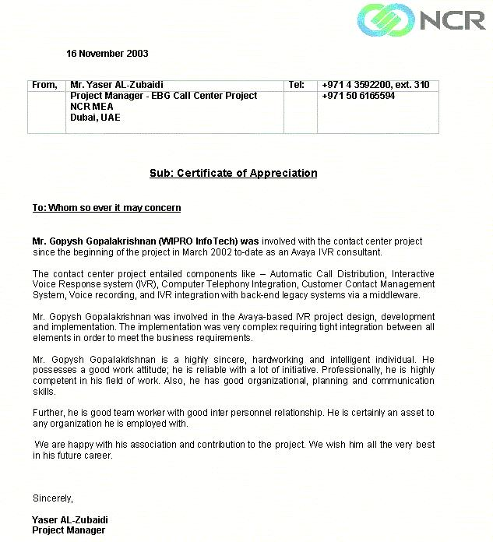
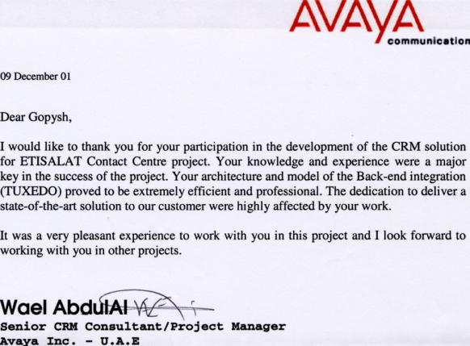
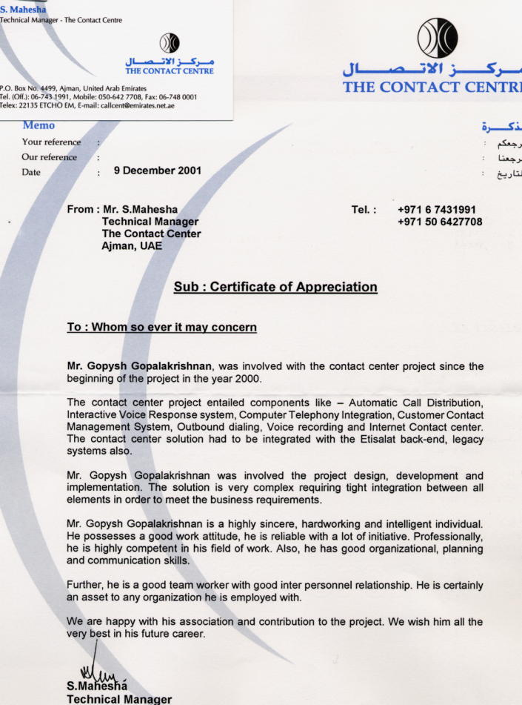

PARTIAL LIST OF PROJECTS

BUZz Contact Center – Dubai – Phase II

Client: Emirates Bank International
Duration: September 2003 – January 2004
Role: Integration Specialist
No. Of persons in team: 3

Project Description:

PHASE II of Buzz Contact Center Solution

Please Call is a banking call center implemented for Emirates Bank International (UAE Government), Dubai.

The project comprises of Avaya Conversant (UCS 1000) IVRS, TIBCO Middleware, Cincom eCRM and Avaya Definity PABX.

The phone banking IVR resides behind a Definity PABX and provides access to banking transactions like balance inquiry, funds transfer, utility bill payments and the like. The TIBCO Interface middleware communicates with Equation on AS400 and CardTek Host to get information about Accounts / Loans / Credit Cards / Debit Cards and Lucky Draw. The IVRS communicates to the Cincom Server through TCP/IP Sockets and with Definity using ASAI Link

Network International and Diners Card Call Center – Dubai

Client: Network International and Diners Card
Duration: January 2003 – July 2003
Role: Project Leader
No. Of persons in team: 4

Project Description:

NI is the sole credit card acquirer for all VISA and Master cards issued in UAE. It is also the Diners Card provider for the country. NI is one of the group companies under the Emirates Bank Group (UAE Government), Dubai.

The project comprises of Avaya Conversant (UCS 1000) IVRS, TIBCO Middleware, Cincom eCRM and Avaya Definity PABX.

The phone banking IVR resides behind a Definity PABX and provides access to banking transactions like balance inquiry, funds transfer, utility bill payments and the like. The TIBCO Interface middleware communicates with Equation on AS400, VisionPlus, Base24 and CardTek Host to get information about Accounts / Loans / Credit Cards / Debit Cards and Lucky Draw. The IVRS communicates to the Cincom Server through TCP/IP Sockets and with Definity using ASAI Link

NBK Call Center – Kuwait

Client: National Bank of Kuwait
Duration: October 2002 – December 2002
Role: Integration Specialist
No. Of persons in team: 3

Project Description:

NBK CC is a banking call center implemented for National Bank of Kuwait (Kuwaiti Government), Kuwait City.

The project comprises of Nortel Periphonics IVRS, SNA Server (Host Integrator) Middleware, Cincom eCRM and Nortel Meridian PABX.

The phone banking IVR resides behind a Meridian PABX and provides access to banking transactions like balance inquiry, funds transfer, utility bill payments and the like. The SNA Interface middleware communicates with Equation on AS400 and CardTek Host to get information about Accounts / Loans / Credit Cards and Debit Card. The IVRS communicates to the Cincom Server through CTConnect and with Meridian (via Symposium) using Symposium Link

BUZz Contact Center – Dubai

Client: Emirates Bank International
Duration: March 2002 – June 2002
Role: Integration Specialist
No. Of persons in team: 6

Project Description:

Please Call is a banking call center implemented for Emirates Bank International (UAE Government), Dubai.

The project comprises of Avaya Conversant (UCS 1000) IVRS, TIBCO Middleware, Cincom eCRM and Avaya Definity PABX.

The phone banking IVR resides behind a Definity PABX and provides access to banking transactions like balance inquiry, funds transfer, utility bill payments and the like. The TIBCO Interface middleware communicates with Equation on AS400 and CardTek Host to get information about Accounts / Loans / Credit Cards / Debit Cards and Lucky Draw. The IVRS communicates to the Cincom Server through TCP/IP Sockets and with Definity using ASAI Link

ETISALAT CONTACT CENTER - Ajman / Sharjah

Client: ETISALAT (UAE Telephones/ISP/GSM/Cable TV / Multimedia)
Duration: August 2000 – December 2001
Role: Addl. Project Manger
No. Of persons in team: 18

Project Description:

Etisalat (UAE Government) is the sole service provider of Internet / GSM / Telephones / Cable TV and Multimedia in UAE.
The Contact Center is a nationwide single point Contact Center for all Etisalat Customers. Etisalat Contact Center is the largest call center (600 Agents) in the Middle East-Africa region. This call center also provides third party call center (Application Service Provider)

Highlights:
- National Call Center
- 500 Agent Main Call Center (Ajman)
- 50 Agent Backup Call Center (Sharjah)
- 100% Fail over Configuration
- 24x7 Call Center
- Zero Single Point Failure
- Combination of 3 CTI’s
- Provision for Third Party Call Center (ASP)
- Currently the call center handles 80,000 calls per day

CTI

- Quintus eCRM (Core CRM Package) on Sun Ultra Enterprise 450 (Solaris 7)
- EASYPhone CTI (Outbound and Recording) on Sun Ultra Enterprise 450 (Solaris 7)
- Lucent ICC CTI (Mail / Fax and Chat) on Windows NT4.0 Server

Backend

- Tuxedo (middleware) - Gateway to Corporate DB
- Oracle 8i(Backend) - Maintains the Contact related history

PBX / IVR / VM

- Lucent Definity (Telephony Switch) G3 Si
- Lucent Conversant (IVRS) Map 100 V7
- Lucent Intuity (Voice Mail)

3rd Party Integration

- CDMS (Legacy Database)
- EIM (Legacy Database)
- E-Vision (Legacy Database) and Oracle Forms
- Lotus Notes (Corporate E-Mail Server)

Agent Desktop

- Quintus Integrated Desktop on Windows NT WS /2000

Call Central

Client: Bank of Punjab
Duration: April 2000 - August 2000
Role: Project Leader
No. Of persons in team: 7

This is now productised under the name of Servion @finity

Project Description:

Call Central is banking call center product implemented at Bank of Punjab, Delhi. The product comprises of a phone banking system, CTS Interface (host interface middleware), CTI interface, e-CRM and agent desktop software. The phone banking IVR resides behind a Lucent Definity and provides access to banking transactions like balance inquiry, funds transfer, utility bill payments and the like. The CTS Interface middleware communicates with Bancs 2000 using ODBC enables on-line transactions using ISO 8583 and communicates with the Depositories Host over ODBC. The CTI interface is developed using CTConnect APIs and communicates with the Lucent Definity using ASAI over TCP/IP.

The e-CRM integrates the various call center modules, manages the workflow, generate reports, provides Bulletin Board Service, agent chat, provides back-end escalation, supervisory assistance, customer search, call history, notes and initiates browser based screen pops. The agent desktop software allows customer verification via security questions, allow agents to perform transactions on caller request, provide account, loan and demat information.

The project is implemented using technologies like ASP, VB, Style sheets, Jscript, ActiveX, IIS, Index Server, and MTS etc.

Response Edge

Client: Solutions Integrated Marketing Services
Duration: February 2000 – May 2000
Role: Project Leader
No. Of persons in team: 6

This is now productised under the name Servion Response Edge

Project Description:

Response Edge is a complete national third party call center solution for 3Com, IBM, COMPAQ and other IT giants outsource to SIMS. The solution encompasses the front-end switch interface, Servion CRM and agent screen software. Calls from different parts of India are routed through leased lines and terminated on the Lucent Definity. A CT Connect based CTI middleware over ASAI bridges the call and data networks over the call center. The Servion CRM enables the call center administrator to create, modify and remove campaigns and associate agents dynamically, specific to campaigns. The Servion CRM also enables knowledge bank update for the agents and administrator, provide voice mail options for agents and generate dynamic reports as per specific campaign requirements.

PruPhone Call Center

Client: Prudential ICICI
Duration: October 1999 – January 2000
Role: Project Leader
No. Of persons in team: 4

Project Description:

This software was developed for NBFC. The project is a IVR based Call Center. The customer calls the pruphone to retrieve his account information, obtain NAV information, perform redemption either through phone or through any of the Customer support officer available. Whenever a customer requests for a transfer to the CSO the customer history is displayed on the CSO’s terminal. The CSO can provide additional services viz., Switch transaction, Detailed Transaction history, information about new funds, Address change, Release Locked Pins, Redemption of funds etc.

The Customer Management Interface allows the admin to import new data from CAMS into the live database using MAPI, view reports, generate and print TINs, update NAV information that comes from MFISC package. All the transaction of a particular day are exported to a FoxPro database, zipped and sent to CAMS automatically by automated email application using MAPI.

This software is developed using Visual Basic 6.0 with Oracle 8 on WinNT 4.0, FoxPro, Oracle on Solaris 2.6, Media soft (Dialogic Platform) and C programs.

