Mordance

art, poetry, story by Tourmalin

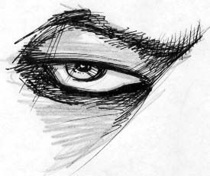

"my candle burns at both ends, it will not last the night,
But ah, my foes, and oh, my friends, It gives a lovely light."
- edna st. vincent millay.

Dedicated to all my buds, you know who you are, and those who choose beauty and freedom over violence and hate. My love is with those who struggle against concrete walls and hunger for liberty against outright oppression. disdain those who claim to know the answers, who threaten to chain your breath. we know right from wrong.

Mordance
By Tourmalin

Chapter One

“Ta den ring og la den vandre…” whispered a strong, foreign voice.
There was a faint sound of a splash into the black waters off the dock. Somewhere at the bottom of the harbor, a white gold ring was floating to rest on the sandy floor. The figure standing at the dock’s edge took a sigh and a slow puff on the remains of his cigarette. Then he turned around and headed back towards the light of the city.
At first glance from the moonlight, he looked like any other young man, perhaps someone with a modern sense of fashion. But in reality, he knew nothing of what was fashionable, or modern. Upon closer look of his face, there was revealed a stunning beauty—something like that of a sad, gothic angel. His raven hair reached in uneven wafts to as far as his chin. His skin was a fine, pale alabaster. His eyes, smokey and heroin chic resembled the natural eyes of a wolf. Their irises shown bright like amber-hazel jewels-- brilliant and attractive against the shady lids of his eyes.
It looked as if he had just come from some place at the last moment. He did not have a coat on, yet it was quite cold outside. He was simply dressed in black. His shirt stretched enough to reveal a fairly stocky build and slim frame. He stood no more than 5’ 9”, but his presence seemed far greater.
It is perhaps hard to explain the nature of his beauty. He looked young, almost adolescent, but matured. His eyes were absolutely piercing; he was the sort of soul that could draw both sexes. Although he looked quite masculine, down to the very stubble outlining his strong jaw, he was beautiful like a naturally gorgeous woman is, equally sensual and romantic. And as the case is, beautiful women can be made; beautiful men are rare.
Something was troubling him. He walked more quickly when he reached closer to the center of downtown. Plenty of drinkers and partygoers were strewed about the streets like stray cats, laughing loudly. There was music and smoke and prostitutes and the greasy food smell of all-night vendors.
His eyes were roaming and assertive as he made his way through the crowds of tattoos and obnoxious laughter and high heels. Eventually he came across a small club/bar in a dark alley set off from the bright walks of the busy streets.
This place, lit by a few bluish fluorescent lights, had no loud music or persons hanging outside with plastic cups of beer. There were only the faint sounds of jazz and the taming, soulful pleasure of a black woman’s voice, reminiscent of Miss Holiday herself. He sat down carefully on the concrete steps under one of the black windows that were lit up by just a few commercial neon signs. He looked especially fascinating bathed in the blue light. He lit up another cigarette and quietly seemed to ponder, his hand holding up his chin as he sat with his knees up and close to him.
It was some time of silence as he sat by himself. About every ten minutes a couple would leave, or a few friends would enter. Although they noticed him, he remained oblivious. It wasn’t until about three-thirty in the morning that out of the darkness of the bar’s doorway a woman appeared. She stepped out onto the stairs, and after she recognized the huddled mass below, she smiled and moved to sit beside him.
He looked up at her and gave a rather tired smile. She, on the other hand, showed she was quite surprised to see him.
“How long have you been sitting here?” she exclaimed rather hoarsely. She had on a regular white T-shirt and jeans, and it wasn’t hard to figure out that she was a bartender for the club. She didn’t look like the clubbers. Her hair was tied up into a frizzled bun of natural blonde hair. She was developing the signs of having worked all day and into the night. But luckily, since she didn’t wear any makeup, she was able to retain a look of natural strength.
“Not long,” he exhaled.
“Something bothering you, Tad?” she asked, genuinely concerned.
“Not sure,” he answered, taking a long, thoughtful drag from his cigarette. His voice was strong and rough but soft and toned. There was a touch of accent, perhaps Nordic. He looked around the alley, the streetlights highlighting his face and sad eyes. “This place is…”
He sighed and shifted, looking restless, and then looked oddly into her eyes.
“It’s killing me,” he said. He shifted again and sniffled loudly, trying to ease his discomfort.
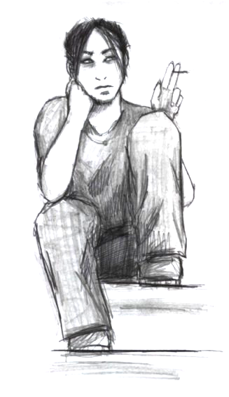
“Tell me about it… What? Do you wanna go do something? Go somewhere or something?” she asked, trying to keep her cool-- to keep from sounding too excited. She was drawn to him like any other.
“I dunno,” he sighed, puffed, exhaled thoughtfully, and glared at the sky, squinting his eyes. “There’s gotta be something better than this.”
He looked down, and put his cigarette out on the steps. He then just stood up, and shivered, shoving his hands down into his pockets. She looked up at him, a bit startled.
“What ya gonna do?” she asked quickly.
He squinted again and looked around. “Don’t worry.”
He grinned optimistically. Even his smile looked as if it were silver—a beautiful smile that was vampire-like, inviting, and seductive. He was still fidgeting as she could only look up at him. She stood up finally.
“Well, I hope ya feel better,” she managed, crossing her arms and shivering. She wanted to hug him, but he seemed like he was miles away.
He looked up at her with gleaming, bright eyes. He stepped a bit closer to her, tilted his head slowly and kissed her on the cheek.
“I’ll be fine,” he said. He then just turned and walked off.

She just stood there, watching after him, until he disappeared from view, too far to call out to or touch.

He found himself wandering around downtown once more and decided to walk into a bar where there seemed to be a lot of people. He felt like he just wanted to be lost.
He found a seat by the bar and asked for vodka. It wasn’t too long before someone else came up beside him and sat down. It was some older guy, somewhere in his thirties. He sat down beside him with a beer.
“You don’t even look old enough to drink. What’s your name, kid?” the man asked in a drunken garble.
The drunken man was met unexpectedly by the piercing eyes that looked like a fair blue-green in the bar’s light.
“Thaddeus,” he responded with a grin, to soften the air.
The drunken man stared at him. He realized this and after a moment he quickly turned to his beer.
“So what ya doing around here. Only us losers come here,” the man chuckled and sighed loudly.
Thaddeus wasn’t paying much attention. He was busy looking into his small glass of vodka. It was shining like some sort of mystic spring water. He was slipping into daydreams, drifting into his own world. The drum of the club music mimicked his heartbeat and he felt rage, unfocused rage. But he couldn’t get a handle on it. He felt a touch on his shoulder and jerked away.
“Take it easy there, kid,” the man beside him said. “No reason to be jumpy.”
Thaddeus looked back at his drink and tipped it back. He chugged it quickly and slammed the glass back down. His body felt a tense and he winced a bit from the strong burn the vodka had run down his throat.
The drunken man gave a loud short laugh. “Now there’s a start! But you ain’t gonna last long like that. You’re a little guy!” he laughed and returned to his beer.
Thaddeus continued with four more glasses until a woman approached him. By that time, the drunken man was gone, and Thaddeus never noticed him leave. So when he saw the woman sit down beside him, he was caught off-guard.
“Hello there,” she smiled at him.
Thaddeus just glanced over with tired eyes. The bright clarity had since faded leaving a clouded gaze. He only stared at his glass that had just a bit left that he was swirling around.
She pulled herself up a bit closer and looked at him curiously. She herself had obviously been drinking but she seemed pretty assertive. She had a bit of quiet class, like she knew a lot of things, seen a lot of things, but wasn’t as cynical as the rest of the world.
“You look like you could use a friend.”
He looked back at her. “What’s your name?” he asked quietly. He now had turned himself toward her and watched her with empty eyes.
“Lillen. You can call me Lily if you like. It doesn’t matter much to me. And you?”
“Lillen,” he repeated slowly like a child would. “Do you want to get out of here? We can…” He suddenly lost thought.
“Where do you want to go?” she kind of laughed. She gave off a feeling of understanding, like a mother has.
“Just…” he started. His mouth gaped, trying to find words. She noticed he had considerably larger canine teeth, giving him the definite impression of a vampire. She thought it weird but figured it was probably one of those fads.
“Come on, I’ll get you out of here,” she said getting up and taking money out to leave as a tip.
He got up carefully but still without grace. She guided him out of the bar. They stopped for a moment outside. Dawn would be there soon; the sky had assumed a gloomy grey. It was still quite cold, enough to show their breath.
"You don't even have a coat," she remarked. "Can you walk alright?"
"Course," he answered with the mock confidence of drunkenness.
They walked several blocks and eventually came to an apartment building where she led him inside. There was a short elevator ride, and they finally came to her place.
Once inside, she left him for a moment to do a few quick things like checking the answering machine, putting away her coat. He stood there looking about him and then wandered around a bit. It was quite gorgeous. The place seemed so warm. It must have been the colors -- warm gold fringed dark, blood and plum. There was Victorian -style furniture and walnut trim. There was velvet and mixes of violet, peach, and deep blues.
He slumped down into a loveseat and pretended to be preoccupied. She came back into the room.
"Do you want something? Like to drink, but besides alcohol…" she said standing.
He looked up and squinted at her. "Nice place."
"Yeah, thanks. It's a haven for me, " she said in a kind of perky voice. She then sat down beside him.
He immediately moved in closer to her.
"What was your name again?" he asked quietly and hoarsely but with definite seduction. He moved in closer and tilted his head to kiss her on the neck.
She moved away, got up and sat in a nearby chair.
"What are you doing?" he asked, surprised and angry.
"You're still drunk, dear. You're not fully capacitated, " she giggled.
He groaned and sighed with aggravation.
"What the fuck, then?"
She sighed. "Oh, calm down. I just wanted to take you away from that place and talk a bit. You looked like something was wrong."
He was growing angry, and growled. He got up, but too quick and tipped backwards. He caught himself and pushed himself up. He looked around, and turned around, looking for the door.
"Where the hell is the door?" he shouted at her. All of a sudden he had changed from quiet and mellow to some sort of caged, harassed animal.
She just sat there looking at him. She had a sort of grin on her face, a smile in the face of his foolishness.
"I think you could use a hot bath, maybe," she said to him calmly.
He turned to her and stared at her with mad dog eyes. "Don't fuck with me."
She frowned at him and sighed. "So angry…that must mean when you're not drunk, you're a pretty good guy."
He held his head and tugged on his hair.
"Hot bath?" she asked, getting up.
He just stood there and glanced up with confused eyes. She laughed goodheartedly and went off into another room. He could hear that she had started running water and followed after her like a lost puppy.
He leaned himself up against the bathroom doorway. It was brighter now and he could now get a somewhat better look. She had very long dark brown hair but it was wrapped up and braided. She was dressed in a mix of rich fabrics -- velvet, silk and wool. She looked very much like a princess, a velvet princess.
He watched her as she tested the water and poured in the bubble-soap. She then finally stood up and turned to him.
"All ready," she smiled.
He took his arm away from the doorway and stood apart. He wore a smirk on his face that tried to conceal his eagerness. He held out his palms in question.
"Well. Take off your shirt," she said brightly.
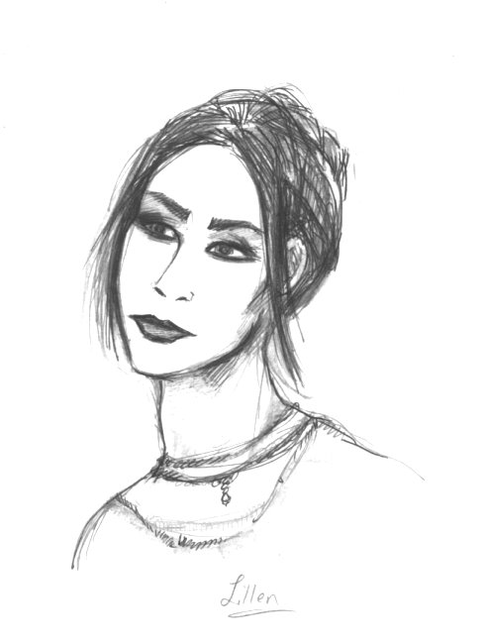
He did as was commanded. He would've continued with his stripping down except that he noticed that she was staring at his body. There was a glint of horror in her eyes.
There were scars all over, from his shoulders down to his forearms, and all along the sides of his waist. Most of them were old but some still looked pink and freshly healed. They were definitely from razor slices or very sharp knives.
"What the hell happened to you?" she let out against her shock. All of a sudden she felt really frightened.
He looked down at himself and was suddenly conscious. "A fight," he said curtly, trying to quickly dissolve his sudden feeling of inferiority and self-consciousness.
"What the hell kind of fight? What the…?"
"Just a fight." He was starting to feel aggravated now.
"Yeah, well you look like a fuckin'…I don't even know…Are you into drugs? I don't want to have nothing to do with that shit at all. I can't believe this…" She kept on rambling, visibly upset and shaking slightly.
He reached out his hand to her, but quickly retrieved it to put his shirt back on. He tried to think quickly of how he could diffuse his situation.
"I'm sorry. I forgot…Don't get so upset," he managed, but with bite. He was starting to sound calm -- sounding much like a child that had been yelled at.
"I..I can't believe this. That's awful. I…" Feeling overwhelmed, she rushed out of the room.
He watched her walk out, and he then realized she had left the water running. He knelt down beside the tub and shut it off. He stayed there for a moment. He was suddenly struck with a sick feeling. She was disgusted by him, so afraid she could hardly even speak. She acted as if he was a monster. His body felt tense, his chest was tight. His eyes were starting to burn with tears. He thought about this for a moment, trying to grasp it. But he suddenly became irritated and frustrated. Why did he even bother? He should've just stayed at the bar. What did she know? She was acting like a hypochondriac.
He came out into the other room and saw her sitting down smoking a cigarette. He sat down across from her and looked at her.
"I, uh…" he started, trying to restrain his anger. He sighed with frustration. "I don’t know what you want from me. I didn’t think it would matter."
She sighed and took a hard drag. "You know, I don’t know who you are," she said, waving her cigarette at him, "or what kind of trouble you're in. I saw you and figured you needed to get out. I figured you needed a friend. Guess it was a stupid idea."
He thought carefully, but anger was ruling. "I don’t need any friends. If I knew you wanted to be friends I wouldn’t have come with you." He thought some more. "Why the hell you want to be my friend? You don’t even know me… Goddammit." He held his head, now thoroughly irritated. "What the fuck?" He was restless.
She was looking away from him and tilting her head, trying to keep the welling tears from falling. There were a few minutes of sighs and silence.
"God, I just don’t know. You seem like a good guy, " she offered quietly.
"Well…I get fucked up from time to time. Damn. I just…" he started but lost thought.
"Ha. Time to time. People binge from time to time and you get knifed? What the fuck kind of sport is that? Shit, I dunno."
He looked to the floor. He was too tired to argue anymore. He wanted to sleep but knew if he didn’t resolve this quick he'd be sleeping in an alley tonight.
"I can explain but its getting late," he finally said.
"Yeah, it is. Huh… Do you even have a place to sleep tonight?" she asked, still annoyed, but concerned.
He shrugged. "Not really."
She looked at him carefully for a moment. "I'll get you some blankets then. I can trust you, right?" she asked, standing up.
"Of course, I’m not a criminal."
She started off to find blankets and get ready for bed.
"Lillen?" he called after her, and she turned around. "My name is Thaddeus, by the way. I…I'm sorry about all this. I can explain later if you really want."
"No problem…" she said stubbornly, but relieved. She turned back around. "No problem at all, Thaddeus," she added aloud with a touch of sarcasm.
He lied down into the loveseat and felt suddenly exhausted but physically relieved.

He opened his eyes to bright light. He got up quickly, shocked for a moment. Then he realized where he was, remembering last night. He groaned, and with effort he pulled off the heavy blankets that had been placed on him during the night. He sat up and held his head for a moment, trying to wake up. He stood up and lost balance. Gaining it back quickly, he stood up and stretched. He took a good look around. He noticed things now that he hadn't before, like the large windows that looked out onto the street. There were paintings of cherubs and medieval things.
He wandered around looking for where the girl might be. He found her still sleeping in a bedroom that was next to the bathroom. The room was dressed in white and there were vases of peach, yellow and red roses everywhere. He smiled to himself and rolled into the large canopy bed.
She didn’t respond, to which he cuddled up closer, wrapping his arms around her. This woke her up but only with a slight shock.
She smiled. "Well, good morning."
He kissed her on the neck playfully. "God morgen," he breathed. "Min honning kake."
She looked up at him with a furrowed brow. "What was that?" she laughed.
"It's…the language of love," he smiled.
They laughed for a moment and sighed.
"No, really. What the hell was that? It wasn’t no French. Are you German or something?"
"Not quite. Norsk…German? Hmmph," he said with fake disgust. Then he laughed. His laugh was deep, warm and rough.
"It's nice. Much sexier that French, anyway."
"Oh, really?" he said with exaggerated wide eyes. He nuzzled and kissed her. "Jeg vil prøve og sinoe meningsfyllt da," he whispered in her ear.
"Alright, alright, enough!" she laughed as she rolled out of bed.
"So cruel you are," he looked up at her, wrapping himself in the sheet. He rolled himself up like a child.
"I have this foreign, gorgeous man in my bed. How can a woman like me be so lucky?" she laughed to herself. "So…" she said, looking in the mirror and putting up her hair. "Are you from Norway then?"
He peered from out of the sheets. "No, I'm from Tokyo. What do you think?"
"Well, I don't know. I don’t think I've ever known anyone from Norway. I don’t think I even know where the hell it is! By Sweden isn't it?"
"Unfortunately," he smiled. He had himself all wrapped up now, except for his face, and she smiled, noticing this.
"So charming, I swear. If I didn’t know any better…My, oh my." She turned back to her hair. "So what's your story?"
"No story," he said, sitting up.
"Everyone has a story. Like, what are you doing here? Where do you live? What about your family?"
He looked at her squinting. "You want to know my life story? Is this an interview or something?"
"You are supposed to be impressing me here, Thaddeus," she said looking over at him. She finished with her hair and went to look through her closet.
He yawned and started to look around. He looked at the nightstand and tried to occupy himself with some jewelry that had been left on it.
"Well?" she said, pulling out a pair of jeans and a shirt. She came over to the bed and put the jeans on.
He turned around and pulled his legs up closer to him on the bed. He realized with confusion that he didn’t have his boots on but then figured she must have taken those off for him and he just didn’t remember. He watched as she took off her nightgown. She had a simple but pretty tattoo on her back of two dragons, simulating wings. She quickly pulled on her shirt, and he looked away.
"God, thank God it's Sunday." She groaned and stood up. "Do you want to go for breakfast or something? Or do you have plans?"
"No, no plans. Just need some aspirin and I'll be fine," he smiled.
"You should probably take a shower, too. You smell like liquor."
He stood up and stretched. "Alright. I'll be out in just a few minutes, then?"
"It's no problem. I'll just be out here," she replied.
He started towards the door, and turned around. She smiled at him gently, to which he returned with a face of mock bashfulness.

He had taken a quick shower and met her in the sitting room where she was looking through some mail. He smiled at her. If one did not know, one might assume the two of them were lovers. There seemed to be a mutual respect between them, and there came a certain kindness especially from her. Thaddeus had picked up on her gentle and friendly nature.
When she noticed him, she got up and picked her coat up off one of the chairs.
"Oh, don't forget your shoes," she reminded him.
They both sat down as he pulled his boots on.
"The, uh, switchblade is still in there," she said irreverently but with a serious tone.
"Oh," he said with a hint of guilt. "Sorry about that. Just for protection," he tried to explain.
"Mmmm-hmmm," she hummed, turning back to her letters. She then looked up and studied his face.
He glanced up at her and then returned to his shoes.
"There," he said. "All ready now." He smiled again.
She stood up, and he followed her to the elevator. It was a patient ride down to the street, and from there he kept to her side as they walked about two blocks to a small cafe.
They entered and found a smoking section. He copied her as she picked up the menu and they both asked for coffee. He looked sternly at the menu.
"Any idea what you want?" she asked, looking over his menu.
He looked up and made a funny face. "Maybe like a burger or something. Do you think they have something like that?" he asked rather politely.
"I'm sure they do," she said looking at him. She was studying his face again. Even after sleep and a shower, she noticed that it was still very dark around his eyes. She reached out her hand and touched his face. He looked down and sort of glanced around self-consciously. She retracted her hand.
"Are you on something?" she asked carefully.
"No," he said quickly and plainly. His brow furrowed, and he returned to his menu briefly. He then set it down and looked back at her. "Why?"
"Well," she started out as if she had a lot to say. "Your eyes. They look so dark. You look like you haven't slept in months. When I first saw you I figured maybe it was heroin or maybe just makeup."
He breathed out a quick laugh. "Makeup? That's pretty bad." He seemed a bit nervous. "No, my only drugs are my cigarettes, the occasional beer and coffee, of course." He smiled tamely.
A waitress came to take their orders and served them coffee.
"You know," he started, after the waitress had left. "I can't pay you. Unless of course..." he hinted flirtingly as a joke.
"Don't worry. I guess your company is good enough."
"Sorry I don't talk much," he offered thoughtfully, lighting a cigarette.
"It's alright. See, I knew you were a nice guy. When I saw you last night you looked like you could've killed somebody."
"Me? I could never do something like that," he responded, rather disapprovingly, exhaling smoke through his nose.
She still looked at him, looking at his eyes, his timid smile and strong shoulders. She was quite attracted to him but mostly out of curiosity. "You're really attractive, you know."
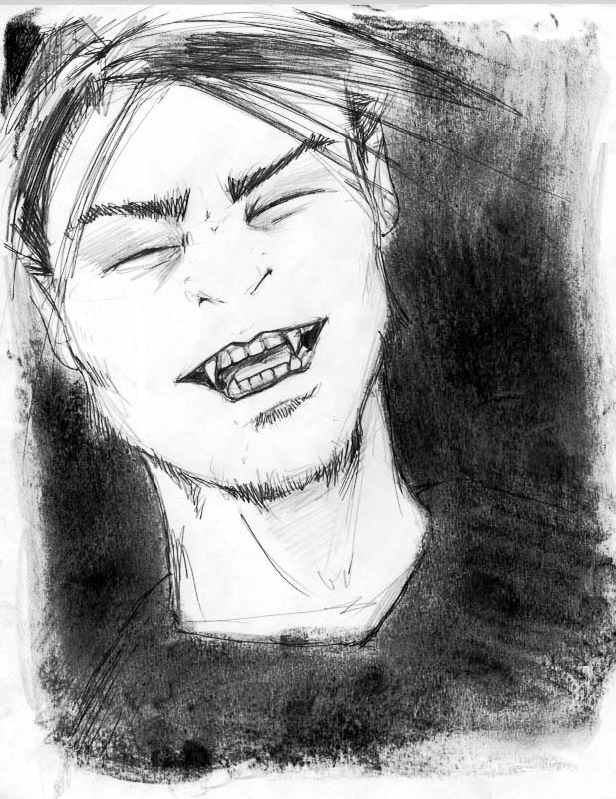
He smiled modestly.
"I'm sure you hear that a lot. Even from guys, right? People find that mysterious, sad type sexy."
"Yep," he said, the only answer he could find.
"I'm sorry," she said, realizing she was maybe being too forward. "I just have like a million questions. Me, I'm boring as all hell." She sipped her coffee.
"Well, how about you ask me a question, and I'll answer, and then I get to ask one that you have to answer," he offered with raised eyebrows.
"Sure," she said happily. "O.K... Umm...What do you do?"
He gave out another short laugh, this time with a true open smile, his eyes shutting briefly. "Well, it depends, I guess. I used to live at home. When I left, I had no money and no job, and I've just been kinda floating around since then. I try to stay away from doing anything illegal if I can. Some people just give me money, or take me out to breakfast, like yourself, so...Does that answer your question?"

"Left? Like left from Norway? How--"
"Eh! It's my turn now," he smiled. He took another drag from his cigarette. "Why didn't you sleep with me?"
"Well!" she gasped with mock offense. "I see where your mind is. I have plenty of reasons... First, I don't know where you've been. I don't even know you. You were drunk. And...I’m not that way either."
"Ha!" He laughed in disbelief. "You and your 'hot bath'. And taking me to your place. What was that about? Were you just teasing me or something?"

"Men. It's as if that's all there is. Sex is the answer for everything and there's nothing else."
"What else is there?" he laughed.
"That does bring me up to my next question. About your scars." There was a pause of silence so she continued. "I shouldn't have overreacted. I think I should’ve been more understanding. I just never seen anything like that. And you looked all fine and normal, I just didn't expect it."
"Normal?" he exhaled. "Actually I forget they're there most of the time..."
"But what kind of fight? You don't look like any gang member to me. Did you fuck with the wrong person or something?"
"It wasn't a fight."
The waitress came and served their food. He started to take a bite but she was now staring at him, perplexed.
"Not a fight?" she asked seriously with confusion.
"You know, this is pretty good," he said, avoiding her eyes.
"Thaddeus, answer my question."
"No, it was not a fight, I said," he replied with an evasive grin. He was starting to feel antagonized but continued on his burger.
She sighed with frustration. "If it wasn't a fight than what was it? An accident? What?"
"You don't give up, do you? Well, if you really want to know...No. It wasn't a fight. I did it myself." He turned back to his food and tried to ignore her attention.
"You did it to yourself? Like, why? I heard of scarring, like instead of tattoos, but that wasn't even...What on earth?" She started to think to herself, trying to understand. She suddenly felt sick, especially looking at her food.
He sighed with equal frustration and set his burger down. "Why do you act like it is so hard to believe? Some people get drunk. Some people cry. I cut myself. Does that make sense to you? Have I answered your question?" He had lost his appetite quickly but wrestled with the fact that he should finish, just for the fact that it was free food.
She stared into empty space. "No...I don't," she said quietly. “How? I mean...” She sighed again.
"Don't worry about it, O.K.? I'm not here worrying about you, am I? I'm just fine. I don't need this, you know," he growled, picking unhappily at his fries.
"No, you need a doctor or something. "That's..." she sighed and noticed he was moving quickly from uneasiness to anger. He was glancing around with fiery eyes. "Look, I'm sorry. I didn't know you had such problems. I guess...I don't have any idea what's going on with you."
"No, you don't," he said, offended. "Just fuck it, alright?"
"No, I can't," she said, feeling the sudden strength to argue. "That's serious, how can I just let that go? Act as if nothing's wrong?"
"Oh, fuck you. Who the hell are you? The messiah? Fuck off, alright?" He stood up abruptly and put his cigarette out. "Thanks for everything. Maybe I'll see you around."
He left so quickly, she didn't realize what was going on. She quickly got up and grabbed her coat. She had to stop herself and fumble through her wallet for money. After much frustration she left some bills on the table and hurried out the door.

She looked around quickly and found him stopping to light another cigarette, and then heading down the street. She ran after him.
"Wait," she yelled as she caught up with him. He jerked aside and glanced angrily at her.
"Fuck off! What the hell's your problem?" he snapped.
"Wait a second, would you? Are you gonna leave? Just like that?"
"What the fuck you want? A marriage license? Get off!" He yelled directly into her face, stopping in his tracks. He was breathing heavy and baring his teeth. His eyes acquired a glint of rage, as he puffed hard smokes.
"What's wrong? You're just going to run away?"
He was looking around him, and trying to quickly finish his cigarette. She reached out to touch his face. He jerked away and growled, flicking the cigarette butt over her shoulder.
“Don’t touch me,” he ordered as he glared at her.
By this point upset and confused tears were starting to trickle down her face. He saw this but it made him even more upset. He just felt trapped and wanted to get out.
“You are fucking with the wrong person, lady. Just turn yourself around and walk the fuck away.”
By this time they were attracting attention from passers-by. He suddenly realized that he was running the risk of attracting a cop’s attention as well.
They stood there, as he thought hard about what to do. He lit another cigarette.
“Please, Thaddeus. I just want…”
He coughed hard. “Why?” He was hoarse and his voice seemed to get weak. He was breathing heavily with a mix of anxiety and frustration, which was growing more intense.
“Because. Thaddeus. You’re … you’re so beautiful. I can’t… what if I never see you again? I want to help you. I mean, soften your pain. Just let me…”
He held his cigarette in his mouth and reached down in his boot to retrieve his switchblade.
“Pain,” he said through gritted teeth. She moved back in horror as the blade flashed open. He held out his forearm and pulled up his sleeve with the blade. “This is how I deal with pain,” he said, sliding the blade effortlessly across his skin with a slight wince.
She stared in horror but quickly came back to reality. “Stop it,” she yelled, grabbing his arm.
He only laughed at her. The blood trickled down his wrist and fingers. It was warm and the pain quickly faded into a throbbing dullness.
“See?” he laughed, “You can’t do anything for me. Sorry.” He jerked his hand down, throwing her grip off.
He walked away from her, holding his arm in an effort to stop some of the bleeding. She noticed this and hurried after him, fumbling with a scarf around her neck.
She grabbed his shoulder and pulled him around. He didn’t resist. He leaned up against the wall of a building as she took his arm and wrapped it tight in the scarf. He was still laughing to himself, but sniffling, and his eyes were glistening with tears. She looked up into them. She felt so sad for him but was starting to feel more empathy. He seemed to be laughing uncontrollably. She guided him to sit on a bench nearby.
He sniffled and smoked his cigarette. He was shaking his head and finally sighed and sat still. He squinted as he looked up and across the street. She ran her fingers though the back of his hair.
“What hurts so bad?” she asked emphatically.
He took a long hard drag as if he needed it to think. “Life,” he said.
“What about life?” she asked quickly.
“Look. Don’t get involved with me, O.K.? You can’t handle it. I can’t handle it. Please, just leave me alone.” He sounded suddenly tired and weak.
“I can’t,” she whispered. “I gotta know…what’s hurting…for you.”
He exhaled. “I told you.” He thought carefully. “Do you ever think about death?”
She looked up at him. “Of course.”
“Do you really? Do you sit there and think about how fuckin’ scary it all is? Can you…” He growled with frustration as she looked to the ground. “You can’t help me. You can’t erase my mind, can’t make me numb from reality. You can’t make me immortal…”
“No… Nobody can. Why? You’re just like everyone else. Death is a part of life, Thaddeus. You just got to try not to think about it.”
“Well, I can’t. How can I? Fuckin’ everything I do. Anything anyone does… Aw, fuck. I don’t want to bring you down. That’s why I told you. Just let me go.”
“No, talk to me. I’ll try to understand. It’s alright.”
He paused and looked off away into space and sighed woefully.
“I really don’t want to deal with this,” he said seriously. “Not now. It was starting off a decent day and then you had to go and get psychological on me. I don’t need it.”
She looked down thoughtfully. “You don’t have a place to stay, right? How about you stay with me for awhile? I have a vacation coming up and I was going to go visit my parents in Illinois. I’d love for you to come.” She held on to his arm hopefully.
“I’m not going to live with you,” he said plaintively.
“No, that’s not… You don’t have to. But just come with me. It’ll get you away from this place. Just give me a chance, please.” She caressed the side of his face.
He looked up at her with thinking eyes. “Wouldn’t your parents just love me. You can tell them I’m your boyfriend. I’m sure they’d love that.”
“Don’t worry about that. Will you do it?”
He finished his cigarette. “I don’t think I have anything else better to do.”

(Gothic Romance)

oh, lily white faery,
would you choose the vampyre?
for I would gladly devour your flesh
were not your eyes like perfect jade.
and still I must wonder:
“what is this love?”
for I could want and I could need most anything
and were it left long enough to grow
I’d call it love
could you choose this dark soul?
I could bond to your beauty
and change into something
more becoming to your kind
but angel,
would that make of me a greater animal?
princess,
would that make of me something whole?

for there is nothing more I treasure
(apart from your sweet admiration)
to feel like I understand to feel like I have a purpose
to know I am not just pieces, fragments,
of delicious encounters of passion
for you make me want to search,
you make me want to know
your world of fresh green life and sunlight
is this fallen creature good enough,
for your warmth?

