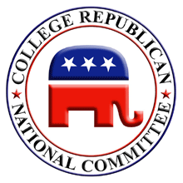 College Republicans at Colorado State University

LEADERSHIP TEAM

Elected:

President

Wendell Charles “Chuck” Fogland, Jr
cfogland@csurepublicans.com
(970) 282-9167 home
(970) 689-0567 mobile

Vice-President

Sara Farb
trekkie_girl_1701@yahoo.com

Secretary of CR and Liaison to Ed Haynes campaign

Paul Klinger
pklinger@simla.colostate.edu
(720) 301-1015

Treasurer and Director of Students for Bush of Colorado

Crystal Korrey
cjkorrey@csurepublicans.com
(970) 520-4106

Appointed:

Executive Director and Director of Students for Bush at Colorado State University

Justin “JT” Davis
wrestlinguy25@aol.com
(970) 443-0568

Program Director

Amanda Lilley
blacksunshine013@yahoo.com
225-2892 home
227-7823 mobile

Membership Director

Curtis Stroud
curtisstroud@yahoo.com
(719) 740-1414

Outreach Director

Sarah Franz
skfranz@holly.colostate.edu
(303) 618-1154

Office Manager

Kat Brownell
katherine.brownell@colostate.edu

Campaign Liaison Chairman

Jacob Seybert
seybertjm@csurepublicans.com
(970) 472-1668

