TRIP TO AUSTRALIA
Monday, September 13, 1999
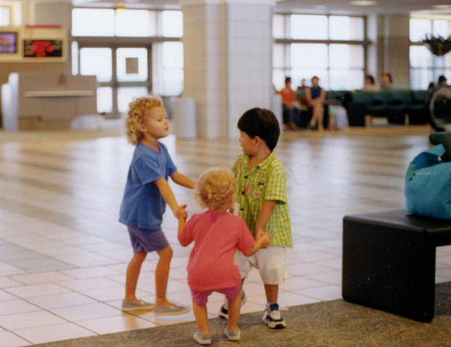
Our eagerly awaited trip to Australia is finally here! Most family trips start a little shaky; ours was no exception. Twenty minutes before leaving for the airport, while loading the car, our oldest got stung on her left eyelid by a boonie bee. For those not from Guam, this is a nasty little wasp with a very powerful sting. She wore herself out crying and fell asleep in her bed. Our potty trained 2 year old decides it is a good time to pee in her pants just as the baby fills up his diaper and falls asleep. (Just in time to get them all up so we can leave.)
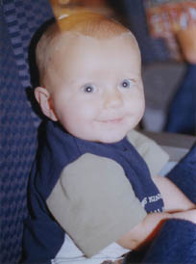
At the airport, after watching Megan and Marion ride the moving sidewalks a few dozen times, we settle in at our gate. The girls have a great time playing with two Japanese boys named Hiroko and Leo while we wait to board our plane.
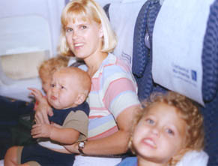
The plane ride went very well. Harrison had his ups and downs but was still very good since it was his first plane ride. Marion had a little trouble on the landing, as usual, so we had to keep pumping gum into her mouth so she could clear her ears. (Even though she has not quite figured out she’s not suppose to swallow it.)
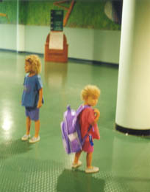
We were getting tired but very excited to land in Cairns, Australia (pronounced cans) about 4 ½ hours later. The only way to describe the airport was green. It looked like a rain forest with carpet resembling squiggly snakes. And I kid you not, I heard chirping noises coming from speakers. Actually, I could swear I heard water running, too. It was nice to finally hear lots of people in the Australian accent. The phrase we heard most often, even that first night, was not “Gooday” but “No worries”. It is such a laid back culture that you instantly start to relax.
We found out we had just missed our hotel bus (the last one that night) after we exchanged some of cash for Australian dollars. Things appear to be a little more expensive until you convert into US dollars, for example a AU $110 hotel actually cost around $60-$70 US or a $20 meal really cost $12-$13. The hotel said that all we had to do was catch a cab and they would pay for it when we got there. Tipping is not customary or expected (unlike in the US) but we were told that cab drivers do appreciate it if you round off your total cab fare to the highest dollar.
Since Guam and eastern Australia are in the same time zone, it was evening by time we headed for the hotel. The temperature is absolutely fantastic in September! And we fortunately arrived after they had just burned a sugar cane crop, so the smell was wonderful. This is common since Australia still produces quite a bit of the world’s sugar cane. But even more interesting is that their #1 crop is bananas. About 90%. We saw huge banana plantations everywhere on our tours. They individually wrap the banana bunches on the trees in bright plastic bags.
We stayed at the Holiday Inn since it was part of our 3-day package from One Stop Travel (thanks Loli Chang) in Tamuning. (A great travel agency that helped us plan our trip after SATO messed up our reservations.) Everyone was excited but tired so it didn’t take to much adjusting to squeeze 4 people and an infant into 2 double beds.

