TRIP TO AUSTRALIA

Wednesday, September 15, 1999 – Let the tours begin!
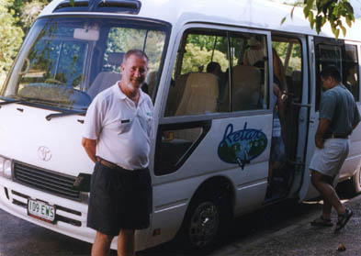
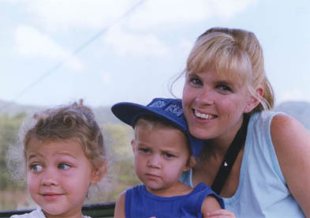
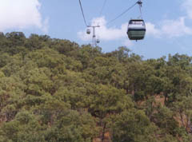
Our first tour began early with a bus coming to pick us up at the hotel. Once all the passengers from other hotels were gathered we drove just a short distance to the entrance to the skyrail. Our tour included the skyrail up to the town of Kuranda, a train ride down the mountain, and bus pick-up in a nearby town--a perfect tour for families. Everything is so organized.
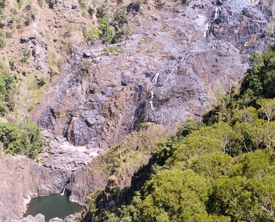
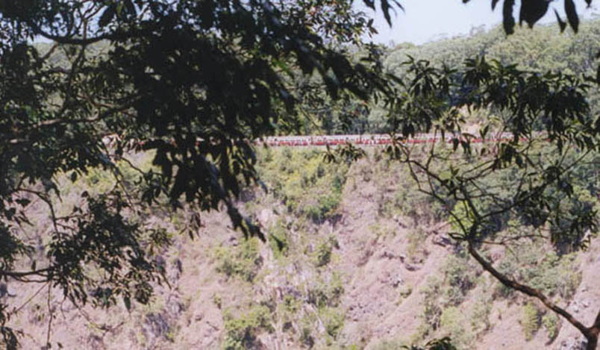
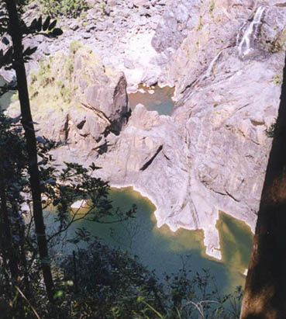
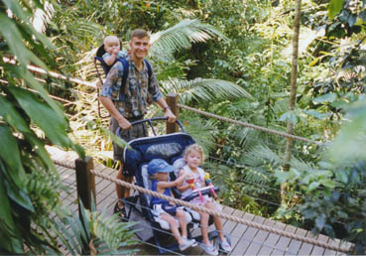
We got on the skyrail (gondola) along with our kids, backpack, and double stroller. It is like riding over an amusement park because each family can have their own car. This is much better though because it last a lot longer. You have the choice of skimming over the rainforest treetops all the way to Kuranda or the option of disembarking twice to get out and walk on a beautiful path along the floor of the rainforest. These are short little walks and also provide environmentally friendly bathrooms. And it’s even possible to use your double stroller because of ramps provided! Of course it is wise to keep a close eye on your younger children so that they don’t sneak a peek at the control room and almost start pushing buttons! (Marion!) But, like all of the casual Australians we’ve met so far, the operator just laughed (with a little note of panic in his voice) and said that only one person has done that so far and that was the owner. So it definitely would have made her famous!

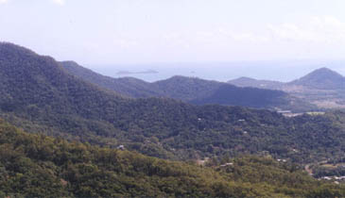
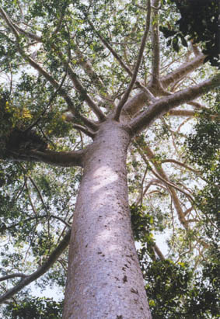
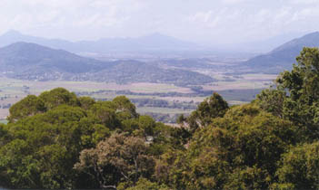
The skyrail was so worth it since you are able to see the most spectacular views of Cairns and the coastline. But only from the ground can you get a fabulous view of Barron Falls and the incredibly tall Kauri pine. The Kauri pine, an emergent (plants that grow taller than the rain forest canopy), are the tallest tree species in Queensland, growing to 165 feet.
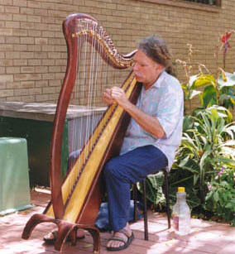
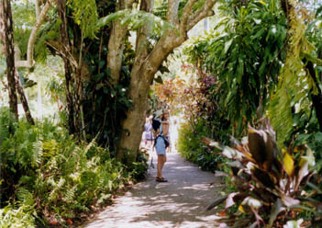
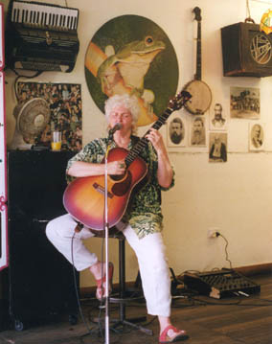
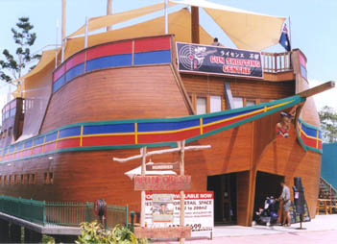
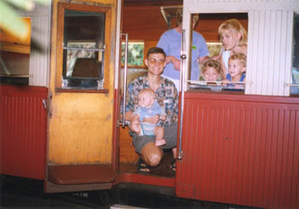
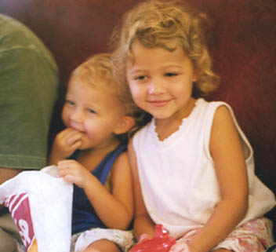
Despite being in a rainforest the temperature was cool with a light breeze. As you approach Kuranda you travel over the Barron River ending your hour and a half gondola ride over the top of Red Peak. Kuranda is an adorable little town that doesn’t really seem like a real place to live. This is basically just a cute little gathering of shops, outdoor café’s, and lots of interesting locals and musicians. Since we were on a tour, we were limited on time a little bit. So we headed to the train station to catch the train down the mountain.
Before we left the station, there were so many people in our train car eating fresh popcorn that the girls were salivating. So I jumped out quickly to get them some before we took off.

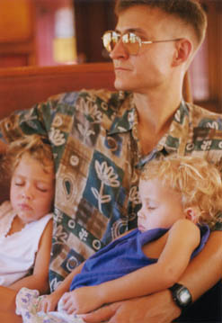
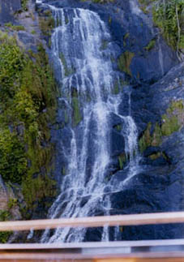
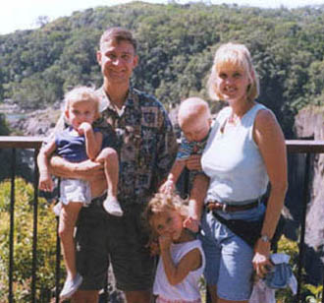
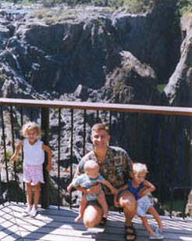
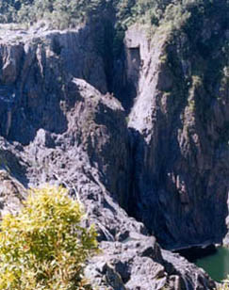
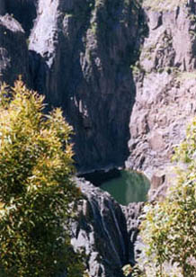
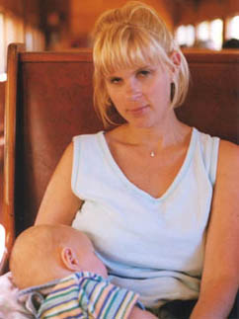
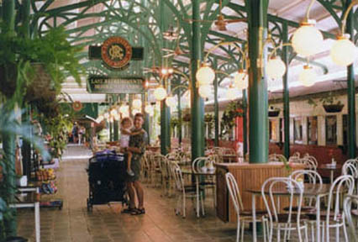
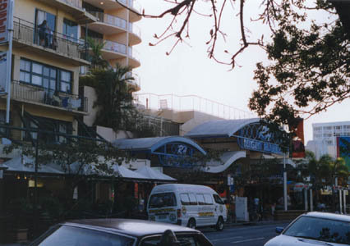
The trip back down is another 1 ½ hour trip with one brief stop at the other side of Barron Falls where you can get out and take pictures. The train ride is a little jerky but relaxing despite the old fashioned wooden benches. The girls loved riding on a real train. While riding through Barron Gorge, the train travels past another beautiful waterfall called Stoney Creek Falls. Getting a picture of it was made difficult by the fact that all three kids had fallen asleep in our arms. Rather than take you all the way back to Cairns, the train tour drops you off at a station in the little town of Freshwater. Quaint is the only way to describe this station and I only wish we could have had more time to roam around. Our bus driver, Doug, was already there waiting for us to drive back to Cairns. On the way back, we were able to get our first glimpse of the Queensland countryside. It’s not a very long drive but the neighborhoods looked really nice with all the houses having tin roofs and their own individual style.
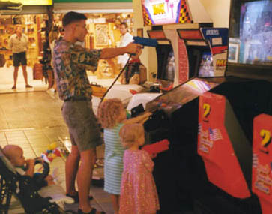
Back in town, we walked the few blocks to the downtown area to eat dinner. (Are you getting the impression that you do a lot of walking yet?) We headed straight for the RH night markets where we ate and then played some video games. We also had the best time people watching. The men are cute in a very rugged way...and very charming. I can’t really say much about the women except they are not the most petite, feminine women. And they all look like hippies! We still had plenty of time to walk around before the sun went down so we stayed out a while longer since there seemed to be no sign of mosquitoes. Would you believe we even passed a Woolworth? But in this case it’s a grocery store. (The only one we saw in all our days in Cairns!) And it seems like everyone drives a white car.

