TRIP TO AUSTRALIA

Friday, September 17, 1999
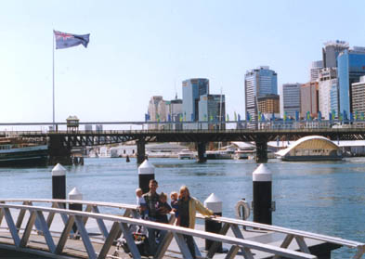
Friday started out with a bang! Literally. Our neighbors who share the other side of the wall from our heads are remodeling their apartment. Actually, it’s only one woman that lives there, but her and her crew started hammering and drilling behind our heads at 6:30am! Since we were fully awake after complaining to the manager, we headed out to see the sites a little earlier than expected.
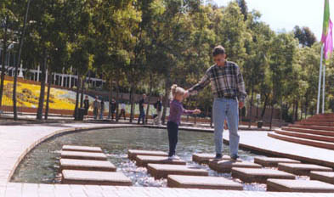
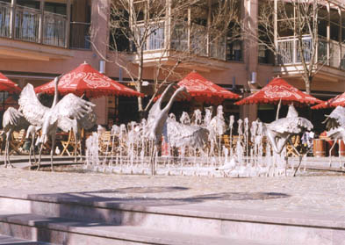
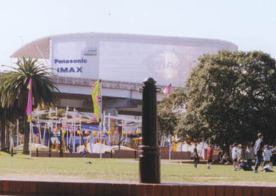
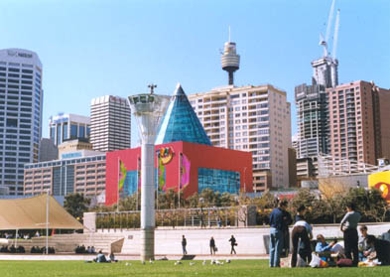
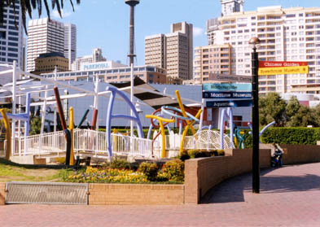
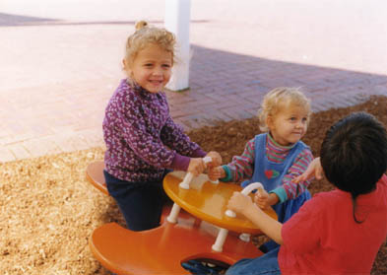
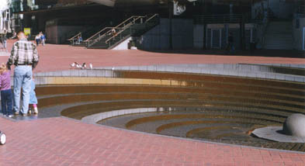
It was a little nippy but we shed our jackets later as the sun came out and warmed things up. Plus, we were walking up a sweat too. It’s great that Darling Harbour was so close because it turned out to be our favorite place to walk around. It’s done up really nice. Very clean with lots of ramps, bathrooms, and an excellent “parenting room”. Artistically, it’s neat too because they have beautiful architectural fountains, sculptures, and walkways. And the flowerbeds are nice too. We did a lot of walking but covered a lot of ground. From the grounds around Darling Harbour, you have a great view of downtown Sydney. We walked next to interesting buildings such as the IMAX theater (largest in the world), Sea World and an incredibly cool playground.
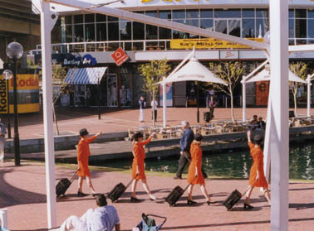
I wasn’t sure what to think when these four mannequin-walking women dressed like orange flight attendants came walking by with all their motions in unison. It was truly weird looking. This was all in an area called Tumbalong Park. The flowers were gorgeous and the whole area was very pretty. We decided to eat at the Harbourside shopping center food court instead of one of the many outdoor cafes because you could see the food they were cooking. And it looked good! We had not had it in so long that we had to give into our temptations and get Mediterranean food. Craig had an excellent Souvlaki and I had a falafel sandwich. Yum! The food court had such a great selection of food that we knew we’d be back. After scanning the sites of Cockle Bay (that’s where we were on Darling Harbour) we decided to head back over past Tumbalong Park to see the Chinese Gardens. Let me just say that most places in Australia cost to get into but if you have children under 3 to 4 years of age, they get in free.

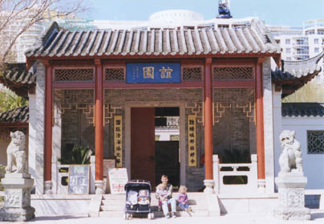
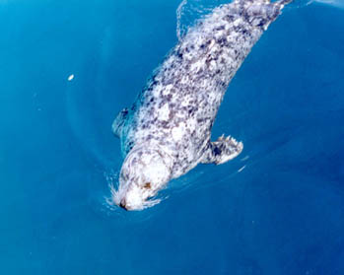
We didn’t realize until after we had completed the gardens that you were not suppose to take pictures. Oops! Luckily for everyone, we did. This place was gorgeous. We get into this sort of thing anyway, but not kidding. It was absolutely breathtaking! Since we have sooooo many photos, (click here) to see the complete collection (be patient since it's an entire page of only pictures). We spent lots of time here and even the girls loved it because they were visiting “Mulan’s house”. One thing we have always found fascinating about Asian gardens is how they are planned in such a way that no matter what direction you are looking in, each view looks like a painting. It just amazes us. Maybe that’s the artist in me, I don’t know. One last thing about the Chinese Gardens is that they had a real teahouse that you could go upstairs and order some tea. We weren't able to stay for tea, but I did sneak up and take a peak. We hated to leave but we still had so much to see.

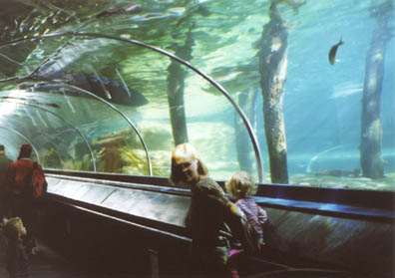
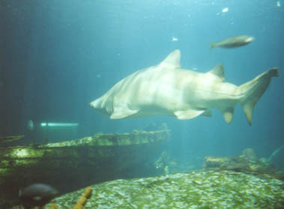
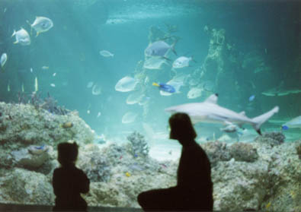
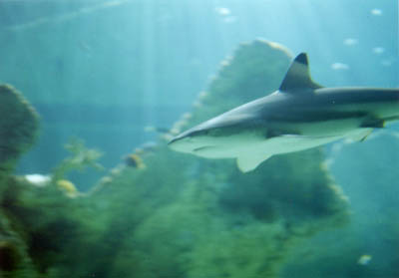
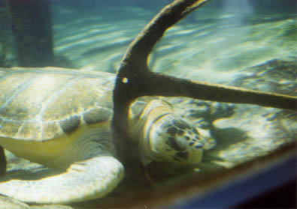
On our way back towards the hotel, we decided to go ahead and do the Sydney Aquarium since it was on our walk back. It was worth it but I’m not sure if it was the wisest decision with three exhausted little kids. This place is much bigger on the inside than it looks on the outside. I thought we would never make it through the whole thing. I wanted to crash in the stroller for a nap so bad! We saw lots of pretty aquarium displays all neatly presented and seals outside in a sectioned off part of the bay. The best part of the whole place though was by far the glass tunnels that lead you through the huge shark and stingray tank. It was way to cool for words. The kids were fascinated by the size of the sharks and stingrays. It was pretty the way the water reflected off of us, too. When the stingrays and sharks (that were about twice the size of me) would glide over me in the tunnel I could reach up and touch the glass and only be about a fingertip separated from it. I could have watched them all day long. They are truly magnificent! It reminded me so much of the scene from The Abyss when Elizabeth Masterentonio reaches up to touch the belly of the alien fish as it glides over her. I almost forgot to mention to that they had equally large sea turtles in this tank too. The last part of the aquarium is a fairly new Great Barrier Reef exhibit. This too is one big tank that is floor to ceiling. At one part of it you not only have water above you and to your sides, but the floor is glass too! You really did feel like you were underwater with all of the incredibly beautiful fish they had on display. I was in awe! By the time we left the kids had all but died. 2 of the 3 were passed out and the other 1 was on her way there too. But . . . we kept on walking. To see the Sydney Aquarium pamphlet, click (here).

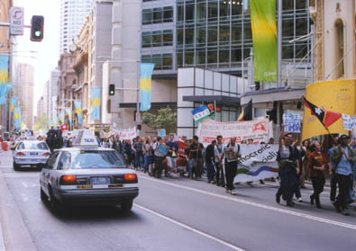
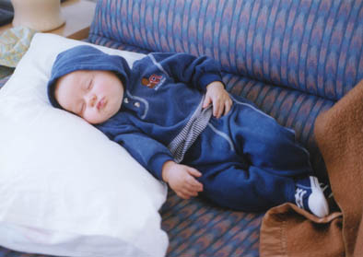
Back into downtown looking for a good place to eat. We had decided on a Pizza Hut that Craig had seen earlier, but after circling the blocks for what felt like a few hundred times, we finally broke down and ate at the nicest McDonalds we had ever seen. Upon leaving, we got caught up in a march of a few thousand demonstrators fighting for the freedom of the East Timor. This was a very hot topic in Australia since they are geographically the closest country. After that, we finally headed home and Craig and I got to pass out along with the kids. I wish I knew how far we had walked! The night outside was loud, but we slept well anyway.

