REMEMBER THAT…
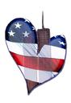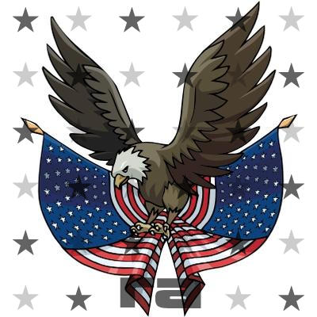
…YOU’RE AN AMERICAN!

ALWAYS REMEMBER THAT NO MATTER WHAT HAPPENS WE ARE AMERICANS.
WE HAVE LIBERTY. WE HAVE FREEDOM.
YOU SHOULD BE PROUD TO BE AN
AMERICAN!


