2.8
TERMINAL CONTENT GUIDELINES

Overview:
This document provides guidelines to developers for PATLOC CP Area usage. Definitions:

THE ETT-ACCESS LOGIN SCREEN SCHEMATIC

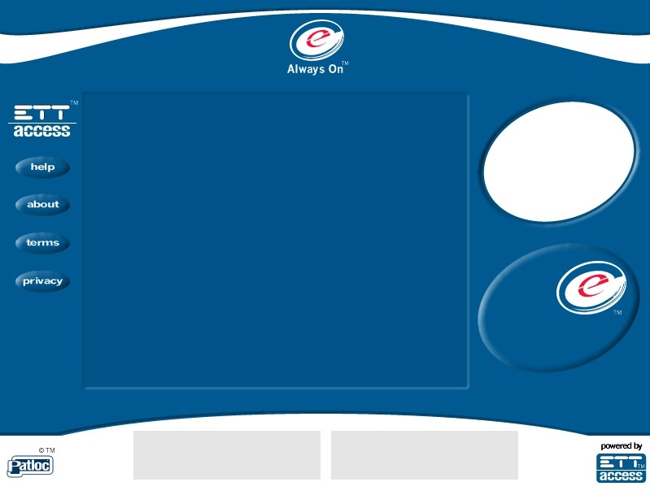

CP-2
CP-1
PC-1
PB-1
PB-3
PB-2
PB-4

Key to User Screen Regions:

CP-1
CP-2
PS-1
THE ETT-ACCESS LOGIN SCREEN SCHEMATIC

Code | Name | Description
PS-1 | PATLOC SERVER ZONE | The Terminal Image. This zone is all main page Graphics and HTML served by the ETT-Access Server.
CP-1 | CP LOGO | This is the Logo for the CP. It is served from the ETT-Access SERVER and may be customised using the Patloc manager.
CP-2 | CP e-BILLBOARD | This is a screen region available to the CP for graphic use or it can be used to host html that can in turn link to graphics or other pages or both.

CP Zone Pixel Specifications

Key Zone | Bounding Region | Comments
CP-1 | 96 x 96 Pixel | For Supply of CP Logo
CP-2 | 480 x 360 Pixel | Main HTML or graphic

Using the Logo and e-Billboard Areas

The logo and e-Billboard areas may be used by the CP to customize the look and feel of the login screen at the site level or for all sites. The e-Billboard is unique in that it can display either a graphic or CP defined HTML that in turn links to graphics or other HTML pages hosted elsewhere. Although there are a few rules outlined below this facility gives unprecedented flexibility in providing for CP defined advertising, promotional or informational use or any other use you can think of !

The CP-1 Logo

The CP-1 logo region is an irregular elliptical area 184 x 147 pixels. The image supplied must fit comfortably within a square of 96 x 96 pixels, but is best a little smaller than this to provide a clean graphic edge to the circle.

Figure 1.

CP-1 Region

CP Provided Logo
96 x 96 pixels

CP-1 Logo Image Specifications

File Types | Background
GIF | Transparent or CP Colour
JPEG | CP Colour

CP-1 Logo Upload

The CP logo can be uploaded by accessing the CP Logo upload option in the Patloc manager. A browse button on the upload page will allow you to select the .gif or .jpg file from your local drives or network. The option exists to upload the graphic so that it applies to a particular site or all sites.

The CP-2 Region
The CP-2 region is referred to as the e-Billboard. This area can be used to display a graphic ( .jpg or .gif) image or be used to host HTML code that may in turn link to graphics and pages hosted by or on behalf of the CP. Using the e-Billboard allows a CP to advertise, display competitions, or perhaps register users and to change the e-Billboard as they wish.

A graphic image can be uploaded using the Patloc manager quite simply as for the CP logo. However if you upload a html file several important implementation considerations apply :

1. All links from this area and any downstream links MUST NOT be allowed access to the wider internet. In other words all links in this area must refer to a closed set of pages.
2. Any links in this area (including extra graphics) must refer to web pages hosted by the CP or on behalf of the CP.
3. An overly complex page referring to multiple images may slow down the display within this area.
4. All graphics and html code that will display in this region MUST be approved by ETT before use.

CP-2 Graphic or HTML Upload

A graphic image or html file is uploaded using the CP e-Billboard Upload option in the Patloc manager. A browse button on the upload page will allow you to select the graphic image or html code file from your local drives or network. If you ae uploading a html file it MUST have an extension of .html or .htm. You will be asked to specify if the uploaded file is to be displayed as an image or as html code. The option exists to upload the file so that it applies to a particular site or all sites.

Privacy and Suitability

Any CP content must be compliant with the ETT-Access Terms & Conditions, Privacy Policy and the CP Agreement.
Legal Clause relating to CP Content area on Terminals

- Compliance with Law. The Client will use the Services offered by ETT in a manner consistent with all applicable Local, State, Federal and International laws, treaties and regulations and any violation of this provision can result in termination immediately or with 30 days notice depending on the severity of the violation and ETT shall retain the unfettered discretion in determining the severity of such a breach.

- Prohibition of Publication of Certain Material. The Client shall not knowingly or unknowingly submit to ETT for publication through the Services any of the following material (including pictures, links, or any other content):

- any material which violates or infringes any copyright, trademark, trade secret, patent, statutory, common law or other proprietary rights of others; or

- any material that is libellous or slanderous; or

- any material which is or contains anything obscene, indecent, inflammatory or pornographic; or

- distribution lists to be used via unsolicited electronic mail or other mass electronic mailings including but not limited to: mass-newsgroup postings, SPAM and unsolicited e-mail sent from the Client's host server, or any other service on the Internet, which contains the Client's domain name or any other domain name on ETT’s network; or

- any material, virus, Trojan Horse or other program which is designed to damage, destroy or harm in any way both hardware and/or software of the computer and electronic operating systems of ETT or any third party; or

- any material, mp3's, video streaming or video files.

ETT will comply with any relevant industry code of practice, notification or direction from the Australian Broadcasting Authority relating to the removal of certain prohibited material or content from its servers. ETT may take any steps necessary in order to ensure compliance, including removing any material or content from its servers, closing or suspending the Client’s account, filtering Internet material or content made available to the Client or restricting access to a particular website.

Any violation of the above conditions or failure or refusal by the Client within 7 days to remove any material or content referred to above on request by ETT may result in termination of the Client's account and ETT has the unfettered discretion in determining what constitutes unacceptable material or content.

ETT does not screen in advance the Client's material submitted to ETT for publication. ETT's publication of material submitted by the Client does not create any express or implied approval by ETT of such material, nor does it indicate that such material complies with the terms of this Agreement.

- Indemnity. The Client agrees to defend, indemnify and hold ETT harmless from and against any and all claims, losses, actions, suits, demands, damages, liabilities, costs and expenses (including lawyers' fees) related to or arising out of the Services provided by ETT to the Client under this Agreement, including without limitation claims made by third parties (including customers of the Client) related to any false advertising claims, liability claims for products or services sold by the Client, claims for patent, copyright or trademark infringement, claims due to disruption or malfunction of services provided here under, or for any content published by the Client using the Services, but excluding those directly caused by the negligence of ETT.

