
HYLTON T H E  W H I S T L E R BROWN  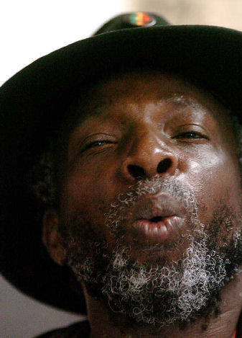  International Whistlers Convention/USA   “General field Marshall of musical inspiration” | Warmest roots and conscious words .He can talk, address the word powerful to the audience.  Sing in a golden tone of voice, make words reach. Dance or shuffle with mighty speedy energy. Then again improvisate , change style from singing to DJ to bongo drumming. Lick straight into my heart.  But, and this is a but – the highpoints of his performance ever when he touches the WHISTLING.  Clean, crystal clear flying spirit - endlessly Y E S.  Countless fan posts on a daily base he is getting from the worldwide community at Youtube.  He won the prestigious award at the Jamaican Pop & Variety Contest four times, first as singer and then as  …… w h i s t l e r.  He was intro for Eric Donaldson and Mutabaruka and performs on many shows and festivals all across Jamaica, Europe and the US. Among these were Melkway Amsterdam Praad Den Haag Fabrik (HH) SO36 (Berlin) Schlachthof (Bremen) Markthalle (HH). And he hosts since the 90ties a catchy weekly TV-show “Movements of a rastaman” broadcasted in Germany , and a radio show. He was choosen for the International Whistlers Convention in Louisburg, US, where he impressed with his untouchable style.  Artists he admires are Ken Boothe, Delroy Wilson, Alton Ellis, Dennis Brown, Peter Tosh, Bunny Wailer, Bob Marley and many more.  Yes, Hylton Brown aka Mighty King Pella has got a big talent as entertainer for all type of audience. Swinging positive , joyful message.
 Reggae mix whistler  H y l t o n B r o w n  “His unique style and presentation will have you up and begging for more. Yes, he whistles and yes, he sings, but most of all he entertains!“ CAB,Salt-Lake-City  “When Hylton Brown steps on stage it’s like a light is switched on. When he whistles, it’s sharing one love..” Gleaner/Jamaica “And as Hylton Brown ..led us loudly and proudly – the lights shined in all of our eyes” John Ward,Radio-DJ,USA  “Quality voice” Musiker Magazin /Germany  “Throbbing nyahbinghi drumming” P.Pilgrim Dub-missive/ USA “Hylton Brown is in a large measure responsible for the popu-larity of reggae music in Germany today. When Hylton whistles, your ears will listen-and-tingle” RAW Las Vegas  ”above all H.W.Brown is ..preacher” TAZ / Germany  “Secretary of state for good vibrations” Reggae Trade /England “Great stage presence, lot’s of joy in presentation, good rhythm, good music selection.” Judges at the International Whistlers Convention USA  .Live on stage you thrilled me! N.Lewis/US Publisher  . |  | .  J&G PRODUCTIONS GbR  .  Postfach 106802 28068 Bremen  Germany  mobil+49 (0)177 8897751  +876 3513137  fon +49 (0)421 555837  jandgprod@hotmail.com  .  …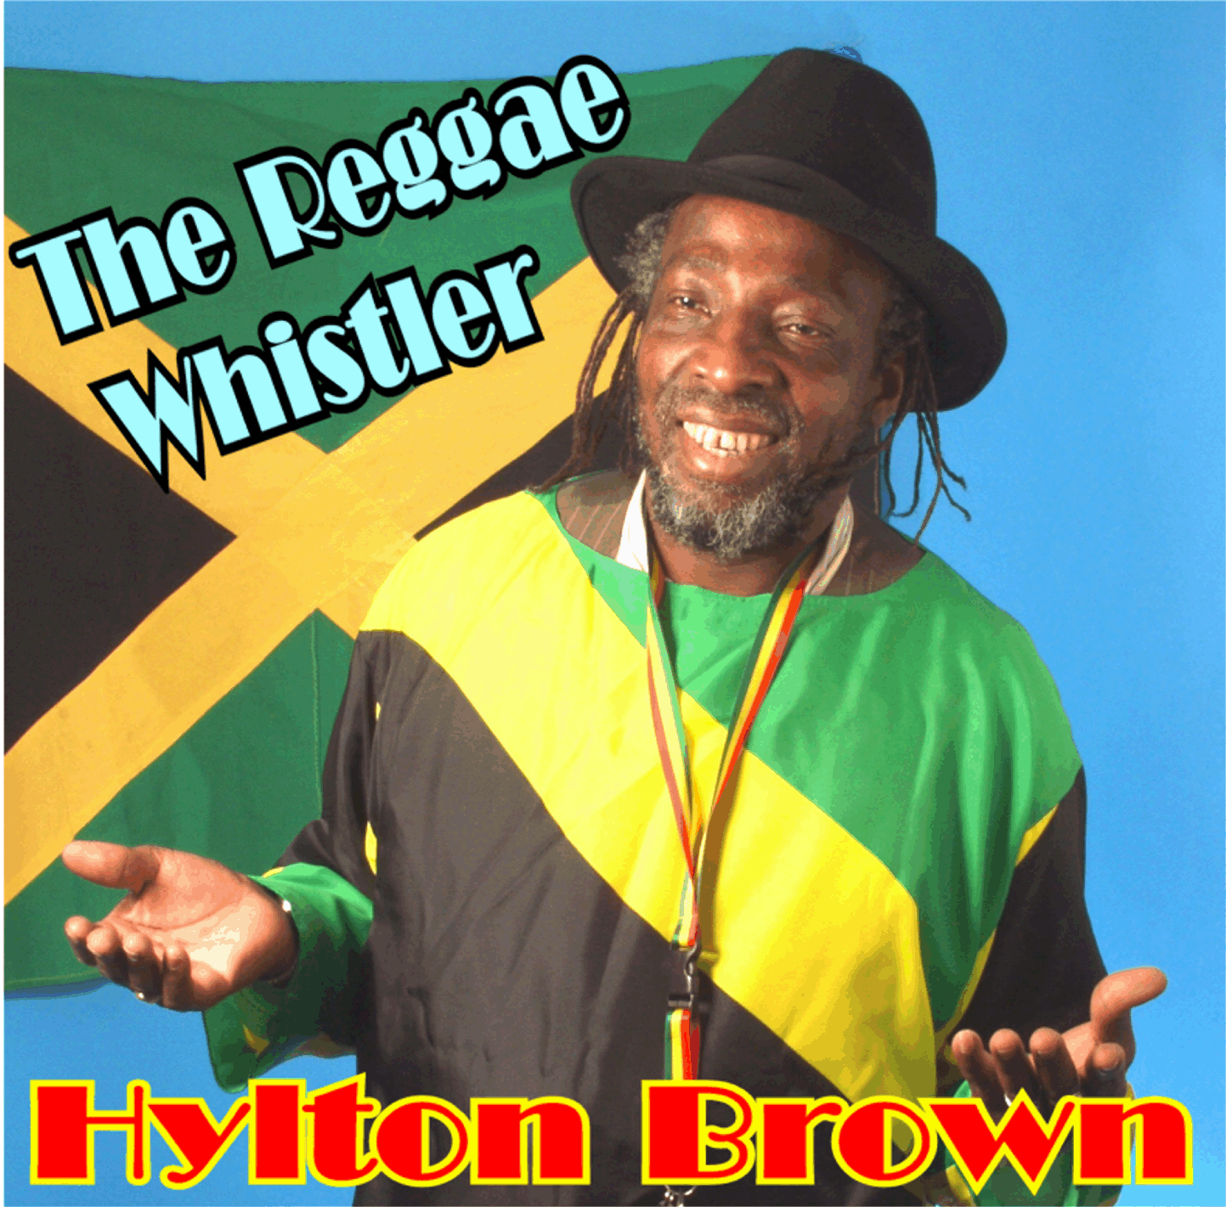  Foto:Pico Willm  geocities.com/reggaewhistler.

