All modern automobiles sold in North America use some sort of fuel injection system. The last car to be sold in the United States without some form of fuel injection was the 1990 Subaru Justy. Fuel Injection systems improve both efficiency and performance of automobiles by allowing more precise control of the fuel delivery and ignition systems. The following considers how fuel injection works and its advantages with respect to a carbureted system.

1. How does Fuel Injection Work?

In a fuel injection system, the fuel is delivered from the fuel cell using a fuel pump. Once the fuel reaches the engine, it enters the fuel rail. During this process the fuel is always pressurized. Each cylinder has its own injector which draws fuel from the pressurized fuel rail and based upon data collected by sensors and computerized calculations, sprays fuel into the cylinder, which is then ignited by the ignition system.

Modern Fuel injection systems are heavily reliant on computerized control systems. These systems can be programmed to provide specific engine characteristics. If the goal of the engine application is for racing, a high performance setup can be used. In contrast, if the engine is used for a daily driven automobile, an efficiency setup would most likely be applied. The fuel injection system controls the engine by using pre-programmed algorithms which are based on the engine setup, performance requirement and fuel used. In addition to the preset engine specifications, the system uses various sensors to determine which constants from the fuel map are required for the current engine condition. Most fuel injection systems use sensors to measure the manifold pressure, exhaust oxygen content, crank angle, voltage, throttle position, air flow, cylinder head temperature and fuel temperature.

The fuel map is the main control in a fuel injection system. By configuring the fuel map, it is possible to run the engine in the most applicable fashion. The fuel consists of multiple coefficients which are stored in table on the fuel computer. These tables in conjunction with pre-defined equations determine the injector pulse width. The pulse width ultimately controls the amount of fuel which enters the engine (See Appendix A for an example of pulse width calculation.).

2. Fuel Injectors

Fuel Injectors are designed to fill the cylinder with the required amount of fuel. The amount of fuel is determined by the pulse width which is calculated by the fuel computer. The most important effect of using a fuel injector is its ability to spray the fuel. By spraying the fuel, more surface area is available for oxygen to interact with during combustion.
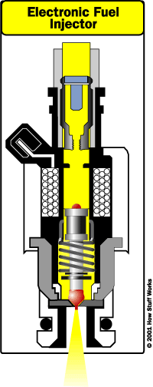
.
The fuel is injected through a small nozzle which is opened and closed using electromagnets. When the electromagnet is turned on, it repulses the head which is supported by a spring, opening the injector. By using the electromagnet, the injector can be opened and closed very quickly.

3. Conclusion - Advantages of Fuel Injection

Fuel injection is advantageous as it allows much more precise engine management when compared to a carbureted system. By using electronically calculated amounts of fuel, the fuel injected engine is able to improve the overall performance of an engine. These increases of overall performance are caused by the ability to run the engine at the optimal fuel to air ratio as well as the ability to combust the majority of fuel in the cylinder.

The fuel to air ratio determines how much fuel can be burned. If not enough air is present, then the fuel cannot be fully combusted in the cylinder, and thus is wasted. By controlling the waste of the system, efficiency is increased. The second major advantage of fuel injection is the ability to have the fuel sprayed into the cylinder, thus increasing the surface area available for the oxygen to react with. This increases the responsiveness of the engine as it is able to combust the fuel at a higher reaction rate.

Today, all cars sold in North America have some form of fuel injection. By increasing the efficiency and performance of the internal combustion engine, fuel injection has taken over automotive fuel delivery.

