Ocean City is fast becoming the Myrtle Beach of the Mid-Atlantic.
Think golfer’s paradise – offering everything from moderately priced executive courses to championship links designed by legends – all within minutes of the beach, Boardwalk, hotels and restaurants.
That combination lures tens of thousands of golfers a
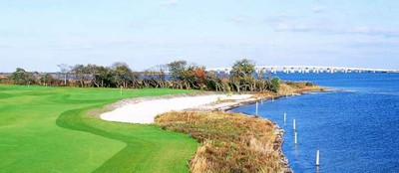
The widely acclaimed Rum Pointe Seaside Golf Links course overlooks the Sinepuxent Bay and Assateague National Seashore Park.
year from far and near to Ocean City-area courses. In fact, more than a few players now choose OC over Myrtle Beach because it’s a shorter, cheaper trip and offers choices aplenty.
The Ocean City area boasts about two dozen courses, and golfers play some 500,000 rounds a year, generating, by conservative estimates, $150 million in annual spending.
Golfers now come here from Pennsylvania, New York, New Jersey, Ohio, New England, even Canada.
And the range of choices will continue to grow, with four new courses planned, three of them Jack Nicklaus-designed.
“It’s really hard to have a bad golfing experience in Ocean City because there’s something for everybody,” says Jon Westman, editor of OC-based Links and Living Magazine. “And if you know what you’re looking for – whether it’s value or quality – you’ll find it.”
Word of the resort’s range of courses has spread in golf circles, says Westman, who also is co-producer of the annual Mid-Atlantic Golf Show here.
Links to Links
For more on golf in the Ocean City area, check out OCgolf.com. To find out about packages that include golf and accommodations, visit Ocean City Golf Packagers, Tee 1 Off Golf Packages, OC Golfing or Ocean City Golf Groups. Look for special deals at Ocean City Golf Packages.
“Ocean City has really gained a solid reputation,” he says. “When you start talking Jack Nicklaus and other legendary names in the industry designing courses in the area, people want to experience the courses.”
Indeed, as Golf Digest put it, “Now, thanks to a mini-boom in golf course construction along miles of unspoiled Atlantic coastline, Ocean City has shouldered its way into consideration with sister-to-the-south Myrtle Beach as a true golf destination. There are enough fairways here to fill even the most ambitious itinerary.”
The boom has gone a long way toward filling hotel rooms in the spring and fall shoulder seasons, with a wide range of packages luring golfers to the links. That, in turn, helps keep the registers ringing at restaurants, bars and other resort businesses, while providing invaluable exposure for the resort.
"Golf is central in our pre- and post-season, and it’s become a main plank to what we’re doing as a resort,” says Ocean City Mayor James N. Mathias Jr. “Being a golf destination introduces a lot of people who come and vacation here with their families, invest in second homes and resort homes. We owe a lot to the growth of golf as an industry.”
Most of that growth has come in the past decade, with a surge in the number of courses, including high-end championship links and golfing communities that include residential housing.
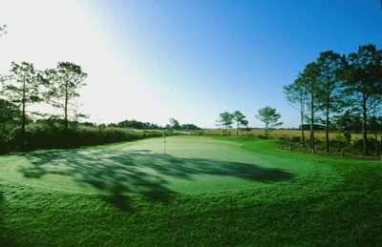
Sunlight streaming through trees casts shadows on the 18th hole at Eagle's Landing Golf Course, rated Maryland's seventh best course.
Renee Seiden, director of sales and marketing at the Clarion Resort Fontainebleau Hotel, says the Clarion and other properties under the same ownership book numerous golf packages, with most bookings coming from New York, New Jersey and Philadelphia.
Time was, that would have been unthinkable. “Probably 15 years ago, if you thought of golf in Ocean City, you would have thought of miniature golf,” Seiden says. “You would not have thought of championship golf courses.”
That’s changed dramatically, especially with the addition of some of the newer, upscale courses.
The Links at Lighthouse Sound, designed by Arthur Hills, the famed golf course architect, made Golf Magazine’s list of top-10 new courses in America. Lighthouse, which features the longest cart bridge in the United States, (nearly 1,500 feet), takes advantage of the expansive views of the bay and Ocean City skyline, and 10 holes border the pristine marshlands. For those who want to live by the links, Lighthouse features homes in course-side community.
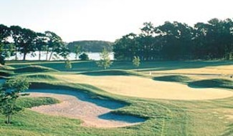
A grove of trees, wildflower fields and the St. Martin's River surround the ninth hole at River Run Golf Club..
Dennis Winters, the head PGA professional at Lighthouse, had held the same position at the prestigious Columbia Country Club in Chevy Chase. He knows his golf courses, and said OC’s best stack up well against other top links. And, yes, that would include those in Myrtle Beach.
“The quality of golf courses we have here are much better than the ones in Myrtle Beach,” Winters says.
Gary Player-designed River Run, which also features fairway home sites and town homes, offers a Scottish links flavor on the front nine, while the challenging back side is cut out of rolling terrain and magnificent pines.
Rum Pointe Seaside Golf Links, too, has won widespread praise, including a four-start rating from Golf Digest, for its seaside course designed by the world-renowned father-and-son team of Pete & P.B. Dye. The course offers expansive views of Assateague National Seashore Park.
Eagle's Landing is “green” in more ways than one, boasting an unusual distinction for a golf course: Audubon Society certification. Here, you’ll find salt marshes bordering Sinepuxent Bay and Assateague Island, native pine and hardwood forests, freshwater wetlands and ponds and a tidal pool and nest boxes built for birds like mallards, purple martins, sparrow hawks and bluebirds.
Ed Colbert, general manager and co-owner of Deer Run Golf Club, says his moderately priced course has drawn record numbers of golfers each of the past
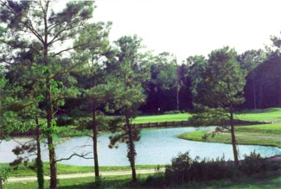
Deer Run provides an alternative to more expensive links. Golf Digest praises Deer Run as 'a great golfing value.'
two years.
“We have definitely made this a golfing destination,” Colbert says. “You have a venue for anybody’s taste or wallet.”
And success has more than a little bit to do with location. “One-quarter of the population of the United States is within a four- to five-hour drive of Ocean City,” Colbert says.
And golf, of course, is but one of the many seaside lures.
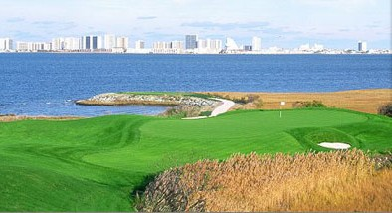
The Links at Lighthouse Sound overlook the water and North OC.

