Crossing the Island:

Georgetown to Richmond
Georgetown (Orange Hill) River Reservoir to Wallibou River/Trinity Falls

Hans Baer, April 30, 2006
(with corrections by Paul Cyrus)

The team: Paul, Stephen, Gus and Hans

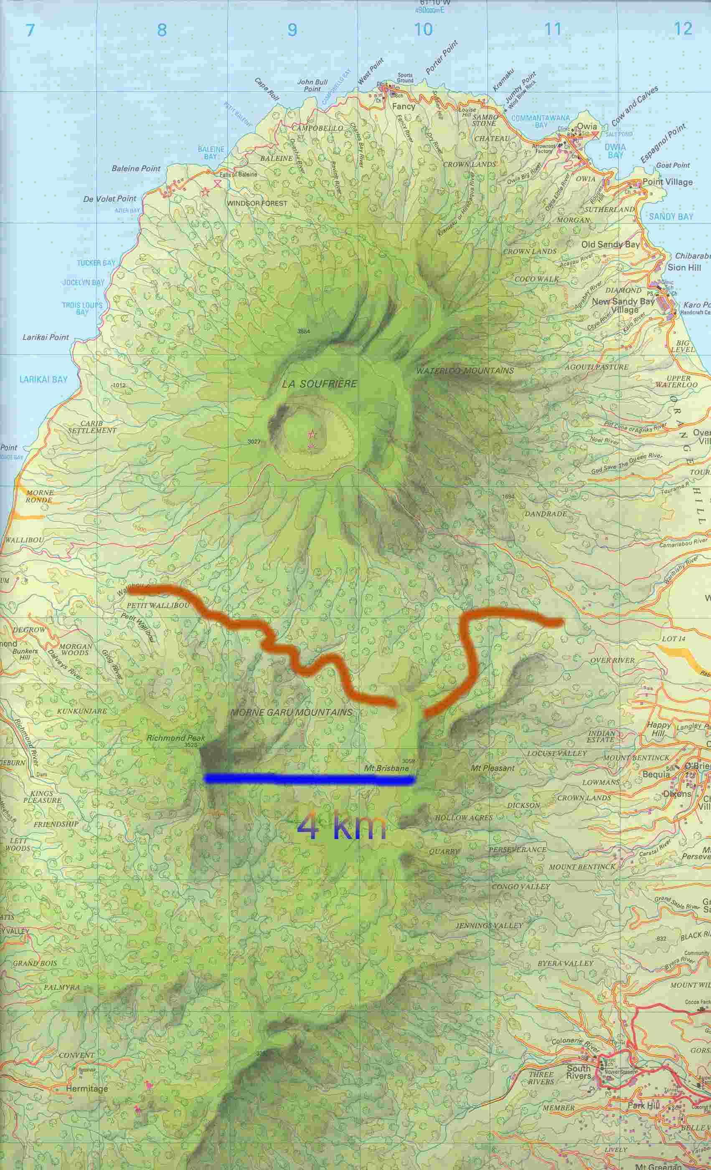
The estimated route: East to West

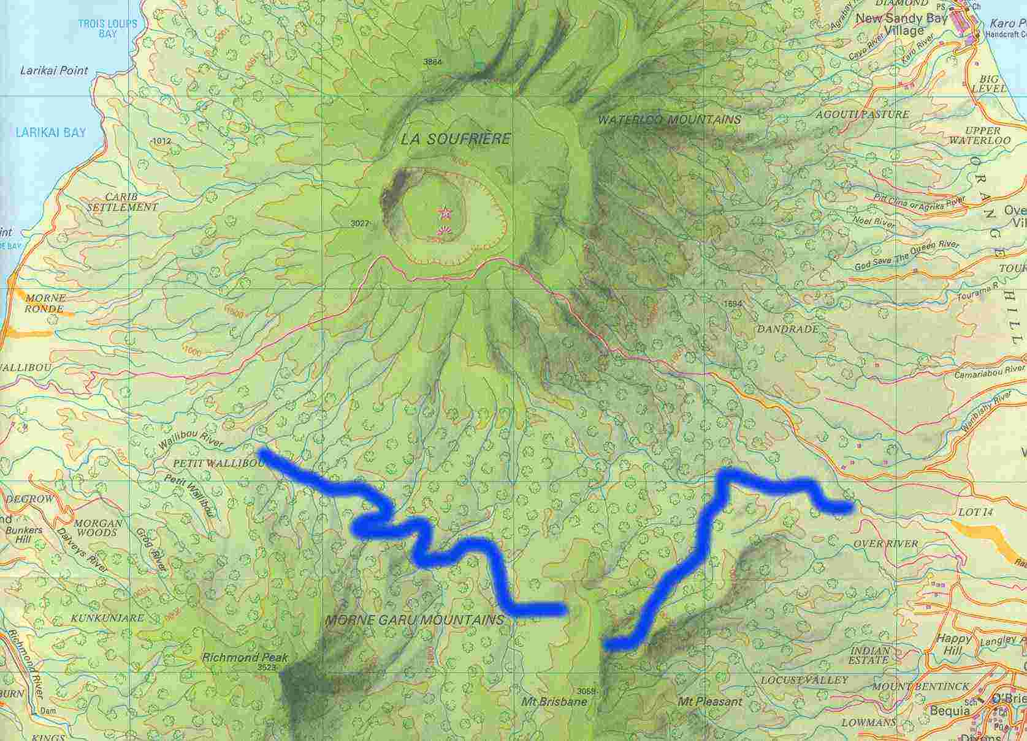

The right (eastern) leg of the route may not be accurate, but it definitely ended up on the ridge extending north from Mt. Brisbane.

This trip has been begging/bugging me for some years, finally it is happening. I am wondering whether I still have the nerve to go on an all-day outing into the Vincentian wilderness and brave the hazards: “a steep bypass to the watershed bypassing a dry and high waterfall, whacking through thick beds of prickly palm debris, blood hungry mosquitoes that sting even under the clothes, tight canyons of the Wallibou River calling for a swim, the risk of a flash flood in a canyon with no escape”...these are some of the scary highlights of Paul’s recollections from his trip with Stephen four years earlier, “arriving after 8 hours of walking at Trinity Falls with bruised, mosquito-bitten and soar legs...”

When Paul said 3 weeks earlier he would like to repeat the trip I "signed up" without hesitation. For assurance in case of problems and weakness, I decided to bring along Gus - a young and strong hiker who, in case of trouble, just would have to carry me out.

April 30, 6 am departure from Kingstown, ready at one of the tributaries of the Rabbacca River by 7:45 am, some 6 km up from Georgetown we are ready to get our feet wet. First problem: Gus lost the back parts of the sole of his shoes! How will he be able to carry me with inadequate foot wear? This is not a time to call it quits - let’s go!

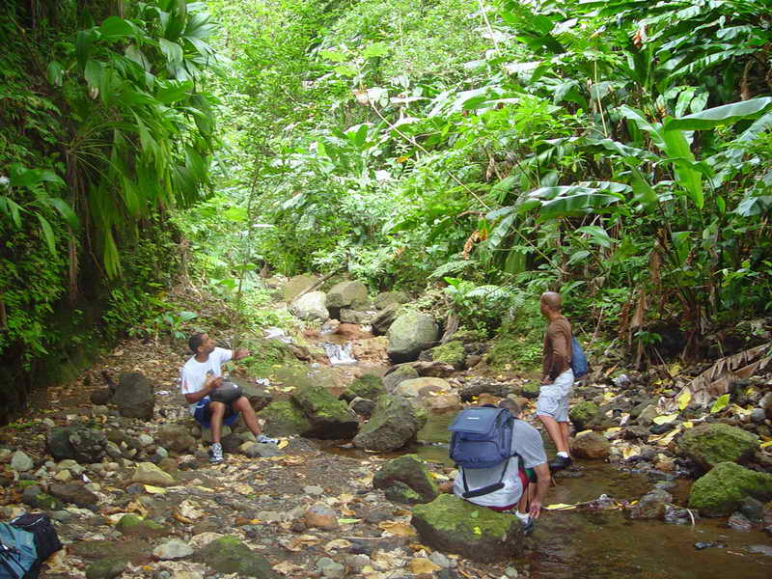

Up the Georgetown River - an earlier rest stop

After about two hours of hiking up the river bed, and as it became steeper, I have second thoughts about this venture: Why am I breathing so heavily, where is my stamina? Getting too old for this? I figure that at this point it would be a simpler for me to return, even if alone, because there are no real hazards - and so I could let the other three go on without me. After a short rest stop of the group, however, I feel quite vigorous again and returning is not in my thoughts any longer. Later, after negotiating stretches that are more difficult to retrace alone, I know I am committed - one way or the other!

At one point, when the river branch we follow narrows to a tiny trickle, suggesting it soon would dry up altogether, we chase a parrot out of its tree - a big Santanay tree, a typical parrot nesting site, whose huge 2 foot wide roots extending across the creek bed damming it. Time for a photo session!

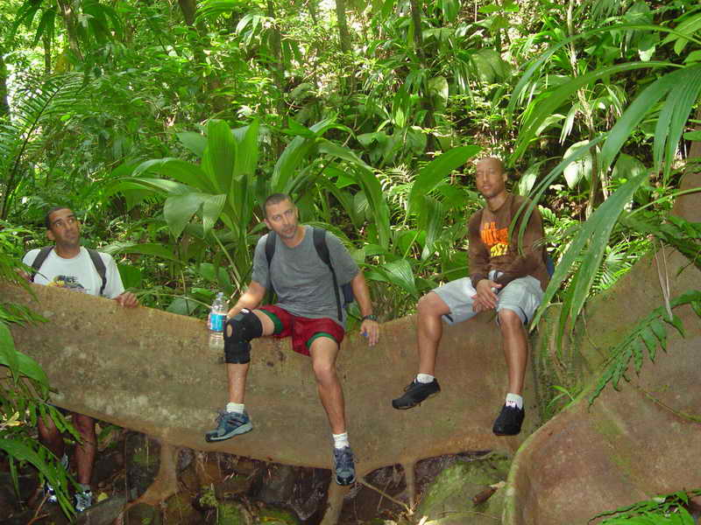

The parrot tree! Close to two hours into the hike.

The creek bed becomes narrower, with a few obstructions by deadfall trees, steeper rock sections and deep channels where water still can be seen gurgling deep down. We fill up our water bottles not knowing when we will hit fresh water again. Paul says something to the effect that he does not entirely recall any of the sections we passed through so far - but it was 4 years ago they did the hike, and I am not attaching any significance to his comments, particularly as he had commented just a while earlier that there are some features he did find to be familiar. We had encountered 2-3 major forks in the river, always following what we judged to be the main flow. Nobody gives any thought to the possibility of getting off track in any way.

After about 2 1/2 hours, by now in an entirely dry creek channel, the route turns more difficult and steeper. We reach a rock section, a 20-30 ft. high crack that does not look inviting. Now Paul is sure that this is not the route they had taken 4 years earlier. He manages to jimmy up the crack only to encounter another more difficult rock pitch in the channel which he says we could or should bypass by moving into the forest slopes beside it. With some heaving and shoving we all manage to get up the crack. My slippery tennis shoe soles are not really suited to this task which in better times and with proper climbing shoes I should have negotiated in a flash. Paul already has moved up and ahead into steep forest soil, leaving our steep creek bed and hanging on to tree roots and little trees. Following him for a few steps I feel like negotiating a steep snow slope because it needs kicking the toes into the soft soil for a hold. Without being able to grab for roots and trees and well-rooted saplings this ascent would not be possible. Paul, instead of angling back into the creek gully above the next rock barrier he intended to bypass has moved way up and to the right and out of sight, dictated by the terrain and available handholds. I praise my foresight of having in my pack some 30 foot of thin nylon rope that I know would allow us to retrace our route if necessary, using it as handhold on the way back down.

Up ahead we hear Paul give some rather dire news: We are sort of lost, on the wrong mountain, in reach of the summit of Mt. Brisbane, with the volcano being way over to our right. Definitely not a place we expected to be. All of us catch up with him after a few minutes, now about 200 feet above the crack we had just negotiated a few minutes earlier in the creek bed. And we now find ourselves on top of a narrow ridge, about 3 to 4 feet wide: On the side we just came from, a retreat would require some serious belaying with my rope, and on the other side the terrain drops off almost vertically for hundreds of feet to a forest basin that stretches for about 1 km to the West. The ridge itself continues steeply down to the north - and I kind of expect that if we follow it we will end up at another steep drop-off that could not be followed.

The mood is at an all time low, failure of our expedition seems a real possibility. While we can easily make out the silhouette of the Soufriere Volcano in the direction the ridge falls off, there is a small, heavily forested maybe 150 m high mountain peak between us and the volcano that is unexpected. Behind us, up the ridge, it seems we have a view of the top of what Paul figures is Mt. Brisbane - about 100 m higher up. One or the other mumbles something to the effect that "nobody would ever find us here”, a comment that does little to make us euphoric and maintains the depressed sentiments all we all have. I am mad at myself, because in the old days similar predicaments during my mountain expeditions would not faze me and only bring out determined survival strategies. Instead, I now feel quite stressed. Are my hands shaking? Come on, man!

My preference is to retrace our steps, with the help of my ropes, arguing that although it was not going to be very easy, we know what we have to expect. Paul favours exploring the ridge downward. There are indeed plenty of small trees to hold on to, and if worse came to worse it would be safe and relatively straightforward to come back up and retrace our ascent. I agree with him in the end and move ahead and descend.

It helps not being scared of heights, because the sharp drop-off of the ridge to the left indeed looks scary - but as long as I have good handholds on trees and roots, this is no cause for concern. After moving down the ridge for some 10 minutes I note that the forest bottom between our ridge and the little mountain structure appears quite close - we are almost level with the taller trees. As well, the slope to the right now looks more gradual, and through the vegetation it appears that further down there is a gully structure. Plenty of trees allow us to move in that direction and indeed reach a muddy gully that now provides for further safe descent, sliding down some deep washouts but not leading us to any obstacles. A few more minutes of further descent and we are standing on the forest floor on a veritable watershed. The drainage of our gully continues from here to West - clearly, we have reached an access route to the Wallibou drainage basin and our expedition is still very much alive! Our stress levels at this point drop sharply! The gully turns into a still dry creek bed, and eventually it fills with water and receives one or two feeders from the right.

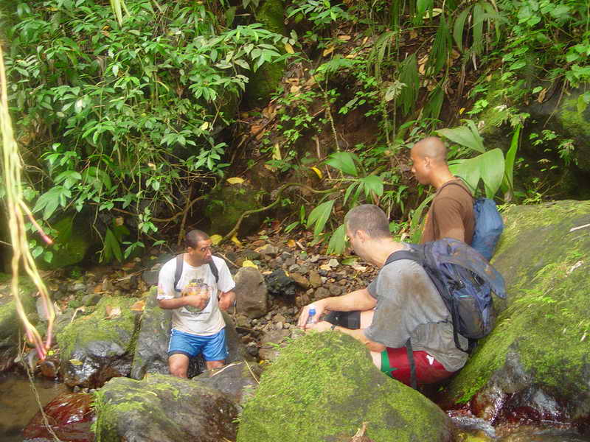
Our "gully" turning into a creek

After about half an hour we reach a larger river flowing in the right direction. The confluence is a very beautiful spot: The wider river allows for some sunlight that illuminates the water. Trees and rocks are covered with moss, we hear the larger body of water gurgling over rocks, there are some noises in the forest from whatever birds and crayfish are now visible in the pools. A fairy-tale, enchanted forest wilderness indeed.

I am not sure Stephen notices any of this as he tends to the mundane task of washing sand out of his socks and shoes. I try for best photo angles to record both a Paul as well as the beauty of this place and almost slip and fall. After a short rest we are ready to go on.

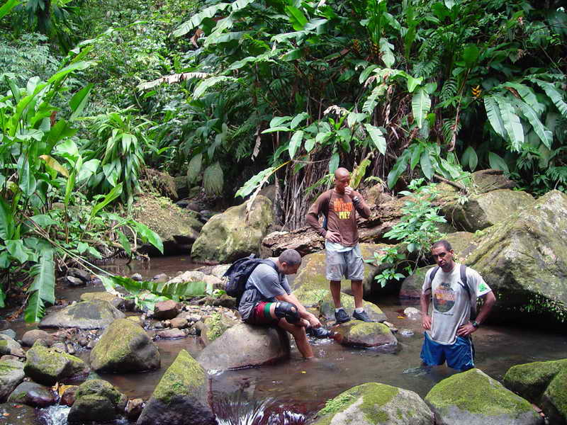

The fairy forest wilderness confluence: sock and shoe washing ceremony

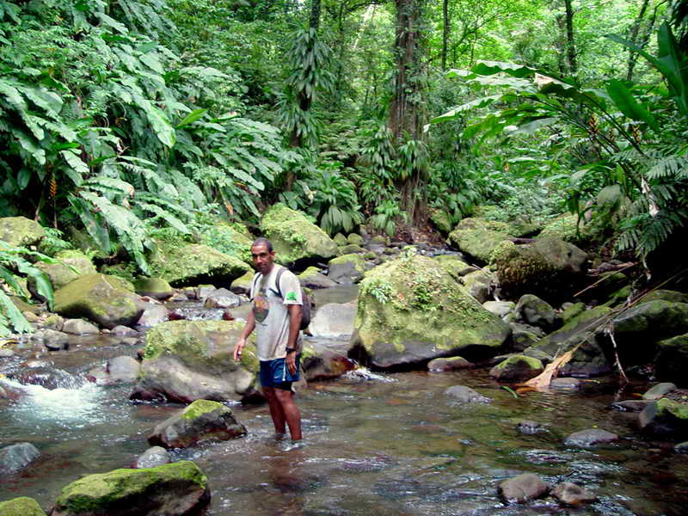

Pristine Vincentian Jungle! Paul posing in the upper reaches of the Wallilabou River: The enchanted forest!

Around the next bend we encounter a deep channel requiring some wading up to our chest, and now we know that we are on route - although not having any idea of how far we are from the place Paul and Stephen had reached this main stream before. Paul estimates we might need an hour of hiking to get there. Paul, keep such news to yourself!

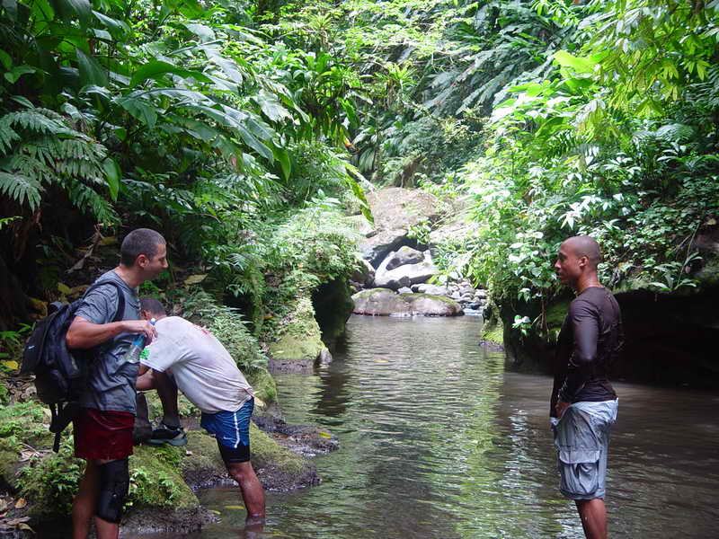

First deep water section for wading in the Wallilabou

The water of this river is warmer than the Georgetown River, and rocks are very slippery. We all move with much caution - this is not the place to twist an ankle or, worse, break a leg. The water is sparkling clear and rocks and sandy beds in the shade of trees and vegetation are covered with innumerable crayfish that scurry in all direction as we barge by. It is now a matter of frequently criss-crossing the river, moving to gravel bars, sometimes hiking on dry gravel and rocks, then again back into the river. We are certainly not going to die from thirst. My nightmares from before of ending up in a continuous canyon structure with no escape from possible flash floods are not realized: the valley is narrow and has steep high sides typical of river courses through soft volcanic deposits, but there always is plenty opportunity to move to higher ground if necessary. There is little worry about such a problem, though: there is patchy cloudiness overhead, but most of the time we move in full sunshine, now becoming a bit hot at times through the noon hours of the day.

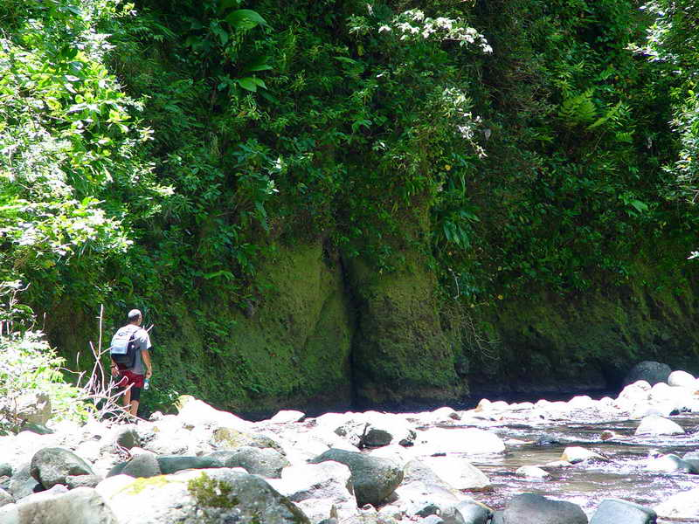

Somewhere along the Wallilabou: Time to cross it again!

At one time, however, I develop some doubt about our whereabouts: The river flows exactly in an easterly direction, according to the sun. I mention this to Paul and he, too, has made the observation. So far the river has not shown any features he remembered, and we have already hiked in it for maybe an hour. Is this the Wallibou River or not? If we had carried a map, we would have had no doubts - and our idea that maybe we actually are in the Richmond River leading to Darkview Falls would have shown to not been realistic. But without a map, we just can't be sure. Only one thing is certain, we have to go on and will reach civilization eventually. Later, back home, I find that indeed the Wallibou River flows through an S-bend with a leg heading straight to the east.

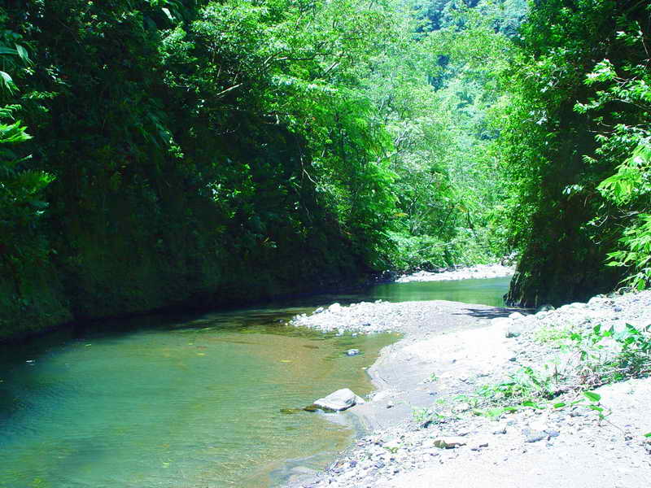

A tranquil section of the river, inviting for a picnic.

We pass confluences of some feeder streams of good size and with lots of signs of big erosive power at times of flood, considering the huge boulders that line their mouths. And eventually after 2 hours of walking down this river and 5 hours since we started the trek a debris-covered feeder from the right is identified by Paul and Stephen as being the route they had come down before. By now our river also seems to flow in the right direction, and we conclude that we have found the correct river after all.

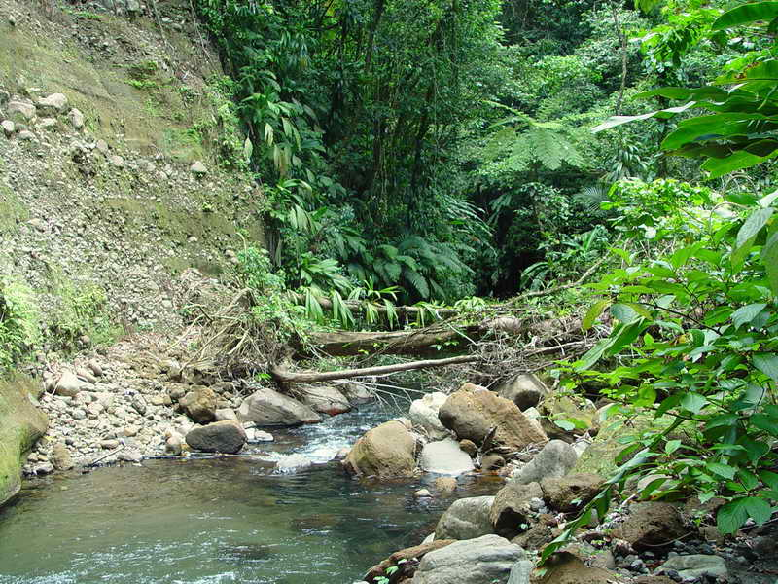

The likely entrance of the earlier route!

Eventually we reached a major landmark: Up ahead it looks like the high valley walls on all sides are coming together, not allowing for any passage of the water. The river actually cascades towards an ominous, dark crack in the wall ahead.

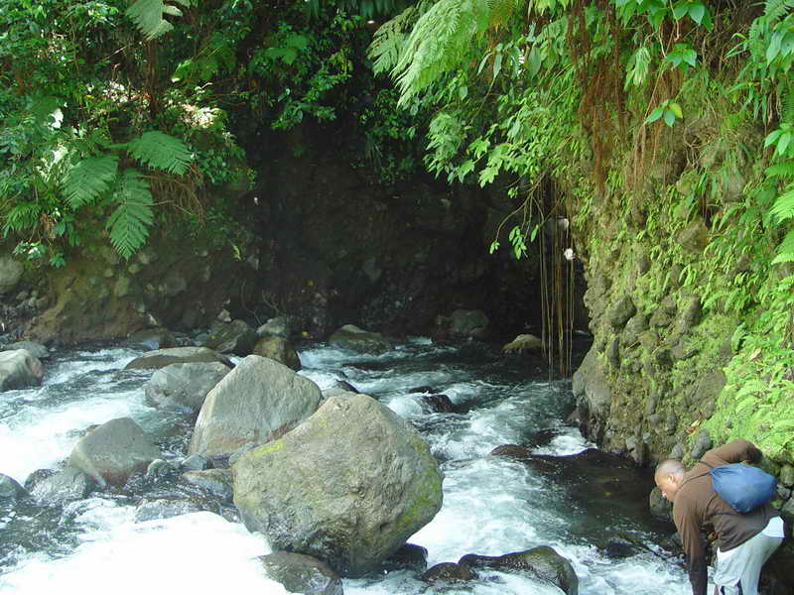

The river disappears into a hole?

Paul and Stephen remember this place very well: The river had cut right through the mountain wall through a narrow, 30 foot wide virtual tunnel with vertical sides, maybe 100-200 foot high canyon walls. Inside this canyon it is dark, like in a tunnel. Air roots hang down to the surface of the cascading waters, and a short section needs a few swim strokes before reaching a shelf and waterfall of some 3 feet in height, with a cascade of warm water dropping down from above to provide a natural shower.

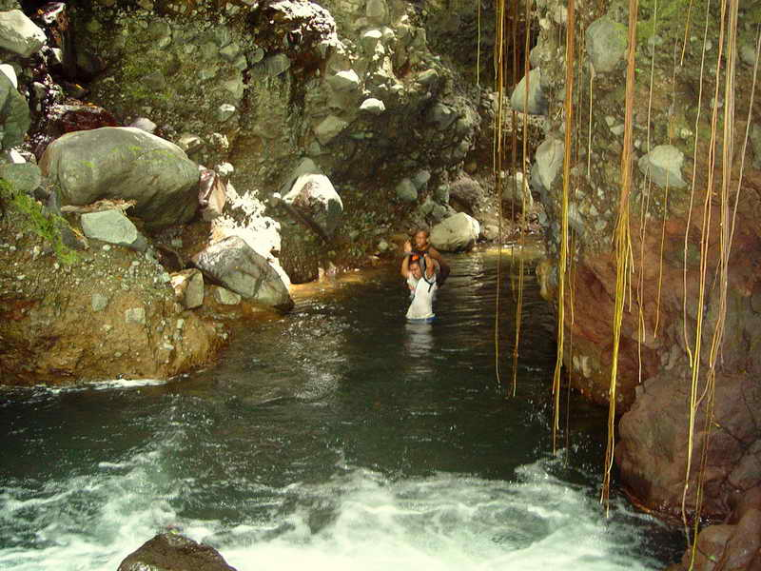

No flash flood please!

The pool under the waterfall provides a swimming hole illuminated by the sun that breaks through the dense foliage and trees lining the rim of the canyon wall, colouring the water iridescent green. The watercourse continues in a crooked fashion, again requiring swimming for a short section. I toss my camera bag to Gus who has reached good footing further down - little do I know right then that these would be my last pictures and video shots on this trip because a distance further on I slip on a sloping rock under water and delve into a water hole, wetting the equipment.

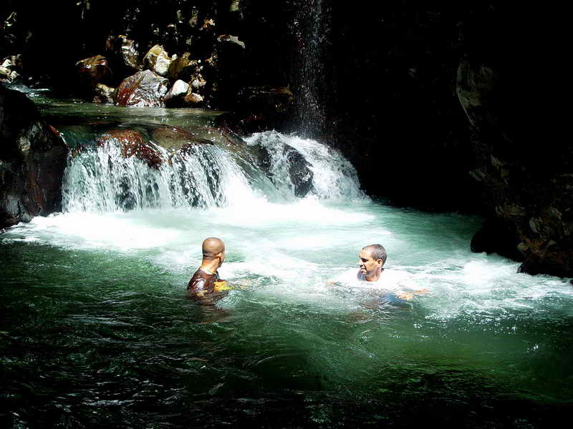

Falls in the Crooked Canyon

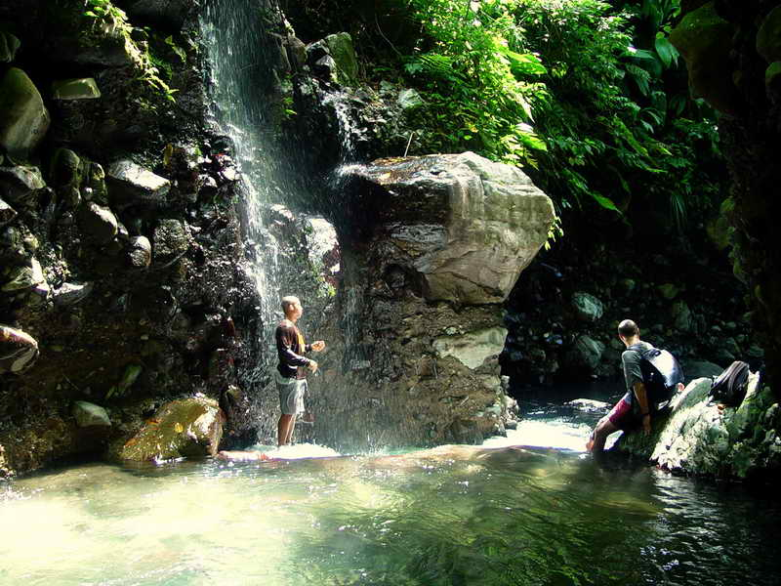

Shower in the Crooked Canyon

The entire place, which I name the "Crooked Canyon" (in memory of another such structure we navigated many years ago in the Nahanni river system in the Northwest Territories with white-water canoes - but at that time in ice cold waters not inviting any of our involuntary dumpings!) is awesome indeed, a small wonder of nature.

The continued hike down the river now leads us too at least one more memorable section - again a narrow passage, though this time lined not by high rock walls as in the Crooked Canyon, but with a much longer stretch of deep, bottomless water we definitely had to swim. I packed my camera equipment - though dysfunctional on account of my slip already, in a plastic bag and float it along as I swim. (My plan now as I am writing this is to hike upstream from Trinity Falls some time to reach this canyon and complete the photo log!).

Further down the river we encounter three spots where on the right hand side of the river, the volcano side, the water is markedly warmer: hot springs! Tired and sluggish as we all are by now, we do not take the time to hike the short distance of a few dozen feet to their origins. At least one of them is supposed to spew 40 degree hot water, and even after diluting with river water Stephen complains that the temperature pains his bruised leg. Heavy algal growth close to the right shore is another indicator of the presence of warm water.

Having hiked now for close to 8 hours, everyone is becoming weary - except for maybe the youngest member of our group, Gus. It becomes more and more difficult to move through the water and avoid slipping on the rocks - and one has to be much on the alert on account of the higher water levels and more powerful rushes of water between the rocks. The hike is an all-body exercise, requiring constant bending down to hold on to rocks above and under the waterline, climbing over bigger boulders along the river edge, crawling under trees and vegetation. This takes its toll after all these hours.

Eventually I make out the steep 300 feet high erosion area on the right river bank which I know to be just above Trinity falls: Within another 15 minutes our trip is to be over - and just above the falls we see the first signs of human activity - a piece of candy wrapper, a drink can and eventual real people who enjoyed a day of

crayfishing and bathing in the river, at the foot of the maintained access trail to the falls.

I try to take a few more shots with my digital still camera - through a water-clouded lens. The video camera I do not dare to try out hopefully the recording tape stayed dry and allows for salvage of the priceless footage.

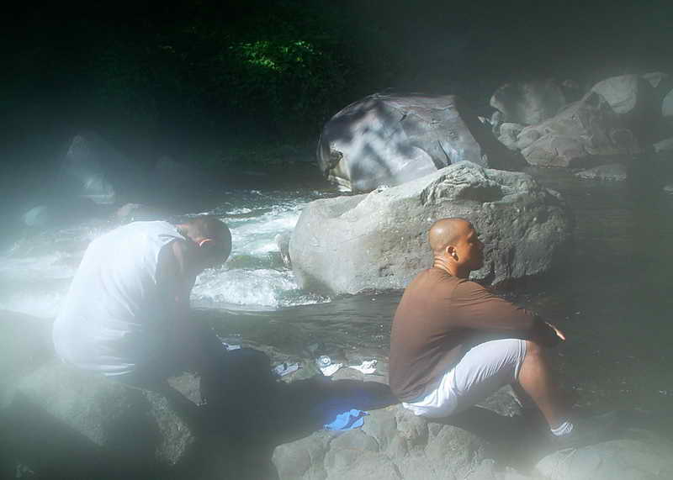

One last shot through my wet camera lens: Relaxing at Trinity Falls

After a short rest we hike up the 20-30 min to the car park area - our pickup vehicle is not there as yet (they are held up by three funeral processions in leeward villages), but we manage, just in time before my legs started to seriously cramp up, to hitch a ride on the back of a truck.

As an encore, back home after taking a shower I notice a significant itch along the sides of my back: I have big erythematous blotches on my back except for the area covered by my backpack. The itching is tolerable, and touch is slightly painful.

None of my companions had this problem - it must be bug that hates white men. Discrimination in the jungle!

Nobody could tell me what kind of bug did this to me until I hit on SVG tour entrepreneur Clint Hazell (hazeco@caribsurf.com) who is in the “bush” every week: he tells me that what I got is the “chiggers”, locally called something like bedrous or badrous (spelling??). Anyone interested, see this website: http://lancaster.unl.edu/enviro/pest/factsheets/008-96.htm

So, according to Clint this problem is only avoidable by spraying yourself with OFF around all covered areas (waist, under socks – ankles – etc.). And repeat this spraying after showering. The bug can be encountered anywhere, not just in the bush, but also maybe in your garden.

THE END

