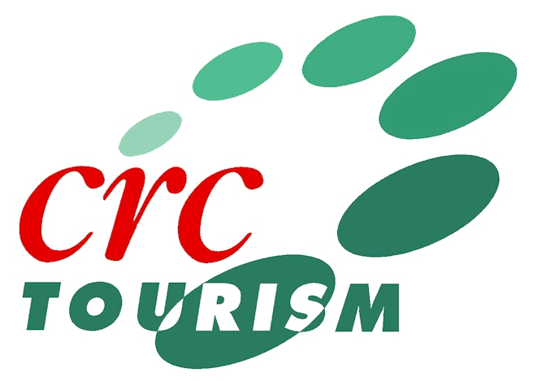
Planning for the Future:
A Profile of Australian Tourist Attractions

WHY STUDY TOURIST ATTRACTIONS?
Tourist attractions, both man-made and natural, are the core components of a region’s tourism product. Without attractions there is no need for other tourism services. It would be fair to say that without attractions, tourism as we know it would not exist.

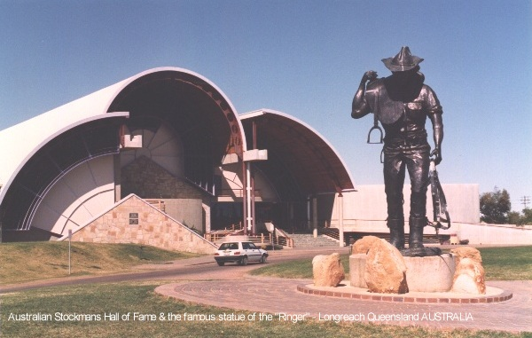

Despite the clear recognition of the role of tourist attractions as generators growth, they have remained what has often been called the “Cinderella” component of an industry which has traditionally placed greater emphasis on sectors such as accommodation, transport and travel retail.
Fact Sheet

It is generally accepted that attractions are not well understood. Attraction research has tended to focus on the characteristics of visitors, with little attention given to the characteristics of attraction businesses. This study will try and balance the lack of understanding of tourist attractions.

WHAT IS THE STUDY ALL ABOUT?
The project will examine the management issues in Australian tourist attractions by working with tourist attraction managers. In doing so, the research will identify areas of excellence, as well as opportunities for improvement which will ultimately enhance the competitive future of Australian attractions.

The research will investigate whether tourist attractions make use of strategic planning, and how formalised the planning process is. The research is divided into three phases.

Phase 1: Australian Attractions Profile
The first phase of the study makes use of your answers in the 2000 Australian Tourist Attraction Survey. Your answers will provide insights into the organisational and managerial characteristics of attractions.

If we want to learn something about where tourist attractions want to be in the future, and how they are planning for this future, then it is also important to know about attractions in the present. Knowing about the present characteristics of attractions provides a starting point from which the future can be studied. It is therefore necessary to develop a profile of tourist attraction characteristics before the planning activities of operators can be investigated. This information is currently unavailable and will provide a useful and interesting snapshot of the attractions sector.

Phase 2: Planning in Attractions
The second phase is the core of the study and focuses on how attractions plan for the future. Phase 2 seeks to provide a detailed description of planning in attractions by working with a small number of operators. This phase will investigate the extent of planning, how planning decisions are made and who is involved in the planning process. The strategic choices adopted by attraction managers will also be investigated.
Fact Sheet

Phase 3: Future Attractions Scenarios
This phase is predominantly concerned with identifying a set of future scenarios for the attraction sector.

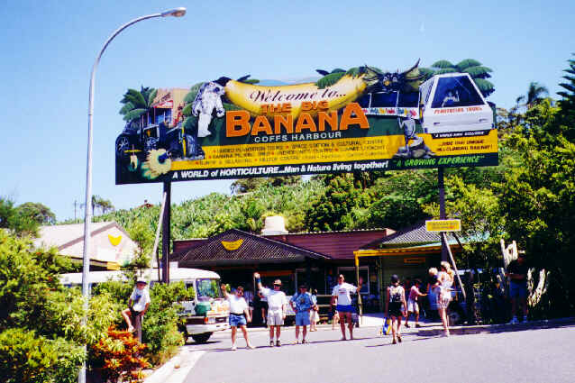
These scenarios will attempt to look into the future to tell us something about what attractions may be like in the next 50 years. Management reactions to these scenarios will be sought.

HOW WILL THE RESULTS BE USED?
The outcomes of the project can best be summarised by the following points:
- The submission of at least three individual papers (based on the three phases of research) to mainstream tourism research journals
- The presentation of findings at tourism industry conferences
- The preparation and distribution of a tourism industry report for participants
- The fostering of new linkages between the attractions sector and James Cook University
- The completion of a PhD thesis detailing the findings of the project.

DO I HAVE TO PARTICIPATE?
No. The last item on the questionnaire gives the following assurances:
- participation in the 2000 Australian Tourist Attraction Survey is voluntary, and
- no individual or organisation will be identified by name unless prior permission has been obtained
You will be asked to sign the questionnaire to show that you understand these assurances. Answering specific questions is also voluntary. You do not have to answer every question.

WHY SHOULD I PARTICIPATE?
Because the attractions sector is under-researched there is an opportunity to learn a great deal about Australian attractions. This information will not just be used by the University. It will be shared with the tourism industry and with the attractions sector specifically in an attempt to make Australia a more competitive destination.
Fact Sheet

In return for your support you can choose to receive an industry report outlining the findings of the project. The report will include timely, practical and relevant information, advice and recommendations regarding the management of attractions in Australia.

Furthermore, your assistance with this study is seen as a reciprocal partnership. To thank you for your time and effort in completing the questionnaire you will receive a recent James Cook University guide entitled Internet Marketing for Australian Tourist Attractions. The guide contains information and tips about how to establish an Internet site for your organisation and has been written specifically with tourist attractions in mind.

WHO IS BEHIND THE RESEARCH?

The Research is being undertaken by Pierre Benckendorff through James Cook University in North Queensland.

James Cook University is a leading education and research institution in the Tourism field. It is the only Australasian University designated as a member of the World Tourism Organisation's Global Network of Education and Training Centres. The Tourism Program at James Cook University was established with the support of the Australian Tourism Industry Association (now Tourism Council Australia) in 1989. The program publishes Australia's leading international tourism journal and is the focus for tourism research in four national cooperative research centres (CRCs).
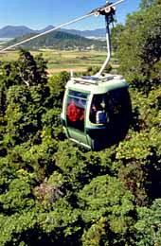

Pierre Benckendorff recently completed a Bachelor of Administration (Tourism) with Class I Honours at James Cook University and has since enrolled in the Ph.D. program. The project will allow the him to pursue joint interests in tourist attractions and regional development and to forge links with the tourism industry through the development of personal and professional skills. The project will enhance understanding of the operational aspects of regional tourist attractions.

HOW CAN YOU FIND OUT MORE?
For further details please contact:

Pierre Benckendorff
Tourism Program
School of Business
James Cook University
TOWNSVILLE QLD. 4811

E-mail: Pierre.Benckendorff@jcu.edu.au
Phone: (07) 3344 4853
Web: www.jcu.edu.au/~coe-pjb/attractions/

