A Guide to Online Franchises

Madden NFL 2001 for the PC

Introduction
With Madden NFL 2001 online franchises, you can compete against other human-controlled teams for the ultimate goal of winning the Super Bowl and building football’s next great dynasty. In an online franchise you can do battle with custom teams and rosters, just like regular franchise mode, but the bonus with online franchises is that you can play against other human players instead of the CPU. During a season, you can discuss trades with other players, sign free agents, release players, send messages to other players, and, of course, play against some real human competition. You can view a wide range of statistics for both your team and individual players, so you can determine who the dominant players in the franchise are. When the post-season starts, you will need to re-sign players that you want to keep if their contracts have expired and possibly make room for the rookies that you draft for the next season. And since online franchises can last up to 30 seasons, you’ll be sure to have the amount of fun and excitement that you desire.

Basic Information on Being A Part of an Online Franchise
- Your user profile will be used as your identification when sending messages or using the chat feature as well as letting others know what team you control.

- If you click on the Active User Profile button, you’ll get a drop-down list of everyone that is a part of the franchise. The user profile with a star (⬇) to the left side of the name is the commissioner of the league.

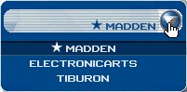
Active User Profile button
Commissioner

- Whether you are the host or client of the franchise, you will have a saved franchise file in the FILES menu at the Main Menu. If you exit out of a franchise, you will need to load the saved online franchise file before connecting back to the commissioner’s computer.

Playing in an Online Franchise
In order to play in an online franchise you have two choices: you can create one or join one. If you decide to create an online franchise, you will assume the position of being the commissioner for your league. This means that you’ll be responsible for communicating with people that join your league. Being the commissioner can be rewarding, but it also involves work because you control how the league will function. Of course, commissioners aren’t restricted to just commissioner duties. They can control a team in the franchise and play along if they choose to. If you decide to join a franchise, you will only be allowed to control the actions of your team.

Joining an Online Franchise
- From the Online Lobby, click on the TYPE arrows to view the League listings.

- Then, you’ll need to browse through the list of leagues that are found in the list. In order to join a league, you must find one that is currently online and accepting new users. Basically, check the PING column to see if a league is online. If the ping reads, “Up” then the league is available. Click on that league and select Join.

- If the league is password protected, you will be prompted to enter a password. You have to talk to the commissioner of that league to get the password.

- If the league is not accepting new users, then you will not be able to join that franchise. A message will pop-up letting you know if the league is not allowing any more players. Joining a franchise can be a trail and error process, but if you can gather a few players of your own, you can always start a new franchise.

Hosting/Creating an Online Franchise
- From the Online Lobby, click on the TYPE arrows to view the League listings.

- Next, click on Create. You will be notified that creating an online franchise will log you out of the online lobby. This is normal, because you have to set up your league offline, and then host it online later.

- Now, all you have to do is set up the settings for your league and host it online for others to join. The sections below will describe that in more detail.

League Setup
Before you can host your online franchise, you must set up the options first. The League Setup menu is where you select the settings for your online franchise. You can change the default settings for this menu at the Gameplay Settings menu.

- league name – Type in the name of league in this textbox. The name will appear in the League list on the Online Lobby when you connect the franchise online.
- number of teams - Selects the number of teams you want to have in your franchise (6, 12, 18, 24, or 31). 31 team leagues play 16 games while 6, 12, 28, and 24 team leagues play 10 games. Also, the Pro Bowl is only available with 31 team franchises.
- draft timer - Selects the amount of time, in minutes, that teams have to select each draft pick per round (1-5 minutes).
- fantasy draft - Selects if you want to do a fantasy draft or not. Choosing this allows the users to draft a whole team from scratch, player by player. This takes place after everyone has chosen a team and advances from the Multi-Team Select menu (on/off).
- coach changes - Selects whether coaches can be changed if a team does not perform well (on/off). If you happen to be a coach that is released from your own team, you can simply rejoin your team by going to the Multi-Team Select menu and assigning your user profile to the team again. For clients, you’ll need to inform the commissioner to do this for you. Usually, online franchises won’t use this option.
- salary cap - Selects if you want to enforce the NFL salary cap (on/off).
- trade deadline - Turn this on if you want to enforce the NFL trade deadline. No trading will be allowed after week 6 with this option on (on/off).
- include career stats - Turn this on if you want the players to start with their real NFL career stats (on/off).
- clear stats yearly - Turn this on if you want to clear each player's stats at the end of each season. With this on, players will not accumulate career stats.

Multi-Team Select
After you finish setting up the options for your online franchise, this menu appears. From this menu, you can assign an active user profile to a particular team, or you can assign teams to CPU control. Once you are finished setting up the teams and controls, the next step will be to host your franchise online so that clients can join and select their team.

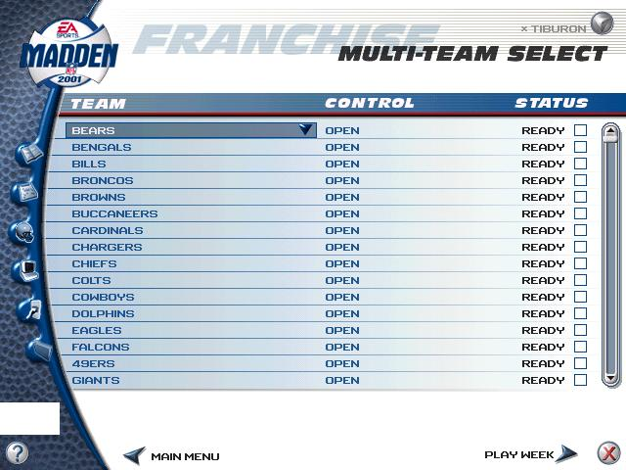
Active User Profile
Stats/Info
NFL Record Book
User Profile
Settings
Remote
Files
Help
Quit

For a complete description of the Stats/Info and NFL Record Book mode menus, see Mode Menus on page 24.

Selecting a Team
The Team column shows a list of the teams that are currently enlisted in the online franchise. If you want to change the teams that are listed, click on a team and select a new one from the pull down menu that appears. All teams that you have available for you to play will show up in this pull down menu. This includes unlocked teams that you may have gained from completing Great Games and custom made teams.

Selecting a User Control
The Control column shows which user profiles control which teams. To change the control of a team, click on the appropriate section and select a user profile that you want to control the team. You may also give control of the teams to the CPU. When clients join your online franchise, they will be allowed to take control of one team that is currently on OPEN control. If you, as the host, don’t want some teams to be available for a client to control, simply change the Control to CPU or a user profile.

Status Button
Once an active user profile has selected control over a team, the online franchise cannot continue until the Ready box has been activated. Once the Ready box has been selected for that team, other users cannot change the team or control. If you, as the host, have designated some teams to CPU control and don’t want a client to change the team, make sure you have checked the Ready box.

Other Setup Settings (Gameplay Settings)
One final step to setting up your online franchise is to change some gameplay settings. You will be able to determine quarter length, adjust gameplay and penalty sliders, as well as many other gameplay options.

To get into the Gameplay Settings menu:
- Click on the Settings menu.
- Then, click on Gameplay Settings.

The following is a detailed list of the different gameplay settings that you can adjust for your franchise. As the host, any settings that you change here will force the clients to use those gameplay settings when playing in your franchise.

- quarter length – Sets the length of the game quarters from 1-15 minutes.
- skill level – Sets the difficulty level of the computer AI. You can set this option to rookie (easiest), pro, all-pro, or madden (hardest).
- player momentum – Sets the player momentum level to normal, more, none, or less. This option takes effect when the players are in motion. When set to NONE, a player can stop almost instantaneously and make a quick cut in a different direction. When set to more, players will need more room to stop and make cuts.
- coach cam – Sets the Coach Cam to offense, defense, both, or off. The Coach Cam displays the play routes for offense, defense, or both on the field, giving a clearer indication of how the play should develop.
- passing mode – Sets the method of in-game passing to normal or directional. When set to normal, you pass the ball by pressing the corresponding passing symbol of the receiver to throw to. When set to directional, only one receiver is highlighted at a time, depending on where the quarterback is facing.
- coach mode – With this option set to on, you assume the position of the coach, meaning that you call the plays, make substitutions, and all other decisions from the sidelines. But once the play starts, the computer controls the action on the field.
- injuries – With this option set to on, players may get injured on the field. The computer substitutes injured players out of the game.
- fatigue – With this option set to on, players may get tired on the field, affecting their performance.
- fatigue subs – With this option set to on, players will automatically be substituted after becoming fatigued. If set to off, players are never substituted, and you will have to substitute them manually.
- play notification – With this option set to on, the current offensive and defensive plays are displayed on an in-game pop-up window.
- play clock – This option turns the play clock on or off. If set to off, then the play clock will be displayed only in the Playcalling screen.
- accel clock – With this option set to on, the play clock winds down at a faster pace between plays.
You can also change other in-game settings by clicking the selector arrows located near the top center part of the menu.

With these selector arrows, you can adjust certain in-game physics to your liking such as:

- special teams
- FG Length - Changes the length a field goal can be kicked (less, normal, or more).
- FG Accuracy - Changes the accuracy of the player kicking the ball (less, normal, or more).
- Punt Length - Changes the length a punt can be kicked (less, normal, or more).
- Punt Accuracy - Changes the accuracy of the player punting the ball (less, normal, or more).
- Kick Length - Changes the overall distance of a kick (less, normal, or more).
- offense
- QB Accuracy -This affects how accurate the ball is thrown to a receiver from the QB.
- Pass Blocking - This affects the degree of success that players have in making successful pass blocks.
- WR Catching - This affects how well a receiver can catch the ball.
- RB Ability - This affects the ratings of a running back such as awareness, agility, speed, acceleration, etc.
- Run Blocking -This affects the degree of success that players have in making successful run blocks.
- defense
- Awareness - This affects how fast a player reacts to a play on the field.
- Pass Knockdown - This affects how often a pass is blocked by the defense.
- Interceptions - This affects how often a pass is intercepted by the defense.
- Break Blocks - This affects how well the offense blocks a defender as well as how good a player is at breaking through blocks.
- Tackling - This affects how well a defender tackles an offensive player.
- penalty levels
- Changing the sliders at this screen either increases or decreases the frequency of penalties called during the game.
- Note: Moving the sliders to the right increases the frequency, and moving the sliders to the left decreases the frequency.

Hosting the Franchise
Once all of your settings are set, and you’re ready to get your franchise moving, the next step is to host your franchise online so others can join.

To host your online franchise:

- Click on the Remote menu.
- Then, click on Connect/Disconnect. The Hosting Franchise window will appear.
- Change the Host/Join selection to read, “Host”.
- Change the Type selection to read, “EA Football Net”.
- Then, click Host

Now, the Connection Status window appears as well as a connection icon in the bottom left hand corner of the screen. If there is nobody connected to your franchise, you’ll see that the connection icon is gray and looks like two separated plugs. Once someone joins your franchise, the connection icons will turn yellow and the two plugs will be joined. Also, your Connection Status window will pop-up every time a client joins or disconnects from your franchise. To see who is currently logged into the franchise, click on the Users drop-down button.

Chat and Messaging (Remote Menu)
The Remote menu is perhaps one of the most useful tools in an online franchise. Within the Remote menu, the commissioner and clients can communicate to each other. Communication is extremely important with online franchises, because if the commissioner is not keeping his clients informed of what’s going on, the franchise will most likely fail.

- Chat - The chat feature is a real-time chat forum, where you and your clients can chat to each other about anything you want. You can tell if someone is in the chat room if you notice a blinking icon of a head above the connection icon.

- Messaging – The messaging feature is used similarly to email. You can type a message and send it to an individual in the franchise or send it to everyone on the franchise. This can be useful for commissioners to relate important information to all the clients, even if they are not online at the time. You can tell if someone sent you a message if you notice a blinking icon of an envelope.

You can send messages to those who are not online. They will see the blinking icon once they connect back to the franchise.

Choosing Teams and Starting the Franchise
When clients begin connecting to your franchise, they will be allowed to select one team to control. Even the commissioner is allowed to control a team and play. Once everybody has selected a team, the commissioner can begin the franchise by advancing to the Play Week menu (or Fantasy Draft if that option was selected in the League Setup menu).

Exiting the Franchise and Re-hosting (For Commissioners)
Obviously, you will not be able to have your franchise connected 24 hours a day, 7 days a week. So, eventually, you’ll need to disconnect your online franchise and host it back up at a later time. When you created your online franchise, you were prompted to name the franchise. A file is saved by the same name in the Files menu. If that file is deleted, your franchise will no longer exist.

To Re-host your franchise:
- Load your saved franchise file from the Files menu.
- Click on the Remote menu.
- Select Connect/Disconnect.
- Then, change the Type connection to “Internet” since this is the easiest way to host your online franchise.
- Next, click on the Resolve button. This will show you what your current IP address is. Every time you reconnect to the Internet, you’ll most likely have a new IP address.
- Let your clients know what IP address to connect to.

Exiting the Franchise and Rejoining (For Clients)
Whenever a client exits out of the franchise (whether to go to bed, or eat, or run errands) a franchise file is saved under the Files menu. When you joined the online franchise for the first time, you were prompted to name your franchise file. That file will need to be loaded every time you want to get back into the online franchise. After you load your franchise file, you will then need to reconnect to the commissioner, provided that he is currently hosting the franchise.

To rejoin the online franchise:
- Load your saved franchise file from the Files menu.
- Click on the Remote menu.
- Select Connect/Disconnect.
- Then, change the Type connection to “Internet” as this is the most common way of establishing an online franchise.
- Next, type in the IP address of the host’s computer.
- Click Join, and you should then be connected to the commissioner’s franchise.

Duties of the Commissioner
To make the franchise run more effectively, the commissioner should set up a schedule with all of the clients, letting them know when the franchise will be online and when certain events are going to happen (Fantasy Draft, advancing to the post-season, etc). Otherwise, the clients will have to guess when the franchise is going to be available and will probably lose interest quickly if they can’t log back into the franchise and/or they notice that five weeks have already been simmed. Use the Chat and/or Messaging features in the Remote menu to keep communications open. You might even consider getting everyone’s email address and creating a website.

Also, keep in mind that, as the commissioner, you control just about everything with your franchise. This means that if your franchise finished its first season and you advance the franchise to the post-season, then all of the clients who may not be connected will miss out on the post-season adjustments. If you are doing a Fantasy Draft, you will want to have all of your clients online before starting, otherwise those not connected will not be able to draft.

Give your clients a deadline to finish playing their designated game for each week. For example, if you wanted to play along with the real NFL, you can give your clients one week to finish their game before you advance to the next week. If you give a timetable as to when you are going to advance to the next week, your clients will appreciate that. It’ll give them time to not only finish their game, but to do trades, sign free agents, or adjust their roster. Of course, you’ll want to give out a schedule of when your franchise will be online. After all, players can’t report their scores or do trades if they can’t connect to your franchise.

Don’t just sim a few weeks or skip through post-season when nobody is connected to your franchise, unless they know and understand your reasons. Be considerate to your clients. If you are, your franchise will be very enjoyable to play.

Fantasy Draft
If you are playing an online franchise with this option on, all the teams will need to draft their players from scratch using a pool of players from all the teams that are enlisted in the franchise. Whenever everyone is finished drafting his or her team, click Play Week to advance to the next stage of the online franchise.
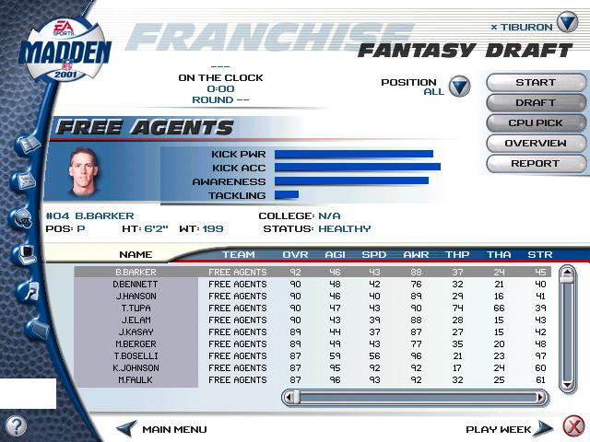
Active User Profile
Stats/Info
NFL Record Book
User Profile
Settings
Remote
Files
Help
Quit
Draft timer
Player information
List of players
Player Stats

Draft Timer
Depending on what you set the Draft Timer option at the League Setup window, this section of the menu shows how much time a team has to make a draft pick. Above the draft timer, whichever team is up on the clock will appear.

List of Players
This section lists every single player that is in the Fantasy Draft pool. Players available to be drafted will be listed in the TEAM column as being on the Free Agents. All others will list the team that drafted them. To scroll through the list, D-Pad  if the list is highlighted, or you can click on the scrollbar to the right side of the list. If you want to sort a column, such as OVR, all you have to do is click on that column as press the S key on the keyboard.

Player Information
This section lists various information about the highlighted player from the list below. Here, you can see the player’s name, photo, position, height, weight, what college they went to, and a few of the player’s important statistic bars.

Player Stats
This section of the player list shows each player’s individual statistics in various categories. This information can be extremely helpful if you are looking for a player with great tackling ability, awareness, stamina, etc.

Start the Draft
In order to start the Fantasy Draft, the commissioner must click the Start button located near the top right hand corner. The draft timer will then begin and whichever team is up can draft a player.

To draft a player:
- Browse through the player list until you find a player that you want to draft.
- Click on the player’s name, and then select the Draft button. That player will now be added to your team roster.

- Note: If you want the CPU to draft for you, click CPU Pick instead of Draft. The CPU will then draft the best available player, according to its logic. Keep in mind, though, that once you select CPU Pick, the computer will select all of your remaining draft picks.

Overview Button
This button is helpful in looking at a basic overview of your team. Use this menu to view your team statistics, coach information, strategy, and most importantly, a breakdown of player positions. You can quickly see how many active players you have in what positions to help assist you in your draft.

Report Button
This option will save the Fantasy Draft’s player list in a printable file. It will contain all the players that are currently showing in the player list. For example, if you sorted the player list to show only quarterbacks, then the Report button will only save the quarterback player list.

Play Week
This screen lists all the games that are to be played throughout the season. You can scroll through each week and observe the scores of games that have been played.

Active User Profile
User-controlled team
Score box
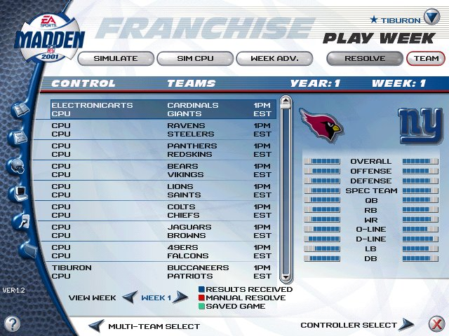
Stats/Info
NFL Record Book
User Profile
Settings
Remote
Files
Help
Quit

Playing a Game
In order to advance through your online franchise, you must either play your designated games or simulate them.

To play a game, highlight the game on the schedule that contains your user profile name, and then select Controller Select. If you are a client of the franchise, you will be disconnected from the franchise while you play your game. If you are playing against another client, one of you must host the game while the other joins. A generally rule of thumb is that the user with a faster connection should host, or the home team should host. You can play your game by connecting IP to IP or through a direct connection with your modem. Most commonly, you’ll play IP to IP. Once your game is done, you will need to reconnect to the commissioner’s franchise to report your scores.

If you are the host, and you are playing a game, then your franchise will become disconnected once you enter the Controller Select menu. You should inform your clients that you are going to play your game and the franchise will become offline, but be sure to tell them when the franchise will be back online. That way, your clients won’t think that you just abandoned them. Even if you disconnect your franchise, your clients can still play their games against their opponents. However, once you finish your game, you’ll need to host your franchise back online to get everybody’s scores.

If you quit a franchise game in the middle of progress, a green box will appear next to your game on the schedule, indicating that your game is saved and still in progress. To resume your game, highlight the game from the schedule, and then click Controller Select.

Simulating Games
This is a helpful tool if you want to have the CPU quickly play all of its games in a week. Only the commissioner may simulate games. There are three different ways to simulate games on the schedule: Simulate, Sim CPU, and Week ADV.

- simulate – This option will simulate the highlighted game in the schedule.
- sim cpu – This option will simulate all CPU vs CPU games listed in the schedule.
- week adv – This option will simulate all games, including user-controlled games. After it is finished simulating the entire week, the schedule for the next week will appear. This option will also delete any pending trades for that week. You also use this option to advance to the next week if everyone has finished playing his or her game.
- RESOLVE – This is accessible only by the commissioner of the league. When a game between two remote users is played, the results are uploaded to the commissioner's computer the next time the users logon to the league server. Problems can arise if the game files from each user do not match (such as in the case of a desynch or disconnection). If there is a discrepancy between the game files from each user, the commissioner will be notified and given choices based on the results of the files.

Team Button
This button will take you to the Team Management screen where you can formulate trades, check depth charts, and many other features. However, you are only allowed to make change to your own team.

Team Management
From this screen, you can change your team’s rosters and make trades to other teams. Once, you have finished making changes to your team, click on Play Week to return to the week’s game schedule.

Active User Profile
Team button
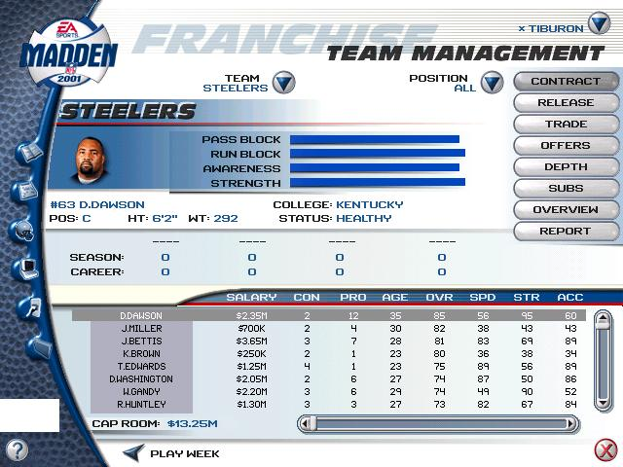

User Profile
Stats/Info
Player information

NFL Record Book
Settings
Remote
Files
Help
Quit
List of players
Player Stats

List of Players
This section lists every player that is on your team. To scroll through the list, D-Pad  if the list is highlighted, or you can click on the scrollbar to the right side of the list.

Player Information
This section lists various information about the highlighted player from the list below. Here, you can see the player’s name, photo, position, height, weight, what college they went to, injury status, and a few of the player’s statistic bars.

Player Stats
This section of the player list shows each player’s individual statistics in various categories. This information can be extremely helpful when modifying depth charts and formation subs.

Team Button
This button will display a pull down menu where you can change to view another team in this menu. Keep in mind, though, that you cannot change a team’s roster unless your user profile is controlling that team.

Contract Button
This button opens the Negotiate Contract screen with the highlighted player in the player list. From here, you can sign free agents. Free agents can be signed by selecting Free Agents in the Team drop-down menu and highlighting the player you want to sign. Then, simply click Contract.

Release Button
This button will release the player highlighted in the player list to the free agent roster.

Trade Button
This button opens the Propose Trade screen. At this menu, you can select players from your roster and propose a trade to another team.

To offer a trade:
- First, select the player(s) from your team roster that you want to trade. Then, press Enter. The player(s) will then appear in the trade block in the middle of the screen.
- Next, click on the Team drop-down button to view the roster of the team you want to trade to.
- From that team’s roster, highlight the player(s) that you want to trade for your player(s). Then, press Enter. The player(s) will appear in the trade block.
- Once, you are finished, click Submit. Your trade will be sent to the other team.

Trades can only be done when your team and the team you want to trade with have both finished playing their game for the week. If the commissioner has already Week Advanced to the next week, you’ll need to play that week’s game before you can trade. Therefore, the commissioner should allow some time after every client has played their game so that trades can be offered. This is where deadlines come in handy. If the commissioner announces that the franchise will week advance every two days (or whatever the commissioner decides as a deadline), then that will allow the clients time to play their game for the week and have time to offer trades, sign free agents, etc.

An example of trading:
- Suppose you control the Rams and want to trade Kurt Warner for Peyton Manning. The first thing you have to do is complete your game for the week. Also, the team you want to trade to (in this case, Indianapolis) will also have to finish their game. Once both teams completed their games, and the commissioner has not advanced the week, you are ready to trade.
- You would then go into the Propose Trade menu and offer your trade using the steps above. As soon as you click the Submit button, the trade offer will be sent to the owner of the Colts.
- The user who controls the Colts will get a message indicating that the Rams want to trade Warner for Manning. He will then need to go into the Trade Offers menu (see Offers Button on page 20). Now, he can see the trade offer as well as compare statistics of the players being traded.
- Let’s assume that the Colts accept the trade. Both users will receive a pop-up telling them that the trade has been accepted. Then, rosters will be changed accordingly. Warner will now be playing on the Colts, and Manning will be wearing a Rams uniform.

Offers Button
This button opens the Trade Offers screen. This screen will display all trade offers the currently selected team has. If a trade has been offered to your team, the Notification window will pop-up, telling you that a trade has been proposed. You would then need to go into the Trade Offers menu to accept or reject the trade.

Depth Button
This button opens the Depth Chart screen of the selected team. You can change and reorder your starters from there.

To change the order of the depth chart:
- From the Current Lineup section, highlight a player to be removed or reordered in the original depth chart.
- Press Enter to move the focus to the Available Players list.
- From the Available Players list, highlight a new player who you want substituted in the original slot.
- Press Enter, and the new player appears in the lineup, and the new depth chart is set.

Subs Button
This button opens the Formation Substitutions screen. You can place certain players on your team in certain formations there.

To change the depth chart of a specific formation:
- Select an offensive or defensive formation and set.
- Select a position by clicking on the X’s or O’s in the formation section.
- From the Available Players list, highlight a player to be substituted in the starting spot and press Enter. The new depth chart is set.

Overview Button
This button opens the Team Overview screen. You can view and change a team's coach info, statistics, rankings, coaching strategy, and roster breakdown.

Report Button
This button saves the current team roster to a printable file.

When a Week is Advanced
When the commissioner feels that it is time to advance to the next week, then he will click on the Week ADV button. As soon as the week is advanced, any games that were not played will get simmed and all trade offers in waiting will be cancelled.

The next week’s schedule will appear, and statistics generated from last week such as Weekly Awards and injuries will become available in the League News menu. If you had a player injured in the previous game, you can click on the Team button to view that player’s injury status. To see how long a player will be out, check the injury report in League News.

The End of the Season
After the regular season ends, the playoffs begin. After the Super Bowl has been played, the Pro Bowl is played (assuming that you are playing a 31 team franchise). When the Pro Bowl has been played, the season ends. The next step is to enter the post-season where you can draft new players, resign free agents, and progress your players. Again, the commissioner should make the clients aware of when post-season activity will be taking place so that they can connect to the franchise.

Post-Season
After any season, it’s time to think about the future. This is where you can build the franchise’s next dynasty by signing key free agents and drafting players.

League News
This menu appears at the end of the season. You can read the list of retired players and review player trades and signings. You can also view through the yearly awards to see which players were the best of the entire league.

Player Progression
This screen shows how your players progressed through the season. If they did well during the season, they are awarded with bonuses to their stats. If they did bad, they may suffer penalties to their stats. The commissioner should advance to the Re-sign and Trade Players menu after all the clients have had enough time to browse through their player progression.

Re-Sign and Trade Players
From this screen, you can re-sign and trade the players on your current roster.

To negotiate a player’s contract:
- Highlight a player from the player list that you want to negotiate a contract with. To easily list the players that have zero years left on their contract, click on the CON column and press S on the keyboard. All players with a zero in the CON column have expired contracts. You must negotiate new contracts with them, otherwise they will become free agents where any team can sign them. To negotiate a player’s contract click Contract. This will bring up the Negotiate Contract menu.
- Offer a salary and length of contract, and click Submit. The player will either accept or decline the offer.

After all clients have finished re-signing their players, then the commissioner should advance to the next stage. Again, this is where a deadline is helpful to determine when the next stage of the franchise will advance.

Free Agent Signing
You have a 45-day period in which to sign available free agents. You must fit all your players under the salary cap (If the salary cap option was set in the League Setup menu). Whenever, you have submitted an offer to a free agent, you’ll need to wait until the commissioner clicks the Advance button to advance through the days. The commissioner should set a time deadline to determine when a day will advance.

To bid on a player:
- Highlight a player from the player list, and click Sign. This will bring up the Negotiate Contract menu.
- Offer a salary and length of contract, and click Submit. The free agent may accept the offer or decline it and solicit offers from other teams. If this is the case, you must come up with a more suitable contract before he decides to sign with another team. Once the commissioner has advanced a day, the free agent will then decide to sign with the highest bidder.

Once all of the 45 days are up, the commissioner can then advance to the NFL Draft menu.

NFL Draft
This screen is where you draft rookies onto your team. Each team selects one player per round. For more information on drafting, see Fantasy Draft on page 12. Once the draft is complete, the commissioner must then advance to the next menu.

Draft Pick Signings
After the NFL Draft, you must sign your draft picks to your roster. Any draft picks that are not signed will become free agents where any team can sign them. The commissioner should wait until all of the teams have finished signing their draft picks before advancing to the next year.

Mode Menus
This section is merely an appendix to a list of menus that are found in the Stats/Info and NFL Record Book menus.


Stats/Info

This button is used to check on statistics and information.

- User Statistics - The user statistics screen displays the current statistics for the active user profile. Statistics are from all games that the user profile has played. This includes exhibition, season, franchise, great games, online, and local games.
- Notification - This screen displays all player movements that apply to your teams. This menu will automatically pop-up when a trade is offered, or if a player is released from your team, or if a player accepts or rejects an offer.
- Team Schedules - This menu lists a team’s schedule for the current season. It also lists the scores of the game that have been played already.
- Team Statistics - This menu is used to view various team statistics.
- Team Standings - This menu is used to check up on the status of your team and how they rank among the other teams in the league.
- Individual Statistics - This screen displays the individual player statistics for the league. You can sort these statistics in several key categories.
- League News - This screen is the center location for all news around the league. If something happened in the league, you'll find it here. You can check up on weekly and yearly awards and see which players are performing better than the other players in the league.
- Draft Preview - This screen will show you a list of players that will be in the next year’s draft. This list only becomes available during the post-season.
- Draft Automation - This menu is used if you want the CPU to draft for your team. You set up positions and priorities to help assist the CPU in drafting the players that you need.


NFL Record Book

This button is used to view records and any user that may have broken them.

- All-Time Records - This screen displays the in-game records that have been broken on the local computer during a game. This includes exhibition, franchise, season, great games, online, and local games.
- Super Bowl History - This menu is used to view past Super Bowl champions whether in your own league or in the NFL.
- League Leaders - This screen displays the leading players in the different statistical categories.
- League Records - League records are tracked through every season and game. When a player breaks a league record, it is saved here.
- Team Records - This screen tracks records that each team in the league sets during a season or game. Every team has its own record book.

Troubleshooting
Occasionally, things may happen to cause your franchise to hit rough times. This section is devoted to help the commissioner deal with these issues to minimize negative effects on the franchise.

Kicking a Player
It may come to your attention that a certain client is causing trouble within your franchise. Perhaps he continuously spams the other clients by sending useless messages or harassing clients through the chat feature. You may even have a client who is purposely breaking any rules that you’ve set for your franchise such as “no going for it on 4th and 20”. These type of players can cause the other clients to become discouraged in playing in the franchise. Luckily, the commissioner has the ability to kick unruly players out of the franchise.

To kick a client permanently from the franchise (assuming that the client is currently connected to the franchise):
- Click on the Remote menu.
- Select Status. The Connection Status window will appear.
- Click on the Users drop-down list.
- Next, select the user that you want to kick and click the Kick button.

To kick a client permanently from the franchise (if the client is not currently connected):
- Go to the Multi-Team Select menu.
- Find that user’s team and change the Control column to CPU.
- Next, click on Play Week to finalize the changes. The client will be removed from the franchise.

Client Deleted Their Franchise File
A client cannot rejoin the online franchise if the franchise file is deleted. If the commissioner deleted the franchise file, then the entire online franchise is dead and must be restarted. However, a client can accidentally delete their own franchise file, and still be able to get back into the franchise, if the commissioner allows it.

If the client is unable to rejoin the franchise because they deleted their franchise folder, the commissioner must do the following to allow that client to rejoin:
- Go to the Multi-Team Select menu.
- Find the client’s user profile in the Control column and change it to CPU.
- Next, click on Play Week. The client will then be kicked off the franchise.
- Now, to let that client back on, go back to the Multi-Team Select and change his team’s Control column to OPEN.
- While the commissioner is still at the Multi-Team Select menu, have the client join the franchise as if he was doing it for the first time. When he logs in, have him select his team with his user profile. Then, click on Play Week to continue your franchise.

