Methodology
The information contained in this report is based on primary and secondary re-search. Primary research included on-site examination of skincare products in retail stores, consultations with retailers and industry executives, and survey data directly pur-chased by Packaged Facts. Secondary research involved information provided by various web sites, annual reports, skincare reports, articles in trade publication and marketing.
Statistics on market revenues, revenue growth rates, marketer shares, and share by retail sector are based on a careful evaluation of all available information on market sales and trends.

Company’s Overview

DHC, a skincare company which was founded in Hong Kong in 2000. It sells high quality skincare products based on the natural benefits of olive oil. All products are made with natural ingredients without any artificial ingredient like coloring agents or irritating fragrances. The product lines included moisturizing for skin, whitening line, anti aging line and UV blocking line

DHC has around 5 retail stores over Hong Kong but the company mainly sells its skincare products through telecom and internet. Once you have ordered the goods through the phone or the internet, the products will be delivered to customers’ home within three days with no relay.

Each month, the customers’ will receive a newsletter from DHC and inform about our new product range. Free samples will be given to the customers once they placed an order.

DHC targets at women aged from 20 – 39. The markup price are slightly lower than other famous skincare competitors in Hong Kong as it the brand doesn’t put much emphasis on design, packaging and packaging, Instead, It stresses on the quality of the products, time efficiency and the degree of convenience.

Hong Kong cosmetic and toilettes market overview
Imported cosmetics and toiletries meet 95% of local demand, as there is very little domestic production. Hong Kong’s cosmetics and toiletries imports totaled USD897million in 2003. China was the largest supplier with a 19% share, followed by Japan (13%), the U.S. (13%), and France (11%.) Imports from the U.S. totaled USD113 million in 2003. U.S. cosmetics and toiletries’ suppliers are known for being innovative in product development, and for producing quality, and safe products at competitive prices.

On Skincare market
Japanese, French and Swiss products are most popular. Among the US retail brands, Max Factor’s SKII, Philosophy (U.S.) and Estee Launder’s Crème de La Mer products enjoy a strong market position. Local consumers cite suitability of Japanese skin care products to Asian skin type as the reason for their preference of Japanese products over American and European products. Shiseido, Shu Uemura and Fancl are the most popular Japanese brands. L’oreal introduced a line of whitening products, labeled, “formulated for Asian skins,” to combat this perception that only Japanese products are suitable for Asian skins. For products used in professional skincare salons, the most popular brands are Valmont (Swiss), Rene Guinot (French) and Clarins ( French.) Skin care for men is gaining wider acceptance in Hong Kong. Several men-only skin care centers have opened in Hong Kong.
Demand for skin-whitening products will continue to remain strong in Hong Kong especially because local Chinese males prefer fair-faced females than those with dark skin. Manufacturers of mass-market skin care products, like Beiersdorf AG ( Nivea White), L’oreal, Oil of Ulay, and Neutrogena are now entering the market for whitening products. These brands compete well with the premium brands on price and quality. In an effort to raise their image, L’oreal has even located retail outlets within high-end department stores to be among the premium brands.
http://strategis.ic.gc.ca/epic/internet/inimr-ri.nsf/en/gr126837e.html

PESTLE Analysis for Hong Kong

Economy Analysis
The economy
Hong Kong is characterized by its business-friendly environment, free trade and free flow of information, open and fair competition, well-established and comprehensive financial networks, superb transport and communications infrastructure, sophisticated support services, and a well-educated workforce Moreover, substantial foreign exchange reserves, a fully convertible and stable currency, and a simple tax system with low tax rates.
Hong Kong has retained its rating as the freest economy in the world in the 2004 Index of Economic Freedom released by The Heritage Foundation, for the 10th consecutive year. The Cato Institute in the United States, in conjunction with more than 50 economic institutes worldwide, also ranks Hong Kong as the world's freest economy. The International Monetary Fund classifies Hong Kong as an advanced economy. Other highly regarded institutions—like the World Economic Forum, the International Institute of Management Development and the Economist Intelligence Unit—also identify Hong Kong as one of the world's most competitive business environments. And Hong Kong is the best-performing host economy for foreign direct investment (FDI) in Asia, according to the World Investment Report 2002 published by the United Nations Conference on Trade and Development (UNCTAD).
Gross Domestic Product (GDP) Growth
Over the past two decades, the Hong Kong economy has a GDP growing at an average annual rate of 4.9 per cent in real terms. Per capita GDP in Hong Kong has an average annual growth rate of about 3.7 per cent in real terms.
Economic Policy
Hong Kong has long been well known for its market-led economic policies. Market-led means that the Government does not seek to direct or plan the course that the economy or the markets should take, as investors and entrepreneurs are deemed to understand markets far better than officials. Private sector initiatives are to build Hong Kong's prosperity than the bureaucrat's blueprints.
Social Analysis

Labour Market
At present, Hong Kong's labour force stands at about 3.5 million, of which 56 per cent are male and 44 per cent are female. The majority (85.2 per cent) are engaged in the service sectors: 31.3 per cent in wholesale, retail and import/export trades, restaurants and hotels; 11.2 per cent in transport, storage and communications; 15.1 per cent in financing, insurance, real estate and business services; and 27.6 per cent in community, social and personal services. Only 5.4 per cent work in the manufacturing sector

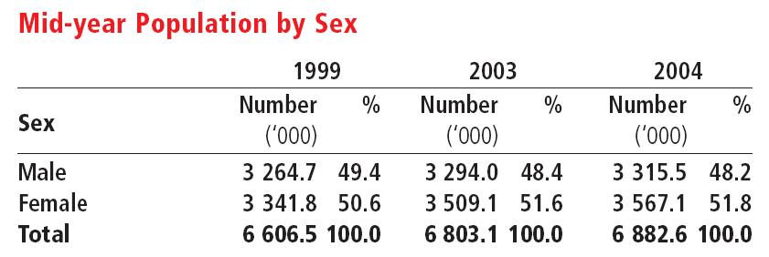

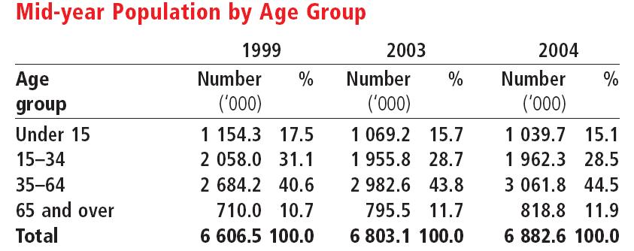

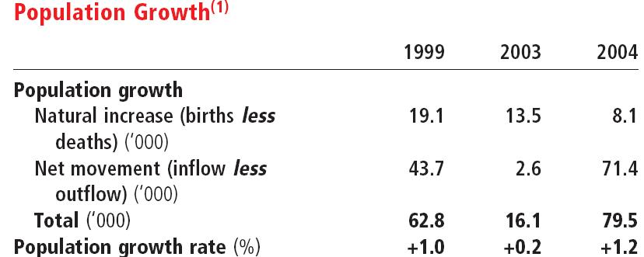
Source: http://www.info.gov.hk/censtatd/eng/hkstat/hkinf/population_index.html

According to the population figures of Hong Kong, we can see that there is a slightly increase in the ratio of women to men in 2004 when compared to 1999. Aged group from 35 -64 has rose a 3.9%, people who aged 65 or above has increased from 10.7% to 11/9%, but conversely for the younger generation, children under 15 has declined from 17.5% to 15.1%, young adults from 15 -34 has also showed a decrease from 31.1% in 1999 to 28.5% in 2004this shows that Hong Kong is facing a aging population.

Political Analysis
The Hong Kong Government believes in 'maximum support and minimum intervention'. Its role is to provide the most business-friendly conditions possible, including the rule of law, a clean and efficient administration, and a level playing field for all businesses.
In addition, the Government has a responsibility for removing market restrictions and promoting fair competition. It has made considerable strides in liberalising the securities, futures and banking industries, and opening up the telecommunications, information technology and broadcasting markets.The Government protects and promotes Hong Kong's commercial interests in the international arena through representation in such international forums as the World Trade Organisation and the Asia-Pacific Economic Co-operation group, and by negotiating and entering into bilateral arrangements such as those for air services.
The Government maintain a simple tax structure with low tax rates that sustain workers incentive to work and entrepreneurs incentive to invest. The corporate profits tax rate and salaries tax rate, at 17.5 per cent and 16 per cent respectively, are low by international standards.

The Government's policy is to maintain and develop a sound legal, regulatory, infrastructural and administrative framework with the aims of providing a level playing field for all market participants, maintaining the stability of the financial and monetary systems and enabling Hong Kong to compete effectively with other major financial centres

Source: http://www.info.gov.hk/info/hkbrief/eng/econ.html

Legal Analysis

The legal system of the HKSAR is based on the rule of law and the independence of the Judiciary. Under the principle of 'one country, two systems', the HKSAR legal system is different from that of the Mainland, and is based on the common law.

Environmental Analysis

With rapid population growth in recent years, the Government has made efforts in reducing the pollution in Hong Kong.

To control air pollution, Hong Kong is now leading in Asia in terms of vehicle emission control and fuel quality standards. Diesel vehicles are responsible for most of the roadside pollution in the urban areas, and the Government's strategies include tighter control on vehicle emissions and introducing cleaner fuel vehicles where practicable. Almost all taxis are running on liquefied petroleum gas (LPG). On fuel quality, Hong Kong became the first city in Asia to introduce ultra-low sulphur diesel for its vehicle fleet.

A sewage disposal strategy was adopted by the Government to combat water pollution caused by increased urban development. A major deep tunnel collector system and treatment works were designed to handle sewage generated from all districts around the Victoria Harbour area. So far, 24 kilometres of large tunnels under the central urban area and a sewage treatment works at Stonecutters Island, providing chemically enhanced primary treatment for up to 3.5 million cubic metres of flow per day, have been commissioned

Source: http://www.info.gov.hk/info/hkbrief/eng/living2.htm#protect

Technological Analysis

Internet
More than 97 per cent of households and virtually all commercial buildings are covered by the broadband network. A total of 201 Internet service providers cater to more than 1 million registered customer accounts and more than 1.2 million registered customer accounts with broadband access.

Telephone Services
At the end of 2003, Hong Kong had more than 3.8 million exchange lines. The telephone density was 70 telephones or 56 exchange lines per 100 population — one of the highest in the world. Also serving Hong Kong's needs in data communication were 491 196 dedicated facsimile lines, representing 29 fax lines per 100 business lines — one of the highest rates of business fax use in the world. The number of subscribers to cellular phones was 7.19 million, a penetration rate of about 106 per cent — one of the highest in the world.

Firm‘s competitiveness in the market

Why DHC should go internationalize?
Demand push for internationalization
There is a restriction of the firm in the domestic market due to the large amount of foreign competitors in the industry. There are many competitors in the skincare industry. Like Shiseido, Kose, Max Factor from Japan. Origins, and Body Shop from the United Kingdom. The competition is too severe that force DHC for internationalization.

Demand pull for internationalization
With reference to the market size and the growth prospects in Hong Kong, DHC which is based on the ordering of goods either by phone calls or through the internet. As the labour and rental prices are very high in Hong Kong, more and more skincare companies will enter the market by using this particular method so as to save money and resources. Therefore, DHC must go internationalization before the market saturates.

Costs
Internationalization maybe motivated by the desire for reducing costs. As the DHC’s skincare products are all made in Hong Kong, resources, materials, research and development of the products are comparatively high as the cost of living is comparatively high when compared to other developing countries like China, Taiwan. DHC can then penetrate into these countries and produce the products there, lower cost of resources and economic of scale can then achieved.

Shortening product lifecycle
As a consequence of technological development, the lifecycle of the products may be shortened, especially in the developed country like Hong Kong. DHC products can be easily replaced by other more advanced skincare products due to the rapid technological development. By internationalization, this can exploit more short run advantage of the product by going internationalize into other developing countries which the technological development are much slower when compared to Hong Kong, our products may still retain as the most updated or the advanced ones.

2. Criterion to be considered:
The Environment
The political factor
As long as we prepare to have the international operations in other countries, we must first make sure the political environment is a stable one. The corruption rate should be kept at a low rate so companies doing business internationally will not receive bribes or favours for foreign officials in order to gain contacts. Bribes can cause a great harm like shoddy performance and loose moral standard among mangers and employees.

The government of the host countries also pays an important row in coordinating the business activities. Government organizations can act as a facilitator to promote exporting or foreign direst investments. Government can carried out supportive activities to make it’s country’s products become more competitive in the world market can also encourage international business operation from foreign countries like granting subsidies, lower taxes on profits, refunding of various indirect tax.

There may have import restriction on the raw materials, machines. So make sure there will not be any restrictions before entering the market.
The economy
The economic environment is a major determinant of market potential. Market size, population, sex ratio and the market growth are going to be considered. Determine the buying power of the countries; the availability of internet, telephone systems, infrastructure will highly influenced the buying power. Exchange rate is also an essential element to be determined.

First of all, inflation rate could be considered as it usually acts as an indicator of economic growth. When a country is locating in the growth or recovery stage of the economic cycle, the inflation rate is usually high. Conversely, when the inflation rate is low, or negative, the country is usually experiencing economic decline. Therefore, we should target at the countries which are having relatively high inflation rates because citizens of those countries are enjoying economic growth, as a result, they would have higher income and willing to spend more on our products.

Moreover, we should also consider exchange rates of different countries. As stable exchange rates present the economic and political stability of a country, when a country has stable exchange rates, the economic and political condition is healthy and stable. In opposition, when fluctuate exchange rates are shown, it implies the country is having economic and political problems.
Demography
The population is an important element in determining which market should enter. The higher the population density rate, the more number of consumers.

By measuring the sex ratio, if the a country consists a ratio of more female to men, then this will be a favour to our company as DHC markets at women.

The proportion of female age group is also essential. Since our target customers are aged between 20 -39. The higher the proportion in this age group, the larger no. of potential customers is going to consume our products.
Economy
National income (GNP) is an important factor to be considered because it determines the purchasing power of people. A country’s GNP per capita is it’s GNP divided by its population. The countries have considerable GDP per capita, usually for the developed countries, have considerable development in the services sector and substantial investment in the infrastructure.

The level of economic integration is going to be considered. This is going to be divided into 4 categories:
1. Free trade area is the least restrictive of economic integration. There are no barriers to trade among member countries.
2. Custom Union means there will be a free trade of goods among its members but there will be a common external tariff to the non member countries.
3. Common market means factor of production are mobile among members countries. But restriction on immigration and cross border investment is abolished.
4. Economic Union means integration of economic policies in addition to the free movement of goods, services across borders.

Free trade area is the most considerable countries for the internationalization of the company.

Technology
The degree of technological advancement is essential for our company. As our company is highly based on internet and telephone services, the higher degree of technological development of one country, the more opportunity will be provided to our company.

The socio cultural environment
Culture characteristics
It is important to define the culture of different countries before stepping into one country for investment.

Hofstede’s (1980) defines culture as a “ the collective programming of the mind which distinguishes the members of one human group from another…Culture, in this sense, includes systems of values; and values are among the building blocks of culture’.

It is essential to understand customers’ personal values and norms of behaviour before entering the foreign markets. Groups with shared cognitions and shared views can facilitate a more efficient internationalization of the company.

Edward T. Hall (1960) demonstrated the concept of high and low context for understanding different cultures. Low context cultures (e.g. China, Japan) reply heavily on spoken and written language for meaning. High- context cultures use and interpret more of the elements surrounding the message to develop their understanding of the message.

It is necessary to find the countries which have more or less the same degree of context in cultures for marketing.

Another approach is the Hofstede (1983) which he has defined four approaches, namely power distance, uncertainty avoidance, individualism and masculinity.

Power distance refers to the degree of inequality between people. High power distance means power is concentrated on the top who make the decisions. Low power distance means the more individuals to participate for the decision making.

Uncertainty avoidance refers to the degree of risk taking. When uncertainty avoidance is strong; a culture tends to perceive unknown situations as threatening so that people tend to avoid them. Examples include South Korea, Japan, and Latin America.
In countries where uncertainty avoidance is weak (the US; the Netherlands; Singapore; Hong Kong, Britain) people feel less threatened by unknown situations. Therefore, they tend to be more open to innovations, risk.

Countries with low uncertainty avoidance are more beneficial for foreign companies to enter as they show a greater acceptance and are more able to adapt new ideas or technology.
In Individualist countries, people are expected to look out for themselves. Typical values are personal time, freedom, and challenge. In collectivist cultures, individuals are bounded through strong personal and protective ties based on loyalty to the group during one’s lifetime.
Masculinity refers to the degree to “masculine” values.) “Feminine” values a good working relationship with their supervisors; working with people who cooperate well with one another, and having the security that they will be able to work for their company as long as they want.
But turn to the other side, Where the masculine index is high, people tend to value having a high opportunity for earnings, getting the recognition they deserve when doing a good job, having an opportunity for advancement to a higher-level job.
Lifestyles
Lifestyles mean typical activity or interest though it is hard to define. Like the domestic country of our company, Hong Kong, there are more and more women care for their appearance and thus skincare products are successful launched. In finding suitable countries, we should find countries which have similar habit as Hong Kong women which they find appearance are relatively important in their lifestyle. Moreover, since DHC aims at the time efficiency, we should find countries with a busy lifestyle as Hong Kong people do.

The firm
Analysis the degree of competitors.

The market share of our particular industry.

4. Factors affecting the foreign market entry mode decision
Internal Factors
- Firm Size, the firm size can determine its resource avalibilty.
- International Experience, this can affect the choses of market entry mode. International experience refers to the extent to which a firm has been involved in operating internationally.
- Product

External Factors:
- Sociocultural distance between home country and the host countires
- Market size and growth
- Direct and indirect trade barriers
- Intensity of competition
- Small number of relevant intermediaries available

3.The process of evaluating suitable foreign markets to be entered can be divided into four stages.
  - Country Identification
  - Preliminary Screening
  - In-depth Screening
  - Final Selection

Step 1 Country Identification

By undergoing the macrosegmentation, it means grouping countries on the basis of common characteristics deemed to be important for marketing process. It is necessary to compare the population, the income level (GDP), cultural similarity of the countries.

Geographic location
Since DHC domestic country is located in Hong Kong, where is the eastern part of the Asia; It maybe too far to have the export of the products all over the world due to the high cost in transportation and the need of infrastructure. Moreover, as there is the different in weather conditions and ethics, the nature and sensitivity of the skin will be different. DHC may not be able to apply to all customers all over the world. For this reason, we decided to have it concentrated on the Asian countries

Stats > Geography > Location
Country (A to Z) | Description
Afghanistan | Southern Asia, north and west of Pakistan, east of Iran
Armenia | Southwestern Asia, east of Turkey
Azerbaijan | Southwestern Asia, bordering the Caspian Sea, between Iran and Russia, with a small European portion north of the Caucasus range
Bangladesh | Southern Asia, bordering the Bay of Bengal, between Burma and India
Bhutan | Southern Asia, between China and India
China | Eastern Asia, bordering the East China Sea, Korea Bay, Yellow Sea, and South China Sea, between North Korea and Vietnam
Georgia | Southwestern Asia, bordering the Black Sea, between Turkey and Russia
India | Southern Asia, bordering the Arabian Sea and the Bay of Bengal, between Burma and Pakistan
Japan | Eastern Asia, island chain between the North Pacific Ocean and the Sea of Japan, east of the Korean Peninsula
Kazakhstan | Central Asia, northwest of China; a small portion west of the Ural River in eastern-most Europe
Korea, North | Eastern Asia, northern half of the Korean Peninsula bordering the Korea Bay and the Sea of Japan, between China and South Korea
Korea, South | Eastern Asia, southern half of the Korean Peninsula bordering the Sea of Japan and the Yellow Sea
Kyrgyzstan | Central Asia, west of China
Maldives | Southern Asia, group of atolls in the Indian Ocean, south-southwest of India
Mongolia | Northern Asia, between China and Russia
Nepal | Southern Asia, between China and India
Pakistan | Southern Asia, bordering the Arabian Sea, between India on the east and Iran and Afghanistan on the west and China in the north
Russia | Northern Asia (that part west of the Urals is included with Europe), bordering the Arctic Ocean, between Europe and the North Pacific Ocean
Sri Lanka | Southern Asia, island in the Indian Ocean, south of India
Tajikistan | Central Asia, west of China
Turkmenistan | Central Asia, bordering the Caspian Sea, between Iran and Kazakhstan
Uzbekistan | Central Asia, north of Afghanistan
http://www.nationmaster.com/graph-T/geo_loc&int=-1&id=ASI&b_printable=1

Population
It is essential to analysis the population structure like the proportion of men to women and the proportion of suitable age group, which our company target customers are aged between20 – 39. For example, if a country consists of more men than women, they this will not be beneficial to our company as DHC markets at women.
The population size is a crucial fact to be evaluated. The larger the population size, the greater the potential customers.

Stats > People > Population

Rank | Country | Amount (top to bottom)
#1 | China | 1,306,310,000
#2 | India | 1,080,260,000
#6 | Pakistan | 162,420,000
#7 | Bangladesh | 144,320,000
#8 | Russia | 143,420,000
#10 | Japan | 127,417,000
#24 | Korea, South | 48,641,000
#38 | Afghanistan | 29,929,000
#40 | Nepal | 27,677,000
#42 | Uzbekistan | 26,851,000
#47 | Korea, North | 22,912,000
#53 | Sri Lanka | 20,065,000
#61 | Kazakhstan | 15,186,000
#91 | Azerbaijan | 7,912,000
#97 | Tajikistan | 7,164,000
#112 | Kyrgyzstan | 5,146,000
#113 | Turkmenistan | 4,952,000
#114 | Georgia | 4,677,000
#133 | Armenia | 2,983,000
#135 | Mongolia | 2,791,000
#141 | Bhutan | 2,232,000
#174 | Maldives | 349,106
 | Total: | 3,193,614,106
 | Weighted average: | 145,164,277.5
http://www.nationmaster.com/red/graph-T/peo_pop&int=-1&id=ASI

Stats > People > Sex ratio > Total population
Rank | Country | Amount (top to bottom)
#19 | India | 1.07
#20 | Bhutan | 1.07
#22 | China | 1.06
#25 | Afghanistan | 1.06
#28 | Bangladesh | 1.05
#29 | Nepal | 1.05
#31 | Pakistan | 1.05
#34 | Maldives | 1.05
#69 | Korea, South | 1.01
#84 | Mongolia | 1
#108 | Tajikistan | 0.99
#123 | Uzbekistan | 0.98
#136 | Turkmenistan | 0.98
#148 | Sri Lanka | 0.97
#158 | Japan | 0.96
#169 | Kyrgyzstan | 0.96
#179 | Azerbaijan | 0.95
#183 | Armenia | 0.95
#198 | Korea, North | 0.94
#210 | Kazakhstan | 0.92
#216 | Georgia | 0.91
#217 | Russia | 0.88
 | Weighted average: | 1.0

http://www.nationmaster.com/graph-T/peo_sex_rat_tot_pop&int=-1&id=ASI&b_printable=1

Stats > People > Female population aged 20-24, thousands
Rank | Country | Amount (top to bottom)
#3 | Sri Lanka | 933
#5 | Korea, North | 862
#13 | Kazakhstan | 722
#38 | Azerbaijan | 358
#43 | Tajikistan | 341
#56 | Kyrgyzstan | 256
#61 | Turkmenistan | 234
#70 | Georgia | 177
#77 | Mongolia | 146
#80 | Armenia | 141
#96 | Bhutan | 94
#109 | China | 49
#110 | India | 48
#113 | Bangladesh | 8
#115 | Pakistan | 7
#117 | Russia | 5
#122 | Japan | 3
#139 | Nepal | 1
#140 | Uzbekistan | 1
#146 | Korea, South | 1
#149 | Afghanistan | 1
#182 | Maldives | 0.015
 | Weighted average: | 199.5
http://www.nationmaster.com/graph-T/peo_fem_pop_age_20_24_tho&int=-1&id=ASI&b_printable=1

Stats > People > Female population aged 25-29, thousands
Rank | Country | Amount (top to bottom)
#5 | Sri Lanka | 856
#7 | Korea, North | 790
#16 | Kazakhstan | 598
#45 | Azerbaijan | 311
#51 | Tajikistan | 275
#67 | Kyrgyzstan | 203
#68 | Turkmenistan | 202
#75 | Georgia | 160
#84 | Mongolia | 133
#89 | Armenia | 119
#100 | Bhutan | 77
#109 | China | 46
#111 | India | 42
#117 | Pakistan | 6
#118 | Bangladesh | 5
#120 | Russia | 5
#121 | Japan | 4
#141 | Nepal | 1
#142 | Uzbekistan | 1
#147 | Korea, South | 1
#150 | Afghanistan | 1
#187 | Maldives | 0.011
 | Weighted average: | 174.4
http://www.nationmaster.com/graph-T/peo_fem_pop_age_25_29_tho&int=-1&id=ASI&b_printable=1

Stats > People > Female population aged 30-34, thousands
Rank | Country | Amount (top to bottom)
#2 | Uzbekistan | 985
#3 | Korea, North | 976
#4 | Afghanistan | 930
#7 | Nepal | 885
#10 | Sri Lanka | 822
#22 | Kazakhstan | 508
#45 | Azerbaijan | 294
#57 | Tajikistan | 243
#73 | Turkmenistan | 178
#75 | Kyrgyzstan | 170
#81 | Georgia | 153
#92 | Mongolia | 118
#93 | Armenia | 112
#100 | Bhutan | 74
#105 | China | 57
#114 | India | 39
#122 | Bangladesh | 5
#123 | Russia | 5
#124 | Pakistan | 5
#125 | Japan | 4
#138 | Korea, South | 2
#185 | Maldives | 0.011
http://www.nationmaster.com/graph-T/peo_fem_pop_age_30_34_tho&int=-1&id=ASI&b_printable=1

Stats > People > Female population aged 35-39, thousands
Rank | Country | Amount (top to bottom)
#5 | Uzbekistan | 861
#10 | Sri Lanka | 787
#12 | Afghanistan | 763
#14 | Nepal | 740
#22 | Kazakhstan | 483
#45 | Azerbaijan | 305
#60 | Tajikistan | 206
#78 | Turkmenistan | 155
#80 | Georgia | 154
#81 | Kyrgyzstan | 153
#92 | Armenia | 110
#95 | Mongolia | 104
#104 | Bhutan | 64
#105 | China | 60
#115 | India | 36
#125 | Japan | 4
#126 | Bangladesh | 4
#127 | Russia | 4
#128 | Pakistan | 4
#140 | Korea, South | 2
#150 | Korea, North | 1
#188 | Maldives | 0.009
 | Weighted average: | 227.3
http://www.nationmaster.com/graph-T/peo_fem_pop_age_35_39_tho&int=-1&id=ASI&b_printable=1

Economy
Economic development level is a critical factor for international market segmentation. Evaluated the income level (GDP) is important, the higher the disposal income of individuals, the higher the purchasing power they have.

Stats > Economy > GDP
Rank | Country | Amount (top to bottom)
#3 | China | $7,262,000,000,000.00
#4 | Japan | $3,745,000,000,000.00
#5 | India | $3,319,000,000,000.00
#11 | Russia | $1,408,000,000,000.00
#15 | Korea, South | $925,100,000,000.00
#27 | Pakistan | $347,300,000,000.00
#33 | Bangladesh | $275,700,000,000.00
#57 | Kazakhstan | $118,400,000,000.00
#59 | Sri Lanka | $80,580,000,000.00
#78 | Uzbekistan | $47,590,000,000.00
#81 | Korea, North | $40,000,000,000.00
#82 | Nepal | $39,530,000,000.00
#92 | Azerbaijan | $30,010,000,000.00
#94 | Turkmenistan | $27,600,000,000.00
#107 | Afghanistan | $21,500,000,000.00
#123 | Georgia | $14,450,000,000.00
#125 | Armenia | $13,650,000,000.00
#141 | Kyrgyzstan | $8,495,000,000.00
#144 | Tajikistan | $7,950,000,000.00
#152 | Mongolia | $5,332,000,000.00
#168 | Bhutan | $2,900,000,000.00
#186 | Maldives | $1,250,000,000.00
 | Total: | $17,741,337,000,000.00
 | Weighted average: | $806,424,409,090.91
http://www.nationmaster.com/graph-T/eco_gdp&int=-1&id=ASI&b_printable=1

The infrastructure level will take into consideration. As DHC is mostly depends on the delivery of products directly to the customers’ home. If a country doesn’t have a good infrastructure, it may cause interruption to the delivery of the product. Therefore, we need to choose countries with a good infrastructure level.

Stats > Economy > Infrastructure
Rank | Country | Amount (top to bottom)
#9 | Japan | 76.424
#32 | Russia | 33.73
#42 | India | 27.239
 | Weighted average: | 45.8
http://www.nationmaster.com/graph-T/eco_inf&int=-1&id=ASI&b_printable=1

Technology
The degree of technological advancement is the basis for segmentation. DHC depends highly on the internet and telephone for marketing; we need to select countries which have a higher degree of technology development. Take an example, for our company, it is essential to analysis the number of internet access people for countries. The higher the number, the greater successful level we can achieve.

Stats > Internet > Users
Rank | Country | Amount (top to bottom)
#1 | China | 94,000,000
#2 | Japan | 57,200,000
#4 | Korea, South | 29,220,000
#7 | India | 18,481,000
#16 | Russia | 6,000,000
#37 | Pakistan | 1,500,000
#59 | Azerbaijan | 300,000
#61 | Kazakhstan | 250,000
#62 | Bangladesh | 243,000
#72 | Kyrgyzstan | 152,000
#73 | Georgia | 150,500
#76 | Armenia | 150,000
#91 | Nepal | 80,000
#104 | Mongolia | 50,000
#139 | Bhutan | 15,000
#141 | Maldives | 15,000
#165 | Afghanistan | 1,000
 | Total: | 207,807,500
 | Weighted average: | 12,223,970.6
http://www.nationmaster.com/graph-T/int_use&int=-1&id=ASI&b_printable=1

Step 2 Preliminary Screening

After the candidate countries have been identified, the preliminary screening stage begins. This is to rate the identified countries on macrolevel like the political risk of entering a country.

It is essential to analysis the political risk of our target countries. If a country suddenly goes to a war, they will certainly ruins up the whole business. That is why an understanding of political risk involved in doing business in a specific region or country is so important.
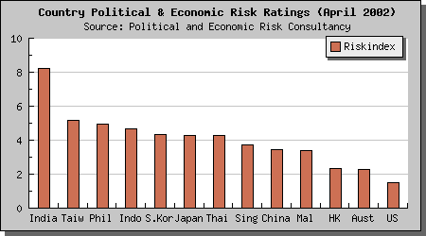
Source: http://www.apmforum.com/news/ap250402.htm

Given an index score of 10 which is the highest, India scores the highest among. There has been a recent increase in religious tensions in multi-religious areas in India, and therefore, high political risk is understandable.

Therefore, other than India, the remaining countries (from Taiwan to Malaysia) can out into consideration for our foreign markets as they all share fairly the same political risk.

The Business Environment Risk Index ( BERI) is a technique used for measuring the general quality of a country’s business climate.
With reference to the business report of BERI 2005, among the Asian countries, Singapore and Japan rated the top from the ranking; Taiwan remains the third which is the same as last year, followed by China, Malaysia and South Korea. They are all low risk countries which suitable for foreign investments.
The Economic Development

Country GDP - real growth rate(%) Date of Information
China 9.10 2004 est.
Singapore 8.10 2004 est.
Hong Kong 7.90 2004 est.
Vietnam 7.70 2004 est.
Malaysia 7.10 2004 est.
Russia 6.70 2004 est.
India 6.20 2004 est.
Thailand 6.10 2004 est.
Taiwan 6.00 2004 est.
Philippines 5.90 2004 est.
Indonesia 4.90 2004 est.
Source: http://www.cia.gov/cia/publications/factbook/rankorder/2003rank.html
The above table is a sum up of the percentage in GDP growth from the main Asia developed countries. The higher the real growth rate in GDP, the better the economic development one country has. Once a country has a good economic development, it has a good figure in GDP; people have more money for expenditure.

The Geographical Distance
The domestic country of DHC, Hong Kong, which located in the south – east part of Asia, bordering the South East Sea and China, is a favourable place for international trade as it is located along the coastline.

As we narrow down our foreign market selection to Asian countries only, it is also beneficial to further distinguish the geographical distance from Hong Kong as Asia consists of a total area of 17226000 square miles.

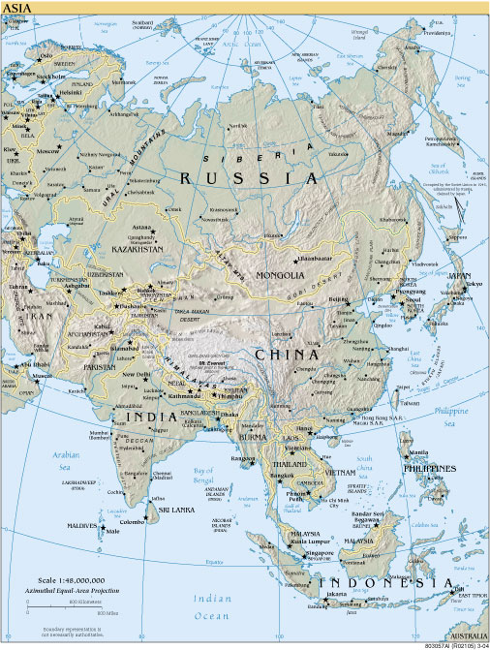

From the map, we can see that China is the nearest country from Hong Kong. Followed by Taiwan, Thailand, Vietnam, Malaysia, Japan. Though the developed countries like Russia, Iraq are part of Asia, but they are too far away from Hong Kong and they may resulted in high transportation cost.
The Financial Risk

The exchange rate

When doing a business in foreign countries, it is important to analysis the financial status like the exchange rates of the candidate countries. Generally if one country has exchange rate volatility, then it indicates that country is underlying economic or political problems which are not favourable for business operating.

The table below generalizes the currency rate of the Asian countries in comparing to the US Dollar.
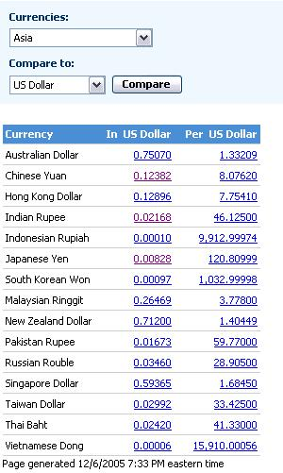
Source: http://moneycentral.msn.com/investor/market/rates.asp?Region=4&Compare=1

The graphs below are the currency fluctuation rate in comparison with the US Dollar in 10 years time.
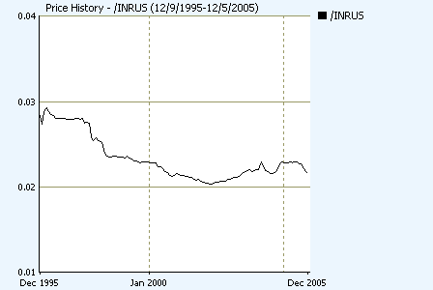India
India is currently facing a continuous decrease in the exchange rate.
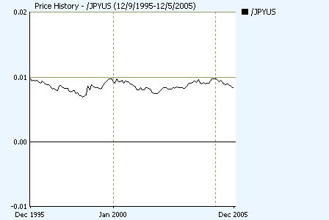Japan
Japan has a stable exchange rate. It’s good for foreign markets to enter.
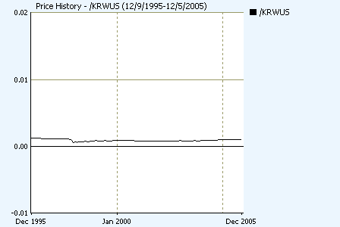South Korea
There is only a slightly change in the South Korea exchange rate. Therefore, it’s under consideration for our company to enter.
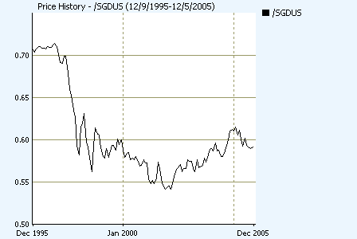Singapore
Singapore’s exchange rate has been decreasing dramatically over the past 10 years. It’s not in favour for business to set up business.
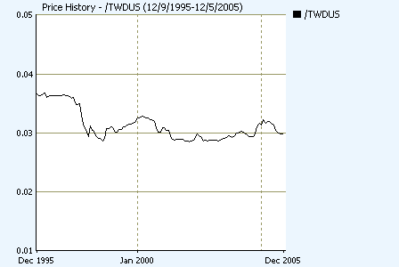Taiwan
There is a decrease in Taiwan exchange rate in around 1997 then become stable from 1997 till 2005.

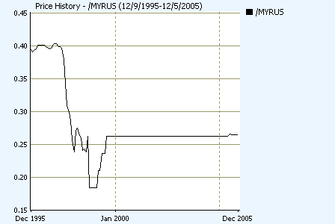Malaysia

Malaysia’s exchange rate has become stable for a 5 years time ( from 2000 – 2005) but beforehand there’s a dramatically decrease.
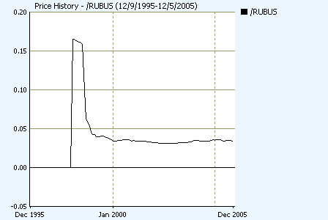Russia

Russia’s

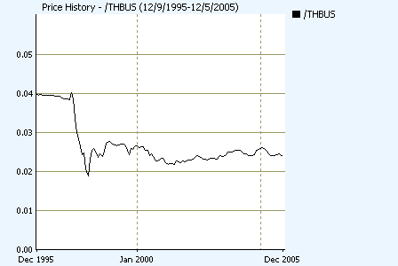 Thailand
Thailand’s exchange rate faced a dramatically decrease from 0.04 to 0.02 in 1997 then become relatively stable from the years onwards.

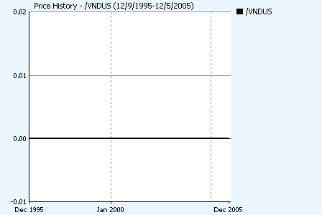Vietnam
There is no change in the Vietnam’s exchange rate over the past 10 years.
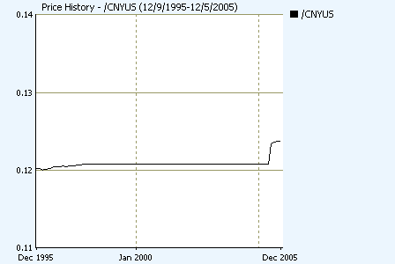China
China’s exchange rate has a recent increase over the past few years.

Source : http://moneycentral.msn.com/detail/stock_quote?Symbol=%2FCNYUS

Culture Distance

Stage 3 – In- Depth Screening
In this stage, data here is specific to the industry and the product markets. This stage involves assessing market potential, actual market size, market growth rate, strengths and weakness of existing and potential competition and trade barriers.

Market Size
This can be found by the local production, which means minus exports plus imports.
China
Japan
Taiwan
The market for skincare & suncare in Taiwan grew slightly between 1998-2003, growing at an average annual rate of 2.7%.
The leading company in the market in 2003 was Procter & Gamble. The second-largest player was Beiersdorf AG, with L'Oreal S.A. in third place.
India
The skin care market in India is about $180 million. The market for specialized skin care products such as sunscreens, toners, cleansers, astringents, dark circle removing creams, anti-wrinkle creams and day and night creams has grown steadily in recent years. Most consumers, however, are still are using only facial cream and moisturizers, with moisturizing lotions, fairness creams and facial cleansers being the most popular products. These products account for approximately 60 percent of the skin-care segment. The major players in this segment are Lakme, Ponds, Fair & Lovely, J.L. Morison and Revlon.
Indonesia
Iraq
Philippines
Russia
Singapore
Total sales of skin care products in Singapore were worth just over US$95.2 million / S$170.5 million in 2002,
Thailand

Market Growth
Japan’s skincare market growth
Skin care, the largest sector in cosmetics and toiletries, saw value growth of an estimated 5% in 2004. Many Japanese women are aware of their skincare so this industry are always attaining a growth. Direct sales used to be the most popular distribution channel for cosmetics and toiletries, but this position was taken over by pharmacies/drugstores in 2003
Cosmetics and toiletries value sales are forecast to see growth of around 9% in constant terms between 2004 and 2009. Sun care and skin care are predicted to see the strongest growth, of 24% and 15%, respectively. As consumers are increasingly concerned with fine lines and wrinkles, due to the ageing of the population in Japan, they will be willing to devote more time and effort to their daily skin care regime, helping to push up value sales of skin care products.
Source: http://www.the-infoshop.com/study/eo31644-toiletries-japan.html

China’s skincare market growth
The cosmetics and toiletries industry in China extended its strong performance in 2004 with current value sales increasing by around 11% to reach over RMB67 billion as growing affluence and greater product availability continued to fuel growth
Skin care accounts for the largest share of cosmetics and toiletries value sales and remained the single largest contributor to the strong overall sales growth in cosmetics and toiletries in 2004. Despite its size, skin care enjoyed the second best growth performance in 2004. Skin care enjoyed relatively high penetration and its sales performance continued to excel as consumers traded up to better quality products. At the same time, growing consumer sophistication has also seen consumers expand their skin care regime from the basic cleanse and moisturizer to include toning and nourishing. The rapidly growing presence of modern retail channels such as supermarkets/hypermarkets and standard convenience stores, was one of the key sales drivers in cosmetics and toiletries in China over the review period.
Source: http://www.the-infoshop.com/study/eo33331-cosmetics-china.html

South Korea’s skincare market growth
The Korean cosmetics and toiletries industry suffered from the country’s ongoing economic depression in 2003. This industry had enjoyed continued growth since 2000 but the strong economic recession in 2002 caused sales to dip by 2% in current value terms in 2003. The major sectors, skin care and colour cosmetics, which accounted for over 60% of the total value, suffered seriously, causing overall cosmetics and toiletries sales to fall.

The trend towards natural products continued well into 2003 and spurred demand for natural-based ingredients for the skincare products.

The distribution of sales
Distribution trends had changed dramatically for cosmetics and toiletries products by 2003, with traditional channels such as specialists suffering the most. As a result of higher levels of disposable income, the preference for one-to-one consultations, and one-stop shopping, more consumers are shopping for big brands either at department stores like Lotte or Shinsagae or discounters like E-mart and Kims Club
Source : http://www.the-infoshop.com/study/eo32795-cosmetics.html

Taiwan’s skincare market growth
The market for skincare in Taiwan grew slightly between 1998-2003, growing at an average annual rate of 2.7%.
The leading company in the market in 2003 was Procter & Gamble. The second-largest player was Beiersdorf AG, with LOreal S.A. in third place.
Source: http://www.the-infoshop.com/study/dc24463_skincare_taiwan.html
India’s skincare market growth
Many of the world’s popular cosmetics brands entered the Indian market in the 1990s as the Indian market opened up to foreign companies. The cosmetics and personal care industry has been growing at an average rate of 15-20 percent for the last few years. Growth has come mainly from the low and medium-priced categories, which account for 90 percent of the cosmetics market in terms of volume. Even though mass-market products still constitute the major portion of the India cosmetics and toiletries market, increased disposable income has led to growth in demand for premium products. The urban population in particular, with its rising purchasing power, is the main force that drives the demand for various cosmetic products in India.
Singapore
an increase of 3.1% over 2001. A

Competitive Intensity
Level of competition can be measured by the no. of competitors in the market and the relative size distribution of market shares. Entry into a foreign market is difficult if there are a few domestic companies which dominate the market., they will certainly be less concerned about a new entrant unless there is some unique features or innovative idea on a certain product.

For Japan, the no. skincare brand is Shiseido, followed by Kose and Sofina They are all dosmsetic companies in Japan. The market share is large of these companies but still Japan attracts a lot of foreign skincare company to enter, like Lancome, Dior, Channel.
In China, the market share of domestic skincare companies are little. The most popular skincare companies from foreign countries are Avon, Clean and Clear, Olay.
As there is a limited amount of skincare domestic companies in China, it is in favour for DHC to enter.
Given that about 95% of cosmetic companies in China are owned by private and foreign companies
In China, Domestic consumer market increased steadily. In 2004, the total retail sales of consumer goods reached 5.4 trillion yuan, up 13.3 percent over the previous year, or a real growth of 10.2 percent if price factors were deducted. Of this total, the retail sales of consumer goods in urban areas reached 3.56 trillion yuan, up 14.7 percent, and the retail sales of consumer goods at and below county level were 1.84 trillion yuan, up 10.7 percent. In terms of different sectors, the sales of the wholesale and retail industries reached 4.484 trillion yuan, up 12.5 percent
http://www.china.org.cn/english/en-sz2005/index.htm
In Taiwan, Exports have provided the primary impetus for industrialization. The trade surplus is substantial, and foreign reserves are the world's third largest.

In India, the skin care segment with the growing belief that chemical-based cosmetics are harmful. Local majors, including Shahnaz, Lotus Herbals, and the Biotique brands dominate the premium herbal cosmetics segment in India, estimated at $100 million. Many companies have expanded their product range into herbal variants, including companies with a primary focus on health care products.
Market penetration levels of international cosmetics brands in India are low. Foreign brands currently constitute only 20 percent of the market, due largely to the higher pricing these brands carry. Foreign brands initially garnered sales in the market based on their international brand image, but repeat purchases were not forthcoming
In Singapore
Brand loyalty for skincare products is very high. For example, skincare accounts for almost 40% of sales, the best performing category amongst L'Oreal's prestige cosmetic and fragrance brands.
Skin care products with whitening properties continue to remain popular. Many manufacturers of mass brands are launching their own whitening ranges, for example, Nivea White from Beiersdorf AG. Skin care manufacturers will see increasing demand among consumers for products that are natural, and which quickly yield visible results.
http://strategis.ic.gc.ca/epic/internet/inimr-ri.nsf/en/gr118492e.html
The distribution channel with the greatest value share of cosmetics and toiletries sales in Singapore was department stores, accounting for nearly 31% of sales, followed by grocery outlets with just over 30%. However, both channels saw their value shares decline, largely to the benefit of pharmacies and drugstores, and to a lesser extent to direct sales and `others' channels
Trade Barriers
The domestic country, Hong Kong
To analysis the business environment on trade of Hong Kong is an essential factor to be considerate before entering into other foreign countries. Hong Kong is the world's 10th largest trading economy, advocating and practising free trade.
Thus, Hong Kong does not charge tariff on importation or exportation of goods. Duty is imposed on imported or locally produced liquors, tobacco, hydrocarbon oil and methyl alcohol.
Source” www.info.gov.hk

Tariffs, taxes of the candidate countries are needed to be analysis since the level of these barriers depends on the exact specification of the goods entered.

China
On 14 November 1999 Chinese and American negotiators signed a historic trade deal that paves the way for China to join the World Trade Organisation. The deal, which will involve major opening of China's markets, will provide a significant boost to China's economic reforms
In the first quarter of this year, China's import and export under general trade stood at US$78.09 billion, up 50%. Of that, export for general trade was US$36.46 billion, up 35.3%; import shot up 65.8% to reach US$41.63 billion, 30.5 percentage points faster than the pace of export growth.
As of 2003, China pruned another one percentage point off its arithmetic mean tariffs rate, and that, coupled with rising domestic demand, resulted in the dramatic increase in import in general trade. In addition, as the quotas acquired in the previous year expired at the end of March, import of some of the commodities under quota control was conducted at the start of the year. The extraordinary increase for import in general trade pushed the deficit for general trade to US$5.17 billion.
http://www.tdctrade.com/report/indprof/indprof_030505.htm

Singapore
Singapore's IP rights record and the high duties it levies on such luxury imports as distilled spirits, wine, tobacco additives and autos remain barriers.
Association of Southeast Asian Nations (ASEAN) was established in August 1967. It was a Free Trade Agreement which consisted of 5 founding members. They were Indonesia, Malaysia, the Philippines, Singapore and Thailand. Afterwards, Brunei Darussalam joined ASEAN in January 1982.
At the Fourth ASEAN Summit meeting in Singapore in January 1992, ASEAN members signed the Singapore Declaration and the Framework Agreement on Enhancing Economic Cooperation, which resulted in the formation of ASEAN Free Trade Agreement (AFTA). The strategic objective of AFTA is to increase the ASEAN region’s competitive advantage as a single production unit. The elimination of trade barriers among member states is expected to promote greater economic efficiency, productivity and competitiveness.
South Korea
Major trading partners of South Korea are the US, Japan, the Chinese mainland, Hong Kong, Taiwan and Germany
South Korea's trade policy used to place a heavy emphasis on import control and export growth promotion. However, in recent years South Korea has revised its trade policy to a more neutral stance. South Korea is considering Free Trade Agreements (FTAs) with Japan, Singapore, Mexico and ASEAN member countries, in addition to the FTA reached with Chile in 2003.
The average tariff rate currently stands at around 8% compared to 24% in 1983. Tariff rates for leading export items from Hong Kong range between 0% and 13%: electrical machinery & equipment (0-13%), office machines & computers (0-8%), clothing & clothing accessories (8-13%), textiles (8-13%), toys and sporting goods (8%), watches and clocks (5-8%), footwear (8-13%) and jewellery (0-8%).
Hong Kong is well placed to facilitate entrepot trade between China and South Korea. In the first eight months of 2004, total trade between these two places via Hong Kong increased by 19% to US$ 6.2 billion.
Source : http://www.tdctrade.com/mktprof/asia/mpsko.htm

5. Factors affecting the foreign market entry mode decision
Internal Factors
- Firm Size, the firm size can determine its resource avalibilty.
- International Experience, this can affect the choses of market entry mode. International experience refers to the extent to which a firm has been involved in operating internationally.
- Product

External Factors:
- Sociocultural distance between home country and the host countires
- Market size and growth
- Direct and indirect trade barriers
- Intensity of competition
- Small number of relevant intermediaries available

The use of franchising for DHC for foreign market entry mode
What is franchising?

