Project Proposal
of
Disc Management System
(DMS)



for

Visual Studio Company

21 February 2007
© Electronic Software House

Distribution of Controlled Copy

Copy No. | Holder
1 | On File
2 | Visual Studio Company

Prepared by :
To Oi Chu, Tobee (036133633), Email: tobeetoc@yahoo.com.hk
Lai Fung Ying, Florence (036255009), Email: bellecurtain@yahoo.com.hk
Lee Pui Chee, Christine (036267727), Email: christinelee01@netvigator.com
Yip Lai Ming, Lily (036250235), Email: lilyylm@yahoo.com.hk

Date of Submission : 21st February 2006
TABLE OF CONTENTS

- Introduction ……………………………………………………………… 4
  - Terms of Reference ……………………………………………… 4
  - Company Profile …………………………………………………... 5
  - Why should Visual Studio Co. use E-Soft product …..…………. 6

- System Overview …………………………………………………… 7
  - Main features …………………………………………………… 8
  - Configuration Setup ……………………………………………… 11

- Other Information …………………………………………………… 12
  - System Requirement ……………………………………………… 12
  - Budget ……………………………………………………………… 13
    - Hardware cost ………………………………………………. 13
    - Installation and operation cost ………………………… 14
    - Cost and Benefit …………………………….…………… 15
  - Schedule Implement ……………………………………………… 16

- Conclusion ……………………………………………………………… 17

- Appendix ………………………………………………………………….. 18
1. Introduction (Prepared by Lai Fung Ying, Florence (036255009))

1.1 Terms of Reference

As a pragmatic and farsighted retailer, to considered how to bring your business a step ahead your rivals is one of the most important matter to do. Business strategies concentrating in price and product differentiation, varieties in the product-mix are designed to make your business stand out from the crowd of competitors. But how to put your strategies into practice without increasing the cost and effectively may be another important matters to considerate.

A perfect retail management system must be cater to the trade and help you actually manage the business in different aspects and to give you instant full picture of your business in order to avoid your marketing efforts in vain.
1.2 Company Profile

Electronic Software House (E-soft) is a software house established in 2003. We provides the tailor made application software for different business from manufacturing, wholesale, retail to customer services. We excel at the Graphical User Interface (GUI) application which provides powerful features, easy to operate, saves time and increases productivity.
1.3 Why should Visual Studio Co. use E-Soft product instead of the packaged software?

The answer is the packaged system may not fully fit into your daily operations. However, E-soft will design and develop an integrated application according to your business features and daily operation needs.

Our services include system study, testing, documentation, on-site technical consultation, installation both of computer hardware and software, full support after completion of the system and staff training.

- System Overview (Prepared by To Oi Chu, Tobee (036133633))

Disc Management System (DMS) is a comprehensive retail management system for a music and video retailing business which with the easy to use front-end comprehensive functions and features for back-office, seamlessly integrated.

DMS comprises system security and authority control, online point-of-sales (POS) solution, inventory control, marketing and promotion campaigns solution, membership management, customer enquiry solution, sales analysis and turnover reports. These features help the administrative officers to manage the data such as sales records, inventory balance, etc. efficiently and also minimize the workload and handling time for each transaction for the front-end staff.

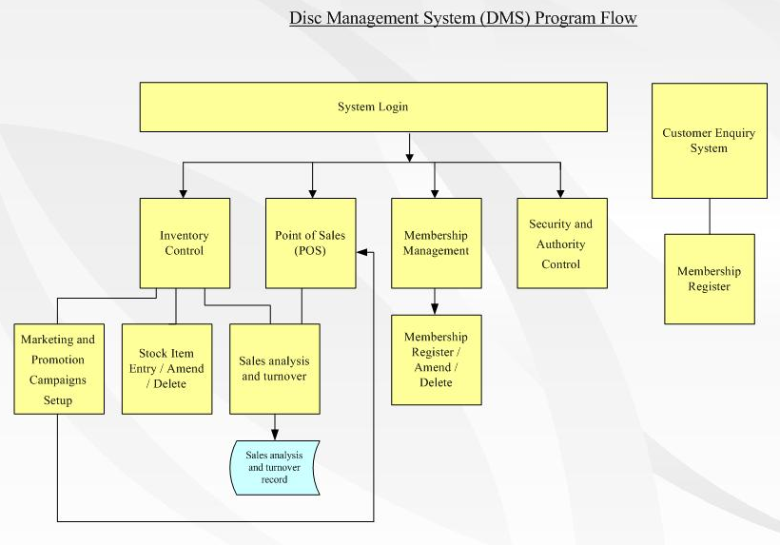

  - Main Features

System Security and Authority Control
- Different staff can be set to different workgroup that allow them to access to the specific function directly after logon.
- Administrator can add new staff, amend staff record, delete deployed staff record and set up the access level for different function for each staff.
- Each function can be set for each user to browse, add, edit and delete.
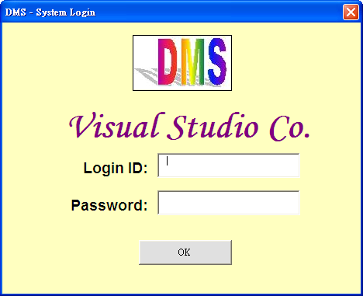

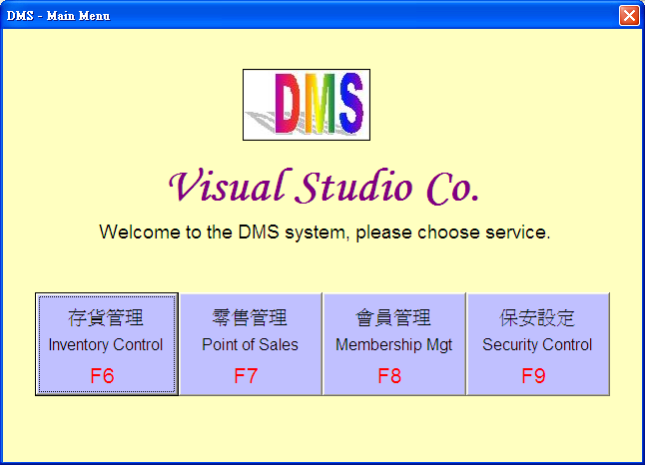

Point of Sales (POS) Solution
- Allows different payment methods, such as cash, credit card, octopus.
- Support multi currency and set exchange rate on every transaction.
- When the sale memo is issued, inventory will be updated and stock sales records will be created automatically without manual interference.
- Goods can be returned or swapped.
- Sales memo can be retrieved and then voided by the authorized person.
- Handle VIP add on service such as goods reserved, bonus point accumulated, special discount.
- Support Receipt Printer, Cash Drawer, Customer Display (Pole Display), Barcode Reader and Programmable Keyboard
- Support English and Traditional Chinese. The interfaces and reports will be displayed according to the selected language.
- Quick price look up

Inventory Control
- Stock item can be add, amend and delete.
- A safe level of stock can be set on each product or in category and the re-order advice reminder will be prompted on every login once the safe level has reached.
- Quick stock search.

Marketing and Promotion Campaigns
Flexible promotion price and discount settings cater for frequent marketing campaigns. The promotion price can be set by theme category, or any combination of product attributes, like artist / director, released date, label…etc.
Membership Management
The front end staff is allow to store the customer information to the membership database or invite the customer to input their information from the customer’s terminal. Membership records could be insert, delete, update or search efficiently under the user friendly interface.
- Supports with membership discounts and bonus points handling.
- Promotion setup allows retailers to set up discounts and bonus for particular member type in a given period of time.
- It also supports the mailing label printing and email broadcasting to your customers.

Customer Enquiry Solution
Customer Enquiry Subsystem is designed for customers to inquire about the products availability, price, etc. by their own via the simple and user friendly interface.

Sales Analysis and Turnover Reports
- User can modify the data field for each report by own self.
- All reports can be exported to the format of Excel or print directly by one-click the print button.
  - Configuration Setup

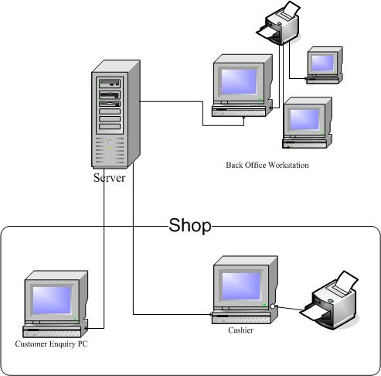

- Other Information (Prepared by Lee Pui Chee, Christine (036267727))

  - System Requirement

- Intel Pentium II 450Mhz or above compatible computer
256MB RAM or above
60MB Hard Disk Space
- 800x600 resolutions
MS Windows 98SE/Me/NT/2000/XP or 100% compatible Operating System
- CD-ROM
- One USB port

Client to server | Server | Monitor | Printer | Keyboard with mouse
Admin
Cashier
Storekeeper
Customers

  - Budget

    - Hardware cost

The system is to serve to the medium-small recorders retailer which have admin, cashier, storekeeper and customers.

Hardware | Total number required | Unit price  HK$ | Total amount  HK$
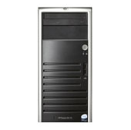  Server | 1 | 10,452 | 10,452
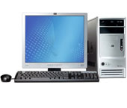  Workstation  (Included keyboard & mouse but not included monitor) | 4 | 4,999 | 19,996
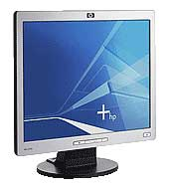  Monitor | 4 | 3,400 | 13,600
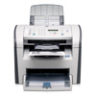  Printer | 4 | 2,688 | 10,752
Total: |  |  | HK$ 54,820
    - Installation & Operation Cost

Description | Amount in HK$
Hardware | 54,820
Software | 50,000
Development | 30,000
Training, Consultation | 20,000
Total | 154,820

    - Cost and Benefit
  - Schedule of Implement

 |  |  |  |  |  |  |  |  |  |  |  |  |  |  | Staff Training
 |  |  |  |  |  |  |  |  |  |  |  | File conversion
 |  |  |  |  |  |  |  | Program testing
 |  |  |  |  | Programming
 |  |  | Application design and draft System specification
 | System Design and draft System proposal
Week | 1 | 2 | 3 | 4 | 5 | 6 | 7 | 8 | 9 | 10 | 11 | 12 | 13 | 14 | 15 | 16

4. Conclusion (Prepared by Yip Lai Ming, Lily (036250235))

The summarization of the advantages to introduce the DMS to Visual Studio Company:

- Easy to search the target disc and stocks.
- Challenges ahead and strong support from all customers.
- Enhance the productivity power.
- Minimize the manpower on every section and thereby to save the labor cost.
- +20% profit in each subsequent year.
- Time and Cost efficiently
- Build up an aggressive image for the company.
- Minimize the manual mistake.

5. Appendix

Reference website:
http://welcome.hp.com/country/hk/zh/welcome.html

