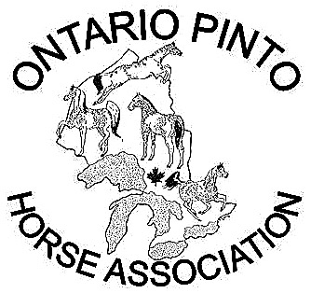
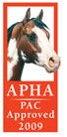

Ontario Pinto Horse Association
Presents
Combined Pinto & All Breed Horse Show
CLASS LIST 2009
Start time—9am

- PtHA Y.A. Western Showmanship
- PtHA Amateur Western Showmanship

- PtHA Halter Geldings/Stallions (all types/ages)
Grand & Reserve Gelding & Stallions
- PtHA Halter Mares (all types & ages)
Grand & Reserve Mares
- Tobiano Color
- Overo Color
6a All Breed Open Halter
6b All Breed Open Showmanship (E&W)
- PtHA Y.A English Showmanship

BREAK

- PtHA Jr Horse English Pleasure
- PtHA Amateur English Pleasure
- PtHA Sr Horse English Pleasure

- PtHA Hunter Under Saddle
- PtHA Amateur Hunter Under Saddle
- PtHA Discipline Rail Horse – English

- PtHA Y.A. English Pleasure
- PtHA Y.A. Hunter Under Saddle
- PtHA Y.A Discipline Rail Horse-English

16a All Breed Open Hunter Under Saddle
16b All Breed Open Discipline Rail Horse(E&W)
16c Beginner All Breed Walk/Jog/Trot
16d Beginner All Breed Walk/Jog/Trot/ Pattern

- PtHA Amateur English Equitation
- PtHA Y.A. English Equitation

- PtHA Hunter Hack
19a All Breed Open Hunter Hack
19b All Breed Open Hunter Over Fences 2’3”

LUNCH BREAK

19c Beginner All Breed Walk/Jog/Trot Trail
19d All Breed Open Trail (E&W)

20. PtHA Trail
21. PtHA Amateur Trail
22. PtHA Y.A. Trail
22a All Breed Open Western Pleasure
23. PtHA Western Pleasure – Jr Horse
24. PtHA Amateur Western Pleasure
25. PtHA Western Pleasure – Sr Horse

26. PtHA Discipline Rail Horse – Western
27. PtHA Y.A. Western Pleasure
28. PtHA Youth Discipline Rail- Western

28a All Breed Open Horsemanship/Equitation
29. PtHA Y.A. Western Horsemanship
30. PtHA Amateur Western Horsemanship

30a All Breed Open Poles
31. PtHA Poles
32. PtHA Y.A Poles
33. PtHA Amateur Poles

33a All Breed Open Barrels
34. PtHA Barrels
35. PtHA Y.A Barrels
36. PtHA Amateur Barrels

37. PtHA Flag Race
- Classes with 2 or less entries will be cancelled.
- Beginner classes are Western or English tack.
- All-Breed classes are Single Judged
- All-Breed classes only are approved for the Paint Alternative competition program (PAC).

- Show Dates:
  - May 18th –Schooling show--All welcome!!
  - June 13th –Pinto - NON-PtHA pointed.
  - July 5th - Pinto & All Breed
  - July 25th - Pinto & All Breed
  - Aug 16th - Pinto & All Breed

