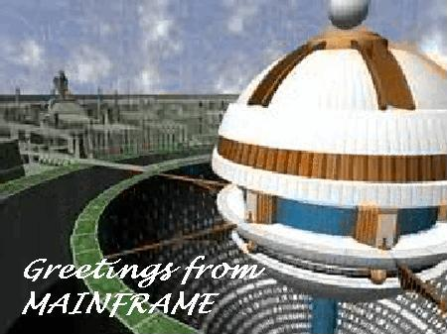

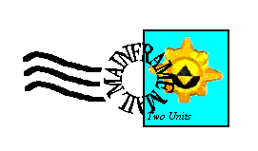
Hi Mum and Dad!
I just wanted you to know that I’m alright.
I know how much you disliked the idea of me leaving the home system
Anyway, I’m settled for a while in a system called Mainframe. The sprites here are really nice, although I feel they’ve been through quite something.
I’ve taken up residence in the Principal Office, and for my meals and “social skills”, I frequent a place called “Dot’s Diner”. It’s owned by the Command.Com of the system, a really nice sprite called Dot (that comes as a surprise, eh?) Matrix. Apparently, there’s a “thing” going on between her and Bob, the Guardian. She also has two brothers, Matrix and Enzo, which seem to be the same sprite, but of different age. That part’s a bit confusing, I know. I haven’t really figured it out myself.
Most important, I’m having a good time over here, and I think that’s the most important thing…
Just remember I love you very much, be I at home or some place else.
Love, Chris

Mum and Dad

Sampler-apartments 17

Highlands sector,

System SUN

